
WELCOME TO ALL OUR VISITORS!
If you are interested in knowing more about St. Peter’s, please see an usher or one of the greeters who stand with the clergy after the service.

10.11.2026 at St. Peter’s
8:15am-11:45am Nursery
8:30am Holy Eucharist Rite I in Chapel
9-10am Breakfast in Daniel Hall
9:50am Children’s Chapel,
10:00am Holy Eucharist Rite II in Nave, WLAQ & YouTube

This week…
Monday October 12th Noon – Reservations for Wednesday
Tuesday October 13th Rith & Naomi Shelter Meal
Wednesday October 14th 5:15-6pm Dinner served
5:30pm Celtic Service in the chapel
7-8pm Adult Choir
Thursday October 15th 3:30pm Stephen Ministry Meeting


Rees Jenkins, Ray Dempsey, Julie Herring, John Schroeder, Dasha, David and Philip Jenkins, Michael Ann Booth, Drew Moss, Nora Barrentios, Basilia Perez, Emily Milstead, Jan Woody, Heather Seckman, Kathrine Ammons, Haywood Patton, Andrew Babcock, Campbell Clark, Katie & Henry Pancione, John Marshall, Gina Schmitz, Carlton Family, Dagmar Schmitz Carlton, Tom Dasher, Carl Neal, Ewald Family, Sherry Finnell and those that care for them.

Beginning of each month the intercessory prayer will be “refreshed”; all names removed. If you wish to add someone, please call, or email the church office. Names will remain on the Prayer List for the entire month.

Military Prayer List:
Megan Massey
Harris Garmon
Phillip Jenkins
Gordon Macy
Charles Lewis
Nolan Kelley
Davis Isley

Andrew Hall
Ted Olney
Michael Blair
Steven Blair
Charlie Hardaker
Justin Yeary

Johnny Crittenden
Sara Carver Thomas
Joshua Ingram
Cherrie Shackelford

Please remember to notify the church office when a service member is no longer on active duty.

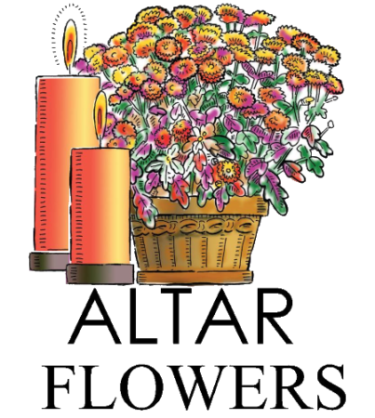
Candles in the Nave given to the Glory of God by Becky and Lee Jones in memory of Janice & William M. Byars, Sr and William M Byars, Jr.

Flowers in the Chapel given to the glory of God by Diann Kothe in celebration of the birthdays of John Hoth, Jr., Megan Aaron and Courtleigh Hoth.

Flowers in the Nave given to the Glory of God by Belinda Martin in thanksgiving for Carolyn and Barry Shinall.


OPEN dates on Flower Calendar:

Nave – October 25th, November 29th, December 6th

Remember departed loved ones or honor someone special, contact church office to secure date.



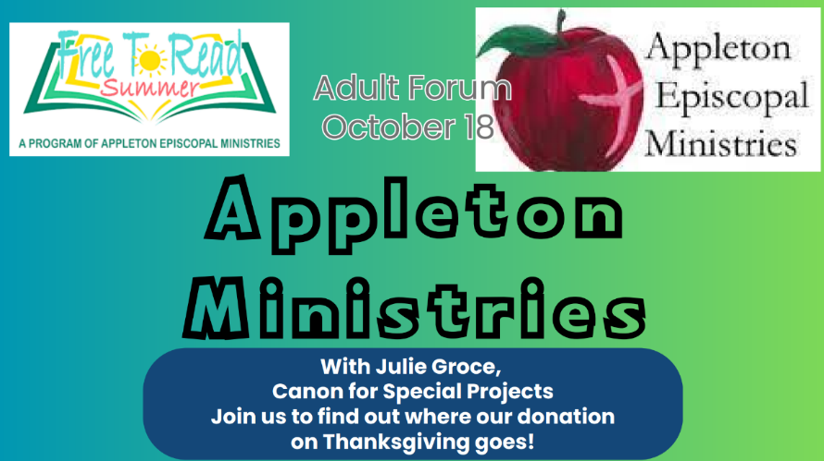
October 18th
Julie Groce from Appleton Ministries.

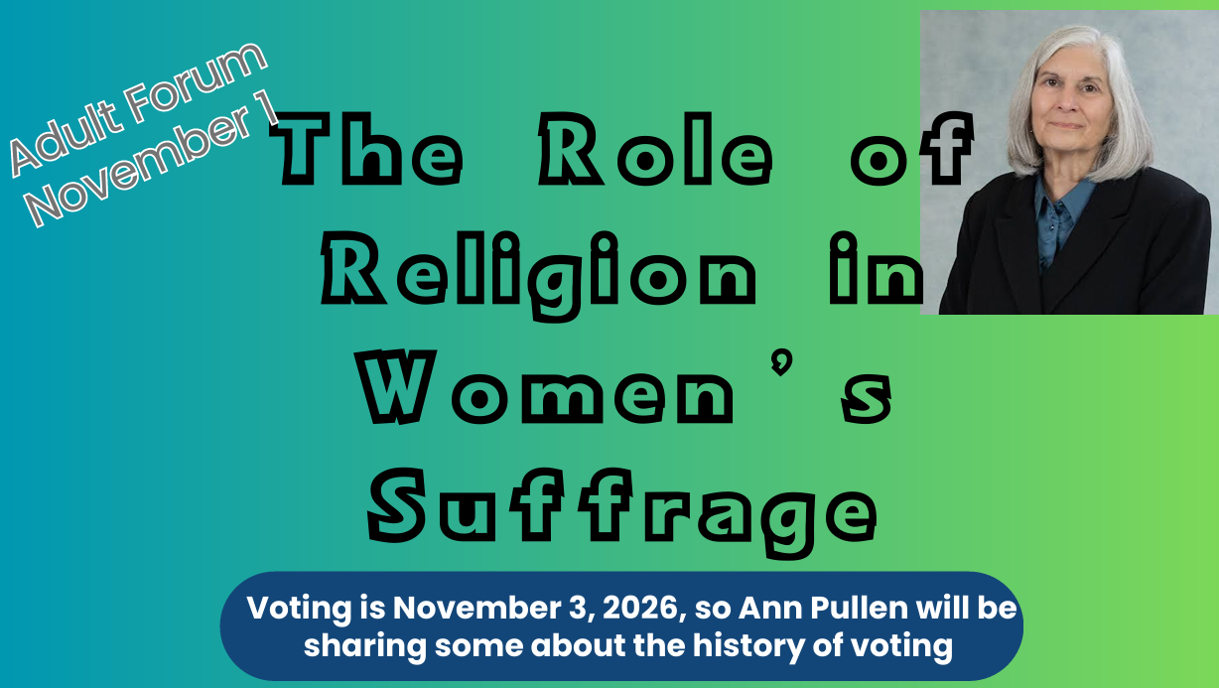

November 1st
Ann Pullen

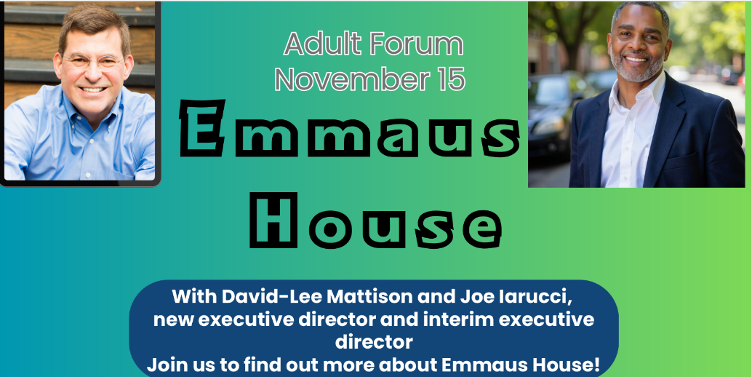
November 15th

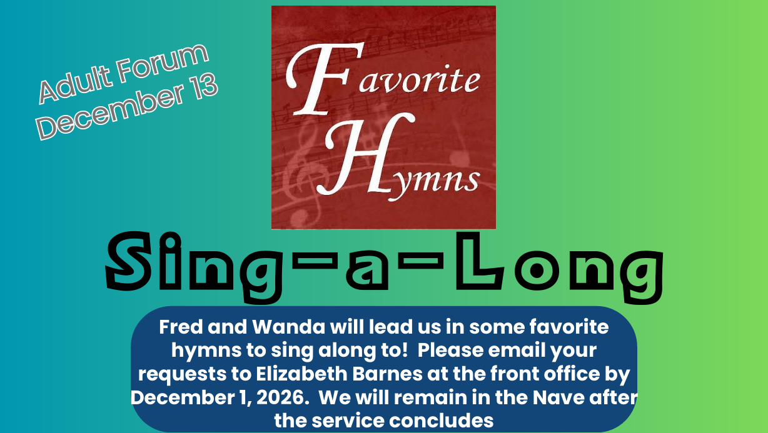

December 13th
Email or call the church office with your hymn selections by December 1st.


2nd Friday each month,
6-8:30pm in Daniel Hall.
Virginia Hunter, 770.530.0079
Come join our fun!

Next Gathering – November 13th

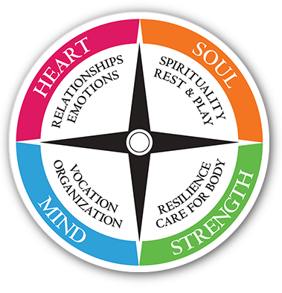
Living Compass

Monday’s at 2pm.
NEW LOCATION – Rhodes Wyatt at St. Peter’s
The Seven Storey Mountain by Thomas Merton is the focus for the group. Order your book today.
Also join via Zoom. Contact D’Ann 706.266.3444

Will NOT meet 10.12.2026


Do you or someone you know Calligraphy?

Church needs their talent for personalizing prayer books, baptismal certificates, etc.
Contact the church office.


November 8th
St. Peter’s Annual Meeting
In Daniel Hall.

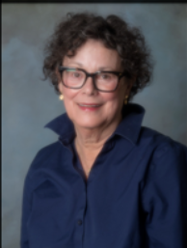
Virginia Hunter
As a cradle Episcopalian, I was baptized and confirmed at Holy Comforter in Gadsden, Alabama. Guy and I were married at Holy Innocents in Atlanta. While we were in Young Harris, Georgia we were members of Good Shepherd in Hayesville, North Carolina where I served on the vestry. We moved to Rome eleven years ago and joined St. Peter’s. At St. Peter’s I serve on the Altar Guild, Greeters, Loaves & Fishes, and host Mah Jongg. It is an honor to be nominated, and I look forward to serving.

Allien McNair

I started coming to St. Peter’s around 1992, when Don Dellis, a neighbor, asked me if I wanted to come to church with him one Sunday at 8:30. I grew up in the Methodist Church but joined St. Peter’s after starting attending.

I have been on a breakfast crew team for many years, I ushered once month a year, previous Vestry member working on the Building and Grounds Committee and Chairperson, Sunday Morning Education Committee under Greg Tallent. Worked on the Lower Memorial Garden, was on the Habitat for Humanity Board of Directors for 6 years and Vice President for 2 years,
helped chaperoned youth New York trip, Chalice Bearer and became an alternate Verger in 2018. I have volunteered for Soup Kitchen, October Fest, Wednesday Night Dinner, St. Peter’s Day, Easter Vigil, and assist Sheila Kinnebrew with jobs around the church property when ever asked.

I taught Special Education for twenty-six years, was named Floyd County Teacher of the Year in 2005, and retired in 2018. I hold a Masters Degree in Emotional Behavioral Disorders from University of West Georgia.

When not working or volunteering at St. Peter’s I enjoy working in my yard, working out, hiking, biking, kayaking, traveling, cleaning, organizing, and Sci Fi movies.
I am the son of Joe and Ramona McNair of Tifton Georgia, brother of Mona Cawley of Ashburn, Georgia. Bill Schoepski and I married at St. Peter’s on September 5, 2015 after 24 years together.

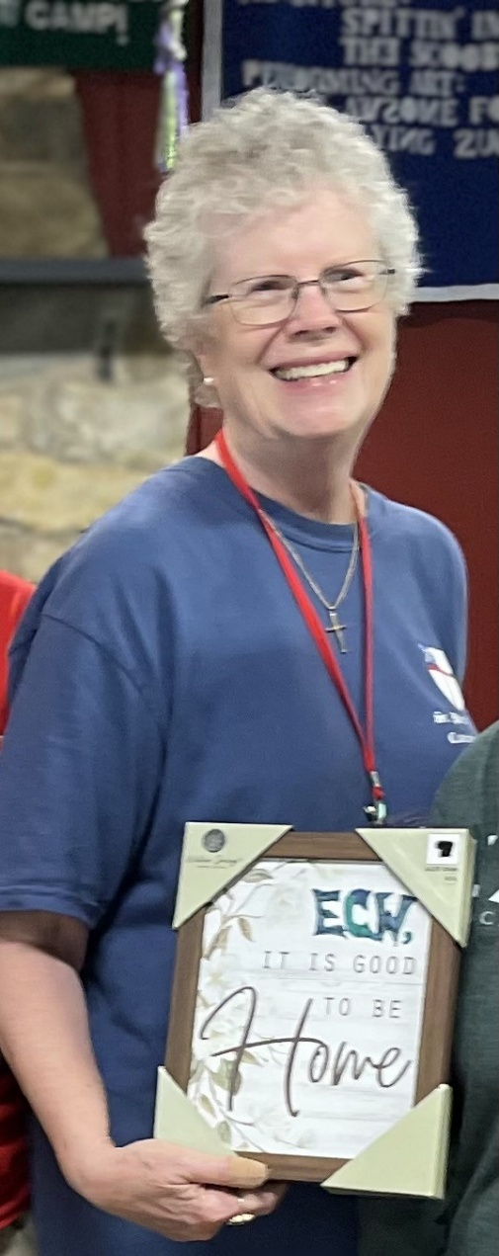
Diane Nance
I’m so excited to have the opportunity to be on the vestry. At one time or another I have tried most of the ministries and activities here at St Peters, and I hope to bring those experiences to the vestry to represent your interests and assist in planning and executing our vision.

I grew up Roman Catholic. Rick and I raised our children in the Lutheran Church and came to St Peters soon after we moved to Rome. I used to say I was a closet Lutheran attending St Peters; but now I feel I’ve completely embraced the Episcopal emphasis on inclusivity and faith in action in the church and in the world.

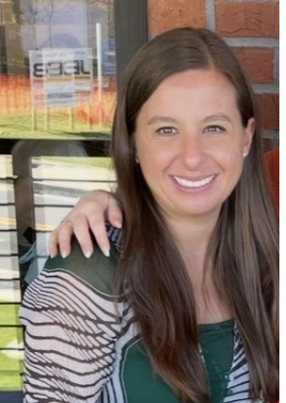
Kellie Wolfe

I was born in Marietta, Georgia and grew up in Cobb County. I came to Rome 16 years ago as a newly graduated teacher. I taught at Rome Middle School for 14 years, and I now teach at Rome High School. In 2023, I began thinking about finding a church in Rome and visited St. Peter's. I was immediately drawn by the welcoming community and the beauty of the liturgy.
After completing the catechumenate course, I was received into the Episcopal Church. This was a special experience both intellectually and spiritually.

Saint Peter’s has become a wonderful third space in my life, and I cherish the time I spend here. I am thankful that I was encouraged to become involved as a volunteer almost immediately. I work with Junior EYC each Sunday evening. It is rewarding to watch our youth build friendships and grow together. I have also served as a Roots leader, work VBS each summer, am a member of Loaves and Fishes, and help with Children’s Chapel.

I am excited for the opportunity to serve the church in a new way.


Episcopal Church Women
3rd Monday of each Month
6:30pm in Daniel Hall
October 19th

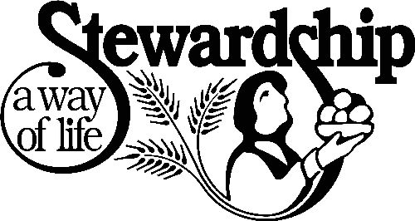
Annual Stewardship Campaign
Consecration Sunday 10.25.2026

Sunday Stewardship Speakers:
9.27 Scott Morris
10.4 Lynnette & Hugh Bonner
10.11 Janet Byington
10.18 John Hawkins
10.25 Dean Hobbs, Campus Missioner, Diocese of Atlanta

Make Plans Today:
- Attend one of the services on Consecration Sunday
- Receive your 2027 Pledge card during the service
- Make your pledge committement
- Attend the brunch/lunch following the 10am service.
  - No charge for the meal
  - Catered by Eric Tant from John Henry’s

Contact office or register on Realm by 10.19.2026 to make your reservation for Consecration Brunch/Lunch!

NO Breakfast service on Consecration Sunday.

St. Peter’s VOLUNTEERs are needed from 9am till noon. HOWEVER, if you are not able to work the full 3 hours, any time you can share is greatly appreciated.


2026 Schedule
Friday Tuesday
August 21 25
September 25 29
October 23 27
November 20 24
December -- 29

Contact Nancy Hunter to volunteer to help, 706.506.3889. THANK YOU


Russ Jennings 12th
Marni Neal 12th
John Kwist 15th
Ann Pullen 16th
Claudia Torres 16th


October 30th 5:30-8pm
- Adults gather at El Zarappe
- Children birth – 5th grade
- $10 per child to cover their food and activities


Potted Mums All Saints Sunday November 1st

If you are interested in placing a potted mum in the Memory Garden for All Saints Sunday, please complete the form below:

Return the Form:
- Place in the collection plate.
- Contact the Office – email elizabeth@stpetersrome.org OR call 706-291-9111 and leave a message, with your name and the name of those to be remembered.
- Checks should be made payable to St. Peter’s Episcopal Church and marked for Mums.
- No specific amount is requested. Give whatever is comfortable for you.
- Deadline for forms/gifts is Wednesday OCTOBER 23rd.

In Memory of

Donor name and phone number (for questions only):



October 28th ~ 5:30-7:30pm in Daniel Hall


Dinner served 5:30-6:30 Grilled Cheese sandwich, tomato soup, baked potato bar, salad, dessert.

Games~Haunted House~Prizes~Face Painting
Cake Walk sponsored by ECW!

Sign up sheet for volunteers on bulletin board in Daniel Hall

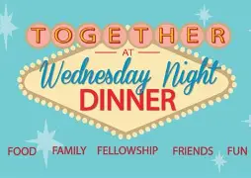
Wednesday

Dinner 5:15pm
Adults $10 - 2 entrees, 2 sides, salad, dessert
children’s menu $4, Vegan $8 (all sides are vegan friendly)
Reservations are GREATLY appreciated by noon on Mondays.

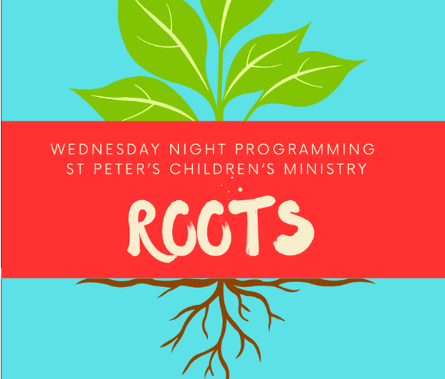
ROOTS 5:45-6:30pm
Pre K – 5th grade
Will NOT meet 10.14.2026



Junior Choir 6:30-7pm
Will NOT meet 10.14.2026

Nursery provided 5:30-7pm for children birth-3yrs old
Wednesday Dinner MENU

October 14th
Spaghetti and meatballs, salad, dessert
Kids menu: same as adults, just smaller portions

October 21st
Baked chicken, fried cabbage, rice, salad, dessert
Kids Menu: pepperoni Pizza

October 28th – All Hallows eve
Grilled Cheese sandwich, tomato soup, baked potato bar, salad, Dessert

November 4th
Meatloaf, mashed potatoes, green beans, Salad, Dessert
Kids Menu: same as adult, smaller portions

November 11th
Fried Chicken, buttered corn, Cole slaw, dessert
Kids Menu: Chicken Tenders, corn

November 18th
Ham, Candied Yams, Grean Beans, salad, dessert
Kids Menu: Cheese Pizza.
Vegetarian meals $8,
All sides are vegan, served with hard boiled eggs.
Joining Realm is NOT mandatory.
By signing up for Realm you can…

- Schedule gifts or pledge payments by credit card or debit to your bank account.
- Register for events at the church
- PREPAY for events before you arrive
- Upload current individual or family photos for the church directory
- Keep your contact information current

If you are not currently signed up for Realm, simply contact the church office and an invite will be emailed to you.

PAYMENT METHODS for St. Peter’s

Remember to always include a note/memo on all
Venmo payments to ensure proper credit. For example, tithe, pledge, Wednesday dinner, Breakfast, etc.

If your Venmo account does not display YOUR NAME please include your name in the memo as well.


Payments via Paypal and the church website, www.stpetersrome.org.
Select Giving on the top banner then stewardship. Follow the Instructions to remit via ACH or Credit Card using Paypal. The fees associated with using Paypal are paid by the church. If you wish to share in this cost simply increase the amount of your gift (2.2% of the given amount plus .30 per transaction).

Link directly to PayPal giving on website Stewardship | St. Peter's Episcopal Church

OCTOBER | Monday | Tuesday | Wednesday | Thursday | Friday | Saturday
 |  |  |  | 1  Stephen Ministry Supervision Mtg 3:30pm R. Wyatt | 2 | 3
4 YOUTH SUNDAY  8:15-11:45 Nursery provided  8:30am – Rite I Chapel  9-10 Breakfast  9:50am Children’s Chapel  10am – Rite II Nave, WLAQ/You tube  11:15am Adult Forum  4pm Blessing of the Animals  5-6 Youth Confirmation class  6-7:30 EYC | 5  Noon Wed. Dinner reservations due.  2pm Living Compass, Rhodes Wyatt | 6  7-9pm Three Rivers Nave | 7  Dinner 5:15-6pm  EYC Dwtn Dinner 6pm  5:30pm Celtic Service  Nursery 5:30-7pm  Roots 5:45-6:30  Jr. Choir 6:30-7pm  7pm Adult Choir | 8  Davies Shelter Meal  10am Bible Study  6:30pm 3 Rivers, Rhodes Wyatt | 9  6pm Mahjong in Daniel Hall | 10
11  8:15-11:45 Nursery provided  8:30am – Rite I Chapel  9-10 Breakfast  9:50am Children’s Chapel  10am – Rite II Nave, WLAQ/You tube | 12  Noon Wed. Dinner reservations due. | 13  Ruth Naomi Shelter Meal  7-8:30pm Indivisible D. Hall  7-9pm Three Rivers Nave | 14  Dinner 5:15-6pm  5:30pm Celtic Service  7pm Adult Choir | 15  10am Bible Study  3:30pm Stephen Ministry R. Wyatt | 16 | 17
18  8:15-11:45 Nursery provided  8:30am – Rite I Chapel  9-10 Breakfast  9:50am Children’s Chapel  10am – Rite II Nave, WLAQ/You tube  11:15am Adult Forum – Julie Grace from Appleton Ministries  5-6 Youth Confirmation class  6-7:30 EYC | 19  Noon Wed. Dinner reservations due.  2pm Living Compass, Rhodes Wyatts  6:30pm ECW D. Hall | 20  5:30pm Vestry Meeting in Rhodes Wyatt  7-9pm Three Rivers Nave | 21  Dinner 5:15-6pm  5:30pm Celtic Service  Nursery 5:30-7pm  Roots 5:45-6:30  Jr. Choir 6:30-7pm  7pm Adult Choir  Noon – Living Proof in Rhodes Wyatt | 22  10am Bible Study | 23 | 24  Jim Keaten Service and Reception, 1pm
25 CONSECRATION Sunday  8:15-11:45 Nursery provided  8:30am – Rite I Chapel  9:50am Children’s Chapel  10am – Rite II Nave, WLAQ/You tube  11:15am Consecration Brunch/Lunch in Daniel Hall  5-6 Youth Confirmation class  6-7:30 EYC | 26  Noon Wed. Dinner reservations due.  2pm Living Compass  Rhodes Wyatt | 27  7-9pm Three Rivers Nave  4-8pm ESP, D. Hall | 28  5:30 Celtic Service  All Hallow’s Eve  5:30-7:30pm | 29  10am Bible Study | 30  PARENTS NIGHT OUT 5:30-8pm  El Zarappe  3:30-9pm ESP, D. Hall | 31  

