
WELCOME TO ALL OUR VISITORS!
If you are interested in knowing more about St. Peter’s, please see an usher or one of the greeters who stand with the clergy after the service.

9.27.2026 at St. Peter’s
8:15am-11:45am Nursery
8:30am Holy Eucharist Rite I in Chapel
9-10am Breakfast in Daniel Hall
9:50am Children’s Chapel,Margaret Louttit & Suzanne Roberts
10:00am Holy Eucharist Rite II in Nave, WLAQ & YouTube
11:15am Adult Forum Book Club
5-6pm Youth Confirmation Class
6-7:30pm EYC – dinner, discussion, prayer

This week…
Monday September 28th Noon – Reservations for Wednesday
2pm Living Compass
Wednesday September 30th 5:15-6pm Dinner served
5:30pm Celtic Service in the chapel
5:30-7pm Nursery for birth-3yrs old
5:45-6:30pm Roots
6:30-7pm Junior Choir
7-8pm Adult Choir
Thursday, October 1st 3:30pm Stephen Ministry Meeting
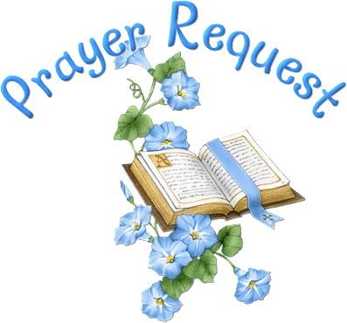
Campbell Clark, Katie & Henry Pancione, John Marshall, Ame Frease, Gina Schmitz, Carlton Family Dagmar Schmitz Carlton, Tony Piacentino, Sherry Hudgins, Marni Neal & Family, Davis Donahue, Skip Howse, John Schroeder, Andrew Babcock, Haywood Patton, Leah, Emily Tarter, Kellie Varnell, Katharine Ammons, Heather Seckman, Jan Woody, Kerri Burk Anderson, William Burk, Basilia Perez, Nora Barrientos, Drew Moss, Michael Ann Booth, Dasha & David Jenkins, Julie Herring, Ray Dempsey, Rees Jenkins and those that care for them.

THIS WEEK the intercessory prayer will be “refreshed”; all names removed. If you wish to add someone, please call, or email the church office. Names will remain on the Prayer List for the entire month.
Military Prayer List:
Megan Massey
Harris Garmon
Phillip Jenkins
Gordon Macy
Charles Lewis
Nolan Kelley
Davis Isley

Andrew Hall
Ted Olney
Michael Blair
Steven Blair
Charlie Hardaker
Justin Yeary

Johnny Crittenden
Sara Carver Thomas
Joshua Ingram
Cherrie Shackelford

Please remember to notify the church office when a service member is no longer on active duty.


Today is Pastor Linda’s final Sunday.

THANK YOU,
Pastor Linda for your care and love during these three months.


Candles in the Nave given to the Glory of God by MJ Chisholm in memory of Emily Barba.

Flowers in the Chapel given to the glory of God by Mary & Jack McGuffey in Thanksgiving for the blessings of their family.

Flowers in the Nave given to the Glory of God.


OPEN dates on Flower Calendar:

Nave – October 4, & 25th , December 6th

Remember departed loved ones or honor someone special, contact church office to secure date.

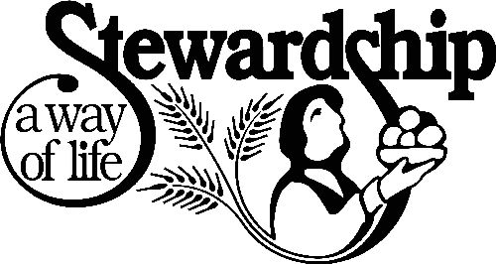
The 2027 Annual Stewardship Campaign will begin shortly.

Contact Church office if your mailing address needs to be update.

Stewardship Speakers:
9.27 Scott Morris
10.4 Lynnette & Hugh Bonner
10.11 Janet Byington
10.18 John Hawkins
10.25 Dean Hobbs, Campus Missioner, Diocese of Atlanta

Consecration brunch will be held on Sunday, October 25th

SUNDAY October 4th
4pm
Pet Memorial Garden

Bring your pets in a cage or on a leash to receive a blessing.


October 4th

Our Youth
will lead all aspects of both Sunday Services.
Don’t miss this very special day!


September 13, 20, 27 & October 4
Book Club
Blessed at the Broken Places
J. Marshall Jenkins.

Coming later in the fall….
October 18th Julie Groce from Appleton Ministries.
November 1st Ann Pullen


Every single PULL TAB you save goes toward supporting Ronald McDonald House Charity. This charity serves families of children facing serious illnesses or accidents so that the parents can stay close to their child while they receive medical care.

I am asking parishioners to help collect PULL TABS from any canned drink. It may seem small, but one PULL TAB joined with another quicky adds up to something BIG!. There is a container in Daniel Hall for you to drop your “tabs” into. Ask your friends and neighbors to save as well. Virginia Hunter, 770.530.0079

St. Peter’s VOLUNTEERs are needed from 9am till noon. HOWEVER, if you are not able to work the full 3 hours, any time you can share is greatly appreciated.

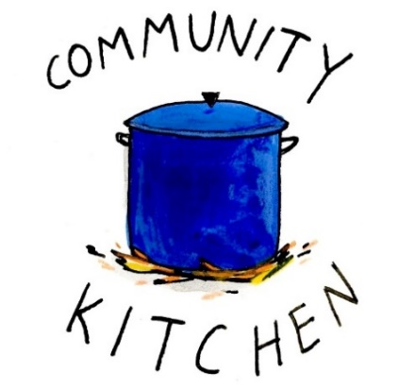
2026 Schedule
Friday Tuesday
August 21 25
September 25 29
October 23 27
November 20 24
December -- 29

Contact Nancy Hunter to volunteer to help, 706.506.3889. THANK YOU


2nd Friday each month,
6-8:30pm in Daniel Hall.
Virginia Hunter, 770.530.0079
Come join our fun!

Next Gathering – October 9th
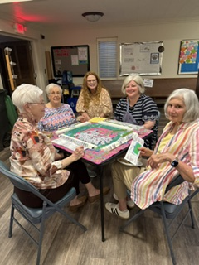

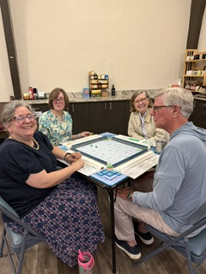
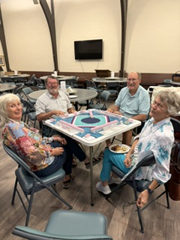


Episcopal Church Women
3rd Monday of each Month
6:30pm in Daniel Hall
October 19th

Diocesan ECW Meeting, October 10th, Cost $25. If you plan to attend submit ASAP

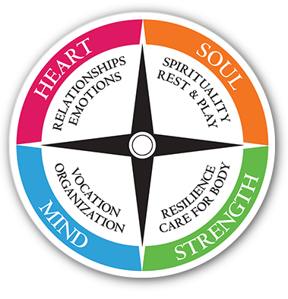
Living Compass

Monday’s at 2pm.
NEW LOCATION - 29 Notasulga Drive
The Seven Storey Mountain by Thomas Merton is the focus for the group. Order your book today.

Also join via Zoom. Contact D’Ann 706.266.3444


Sunday breakfast
9-10am in Daniel Hall.

Come join us for fresh coffee, eggs, meat, bisquits and plenty of fellowship.


October 28th ~ 5:30-7:30pm in Daniel Hall
Games~Haunted House~Cake Walk~Face Painting
Sign up sheet for volunteers on bulletin board in Daniel Hall


Stephen Patton 28th
Jen Cromer 28th
Emi Grace Wood 29th
Daniel Pugh 30th
David Hunter October 1st
Jesse Stoll 1st
Ryan Murphy 2nd
Patti Brown 3rd


October 30th 5:30-8pm
- Adults gather at El Zarappe
- Children birth – 5th grade
- $10 per child to cover their food and activities

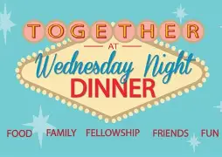
Wednesday

Dinner 5:15pm
Adults $10 - 2 entrees, 2 sides, salad, dessert
children’s menu $4, Vegan $8 (all sides are vegan friendly)
Reservations are GREATLY appreciated by noon on Mondays.

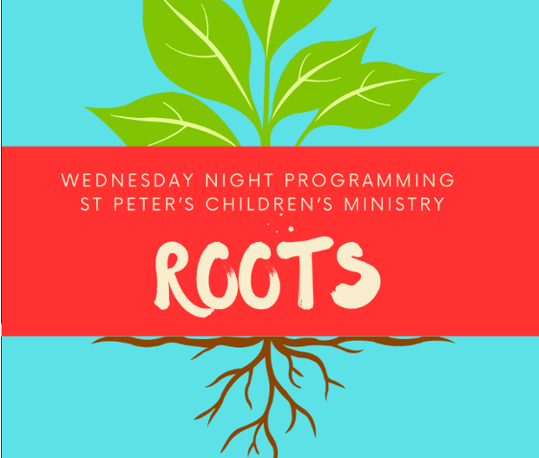
ROOTS 5:45-6:30pm
Pre K – 5th grade



Junior Choir 6:30-7pm

Nursery provided 5:30-7pm for children birth-3yrs old

Wednesday Dinner MENU

September 30th
Fried Chicken
Buttered Corn, Cole slaw, dessert
Kids Menu: Chicken tenders, corn

October 7th
Ham, candied yams, collards, salad, dessert
Kids menu: cheese pizza

October 14th
Pasta, salad, dessert
Kids menu: same as adults, just smaller portions

October 21st
Baked chicken, fried cabbage, rice, salad, dessert
Kids Menu: pepperoni Pizza

October 28th – All Hallows eve
Grilled Cheese sandwich, tomato soup, baked potato bar, salad, Dessert

Vegetarian meals $8,
All sides are vegan, served with hard boiled eggs.

Joining Realm is NOT mandatory.
By signing up for Realm you can…

- Schedule gifts or pledge payments by credit card or debit to your bank account.
- Register for events at the church
- PREPAY for events before you arrive
- Upload current individual or family photos for the church directory
- Keep your contact information current

If you are not currently signed up for Realm, simply contact the church office and an invite will be emailed to you.

PAYMENT METHODS for St. Peter’s

Remember to always include a note/memo on all
Venmo payments to ensure proper credit. For example, tithe, pledge, Wednesday dinner, Breakfast, etc.

If your Venmo account does not display YOUR NAME please include your name in the memo as well.


Payments via Paypal and the church website, www.stpetersrome.org.
Select Giving on the top banner then stewardship. Follow the Instructions to remit via ACH or Credit Card using Paypal. The fees associated with using Paypal are paid by the church. If you wish to share in this cost simply increase the amount of your gift (2.2% of the given amount plus .30 per transaction).

Link directly to PayPal giving on website Stewardship | St. Peter's Episcopal Church

SEPTEMBER/OCTOBER | Monday | Tuesday | Wednesday | Thursday | Friday | Saturday
27 – Linda Alessandri  8:15-11:45 Nursery provided  8:30am – Rite I Chapel  9-10 Breakfast  9:50am Children’s Chapel  10am – Rite II Nave, WLAQ/You tube  11:15am Adult Forum  5-6 Youth Confirmation class  6-7:30 EYC | 28  Noon Wed. Dinner reservations due.  2pm Living Compass | 29  7-9pm Three Rivers Nave | 30  Dinner 5:15-6pm  5:30pm Celtic Service  Nursery 5:30-7pm  Roots 5:45-6:30  Jr. Choir 6:30-7pm  7pm Adult Choir | October 1    Stephen Ministry Supervision Mtg 3:30pm R. Wyatt | 2 | 3
4 YOUTH SUNDAY  8:15-11:45 Nursery provided  8:30am – Rite I Chapel  9-10 Breakfast  9:50am Children’s Chapel  10am – Rite II Nave, WLAQ/You tube  11:15am Adult Forum  4pm Blessing of the Animals  5-6 Youth Confirmation class  6-7:30 EYC | 5  Noon Wed. Dinner reservations due.  2pm Living Compass | 6  7-9pm Three Rivers Nave | 7  Dinner 5:15-6pm  EYC Dwtn Dinner 6pm  5:30pm Celtic Service  Nursery 5:30-7pm  Roots 5:45-6:30  Jr. Choir 6:30-7pm  7pm Adult Choir | 8  Davies Shelter Meal  6:30pm 3 Rivers, Rhodes Wyatt | 9  6pm Mahjong in Daniel Hall | 10
11  8:15-11:45 Nursery provided  8:30am – Rite I Chapel  9-10 Breakfast  9:50am Children’s Chapel  10am – Rite II Nave, WLAQ/You tube | 12  Noon Wed. Dinner reservations due.  2pm Living Compass | 13  Ruth Naomi Shelter Meal  7-8:30pm Indivisible D. Hall  7-9pm Three Rivers Nave | 14  Dinner 5:15-6pm  5:30pm Celtic Service  Nursery 5:30-7pm  Roots 5:45-6:30  Jr. Choir 6:30-7pm  7pm Adult Choir | 15  3:30pm Stephen Ministry R. Wyatt | 16 | 17  DKG – D. Hall 1:30-4:30pm
18  8:15-11:45 Nursery provided  8:30am – Rite I Chapel  9-10 Breakfast  9:50am Children’s Chapel  10am – Rite II Nave, WLAQ/You tube  11:15am Adult Forum – Julie Grace from Appleton Ministries  5-6 Youth Confirmation class  6-7:30 EYC | 19  Noon Wed. Dinner reservations due.  2pm Living Compass  6:30pm ECW D. Hall | 20  5:30pm Vestry Meeting in Rhodes Wyatt  7-9pm Three Rivers Nave | 21  Dinner 5:15-6pm  5:30pm Celtic Service  Nursery 5:30-7pm  Roots 5:45-6:30  Jr. Choir 6:30-7pm  7pm Adult Choir  Noon – Living Proof in Rhodes Wyatt | 22 | 23 | 24  Jim Keaten Service and Reception, 1pm
25 CONSECRATION Sunday  8:15-11:45 Nursery provided  8:30am – Rite I Chapel  9:50am Children’s Chapel  10am – Rite II Nave, WLAQ/You tube  11:15am Consecration Brunch in Daniel Hall  5-6 Youth Confirmation class  6-7:30 EYC | 26  Noon Wed. Dinner reservations due.  2pm Living Compass | 27  7-9pm Three Rivers Nave  4-8pm ESP, D. Hall | 28  5:30 Celtic Service  All Hallow’s Eve  5:30-7:30pm | 29 | 30  PARENTS NIGHT OUT 5:30-8pm  El Zarappe  3:30-9pm ESP, D. Hall | 31

