
WELCOME TO ALL OUR VISITORS!
If you are interested in knowing more about St. Peter’s, please see an usher or one of the greeters who stand with the clergy after the service.

9.13.2026 at St. Peter’s
8:15am-11:45am Nursery
8:30am Holy Eucharist Rite I in Chapel
9-10am Breakfast in Daniel Hall
9:50am Children’s Chapel – Katherine Patterson & Lee Morris
10:00am Holy Eucharist Rite II in Nave, WLAQ & YouTube
11:15am Adult Forum Book Club
5-6pm Youth Confirmation Class
6-7:30pm EYC
This week…
Monday September 14th Noon – Reservations for Wednesday
2pm Living Compass
Wednesday September 15th 5:15-6pm Dinner served
5:30pm Celtic Service in the chapel
5:30-7pm Nursery for birth-3yrs old
5:45-6:30pm Roots
6:30-7pm Junior Choir
7-8pm Adult Choir
Thursday September 17th 3:30pm Stephen Ministry Meeting

Campbell Clark, Katie & Henry Pancione, John Marshall, Ame Frease, Gina Schmitz, Carlton Family Dagmar Schmitz Carlton, Carol Farmer, Tony Piacentino, Sherry Hundgins, Marni Neal & Family, Davis Donahue, Skip Howse, John Schroeder, Andrew Babcock, Haywood Patton, Leah, Emily Tarter, Kellie Varnell, Katharine Ammons, Heather Seckman, Jan Woody, Kerri Burk Anderson, William Burk, Basilia Perez, Nora Barrientos, Drew Moss, Michael Ann Booth, Dasha & David Jenkins, Julie Herring, Ray Dempsey, Rees Jenkins and those that care for them.

Beginning of the month the intercessory prayer will be “refreshed”; all names removed. If you wish to add someone, please call, or email the church office. Names will remain on the Prayer List for the entire month.
Military Prayer List:
Harris Garmon
Phillip Jenkins
Gordon Macy
Charles Lewis
Nolan Kelley
Davis Isley

Andrew Hall
Ted Olney
Michael Blair
Steven Blair
Charlie Hardaker
Justin Yeary

Thomas Keefe
Johnny Crittenden
Sara Carver Thomas
Joshua Ingram
Cherrie Shackelford

Please remember to notify the church office when a service member is no longer on active duty.



Candles in the Nave given to the Glory of God by MJ Chisholm in memory of Emily Barba.

Flowers in the Chapel given to the glory of God by Bob Kane in loving memory of Linda Prestwood and Frank Joseph Kane.

Flowers in the Nave given to the Glory of God by MJ Chisholm in loving memory Elizabeth & Robert Chisholm, Jim Chisholm and Barbara & CJ Wyatt, Jr.


OPEN dates on Flower Calendar:

Chapel – October 18th
Nave – October 25th, December 6th

Remember departed loved ones or honor someone special, contact church office to secure date.

6 NEW Vestry Members will be elected at the Annual Meeting in November.

NOW is the time for you to put forth your nominees.

VESTRY CANDIDATE RECOMMENDATIONS

SIX new vestry members will be elected to replace the retiring members. Please remember that the Canons of the Episcopal Diocese of Atlanta do not permit absentee ballots at the Annual Meeting. You must be present to vote. Parish bylaws require that there be at least one nominee for each vacant position.

If you have a potential candidate(s) you wish to recommend, please submit your recommendation(s) by email to Sr. Warden, Nat Massey, No later than September 27.
Email address for recommendations: nat.massey@fandPgeorgia.com

You must receive the consent of the potential candidate prior to submitting her/his name.

The members of the Nominating Committee: Nat Massey, Mark Jones, Eli Jackson, Nancy Knight

Those qualified for election to the office of Vestry Member must align with the following guidelines:

Any confirmed communicant in good standing of the Parish who is not less than 18 years of age, is a regular attendant at the services of the Church in the proceeding election and is known by the Treasurer to have made and fulfilled a stated financial commitment for the church support in the year proceeding election.

Please note that the new bylaws do not permit nominations from the floor because candidates must be vetted against the above requirements prior to nomination.


2nd Friday each month,
6pm in Daniel Hall.
Virginia Hunter, 770.530.0079
Come join our fun!

Next Gathering – October 9th


Episcopal Church Women
3rd Monday of each Month
6:30pm in Daniel Hall
September 21st

Diocesan ECW Meeting, October 10th, Cost $25. If you plan to attend submit ASAP

Every single PULL TAB you save goes toward supporting Ronald McDonald House Charity. This charity serves families of children facing serious illnesses or accidents so that the parents can stay close to their child while they receive medical care.

I am asking parishioners to help collect PULL TABS from any canned drink. It may seem small, but one PULL TAB joined with another quicky adds up to something BIG!. There is a container in Daniel Hall for you to drop your “tabs” into. Ask your friends and neighbors to save as well. Virginia Hunter, 770.530.0079
St. Peter’s VOLUNTEERs are needed from 9am till noon. HOWEVER, if you are not able to work the full 3 hours, any time you can share is greatly appreciated.


2026 Schedule
Friday Tuesday
August 21 25
September 25 29
October 23 27
November 20 24
December -- 29

Contact Nancy Hunter to volunteer to help, 706.506.3889. THANK YOU

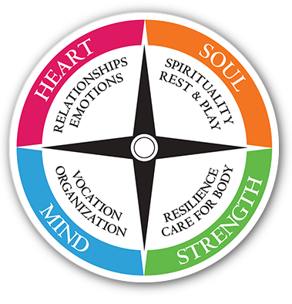
Living Compass
Monday 9.14.2026 at 2pm.
NEW LOCATION - 29 Notasulga Drive
Also join via Zoom.

Contact D’Ann 706.266.3444


Sunday breakfast
September 13th
9-10am in Daniel Hall.

Come join us for fresh coffee, eggs, meat, bisquits and plenty of fellowship.

Shelley Parris 13th
Stephen Moseley 13th
Rebecca Brantley 13th
Beverly Birdyshaw 15th
John Herring 15th
Erin Kennedy 15th
Clay Hardaker 16th
Sam Warner 17th
Forrest Schrum 18th
Holley Smith 18th



EYC head to Six Flags on Sunday 9.20.2026


October 16th 5:30-8pm
- Adults gather at Doug’s Deli
- Children birth – 5th grade
- $10 per child to cover their food and activities

Safeguarding God’s Children & People certifications required for everyone that volunteers with children, youth & adults.

In person traning offered at St. Mark’s in Dalton – 9.19.2026. Register by 9.10.2026.
- 10-1pm Safeguarding God’s Children
- 1-1:30pm Lunch Provided
- 1:30-4:30pm Safeguarding God’s People

Gods Children
- Renewed every 3 years
- All clergy, vestry, staff or volunteer working with children or youth.
- If you have NEVER taken SGC or did so prior to 2020 you are required to attend a 2hr Zoom training and designated online modules or attend a 3yr IN PERSON training. https://safechurchatlanta.org/sgc/who-needs-sgc-training/
- If you have taken SGC since 2020 you only need to complete a designated online module to refresh.
- Nursery do not need to take the full SGC but have to complete a designated online module. https://safechurchatlanta.org/preschool/

Safeguarding God's Children: Scheduled Zoom Training Dates
- Saturday, September 26, 2026: 10:00 AM - 12:00 PM
- Tuesday, October 20, 2026: 6:30 PM - 8:30 PM
- Tuesday, November 17, 2026: 6:30 PM - 8:30 PM

Gods People
- Must be renewed every 5 years
- All clergy, vestry are required to complete training as well as staff or volunteers who work with adults. https://safechurchatlanta.org/sgp/who-needs-sgp-training/
- If you have NEVER taken SGP or did so prior to 2020 you are required to attend a 2hour zoom training and complete a designated module or attend a 3 your IN PERSON training.
- If you have taken SGP in 2020 or 2021 you only need to complete a designate online module.
Safeguarding God's People: Scheduled Zoom Training Dates
- Friday, August 14, 2026: 10:00 AM - 12:00 PM
- Thursday, September 17, 2026: 6:30 PM - 8:30 PM
- Saturday, October 17, 2026: 10:00 AM - 12:00 PM
- Monday, November 16, 2026: 6:30 PM - 8:30 PM

Link to register for an online training class: Safeguarding Training Registration
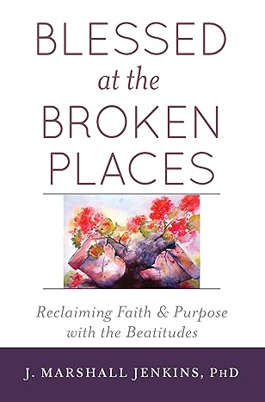
September 13, 20, 27 & October 4
Book Club - Blessed at the Broken Places
J. Marshall Jenkins.


Coming later in the fall….
October 18th Julie Groce from Appleton Ministries.
November 1st Ann Pullen

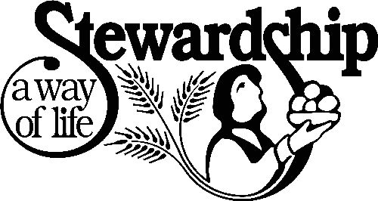

The 2027 Annual Stewardship Campagin will begin shortly.

Contact Church office if your mailing address needs to be update.

Consecration brunch will be held on Sunday, October 25th


Wednesday

Dinner 5:15pm
Adults $10 - 2 entrees, 2 sides, salad, dessert
children’s menu $4, Vegan $8 (all sides are vegan friendly)
Reservations are GREATLY appreciated by noon on Mondays.
When making reservations adults do NOT need to specify entrée.
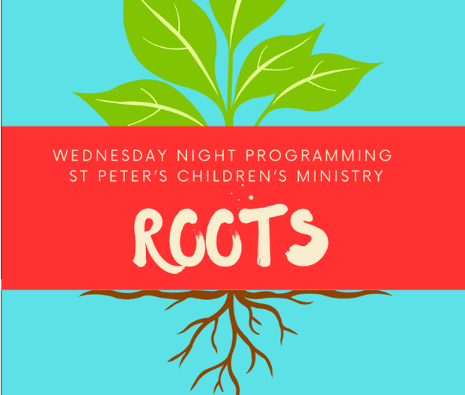
ROOTS 5:45-6:30pm
Pre K – 5th grade



Junior Choir 6:30-7pm

Nursery provided 5:30-7pm for children birth-3yrs old

Wednesday Dinner MENU

September 16th
Greek Chicken OR Brown Sugar & Teriyaki Pork
Rice, Broccoli, Salad, Dessert
Kids Menu: Pepperoni Pizza

September 23rd
Baked Ham OR Smothered Chicken
Candied yams, Collards, Salad, Dessert
Kids Menu: Smothered Chicken

September 30th
Salisbury Steak/gravy OR Fried Chicken
Mashed Potatoes, buttered corn, salad, dessert
Kids Menu: Cheese Pizza

Vegetarian meals $8, a
All sides are vegan, served with hard boiled eggs.

Joining Realm is NOT mandatory.
By signing up for Realm you can…

- Schedule gifts or pledge payments by credit card or debit to your bank account.
- Register for events at the church
- PREPAY for events before you arrive
- Upload current individual or family photos for the church directory
- Keep your contact information current

If you are not currently signed up for Realm, simply contact the church office and an invite will be emailed to you.

PAYMENT METHODS for St. Peter’s

Remember to always include a note/memo on all
Venmo payments to ensure proper credit. For example, tithe, pledge, Wednesday dinner, Breakfast, etc.

If your Venmo account does not display YOUR NAME please include your name in the memo as well.


Payments via Paypal and the church website, www.stpetersrome.org.
Select Giving on the top banner then stewardship. Follow the Instructions to remit via ACH or Credit Card using Paypal. The fees associated with using Paypal are paid by the church. If you wish to share in this cost simply increase the amount of your gift (2.2% of the given amount plus .30 per transaction).

Link directly to PayPal giving on website Stewardship | St. Peter's Episcopal Church

SEPTEMBER | Monday | Tuesday | Wednesday | Thursday | Friday | Saturday
 |  | 1  7-9pm Three Rivers Nave | 2  Dinner 5:15pm  5:30pm Celtic Service  Nursery 5:30-7pm  Roots 5:45-6:30  Jr. Choir 6:30-7pm  7pm Adult Choir | 3  Stephen Ministry Supervision Mtg 3:30pm R. Wyatt | 4 | 5
6  Marshall Jenkins  8:15-11:45 Nursery provided  8:30am – Rite I Chapel  9:50am Children’s Chapel  10am – Rite II Nave, WLAQ/You tube | 7  LABOR DAY  Office Closed  Noon Wed. Dinner reservations due. | 8  Ruth/Naomi Shelter Meal  7-8:30pm Indivisible  D. Hall  7-9pm Three Rivers Nave | 9  5:30pm Celtic Service  Nursery 5:30-7pm  6pm EYC Dwtn Dinner  Roots 5:45-6:30  Jr. Choir 6:30-7pm  7pm Adult Choir | 10  Davies Shelter Meal  11:30- ESP R.Wyatt  ESP 4-8pm D. Hall  6:30pm Three Rivers,  R. Wyatt | 11  Mahjong 6:30pm Daniel Hall | 12
13 -Devon Smyth  8:15-11:45 Nursery provided  8:30am – Rite I Chapel  9:50am Children’s Chapel  10am – Rite II Nave, WLAQ/You tube  11:15am Adult Forum  5-6 Youth Confirmation class  6-7:30 EYC | 14  Noon Wed. Dinner reservations due.  2pm Living Compass | 15  7-9pm Three Rivers Nave | 16  Dinner 5:15-6pm  5:30pm Celtic Service  Nursery 5:30-7pm  Roots 5:45-6:30  Jr. Choir 6:30-7pm  7pm Adult Choir  Noon Living Proof – Rhodes Wyatt | 17  Stephen Ministry Supervision Mtg 3:30pm R. Wyatt | 18 | 19
20 - Linda Alessandri  8:15-11:45 Nursery provided  8:30am – Rite I Chapel  9:50am Children’s Chapel  10am – Rite II Nave, WLAQ/You tube  11:15am Adult Forum  EYC to Six Flags | 21  Noon Wed. Dinner reservations due.  2pm Living Compass  6:30pm ECW, Daniel Hall | 22  7-9pm Three Rivers Nave | 23  Dinner 5:15-6pm  5:30pm Celtic Service  Nursery 5:30-7pm  Roots 5:45-6:30  Jr. Choir 6:30-7pm  7pm Adult Choir | 24 | 25  3:30-9pm ESP Daniel Hall | 26
27 – Linda Alessandri  8:15-11:45 Nursery provided  8:30am – Rite I Chapel  9:50am Children’s Chapel  10am – Rite II Nave, WLAQ/You tube  11:15am Adult Forum | 28  Noon Wed. Dinner reservations due.  2pm Living Compass | 29  7-9pm Three Rivers Nave | 30  Dinner 5:15-6pm  5:30pm Celtic Service  Nursery 5:30-7pm  Roots 5:45-6:30  Jr. Choir 6:30-7pm  7pm Adult Choir | October 1  Stephen Ministry Supervision Mtg 3:30pm R. Wyatt | 2 | 3

