
WELCOME TO ALL OUR VISITORS!
If you are interested in knowing more about St. Peter’s, please see an usher or one of the greeters who stand with the clergy after the service.

8.23.2026 at St. Peter’s
8:15am-11:45am Nursery
8:30am Holy Eucharist Rite I in Chapel
9-10am Java Joy in Daniel Hall
9:50am Children’s Chapel – Katherine Patterson & Katie Smyth
10:00am Holy Eucharist Rite II in Nave, WLAQ & YouTube
Blessing of the Backpacks
11:15am Ice Cream Social in Daniel Hall
3-6pm EYC Pool Party
This week…
Wednesday August 26th 5:15pm Dinner served in Daniel Hall
5:30pm Celtic Service in the chapel
5:45-6:30pm Roots
6:30-7pm Junior Choir
7-8pm Adult Choir
Friday August 28th 5:30-8pm Parents Night Out


Rees Jenkins, Ray Dempsey, Julie Herring, John Schroeder, Dasha & David Jenkins, Michael Ann Booth, Ame Frease, Drew Moss, Nora Barrientos, Basilia Perez, Sherri & Tony Hudgins, William Burk, Kerri Burk Anderson, John Marshall, Henry & Katie Pancione, Haywood Patton, Andrew Babcock, Stephen Patton, Campbell Clark, James, Emily Milstead, Davis Donahue, Gina Schmitz, Carlton Family, Dagmar Schmitz Carlton, Nila Ewald, Jan Woody, Heather Seckman, Katharine Ammons, Kelli Varnell and those that care for them.

Beginning of each Month the intercessory prayer will be “refreshed”; all names removed. If you wish to add someone, please call, or email the church office. Names will remain on the Prayer List for the entire month.

Military Prayer List:
Phillip Jenkins
Gordon Macy
Charles Lewis
Nolan Kelley
Davis Isley

Andrew Hall
Ted Olney
Michael Blair
Steven Blair
Charlie Hardaker
Justin Yeary

Thomas Keefe
Johnny Crittenden
Sara Carver Thomas
Joshua Ingram
Cherrie Shackelford

Please remember to notify the church office when a service member is no longer on active duty.



Candles in the Nave given to the Glory of God by Tricia Richards in memory of her departed loved ones.

Flowers in the Chapel given to the glory of God by Larry Osborn in honor of his wife, Kathy Osborn.

Flowers in the Nave given to the Glory of God and in memory and recognition of birthdays by Sharon Norman for her daughter, Christy Leigh Jones Nixon Hernandez and her husband, Jerry L. Norman.


OPEN dates on Flower Calendar:
Chapel – October 4th, 11th, 18th
Nave – October 25th, December 6th & 20th
Nave Candles – September

Remember departed loved ones or honor someone special, contact church office to secure date.

2nd Friday each month,
6pm in Daniel Hall.
Virginia Hunter, 770.530.0079
Come join our fun!

Next Gathering – September 11th
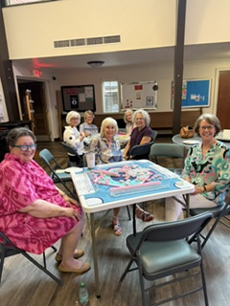

At our August meeting we seated 5 tables!

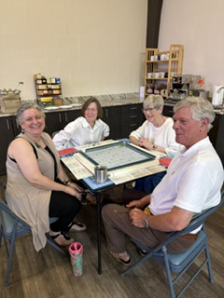

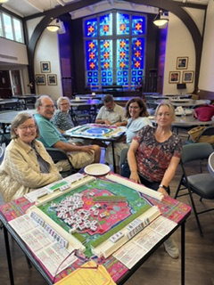

Episcopal Church Women
3rd Monday of each Month
6:30pm in Daniel Hall
September 21st


Ruth & Naomi Shelter Meal Team for September 8th
Margaret Louttit
Laura Walley
Brynn Dexter

Davies Shelter Meal Team for
September 10th
Beverly Burnes
Ann Pullen
Sara Clark

Margaret Louttit, Meal Captain – 678.641.5895


Every single PULL TAB you save goes toward supporting Ronald McDonald House Charity. This charity serves families of children facing serious illnesses or accidents so that the parents can stay close to their child while they receive medical care.

I am asking parishioners to help collect PULL TABS from any canned drink. It may seem small, but one PULL TAB joined with another quicky adds up to something BIG!. There is a container in Daniel Hall for you to drop your “tabs” into. Ask your friends and neighbors to save as well. Virginia Hunter, 770.530.0079

Foyer Groups
Sign up today, contact church office

For the month of August, the Church will collect names of parishioners who want to join a Foyer group.
In early September the Foyer Group Committee will convene and assign each participating parishioner into a Foyer group of 6-8 people. The people in the foyer group will then get together once a month and enjoy supper and community. The Foyer group will last from September until May. Then, we have the summer off and start all over again next year.

Scott Morris, 404.428.6991

Collecting full size donations of:

Shampoo
Bath Soap
Toothbrush
Toothpaste

Bin located in Daniel hall

St. Peter’s VOLUNTEERs are needed from 9am till noon. HOWEVER, if you are not able to work the full 3 hours, any time you can share is greatly appreciated.


2026 Schedule
Friday Tuesday
August 21 25
September 25 29
October 23 27
November 20 24
December -- 29

Contact Nancy Hunter to volunteer to help, 706.506.3889. THANK YOU


Collier Murphy 23rd
Josalin Shackelford 24th
Leigh Patterson 25th
Janet Byington 25th
JadaJoy Holley 26th
Cynthia Burnes 28th
Teague Williams 28th

Safeguarding God’s Children & People certifications required for everyone that volunteers with children, youth & adults.

In person traning offered at St. Mark’s in Dalton – 9.19.2026.
Register by 9.10.2026.
- 10-1pm Safeguarding God’s Children
- 1-1:30pm Lunch Provided
- 1:30-4:30pm Safeguarding God’s People

Online classes are offered via Zoom. Contact the church office with questions or to register.
ADULT FORUM


August 30th - Religious Icons
Michael Papazian
Berry College Professor


September 13, 20, 27 & October 4
Book Club - Blessed at the Broken Places
J. Marshall Jenkins.

October 18th Julie Groce from Appleton Ministries.
November 1st Ann Pullen
November 8th Devon Smyth

Blessing of Prayer Shawls ~ Sunday August 30th
Both services



August 26th

Dinner 5:15pm
Adults $10 - 2 entrees, 2 sides, salad, dessert
children’s menu $4
Reservations are GREATLY appreciated by noon on Mondays.
When making reservations adults do NOT need to specify your entrée.
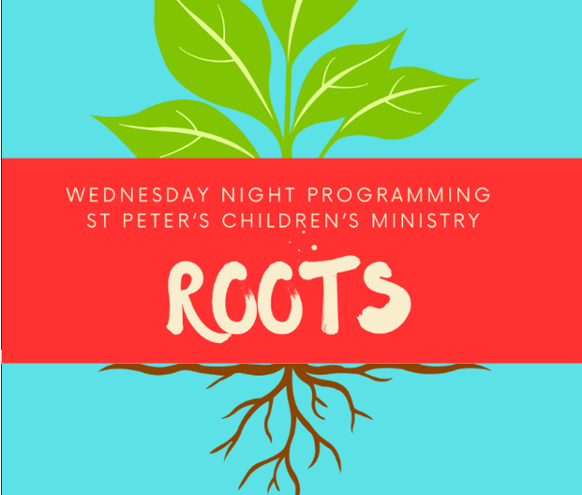
ROOTS 5:45-6:30pm
Pre K – 5th grade



Junior Choir 6:30-7pm

Nursery provided 5:30-7pm for children birth-3yrs old

Presented by Children’s Ministry
for the entire parish!

Saturday August 28th

5:30-8pm, birth-5th grade
Adults gather at MELLOW MUSHROOM
$10 per child to cover their food/crafts

Wednesday Dinner MENU

August 26th
Traditional Meatloaf with sweet ketchup glaze OR BBQ Chicken.
Mashed Potatoes, Green Beanes, salad, dessert
Kids Menu: Cheese Pizza.

September 2nd
Brown Sugar Sausage with corn/red potatoes OR Herb Baked Chicken
Fried Cabbage, Black Eye Peas, Salad, Dessert
Kids Menu: Macaroni & Cheese

September 9th
Mississippi Meatballs OR Baked Ziti (vegetarian)
Mashed Potatoes, Mixed Veggies, salad, dessert
Kids Menu: Ziti & Meatballs

September 16th
Greek Chicken OR Brown Sugar & Teriyaki Pork
Rice, Broccoli, Salad, Dessert
Kids Menu: Pepperoni Pizza

September 23rd
Baked Ham OR Smothered Chicken
Candied yams, Collards, Salad, Dessert
Kids Menu: Smothered Chicken

September 30th
Salisbury Steak/gravy OR Fried Chicken
Mashed Potatoes, buttered corn, salad, dessert
Kids Menu: Cheese Pizza
Vegetarian meals $8, all sides are vegan.
Joining Realm is NOT mandatory.
By signing up for Realm you can…

- Schedule gifts or pledge payments by credit card or debit to your bank account.
- Register for events at the church
- PREPAY for events before you arrive
- Upload current individual or family photos for the church directory
- Keep your contact information current

If you are not currently signed up for Realm, simply contact the church office and an invite will be emailed to you.

PAYMENT METHODS for St. Peter’s

Remember to always include a note/memo on all
Venmo payments to ensure proper credit. For example, tithe, pledge, Wednesday dinner, Breakfast, etc.

If your Venmo account does not display YOUR NAME please include your name in the memo as well.


Payments via Paypal and the church website, www.stpetersrome.org.
Select Giving on the top banner then stewardship. Follow the Instructions to remit via ACH or Credit Card using Paypal. The fees associated with using Paypal are paid by the church. If you wish to share in this cost simply increase the amount of your gift (2.2% of the given amount plus .30 per transaction).

Link directly to PayPal giving on website Stewardship | St. Peter's Episcopal Church

AUGUST | Monday | Tuesday | Wednesday | Thursday | Friday | Saturday
9 Devon Goddard Smyth  8:15-11:45 Nursery provided  9:50am Children’s Chapel  8:30am – Rite I Chapel  10am – Rite II Nave, WLAQ/You tube  4th & 5th Graders  POOL PARTY  4-6p | 10 | 11  Ruth/Naomi Shelter Meal  7-9pm Three Rivers Nave  7-8:30pm Indivisible  D. Hall | 12  5:30pm Celtic Service | 13  Davies Shelter Meal  6:30 Rhodes Wyatt  Three Riveres | 14  6pm Mahjong in Daniel Hall | 15  St. Paula’s Guild  5pm  401 East 4th ave
16 Pastor Linda Alessandri  8:15-11:45 Nursery provided  9:50am Children’s Chapel  8:30am – Rite I Chapel  10am – Rite II Nave, WLAQ/You tube  Adult Forum  EYC Parent Meeting after the 10am service. | 17  Episcopal Church Women  6:30pm Daniel Hall | 18  5:30pm Vestry meeting in Rhodes Wyatt  Noon – Rhodes Wyatt Living Proof  7-9pm Three Rivers Nave | 19  5:30pm Celtic Service | 20 | 21  9-Noon Community Kitchen Volunteers | 22
23 J. Marshall Jenkins  8:15-11:45 Nursery provided  9-10 Jave Joy in Daniel Hall  9:50am Children’s Chapel  8:30am – Rite I Chapel  10am – Rite II Nave, WLAQ/You tube  Blessing of the Backpacks  Ice Cream Social after service in Daniel Hall  EYC POOL PARTY | 24 | 25  9-Noon Community Kitchen Volunteers  7-9pm Three Rivers Nave | 26  Dinner 5:15pm  5:30pm Celtic Service  Nursery 5:30-7pm  Roots 5:45-6:30  Jr. Choir 6:30-7pm  7pm Adult Choir | 27 | 28  Parents Nite Out  5:30-8pm  Mellow Mushroom | 29
30 Pastor Linda Alessandri  8:15-11:45 Nursery provided  9:50am Children’s Chapel  8:30am – Rite I Chapel  10am – Rite II Nave, WLAQ/You tube  6:30pm EYC & Confirmation Class  Blessing of Prayer Shawls, both services  Adult Forum | 31 | September 1  7-9pm Three Rivers Nave | 2  Dinner 5:15pm  5:30pm Celtic Service  Nursery 5:30-7pm  Roots 5:45-6:30  Jr. Choir 6:30-7pm  7pm Adult Choir | 3  Stephen Ministry Supervision Mtg 3:30pm R. Wyatt | 4 | 5
6 – Marshall Jenkins  8:15-11:45 Nursery provided  8:30am – Rite I Chapel  10am – Rite II Nave, WLAQ/You tube  No EYC or Confirmation Class | 7  LABOR DAY  Office Closed | 8  Ruth/Naomi Shelter Meal  7-8:30pm Indivisible  D. Hall  7-9pm Three Rivers Nave | 9  Dinner 5:15pm  EYC Downtown Dinner  5:30pm Celtic Service  Nursery 5:30-7pm  Roots 5:45-6:30  Jr. Choir 6:30-7pm  7pm Adult Choir | 10  Davies Shelter Meal  ESP 4-8pm D. Hall  6:30pm Three Rivers,  R. Wyatt | 11  Mahjong 6:30pm Daniel Hall | 12

