
WELCOME TO ALL OUR VISITORS!
If you are interested in knowing more about St. Peter’s, please see an usher or one of the greeters who stand with the clergy after the service.

6.28.2026 at St. Peter’s
8:15am-11:45am Nursery
8:30am Holy Eucharist Rite I in Chapel
9:50am Children’s Chapel – Lee Morris & Katie Smyth
10:00am Holy Eucharist Rite II in Nave, WLAQ radio & YouTube

This week…
Monday June 29th 2pm Living Compass Study Group
Wednesday July 1st 5:30pm Celtic Service in the chapel


Rees Jenkins, Ray Dempsey, Stephen Patton, Campbell Clark,
Bonnie & Joe Herring, William Burk, Gina Schmitz, Carlton Family,
Julie Herring, John Schroeder, Andrew Babcock, Haywood Patton,
Myra Frances Johnston, Edwin, Nancy Bess & Tripp Johnston,
Heather & Murphy Family, Dasha and David Jenkins, Jim & Helen Keaten, Tony, Sherrie Hudgins, Cathy Varidel, Matt Sirmans,
Herring Family, Harbin Waterfield, Henry Pancione, Katie Pancione, John Marshall, Michael Ann Booth, Ame Frease, Larry Silvers, Bonnie Foster, Jackie Hizel, Don Ayer, Jane Cunningham, Sam Moss, Frieda Yeary, Martha and those that care for them.

THIS WEEK the intercessory prayer will be “refreshed”; all names removed. If you wish to add someone, please call, or email the church office. Names will remain on the Prayer List for the entire month.


Available in the church office or in Daniel Hall.
Digital copy available upon request.

Military Prayer List:
Phillip Jenkins
Gordon Macy
Charles Lewis
Nolan Kelley
Davis Isley

Andrew Hall
Ted Olney
Michael Blair
Steven Blair
Charlie Hardaker
Justin Yeary

Thomas Keefe
Johnny Crittenden
Sara Carver Thomas
Joshua Ingram
Cherrie Shackelford

Please remember to notify the church office when a service member is no longer on active duty.


Candles in the Nave given to the Glory of God by Melissa & Brian Keefe in memory of their parents; Pat & Frank Velhage and Jean & Arthur Keefe.

Flowers in the Chapel given to the glory of God and in honor of Bill Schoepski by Allien McNair.

Flowers in the Nave given by Sue Anderson in honor of Randall M. Anderson, Sr. and all members of the US Armed Forces.

OPEN dates on Flower Calendar:
Chapel – July 12th, 19th & 26th, August 9th
Nave – August 30th
Remember someone special, contact church office to secure date.

From the Desk of
Father John

Brothers and Sisters in Christ,

One of the standard portions in the Letter of Agreements for priests in the Diocese of Atlanta is a requirement for Sabbatical of no less than 3 months after each 6 years of ministry. This is done for two reasons. First, to alleviate “burn out” among priests, particularly Rectors. Second, to model for the rest of the community the importance of rest and rejuvenation. I was ordained 18 years ago and have only taken one sabbatical in that time, the previous one being in 2018. Therefore, this summer I will be on Sabbatical during the months of July, August, and September. I plan on small road trips interspersed throughout the three months, some camping, and helping our son Lucas move to the University of South Florida in Tampa. I also have a pile of small projects to do around the house, books to read, and grills to use! It will be time well spent.

It is hard for me to believe that almost 14 years have passed since my first Sunday at St. Peter’s in August of 2012. St. Peter’s is truly a special place, and I still enjoy sharing ministry with you all here as your Rector and serving Dean of the Northwest Georgia Convocation. I look forward to taking some time to recharge and then continuing in both capacities in the Fall.

Pastor Linda Allesandri will be here in my stead, presiding over Sunday and Wednesday services. Pastor Linda, The Rev. Deacon Devon Goddard Smyth, and Marshall Jenkins will share the pulpit over the next three months. You are in good hands!

The program year will begin in early to mid-August, and I will return October 1st ready to engage in ministry with you all again. I am looking forward to that already. Please keep me and Keri in your prayers this summer and know that I am praying for you.

Yours in Christ,

John

Pastor Linda M. Alessandri

Born and raised in the suburbs of Baltimore, Maryland, I returned to teach middle school social studies for nine years after graduating from American University (Wash. D.C). I then was a full-time Youth and Christian Education Associate at Second English Lutheran Church (Balto. MD) until I headed to Trinity Lutheran Seminary (Columbus, OH) in 1996. After graduating in 2000, I was an associate Pastor at Atonement Lutheran Church (Florissant MO) for 7 years until called back to Maryland to serve as Pastor of Haven Lutheran Church (Hagerstown MD).
When I retired in 2023, I moved to Rome, GA to be close to my family who live in Marietta, GA. I am thoroughly enjoying life in Rome, with its many recreational, musical and educational offerings.
I am honored to share worship with you while Father John is on sabbatical through September.

July through the end of September, if you need to connect with Linda please call 706.844.5770

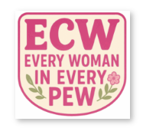
Save the Date!
The inaugural meeting of the St. Peter’s Episcopal Church Women will be:
Monday, August 17th at 6:30pm
In Daniel Hall

Our vision for what the group could become will be shared,
and your input will be invited.
Refreshments will be served and a short program.
Remember Every woman in Every pew
is already a member of ECW!
Diane Nance, 706.936.6006


2nd Friday each month,
6pm in Daniel Hall.
Virginia Hunter, 770.530.0079
Come join our fun!

Next Gathering – July 10th

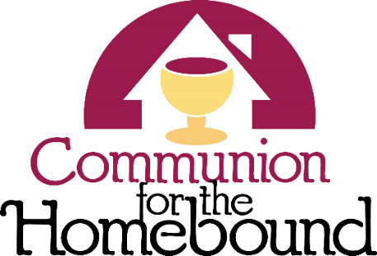
Eucharistic Visitors share communion with those in our parish that are unable to attend church.

If you know someone that would like to receive communion on a regular monthly basis or just every now and then, please contact the church office.

706.291.9111 OR elizabeth@stpetersrome.org
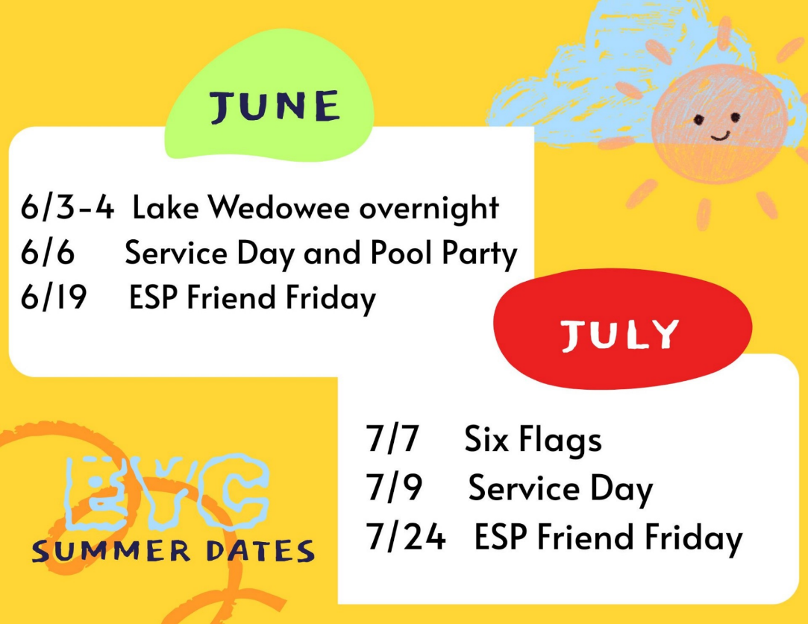
EYC Summer Events for
rising 6th graders through
graduating seniors.

Mark your calendar so you do not miss any of our summer fun.

Cameron Jackson, Youth Coordinator or 770.823.4782

St. Peter’s VOLUNTEERs are needed from 9am till noon. HOWEVER, if you are not able to work the full 3 hours, any time you can share is greatly appreciated.


2026 Schedule
Friday Tuesday
June -- 23
July 24 28
August 21 25
September 25 29
October 23 27
November 20 24
December -- 29

Contact Nancy Hunter to volunteer to help, 706.506.3889. THANK YOU

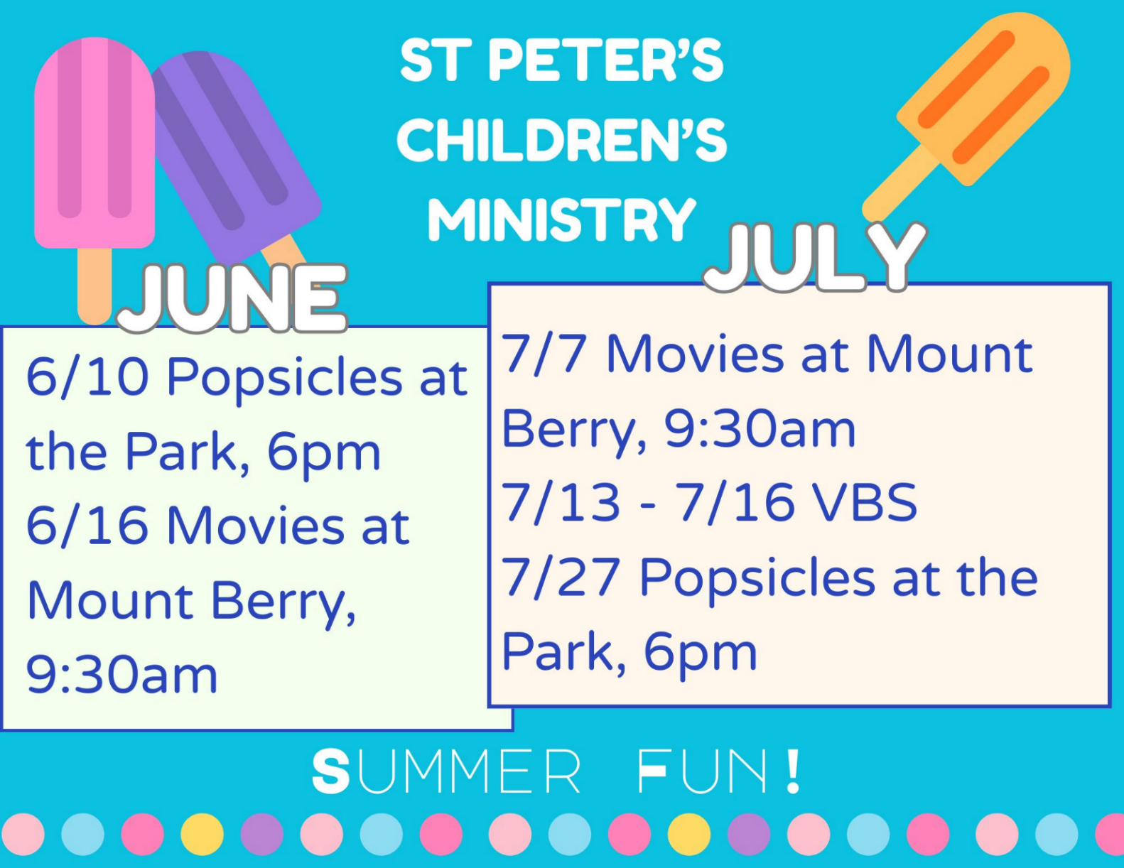


Church & Office will be CLOSED
Monday, July 6th

Sue Mann 28th
Lisa Bell 29th

Patti Barron 29th
Belinda Martin 29th
Myrtle Marshall 29th
Russell Brock 29th
Leah Sherwin 30th
Tricia Richards July 1st
Buster Wright 1st
Jackie Trammell 2nd
Karlene Spencer 3rd
Linda Voccio 4th
Ford Knight 4th



If you have a friend/loved one on the prayer list that is NOT in the St. Peter’s directory and would like them to receive a card from the Card Ministry team,
please contact the church office with their address.

The Card Ministry teams send cards of care and encouragement to those in need within our parish and those on the church prayer list.


VBS Registration
OPEN

A Wrinkle in Time
July 13th – 16th
9am-12pm

Children 3 years through 5th grade

VBS REGISTRATION
https://docs.google.com/forms/d/e/1FAIpQLSdJm1Anx6U-FwpUO-fYHX8DvF4Q2PWaqLIj2pBAyFpgw8xqKg/viewform?usp=header

VBS VOLUNTEER SIGN UP
https://docs.google.com/forms/d/e/1FAIpQLSfVsfPPPMnXVgj1AAV3jtEyHFfGmNTW7r9d_jXQZUJyP8gElQ/viewform?usp=header

Volunteer Details
- Arrive at 8:15 on Monday and 8:30 the other days
- If you cannot commit to the entire week that is fine.
- Group Leader – will escort kiddos from point to point and assist them in participating.
- Activity Leader – Lead one of the activities; team building, craft, storytelling, music
- Activity Helper – Assist the activity leader in facilitating their activity.
- Floater – Jump into the fun where needed.

Blesssed at the broken places
Join Our
Adult Forum Book Club

By J. Marshall Jenkins
September 13, 20, 27 & October 4, 2026
In Daniel Hall after the 10am service
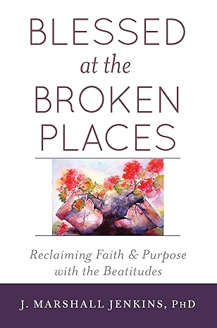
Order your book

Lets get reading!

Joining Realm is NOT mandatory.
By signing up for Realm you can…

- Schedule gifts or pledge payments by credit card or debit to your bank account.
- Register for events at the church
- PREPAY for events before you arrive
- Upload current individual or family photos for the church directory
- Keep your contact information current

If you are not currently signed up for Realm, simply contact the church office and an invite will be emailed to you.

PAYMENT METHODS for St. Peter’s
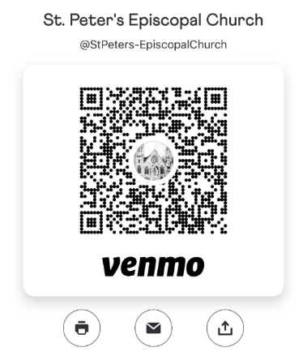
Remember to always include a note/memo on all
Venmo payments to ensure proper credit. For example, tithe, pledge, Wednesday dinner, Breakfast, etc.

If your Venmo account does not display YOUR NAME please include your name in the memo as well.


Payments via Paypal and the church website, www.stpetersrome.org.
Select Giving on the top banner then stewardship. Follow the Instructions to remit via ACH or Credit Card using Paypal. The fees associated with using Paypal are paid by the church. If you wish to share in this cost simply increase the amount of your gift (2.2% of the given amount plus .30 per transaction).

Link directly to PayPal giving on website Stewardship | St. Peter's Episcopal Church

JUNE | Monday | Tuesday | Wednesday | Thursday | Friday | Saturday
21 – Father’s Day  8:15-11:45 Nursery provided  9:50am Children’s Chapel  8:30am – Rite I Chapel  10am – Rite II Nave, WLAQ/You tube | 22  2pm Living Compass | 23  7-8:30pm Three Rivers, Rhodes Wyatt | 24  5:30pm Celtic Service  St. Peter’s Day Celebration  6pm Daniel Hall | 25 | 26 | 27
28  8:15-11:45 Nursery provided  9:50am Children’s Chapel  8:30am – Rite I Chapel  10am – Rite II Nave, WLAQ/You tube | 29  2pm Living Compass | 30  7-8:30pm Three Rivers, Nave  4-8pm ESP D. Hall | JULY 1  5:30pm Celtic Service | 2 | 3 | 4  
5  8:15-11:45 Nursery provided  9:50am Children’s Chapel  8:30am – Rite I Chapel  10am – Rite II Nave, WLAQ/You tube | 6  OFFICE CLOSED  2pm Living Compass | 7  9:30am Children’s Ministry Movies @ Mt. Berry Mall  EYC – Six Flags  7-8:30pm Three Rivers, Nave | 8  5:30pm Celtic Service | 9  EYC Service Day  1pm FRREA – Rhodes Wyatt  6:30pm Three Rivers, R. Wyatt | 10  6pm Mahjong in Daniel Hall | 11
12  8:15-11:45 Nursery provided  9:50am Children’s Chapel  8:30am – Rite I Chapel  10am – Rite II Nave, WLAQ/You tube  VBS Work Day, lunch provided | 13  VBS 9am - Noon  2pm Living Compass | 14  VBS 9am – Noon  7-8:30pm Three Rivers, Nave  7-8:30pm D. Hall Indivisible | 15  VBS 9am – Noon  5:30pm Celtic Service | 16  VBS 9am - Noon | 17  10am Stephen Ministry, Rhodes Wyatt | 18
19  8:15-11:45 Nursery provided  9:50am Children’s Chapel  8:30am – Rite I Chapel  10am – Rite II Nave, WLAQ/You tube | 20  Office Volunteers  9-Noon  2pm Living Compass | 21  Office Volunteers  9-Noon  7-9pm Three Rivers, Daniel Hall | 22  Office Volunteers  9-Noon  5:30pm Celtic Service | 23  Office Volunteers  9-Noon | 24  Office Volunteers  9-Noon  ESP Friend Friday  Community Kitchen 9-12  8:30-11am Compassion, Rhodes Wyatt | 25

