
WELCOME TO ALL OUR VISITORS!
If you are interested in knowing more about St. Peter’s, please see an usher or one of the greeters who stand with the clergy after the service.

6.21.2026 at St. Peter’s
8:15am-11:45am Nursery
8:30am Holy Eucharist Rite I in Chapel
9:50am Children’s Chapel – Kellie Wolfe & Diane Nance
10:00am Holy Eucharist Rite II in Nave, WLAQ radio & YouTube

This week…
Monday June 22nd 2pm Living Compass Study Group
Tuesday June 23rd 9am till Noon Community Kitchen Volunteers
Wednesday June 24th 5:30pm Celtic Service in the chapel
6pm St. Peter’s Day Celebration


Rees Jenkins, Ray Dempsey, Stephen Patton, Campbell Clark,
Bonnie & Joe Herring, William Burk, Gina Schmitz, Carlton Family,
Julie Herring, John Schroeder, Andrew Babcock, Haywood Patton,
Myra Frances Johnston, Edwin, Nancy Bess & Tripp Johnston,
Heather & Murphy Family, Dasha and David Jenkins, Jim & Helen Keaten, Tony, Sherrie Hudgins, Cathy Varidel, Matt Sirmans,
Herring Family, Harbin Waterfield, Henry Pancione, Katie Pancione, John Marshall, Michael Ann Booth, Ame Frease, Larry Silvers, Bonnie Foster, Jackie Hizel, Don Ayer, Jane Cunningham and those that care for them.

Beginning of the Month the intercessory prayer will be “refreshed”; all names removed. If you wish to add someone, please call, or email the church office. Names will remain on the Prayer List for the entire month.


Available in the church office or in Daniel Hall.
Digital copy available upon request.

Military Prayer List:
Phillip Jenkins
Gordon Macy
Charles Lewis
Nolan Kelley
Davis Isley

Andrew Hall
Ted Olney
Michael Blair
Steven Blair
Charlie Hardaker
Justin Yeary

Thomas Keefe
Johnny Crittenden
Sara Carver Thomas
Joshua Ingram
Cherrie Shackelford

Please remember to notify the church office when a service member is no longer on active duty.


Candles in the Nave given to the Glory of God by Melissa & Brian Keefe in memory of their parents; Pat & Frank Velhage and Jean & Arthur Keefe.

Flowers in the Chapel given to the glory of God by Joe Morgan in memory of Jane Morgan, Dean Morgan, Morgan Sisley and Dan Mozley

Flowers in the Nave given to the glory of God by Paula and Norman Fletcher in thanksgiving for their families.

OPEN dates on Flower Calendar:
Chapel – June 28th & July 12th, 19th & 26th
Remember someone special, contact church office to secure date.


Save the Date!
The inaugural meeting of the St. Peter’s Episcopal Church Women will be:
Monday, August 17th at 6:30pm
In Daniel Hall

Our vision for what the group could become will be shared,
and your input will be invited.
Refreshments will be served and a short program.
Remember Every woman in Every pew
is already a member of ECW!
Diane Nance, 706.936.6006


2nd Friday each month,
6pm in Daniel Hall.
Virginia Hunter, 770.530.0079
Come join our fun!

Next Gathering – July 10th


Eucharistic Visitors share communion with those in our parish that are unable to attend church.

If you know someone that would like to receive communion on a regular monthly basis or just every now and then, please contact the church office.

706.291.9111 OR elizabeth@stpetersrome.org
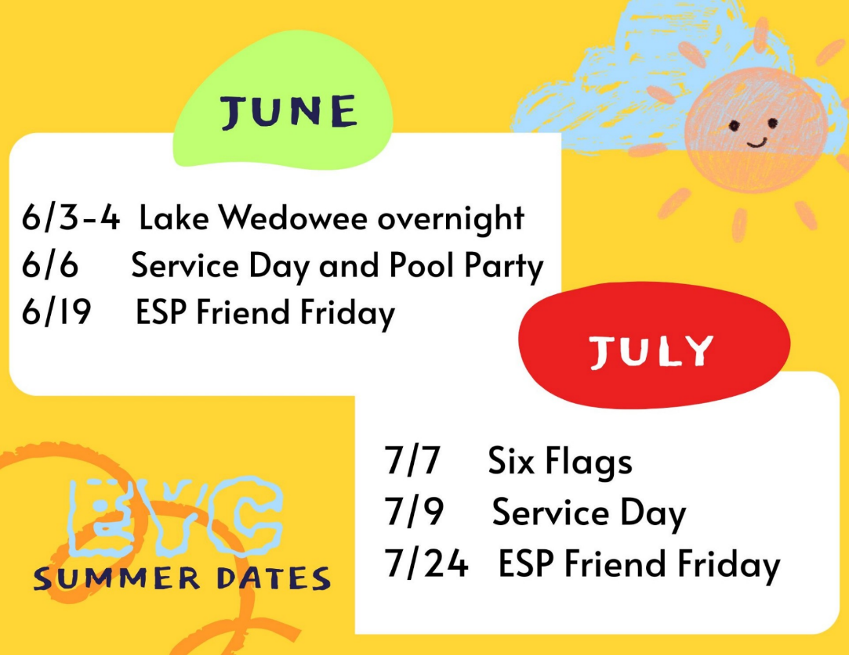
EYC Summer Events for
rising 6th graders through
graduating seniors.

Mark your calendar so you do not miss any of our summer fun.

Cameron Jackson, Youth Coordinator or 770.823.4782

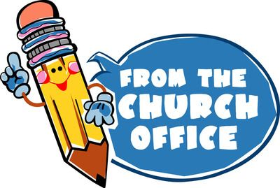
Need Volunteers to staff the office by answering the phone 9am till noon on the following days:

Thursday, July 23rd
Friday, July 24th

Call (706.291.9111) or email elizabeth (elizabeth@stpetersrome.org) to pick you date(s).

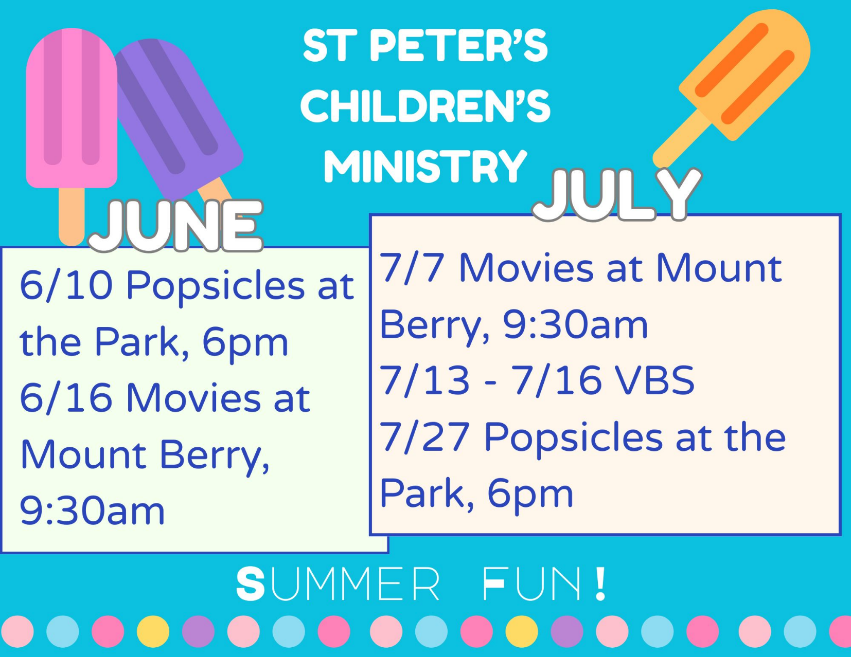


Wright Smith 21st
Hudson Lucas 21st
Clyde Knowles 22nd
Quinn Sikes 22nd
Scott McDaniel 23rd
Ellen Smith 24th
Jim Ware 24th
Susan Harvey 26th
Carey Pilgrim 27th

St. Peter’s VOLUNTEERs are needed from 9am till noon. HOWEVER, if you are not able to work the full 3 hours, any time you can share is greatly appreciated.


2026 Schedule
Friday Tuesday
June -- 23
July 24 28
August 21 25
September 25 29
October 23 27
November 20 24
December -- 29

Contact Nancy Hunter to volunteer to help, 706.506.3889. THANK YOU



If you have a friend/loved one on the prayer list that is NOT in the St. Peter’s directory and would like them to receive a card from the Card Ministry team,
please contact the church office with their address.

The Card Ministry teams send cards of care and encouragement to those in need within our parish and those on the church prayer list.


VBS Registration
OPEN

A Wrinkle in Time
July 13th – 16th
9am-12pm

Children 3 years through 5th grade

VBS REGISTRATION
https://docs.google.com/forms/d/e/1FAIpQLSdJm1Anx6U-FwpUO-fYHX8DvF4Q2PWaqLIj2pBAyFpgw8xqKg/viewform?usp=header

VBS VOLUNTEER SIGN UP
https://docs.google.com/forms/d/e/1FAIpQLSfVsfPPPMnXVgj1AAV3jtEyHFfGmNTW7r9d_jXQZUJyP8gElQ/viewform?usp=header


Wednesday June 24th
6pm in Daniel hall
Reservations greatly appreciated
Adults $8 ~ Children 12 and under $4
Family maximum $25


BBQ Pork
Chicken Breast
Smoked Salmon
Baked Beans
Cole Slaw
Potato Salad
Mac N Cheese
Collard Greens
Banana Pudding OR Peach Cobbler
Tea, Lemonade, Wine, Beer, Coke, Sprite

RSVP on REALM or contact church office. thanks
GET YOUR RED ON!

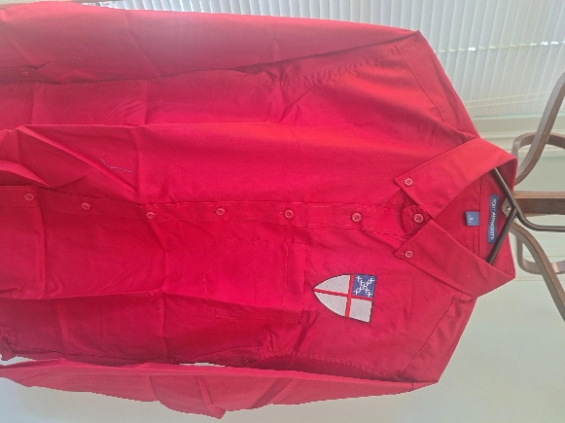
Deep red long sleeve button down shirt $45
Small, Large and XLarge sizes available.

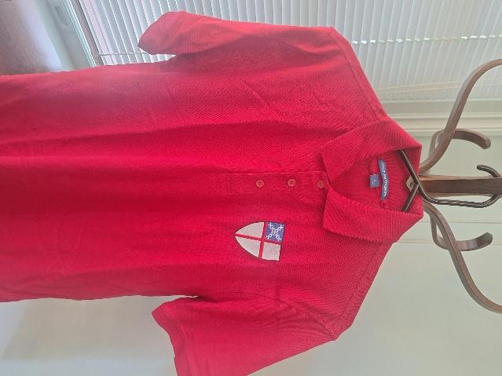

Deep red short sleeve cotton polo shirt $25
Small and Large sizes available

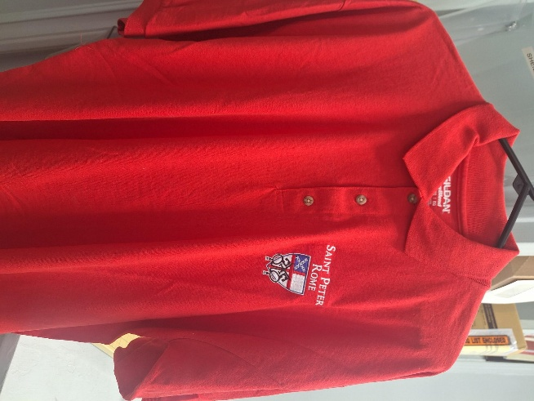
Red short sleeve polo is XL $25
ONLY 1 Shirt

Blesssed at the broken places
Join Our
Adult Forum Book Club

By J. Marshall Jenkins
September 13, 20, 27 & October 4, 2026
In Daniel Hall after the 10am service
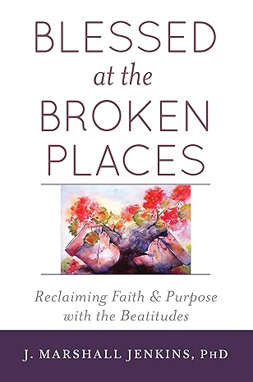
Order your book

Lets get reading!

Joining Realm is NOT mandatory.
By signing up for Realm you can…

- Schedule gifts or pledge payments by credit card or debit to your bank account.
- Register for events at the church
- PREPAY for events before you arrive
- Upload current individual or family photos for the church directory
- Keep your contact information current

If you are not currently signed up for Realm, simply contact the church office and an invite will be emailed to you.

PAYMENT METHODS for St. Peter’s
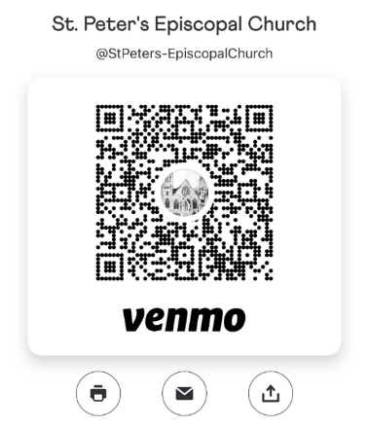
Remember to always include a note/memo on all
Venmo payments to ensure proper credit. For example, tithe, pledge, Wednesday dinner, Breakfast, etc.

If your Venmo account does not display YOUR NAME please include your name in the memo as well.


Payments via Paypal and the church website, www.stpetersrome.org.
Select Giving on the top banner then stewardship. Follow the Instructions to remit via ACH or Credit Card using Paypal. The fees associated with using Paypal are paid by the church. If you wish to share in this cost simply increase the amount of your gift (2.2% of the given amount plus .30 per transaction).

Link directly to PayPal giving on website Stewardship | St. Peter's Episcopal Church

JUNE | Monday | Tuesday | Wednesday | Thursday | Friday | Saturday
 | 1 | 2 | 3  5:30pm Celtic Service  EYC – Lake Wedowee Overnight | 4  3:30pm Stephen Ministry meeting, R. Wyatt  EYC – Lake Wedowee Overnight | 5  11:30am Sylvia Hine Funeral | 6  EYC  Service Day Backpack Buddies & Pool Party
7  Bishops Visit with Confirmations  8:15-11:45 Nursery provided  9:50am Children’s Chapel  9-10am Java Joy Coffee & Doughnuts  8:30am – Rite I Chapel  10am – Rite II Nave, WLAQ/You tube  11:15am Bishops Reception | 8  2pm Living Compass  NEW book study begins | 9 | 10  5:30pm Celtic Service  6pm Popsicles in the Park | 11  6:30pm R. Wyatt 3 Rivers | 12  8:30-11am Compassion R. Wyatt  6pm Mahjong | 13
14  8:15-11:45 Nursery provided  9:50am Children’s Chapel  8:30am – Rite I Chapel  10am – Rite II Nave, WLAQ/You tube | 15  2pm Living Compass | 16  9:30am Children’s Ministry MOVIE  Vestry Meeting 5:30pm | 17  5:30pm Celtic Service  Noon – Living Proof,  R. Wyatt | 18  3:30pm Stephen Ministry R. Wyatt | 19  EYC Friend Friday with ESP | 20
21 – Father’s Day  8:15-11:45 Nursery provided  9:50am Children’s Chapel  8:30am – Rite I Chapel  10am – Rite II Nave, WLAQ/You tube | 22  2pm Living Compass | 23 | 24  5:30pm Celtic Service  St. Peter’s Day Celebration  6pm Daniel Hall | 25 | 26 | 27
28  8:15-11:45 Nursery provided  9:50am Children’s Chapel  8:30am – Rite I Chapel  10am – Rite II Nave, WLAQ/You tube | 29  2pm Living Compass | 30  4-8pm ESP D. Hall | JULY 1  5:30pm Celtic Service | 2 | 3 |   4

