
WELCOME TO ALL OUR VISITORS!
If you are interested in knowing more about St. Peter’s, please see an usher or one of the greeters who stand with the clergy after the service.

5.31.2026 at St. Peter’s

8:15am-11:45am Nursery
8:30am Holy Eucharist Rite I in Chapel
0am Children’s Chapel – Josh Bell & Lee Morris
10:00am Holy Eucharist Rite II in Nave, WLAQ radio & YouTube
11:30am Street Tacos/Drinks in Daniel Hall support Victor
1pm Victor Rendon Voice Recital in Nave

This week…
Monday June 1st 2pm Living Compass Study
Wednesday June 3rd 5:30pm Celtic Service in the chapel
EYC Lake Wedowee Overnight
Thursday June 4th 3:30pm Stephen Ministry meeting
Friday June 5th 11:30am Funeral for Sylvia Hine, reception after service
Saturday June 6th EYC Service Day & Pool Party

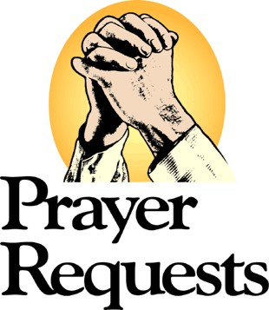
Jim Keaten, Dasha & David Jenkins, Edwin, Nancy Bess & Tripp Johnston, Myra Frances Johnston, Dagmar Schmitz-Carlton, Ann Harrison, Larry Caywood, Carol Novian, Leah, Haywood Patton, Andrew Babcock, John Schroeder, Jackie Hizel, Bonnie Foster, Kelli Varnell, John Marshall, Henry Pancione, Katie Pancione, Drew Moss, Clyde Herron, Julie Herring, Sue Anderson, Martha, Camry McCullough, Carlton Family, Gina Schmitz, William Burk, Bonnie & Joe Herring, Campbell Clark, Stephen Patton, Ray Dempsey, Rees Jenkins and those that care for them.

THIS WEEK the intercessory prayer will be “refreshed”; all names removed. If you wish to add someone, please call, or email the church office. Names will remain on the Prayer List for the entire month.

Military Prayer List:
Phillip Jenkins
Gordon Macy
Charles Lewis
Nolan Kelley
Davis Isley

Andrew Hall
Ted Olney
Michael Blair
Steven Blair
Charlie Hardaker
Justin Yeary

Thomas Keefe
Johnny Crittenden
Sara Carver Thomas
Joshua Ingram
Cherrie Shackelford

Please remember to notify the church office when a service member is no longer on active duty.


NEXT SUNDAY – June 7th
BISHOP WRIGHT
at St. Peter’s

He will preside over Rite I service at 8:30am and Rite II service at 10am with confirmations/receptions and re-affirmations.

Java Joy will be on site 9-10am with coffee and doughnuts, serving from kitchen in Daniel Hall.

Bishops Reception in Daniel Hall after the 10am service, make plans to be present.


Candles in the Nave given by Peggy Nash for the month of May in appreciation to the St. Peter’s Community

Flowers in the Chapel given to the glory of God and in memory of Karl Kothe by Diann Kothe.

Flowers in the Nave given to the glory of God and in thanksgiving for Anthea & Bob Evans and in memory of Les & Delma Bowen, Roger Bowen, Alison Owens, Nancy Owens, Nancy Hainlin and Ella & Bob Evans, Sr. By Sarah, Lucy and Robert Joseph.

OPEN dates on Flower Calendar:
Nave - July 19th
Chapel – June 7th, 28th & July 19th & 26th
Remember someone special, contact church office to secure date.


Available in the church office.
Digital copy available upon request.

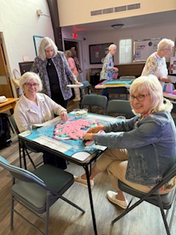
Mahjong
2nd Friday each month,
6pm in Daniel Hall.
Virginia Hunter, 770.530.0079

Come join our fun!
Next Gathering – June 12th

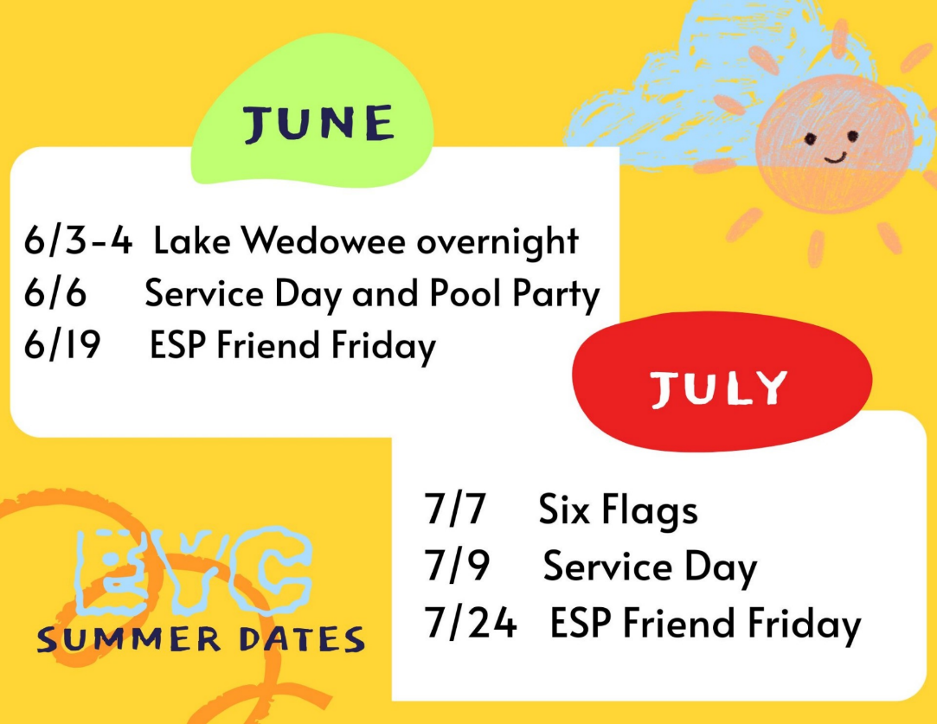
EYC Summer Events for
rising 6th graders through
graduating seniors.

Mark your calendar so you do not miss any of our summer fun.

Cameron Jackson, Youth Coordinator or 770.823.4782

Lake Hangout – June 3-4
- Depart on Wednesday at 10:30am
- Return approximatly 7pm on Thursday
- Meet at St. Peter’s parking lot for departure and return
- $40 covers transportaion, food and all the fun you can have!

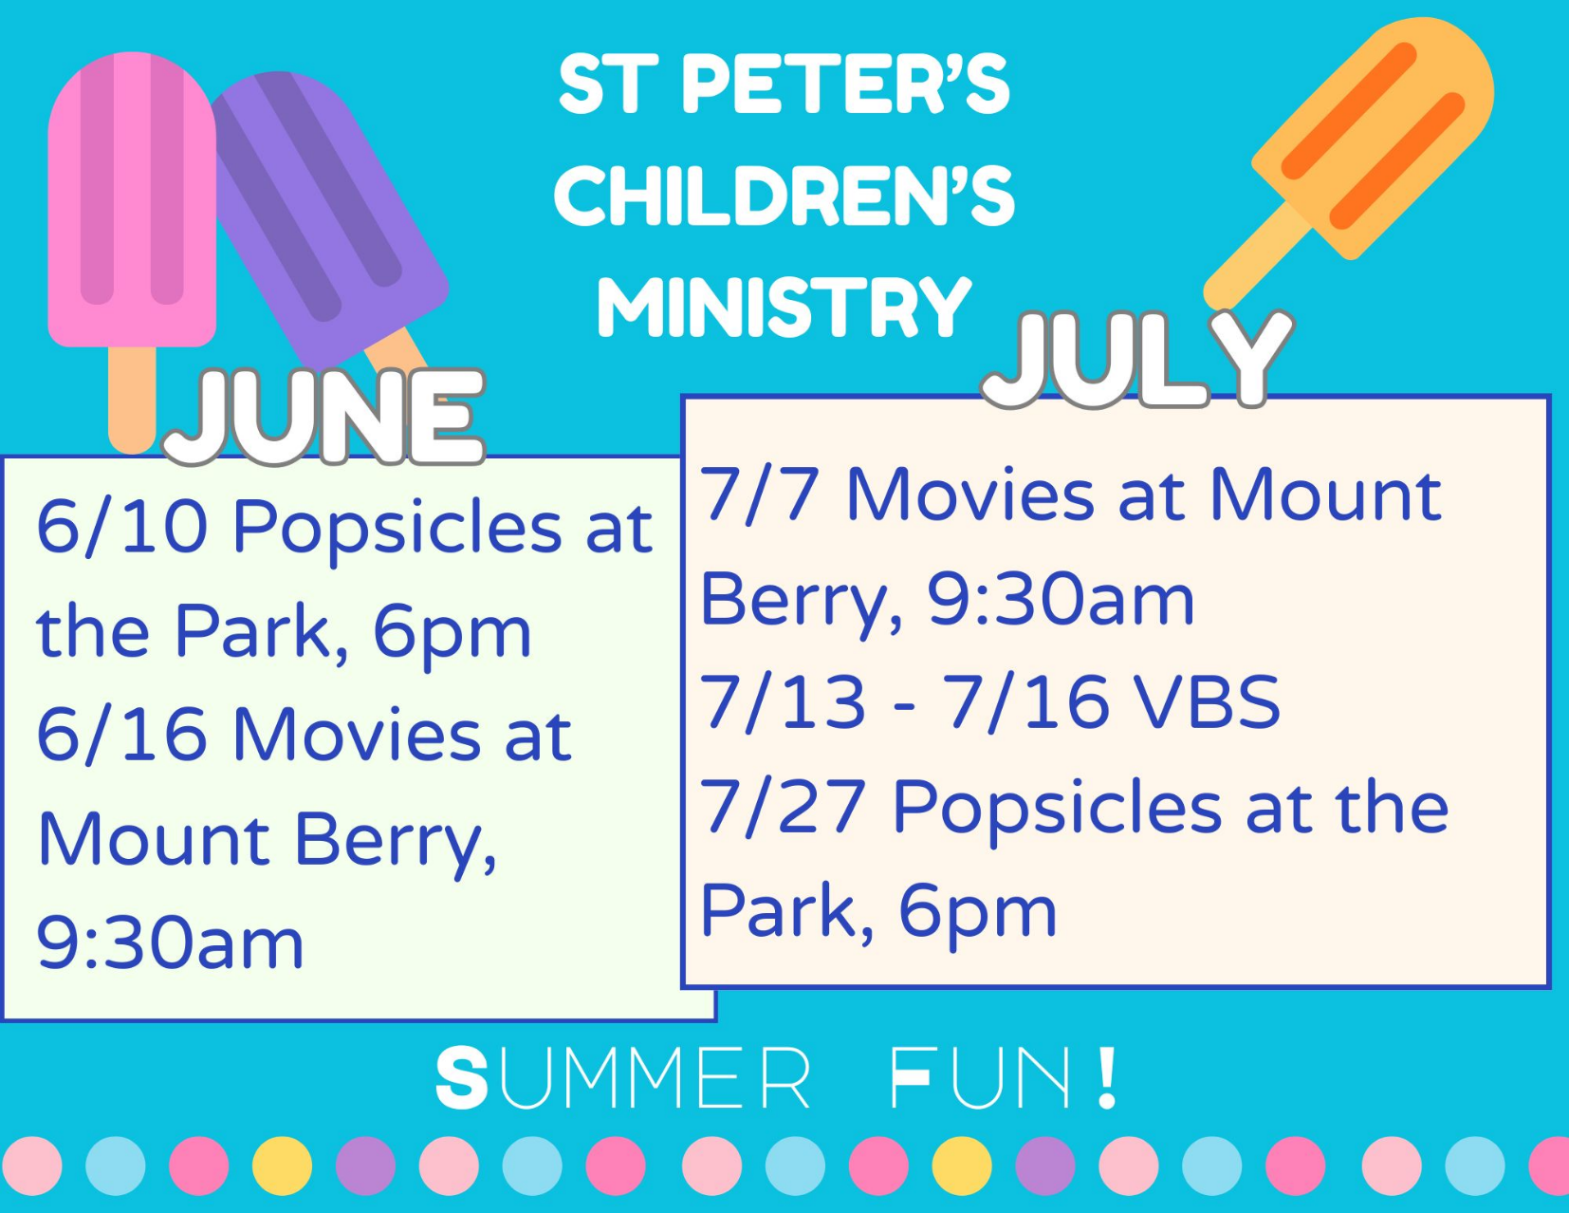

June Movie – K-Pop Demon Hunters.
- Children 3rd- 5th grades may be left with Children’s Ministry Volunteers.
- ALL other ages must have a parent/guardian attend with them.
- Cost $2 per ticket. Bring more if you want concessions.

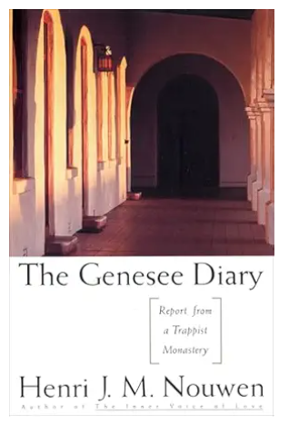
Living Compass NEW book group

Beginning Monday June 8th, 2pm
401 E. 4th Avenue

D’Ann Downey, 706.266.3444

Anthea Evans 31st
Richard Dunwoody 31st

Harriet Johnston 31st
Christine Pilgrim 31st
Cathy Varidel July 1st
Larry Mooseberg 1st
Helen Lansing 2nd
Gayle Keith 2nd
Curt Yarbrough 2nd
Jennifer shipp 2nd
Jan Woody 3rd
Beverly Schrum 4th
Nancy Hunter 4th
Maggi Smith 4th

St. Peter’s VOLUNTEERs are needed from 9am till noon. HOWEVER, if you are not able to work the full 3 hours, any time you can share is greatly appreciated.

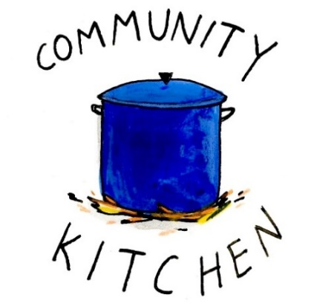
2026 Schedule
Friday Tuesday
June -- 23
July 24 28
August 21 25
September 25 29
October 23 27
November 20 24
December -- 29

Contact Nancy Hunter to volunteer to help, 706.506.3889. THANK YOU


Centering Prayer
Thursday Bible Study
Roots
Jr. Choir
Wednesday Dinner
Adult Choir
EYC Sunday gatherings

These program/activities will resume in the fall.

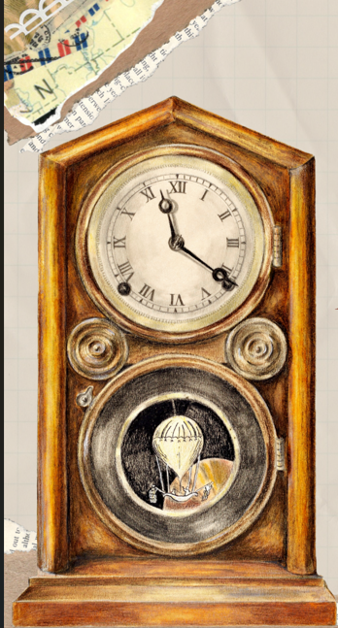
VBS Registration
OPEN

A Wrinkle in Time
July 13th – 16th
9am-12pm

Children 3 years through 5th grade

VBS REGISTRATION
https://docs.google.com/forms/d/e/1FAIpQLSdJm1Anx6U-FwpUO-fYHX8DvF4Q2PWaqLIj2pBAyFpgw8xqKg/viewform?usp=header

VBS VOLUNTEER SIGN UP
https://docs.google.com/forms/d/e/1FAIpQLSfVsfPPPMnXVgj1AAV3jtEyHFfGmNTW7r9d_jXQZUJyP8gElQ/viewform?usp=header


St. Peter’s day Celebration
Wednesday June 24th.

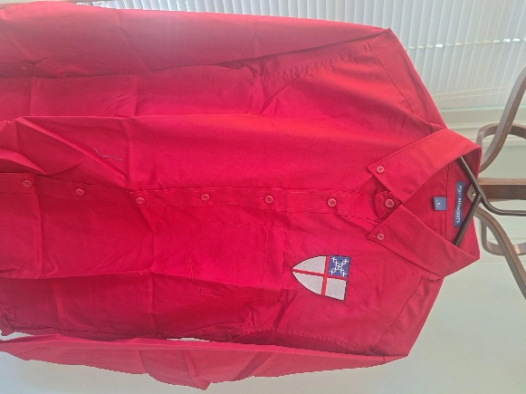
Deep red long sleeve button down shirt $45
Small, Large and XLarge sizes available.

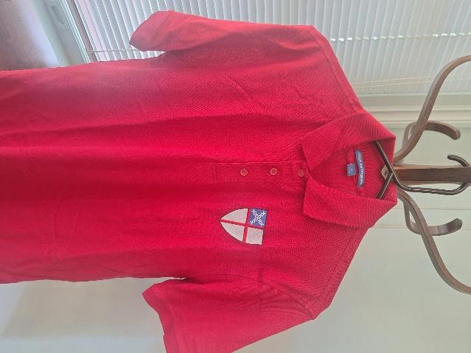

Deep red short sleeve cotton polo shirt $25
Small and Large sizes available

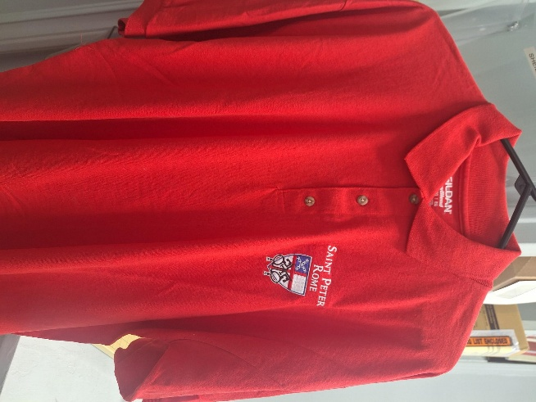
Red short sleeve polo is XL $25
ONLY 1 Shirt

JUNE | Monday | Tuesday | Wednesday | Thursday | Friday | Saturday
31  8:15-11:45 Nursery provided  9:50am Children’s Chapel  8:30am – Rite I Chapel  10am – Rite II Nave, WLAQ/You tube  Victor Rendon Recital 1pm  Food served 11:30am | JUNE 1 | 2 | 3  5:30pm Celtic Service  EYC – Lake Wedowee Overnight | 4  3:30pm Stephen Ministry meeting, R. Wyatt  EYC – Lake Wedowee Overnight | 5  11:30am Sylvia Hine Funeral | 6  EYC  Service Day & Pool Party
7  Bishops Visit with Confirmations  8:15-11:45 Nursery provided  9:50am Children’s Chapel  9-10am Java Joy Coffee & Doughnuts  8:30am – Rite I Chapel  10am – Rite II Nave, WLAQ/You tube  11:15am Bishops Reception | 8  2pm Living Compass  NEW book study begins | 9 | 10  5:30pm Celtic Service  6pm Popsicles in the Park | 11  6:30pm R. Wyatt 3 Rivers | 12  8:30-11am Compassion R. Wyatt  6pm Mahjong | 13
14  8:15-11:45 Nursery provided  9:50am Children’s Chapel  8:30am – Rite I Chapel  10am – Rite II Nave, WLAQ/You tube | 15  2pm Living Compass | 16  9:30am Children’s Ministry MOVIE  Vestry Meeting 5:30pm | 17  5:30pm Celtic Service  Noon – Living Proof,  R. Wyatt | 18  3:30pm Stephen Ministry R. Wyatt | 19  EYC Fried Friday with ESP | 20
21 – Father’s Day  8:15-11:45 Nursery provided  9:50am Children’s Chapel  8:30am – Rite I Chapel  10am – Rite II Nave, WLAQ/You tube | 22  2pm Living Compass | 23 | 24  5:30pm Celtic Service  St. Peter’s Day Celebration | 25 | 26 | 27
28  8:15-11:45 Nursery provided  9:50am Children’s Chapel  8:30am – Rite I Chapel  10am – Rite II Nave, WLAQ/You tube | 29  2pm Living Compass | 30  4-8pm ESP D. Hall | JULY 1  5:30pm Celtic Service | 2 | 3 | 4

