
WELCOME TO ALL OUR VISITORS!
If you are interested in knowing more about St. Peter’s, please see an usher or one of the greeters who stand with the clergy after the service.

5.24.2026 at St. Peter’s

8:15am-11:45am Nursery
8:30am Holy Eucharist Rite I in Chapel
0am Children’s Chapel – M.J. Chisholm & Nancy Hunter
10:00am Holy Eucharist Rite II in Nave, WLAQ radio & YouTube

This week…
Monday May 25th 1pm Centering Prayer
2pm Living Compass Study
Wednesday May 27th 5:30pm Celtic Service in the chapel

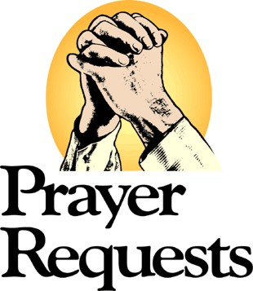

Dagmar Schmitz-Carlton, Ann Harrison, Larry Caywood, Carol Novian, Leah, Haywood Patton, Andrew Babcock, John Schroeder, Jackie Hizel, Bonnie Foster, Kelli Varnell, John Marshall, Henry Pancione, Katie Pancione, Drew Moss, Clyde Herron, Julie Herring, Sue Anderson, Martha, Camry McCullough, Carlton Family, Gina Schmitz, William Burk, Bonnie & Joe Herring, Campbell Clark, Stephen Patton, Ray Dempsey, Rees Jenkins and those that care for them.

Beginning of each Month the intercessory prayer will be “refreshed”; all names removed. If you wish to add someone, please call, or email the church office. Names will remain on the Prayer List for the entire month.


Available in the church office.

Digital copy available upon request.

Military Prayer List:
Phillip Jenkins
Gordon Macy
Charles Lewis
Nolan Kelley
Davis Isley

Andrew Hall
Ted Olney
Michael Blair
Steven Blair
Charlie Hardaker
Justin Yeary

Thomas Keefe
Johnny Crittenden
Sara Carver Thomas
Joshua Ingram
Cherrie Shackelford

Please remember to notify the church office when a service member is no longer on active duty.


Candles in the Nave given by Peggy Nash for the month of May in appreciation to the St. Peter’s Community

Flowers in the Chapel given to the Glory of God.

Flowers in the Nave given by Scott Morris in loving memory of his father, Thornton Morris, Sr.
.

OPEN dates on Flower Calendar:

Nave - June 21st , July 19th
Chapel – June 7th, 28th & July 26th

Remember someone special, contact church office to secure date.
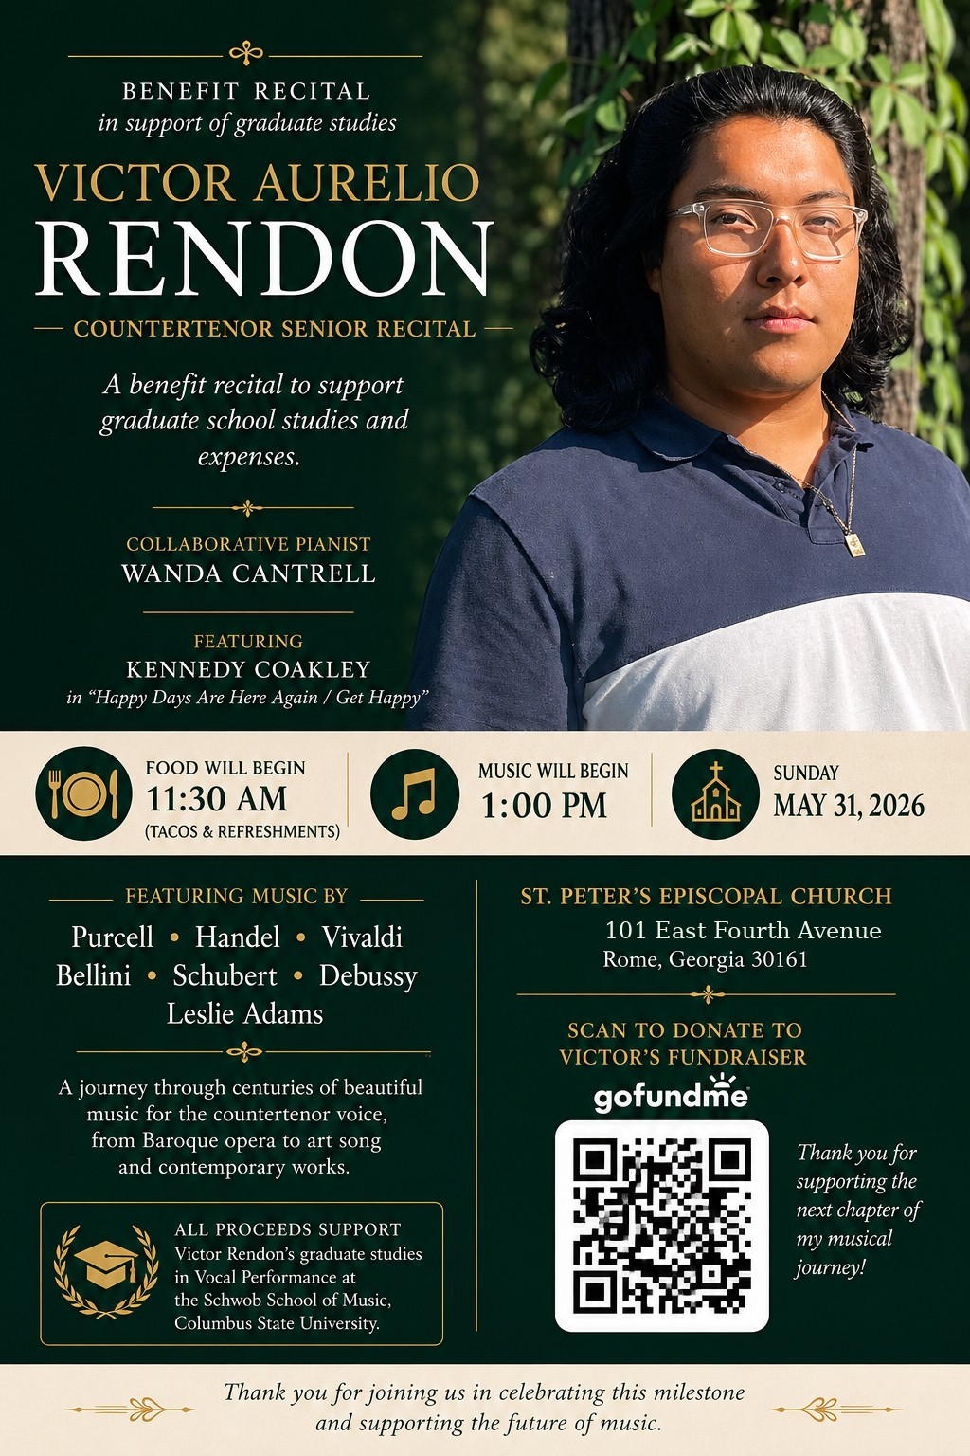

Homemade Tacos & Drinks will be sold
before the recital.
Taco’s $2.5 each and canned drinks $1
All proceeds benefit Victor’s graduate studies
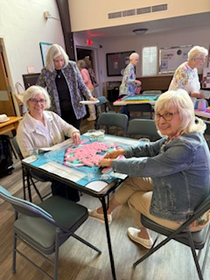
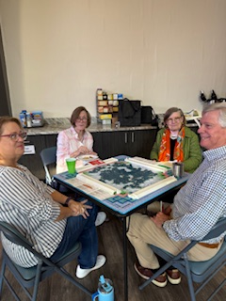
Mahjong

2nd Friday each month,
6pm in Daniel Hall.
Virginia Hunter, 770.530.0079

Come join our fun!
Next Gathering – June 12th

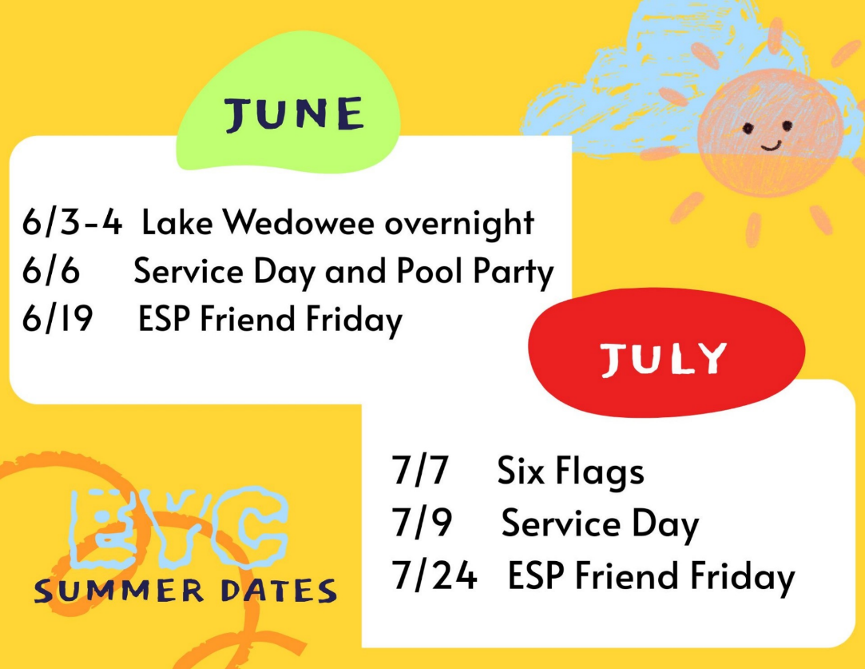
EYC Summer Events for
rising 6th graders through
graduating seniors.

Mark your calendar so you do not miss any of our summer fun.

Cameron Jackson, Youth Coordinator or 770.823.4782

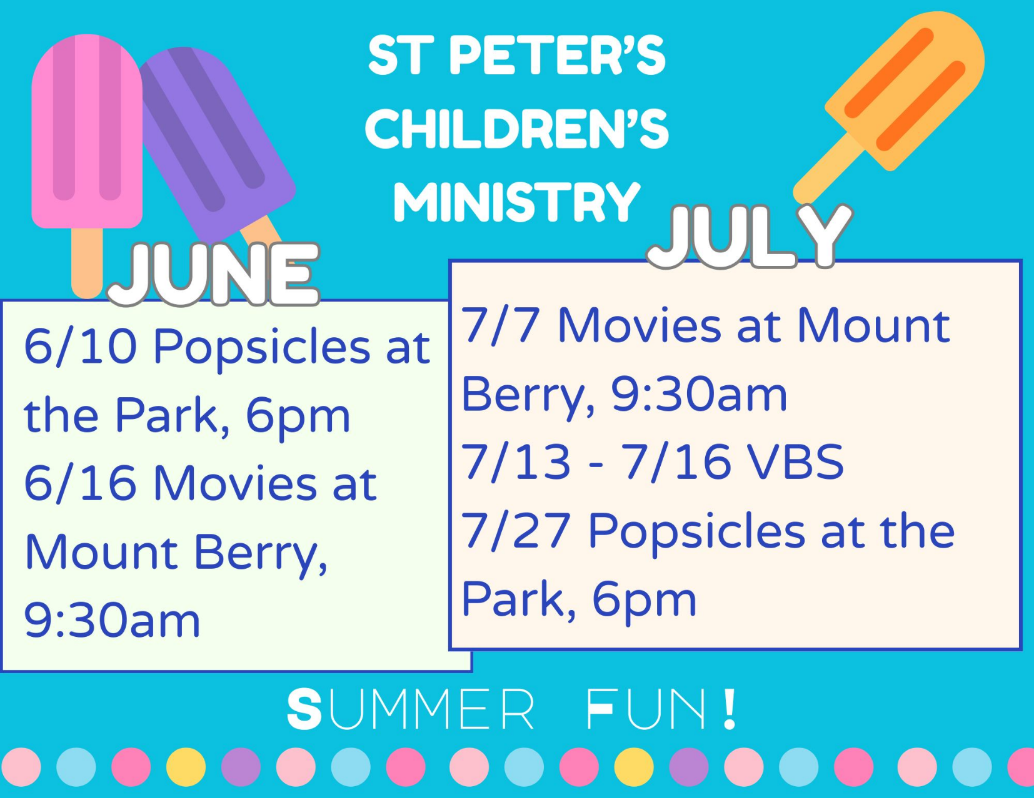

June Movie – K-Pop Demon Hunters.
- Children 3rd- 5th grades may be left with Children’s Ministry Volunteers.
- ALL other ages must have a parent/guardian attend with them.
- Cost $2 per ticket. Bring more if you want concessions.


Julie Lucas 24th
Frank Minor 25th
Brian Abbott 25th
Beth Wellesley 25th
Victor Chin 27th
Carlye Robinson 27th
Mary yarbrough 29th
Melissa Tarrant 29th
Noah Abbott 29th
Nathan Abbott 29th
Anna Abbott 29th
Jack Gilreath-Harvey 29th
Donna Griffin 30th
Molly Rutledge 30th
Wes Henderson 30th
William Gilr3ath-Harvey 30th

St. Peter’s VOLUNTEERs are needed from 9am till noon. HOWEVER, if you are not able to work the full 3 hours, any time you can share is greatly appreciated.

2026 Schedule
Friday Tuesday
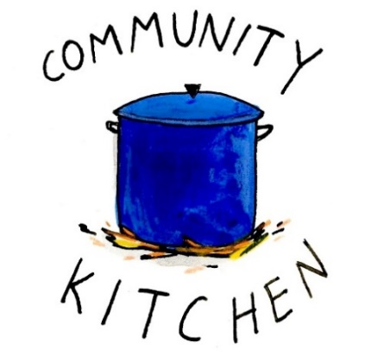
May 22 26
June -- 23
July 24 28
August 21 25
September 25 29
October 23 27
November 20 24
December -- 29

Contact Nancy Hunter to volunteer to help, 706.506.3889. THANK YOU

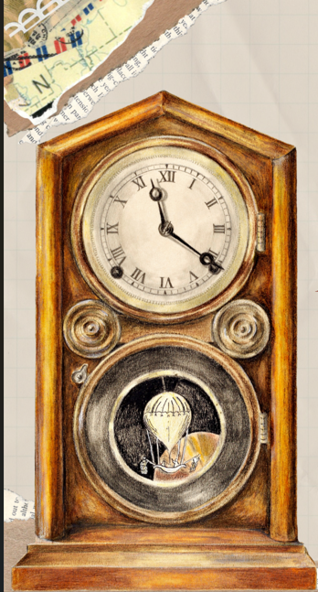
SAVE THE DATE
VBS 2026
A Wrinkle in Time
July 13th – 16th
9am-12pm

Children 3 years through 5th grade

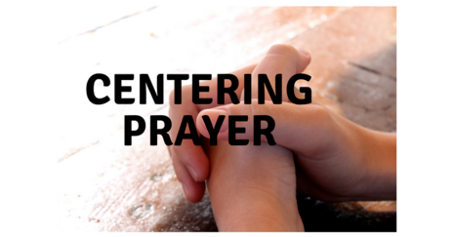
Centering Prayer
will NOT meet during the months of June and July.


St. Peter’s day Celebration
Wednesday June 24th.

MAY | Monday | Tuesday | Wednesday | Thursday | Friday | Saturday
17  8:15-11:45 Nursery provided  9:50am Children’s Chapel  8:30am – Rite I Chapel  9-10 FINAL Breakfast  10am – Rite II Nave, WLAQ/You tube  11:15am Adult Forum  11:15am Children’s Ministry Volunteer Lunch & Meeting  4-6pm D. Hall/green space – C. Jackson | 18  1pm Centering Prayer  2pm Living Compass | 19  3 Rivers 7-8:30pm Nave | 20  Noon – Living Proof, R. Wyatt  10am Staff Meeting  5:30pm Celtic Service  5:30 GRILL OUT  6-7:30pm End of Yr. Party for Roots &  Jr. Choir  7pm Adult Choir | 21  10am Bible Study  3:30pm Stephen Ministry meeting in R. Wyatt | 22 | 23
24  8:15-11:45 Nursery provided  9:50am Children’s Chapel  8:30am – Rite I Chapel  10am – Rite II Nave, WLAQ/You tube | 25  1pm Centering Prayer  2pm Living Compass | 26  9-Noon Community Kitchen  3 Rivers 7-8:30pm Nave | 27  5:30pm Celtic Service | 28 | 28 | 30
31  8:15-11:45 Nursery provided  9:50am Children’s Chapel  8:30am – Rite I Chapel  10am – Rite II Nave, WLAQ/You tube  Victor Rendon Recital 1pm  Food served 11:30am | JUNE 1  1pm Centering Prayer  2pm Living Compass | 2 | 3  5:30pm Celtic Service  EYC – Lake Wedowee Overnight | 4  3:30pm Stephen Ministry meeting, R. Wyatt  EYC – Lake Wedowee Overnight | 5 | 6  EYC  Service Day & Pool Party
7  Bishops Visit with Confrimations  8:15-11:45 Nursery provided  9:50am Children’s Chapel  8:30am – Rite I Chapel  10am – Rite II Nave, WLAQ/You tube  11:15am Bishops Reception | 8 | 9 | 10  5:30pm Celtic Service  6pm Popsicles in the Park | 11  6:30pm R,. Wyatt 3 Rivers | 12  8:30-11am Compassion R. Wyatt  6pm Mahjong | 13
14  8:15-11:45 Nursery provided  9:50am Children’s Chapel  8:30am – Rite I Chapel  10am – Rite II Nave, WLAQ/You tube | 15 | 16 | 17  Noon – Living Proof,  R. Wyatt | 18  3:30pm Stephen Ministry R. Wyatt | 19 | 20

