
WELCOME TO ALL OUR VISITORS!
If you are interested in knowing more about St. Peter’s, please see an usher or one of the greeters who stand with the clergy after the service.

5.10.2026 at St. Peter’s

8:15am-11:45am Nursery
8:30am Holy Eucharist Rite I in Chapel
9-10am Breakfast
9:50am Children’s Chapel – Suzanne Roberts & Margaret Louttit
10:00am Holy Eucharist Rite II in Nave, WLAQ radio & YouTube

This week…

Monday May 11th Noon RSVP for Wednesday Dinner
1pm Centering Prayer
2pm Living Compass Study
Wednesday May 13th Parish Retreat Deposit Due
5:30pm Celtic Service in the chapel
5:30pm Dinner served in Daniel Hall
6-6:30pm Roots
6:30-7pm Jr. Choir
7pm Adult Choir
Thursday May 14th 6pm Bridges Graduation & Dinner


Dagmar Schmitz-Carlton, Ann Harrison, Larry Caywood, Carol Novian, Leah, Haywood Patton, Andrew Babcock, John Schroeder, Martha, Jackie Hizel, Bonnie Foster, Kelli Varnell, John Marshall, Henry Pancione, Katie Pancione, Drew Moss, Clyde Herron, Julie Herring, Sue Anderson, Martha, Bonnie Foster, Carmy McCullough, Carlton Family, Gina Schmitz, William Burk, Bonnie & Joe Herring, Campbell Clark, Stephen Patton, Ray Dempsey, Rees Jenkins, and those that care for them.

Beginning of each Month the intercessory prayer will be “refreshed”; all names removed. If you wish to add someone, please call, or email the church office. Names will remain on the Prayer List for the entire month.
Military Prayer List:
Phillip Jenkins
Gordon Macy
Charles Lewis
Nolan Kelley
Davis Isley

Andrew Hall
Ted Olney
Michael Blair
Steven Blair
Charlie Hardaker
Justin Yeary

Thomas Keefe
Johnny Crittenden
Sara Carver Thomas
Joshua Ingram
Cherrie Shackelford

Please remember to notify the church office when a service member is no longer on active duty.


May 17th Berry Professor, Coleman Fannin,
Environmental Ethics


FINAL BREAKFAST
May 17th

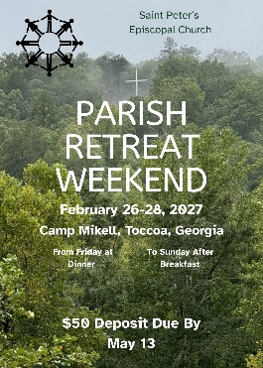
Wednesday May 13th
Remit DEPOSIT $50

2027 PARISH RETREAT at Camp Mikell


Children’s Ministry VOLUNTEER Meeting & Lunch – May 17th in the Green Space on 4th floor.

Current as well as prospective VOLUNTEERS are all welcome.


Saturday May 9th
10-11am

First Baptist Church

Success Coach Informatio Session
9 Female & 3 Male coaches needed

Bridges Graduation & Dinner
Thursday May 14th.
RSVP for dinner, call church office.

EYC SUMMER SCHEDULE

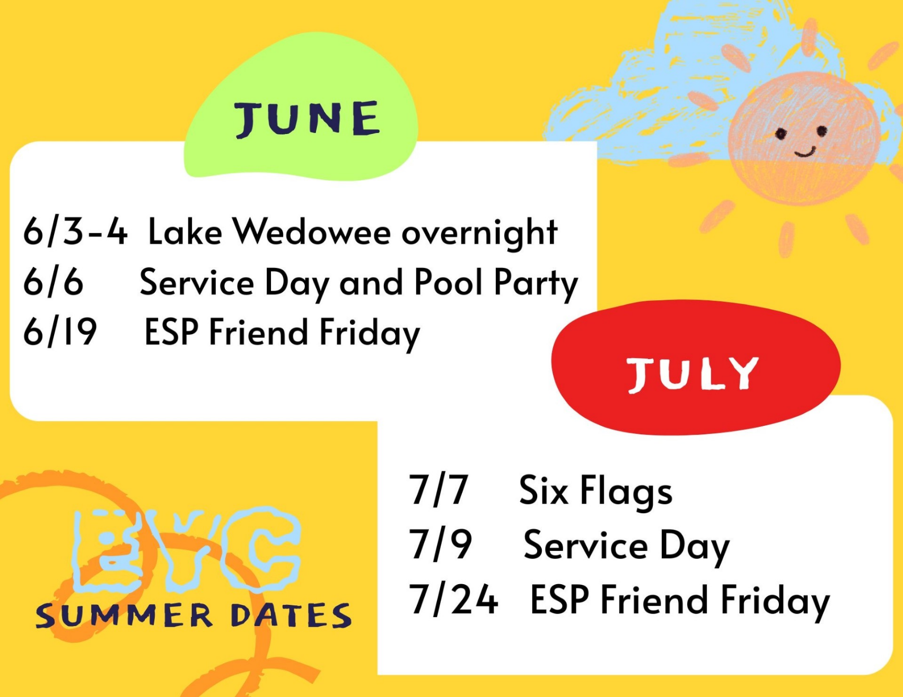

Mark your calendars,
do not miss any of our summer fun!

Cameron Jackson, Youth Coordinator
770.823.4782 or stpetersromeeyc@gmail.com

Elaine Smith 10th
Jim Keaten 10th
Ragon Crabtree 10th
Leigh Holmes 10th
Casey Dexter 11th
Bobo Smith 11th
Laura Elliott 11th
Eli Gilreath-Harvey 11th
Janet Flippen 13th
Janice Holley-Houck 14th
Kellie Wolfe 14th
Christy Ptuitt 15th

St. Peter’s VOLUNTEERs are needed from 9am till noon. HOWEVER, if you are not able to work the full 3 hours, any time you can share is greatly appreciated.

2026 Schedule
Friday Tuesday
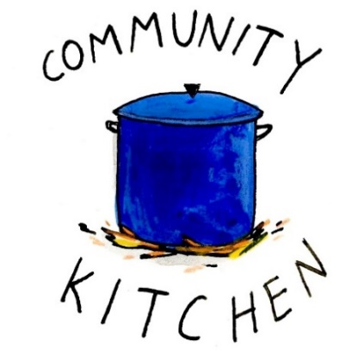
April 24 28
May 22 26
June -- 23
July 24 28
August 21 25
September 25 29
October 23 27
November 20 24
December -- 29

Contact Nancy Hunter to volunteer to help, 706.506.3889. THANK YOU
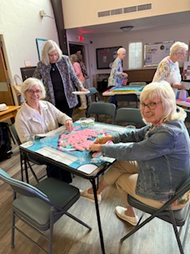
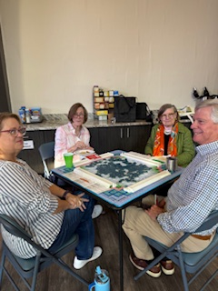
Mahjong

2nd Friday each month,
6pm in Daniel Hall.
Virginia Hunter, 770.530.0079

Come join our fun!



SAVE THE DATE
VBS 2026
A Wrinkle in Time
July 13th – 16th
9am-12pm
Children 3 years through 5th grade


Available in the church office.

Digital copy available upon request.

Children’s Chapel
Sundays, 9:50am

We depart as a group from the nave and return during the Peace to share Eucharist with our families.
Children’s Chapel is available for children aged Pre-K through 2nd grade.


Junior Choir ~Wednesday Nights
6:30-7pm through 5.20.2026



ROOTS ~Wednesday Nights
6-6:30pm through 5.20.2026

End of the Year Party on 5.20.2026

MAY 15^{th ~} 5:30-8pm
Parents, take the night off
enjoy dinner & fellowship at john henry’s



Cost $10 per child, $20 Family Maximum
Register on Realm or contact the church office


Adults $10 - Kids $4 - Family Maximum $25
Vegetarian/Gluten Free $8: Sides with rotating meatless burger or egg.
Gluten Free $10 entrée sides, see notes below when ordering.

May 13
Adults/Kids – Grilled Cheese Sandwich, Vegetarian soup, salad, dessert
Vegetarian – Soup, salad
Gluten Free – Specify when placing your order and your sandwich will be made with gluten free bread.

May 20 COOK OUT
Burgers and Hotdogs, pasta salad, potato salad, chips dessert
Gluten Free – Specify when placing your order for a gluten free bun.
Vegetarian – Specify when placing your order for a meatless burger patty

NAME:
Drop this in the collection plate, by the church office or snap a photo and email to elizabeth@stpetersrome.org.


Flowers in the Chapel given by Thayer Manis in prayerful reverence for her sister, Lisa Larrimore and all who struggle with addiction.

Flowers in the Nave given by Thayer Manis in thanksgiving for her brothers, Walter Larrimore and Robert Larrimore.

Candles in the Nave given by Peggy Nash for the month of May in appreciation for the St. Peter’s Community.

MAY | Monday | Tuesday | Wednesday | Thursday | Friday | Saturday
3 YOUTH SUNDAY  8:15-11:45 Nursery provided  9:50am Children’s Chapel  8:30am – Rite I Chapel  9-10 Breakfast  10am – Rite II Nave, WLAQ/You tube  11:15 Senior Reception, Daniel Hall  Grill Out: Children, EYC & Family | 4  Noon – RSVP for Wednesday Dinner  1pm Centering Prayer  2pm Living Compass | 5  3 Rivers 7-8:30pm Nave | 6  5:30pm Dinner begins  5:30pm Celtic Service  6-6:30pm Roots  6:30-7pm Jr. Choir  7pm Adult Choir | 7  10am Bible Study  3:30pm S. Ministry Meeting  6-8:30 Bridges D. Hall, Kitchen | 8  6pm Mahjong in Daniel Hall.  8-11am Compassion Resilience  Rhodes Wyatt | 9  10-2 Voter Registration,  D. Hall
10  8:15-11:45 Nursery provided  9:50am Children’s Chapel  8:30am – Rite I Chapel  9-10 Breakfast  10am – Rite II Nave, WLAQ/You tube | 11  Noon – RSVP for Wednesday Dinner  1pm Centering Prayer  2pm Living Compass | 12  Indivisible 7-8:30 D. Hall  3 Rivers 7-8:30pm Nave | 13  5:30pm Dinner begins  5:30pm Celtic Service  6-6:30pm Roots  6:30-7pm Jr. Choir  7pm Adult Choir | 14  6-8:30 Bridges Graduation & Dinner  6:30 3 Rivers R. Wyatt | 15  PARENT Night Out | 16  Violin Recital in D. Hall 1-4pm
17  8:15-11:45 Nursery provided  9:50am Children’s Chapel  8:30am – Rite I Chapel  9-10 FINAL Breakfast  10am – Rite II Nave, WLAQ/You tube  11:15am Adult Forum  11:15am Childrens Ministry Volunter Meeting & Lunch  4-6pm D. Hall/green space – C. Jackson | 18  Noon – RSVP for Wednesday Dinner  1pm Centering Prayer  2pm Living Compass | 19  Vestry Meeting, 5:30pm  3 Rivers 7-8:30pm Nave | 20  9am Staff Meeting  Noon – Living Proof, R. Wyatt  5:30pm Celtic Service  5:30 COOK OUT  6-7:30pm End of Yr. Party for Roots &  Jr. Choir  7pm Adult Choir | 21  10am Bible Study  3:30pm Stephen Ministry meeting in R. Wyatt | 22  9-noon  Community Kitchen | 23
24  8:15-11:45 Nursery provided  9:50am Children’s Chapel  8:30am – Rite I Chapel  10am – Rite II Nave, WLAQ/You tube | 25  1pm Centering Prayer  2pm Living Compass | 26  9-Noon Community Kitchen  3 Rivers 7-8:30pm Nave | 27  5:30pm Celtic Service  7pm Adult Choir | 28 | 28 | 30
31  8:15-11:45 Nursery provided  9:50am Children’s Chapel  8:30am – Rite I Chapel  10am – Rite II Nave, WLAQ/You tube  Victor Rendon Recital | JUNE 1  1pm Centering Prayer  2pm Living Compass | 2 | 3  5:30pm Celtic Service  7pm Adult Choir | 4  3:30pm Stephen Ministry meeting, R. Wyatt | 5  Funeral for Sylvia Hine | 6

