
WELCOME TO ALL OUR VISITORS!
If you are interested in knowing more about St. Peter’s, please see an usher or one of the greeters who stand with the clergy after the service.

4.26.2026 at St. Peter’s
8:15am-11:45am Nursery
8:30am Holy Eucharist Rite I in Chapel
9-10am Breakfast
9:50am Children’s Chapel – Margaret Louttit & Lee Morris
10:00am Holy Eucharist Rite II in Nave, WLAQ radio & YouTube
11:15am Adult Forum – Bob Berry, End of Life Planning
6-7:30pm Game Night for Jr. EYC, 4ht & 5th graders
6pm Sr. EYC at the church
This week…
Monday April 27th Noon RSVP for Wednesday Dinner
1pm Centering Prayer
2pm Living Compass Study
Tuesday April 28th 9am till Noon Community Kitchen
Wednesday April 29th 5:30pm Celtic Service in the chapel
5:30pm Dinner served in Daniel Hall
6-6:30pm Roots
6-7pm Catechumenate – FINAL class
6:30-7pm Jr. Choir
7pm Adult Choir
Thursday April 30th 10am Bible Study
6pm Bridges
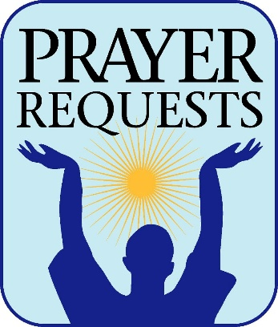
Sylvia Hine, Rees Jenkins, Ray Dempsey, Stephen Patton, Dasha & David Jenkins, Campbell Clark, Bonnie & Joe Herring, John Marshall, Henry Pancione, Katie Pancione, Michael Ann Booth, Andrew Babcock, Haywood Patton, John Schroeder, Sherron Badgett, Rebecca Francis, William Burk, Gina Schmitz, Carlton Family, Camry McCullough, Bonnie Foster, Martha, Jackie Hizel, Leah, Tony, Jim Chisholm, Sue Anderson, Dana Huskins, Chuck Worthington, Julie Herring, Stephen Taylor and those that care for them.

Next Week the intercessory prayer will be “refreshed”; all names removed. If you wish to add someone, please call, or email the church office. Names will remain on the Prayer List for the entire month.

Military Prayer List:
Phillip Jenkins
Gordon Macy
Charles Lewis
Nolan Kelley
Davis Isley

Andrew Hall
Ted Olney
Michael Blair
Steven Blair
Charlie Hardaker
Justin Yeary

Thomas Keefe
Johnny Crittenden
Sara Carver Thomas
Joshua Ingram
Cherrie Shackelford

Please remember to notify the church office when a service member is no longer on active duty.


April 26th Bob Berry, End of Life Planning

May 17th Berry Professor, Coleman Fannin,
Environmental Ethics

Sunday May 3rd is YOUTH SUNDAY

If you have a graduate send bio, photo and their future plans to the church office by 4.29.2026 to be included in bulletin.

Sr. Reception, 11:15am in Daniel Hall
Grill Out for EYC, Children & their families

A few SHIRTS REMAINING….

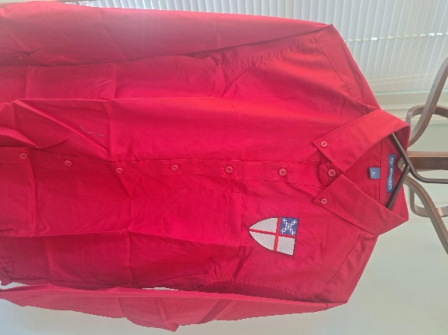
Deep red long sleeve button down shirt $45
Small, Large and XLarge sizes available.

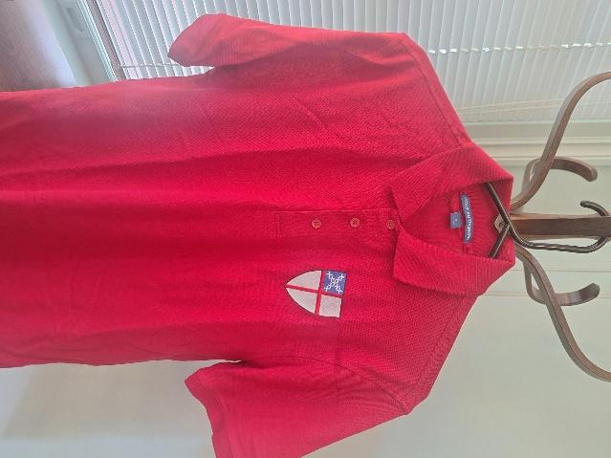

Deep red short sleeve cotton polo shirt $25
Small and Large sizes available

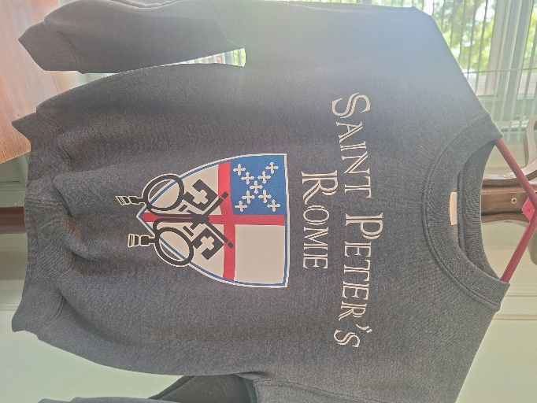

Charcoal grey sweatshirt, size Youth Small. $10

Red short sleeve polo is XL $25

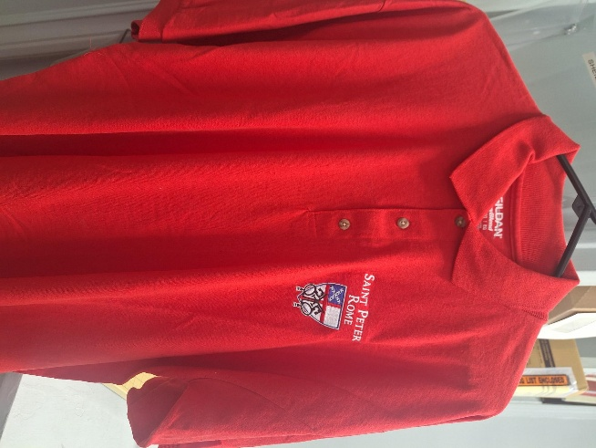


Barbara Dixon 27th
Julia Thomas 27th
Marissa Rayburn 27th
Keith Summerlin 28th
Sara Harbin Pickett 28th
Rosemary Holcombe 28th
Beverly Yancy 29th
Janice Carter May 1st
Caroline Sawhill 1st
Lila Niedrach 1st
Barbara Briley 2nd
Alex Natarella 2nd


Can you say HELLO with a friendly smile?

Come join our team of greeters to welcome everyone to Sunday Worship.

You will greet at the 10am service, 2 months each year, or what fits your schedule. Contact Mary Kirkland, 706.291.0558


Church Flower Calendar
OPEN DATES:

Chapel – May 3rd, May 24th, 31st

Honor a loved one or friend by donating flowers for one of the church altars. Contact the church office, 706.291.9111 or elizabeth@stpetersrome.org to choose your date.

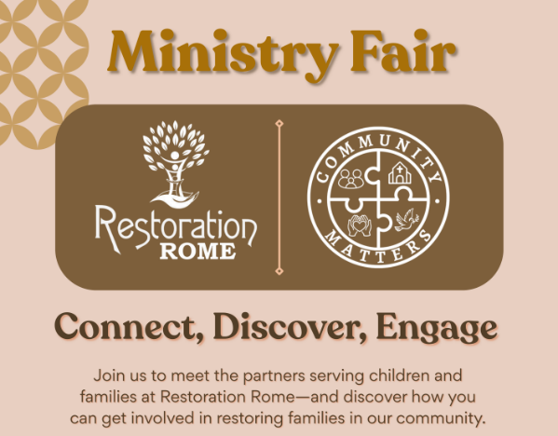
May 4th 5:30-7pm
Cafeteria @ Restoration Rome
1400 Crane Street
706.528.4033

Discover ways YOU can get involved!

St. Peter’s VOLUNTEERs are needed from 9am till noon. HOWEVER, if you are not able to work the full 3 hours, any time you can share is greatly appreciated.

2026 Schedule
Friday Tuesday
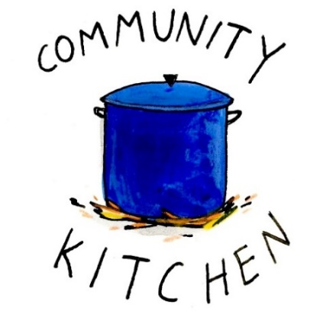
April 24 28
May 22 26
June -- 23
July 24 28
August 21 25
September 25 29
October 23 27
November 20 24
December -- 29
Contact Nancy Hunter to volunteer to help, 706.506.3889. THANK YOU
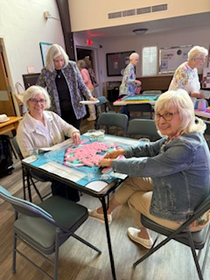
Mahjong
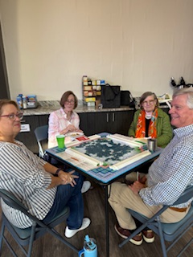
2nd Friday each month,
6pm in Daniel Hall.
Virginia Hunter, 770.530.0079

Come join our fun!


St. Paula’s Guild a

Gathering at the Lodge at Maplewood Village on
May 2nd, Noon.
Gate open from 11:30am till noon.

If you need transportation assistance, email D’Ann Downey,
ddowneywarley@comcast.net


Brown bag your lunch and drink.

We will discuss our small group gatherings as well as enjoy a story from Jane Cunningham.



SAVE THE DATE
VBS 2026
A Wrinkle in Time

July 13th – 16th
9am-12pm

Children 3 years through 5th grade

FINAL BREAKFAST – May 17th



Children’s Chapel
Sundays, 9:50am

We depart as a group from the nave and return during the Peace to share Eucharist with our families.
Children’s Chapel is available for children aged Pre-K through 2nd grade.


Junior Choir ~Wednesday Nights
6:30-7pm through 5.20.2026



ROOTS ~Wednesday Nights
6-6:30pm through 5.20.2026

End of the Year Party on 5.20.2026

MAY 15^{th ~} 5:30-8pm
Parents, take the night off
enjoy dinner & fellowship at john henry’s



Cost $10 per child, $20 Family Maximum
Register on Realm or contact the church office


Adults $10 - Kids $4 - Family Maximum $25
Vegetarian/Gluten Free $8: Sides with rotating meatless burger or egg.
Gluten Free $10 entrée sides, see notes below when ordering.

April 29
Adults/Kids: Taco Bar with seasoned taco beef and all the trimmings, chips/salsa
Gluten Free, please note when placing your order. Taco Seasoning is gluten free.

May 6
Adults/Gluten Free – Chicken, Beef sausage jambalaya, salad, garlic bread
Kids – Pepperoni Pizza, salad, fruit, cookies
Vegetarian – salad with meatless burger patty

May 13
Adults/Kids – Grilled Cheese Sandwich, Vegetarian soup, salad, dessert
Vegetarian – Soup, salad
Gluten Free – Specify when placing your order and your sandwich will be made with gluten free bread.

May 20 COOK OUT
Burgers and Hotdogs, pasta salad, potato salad, chips dessert
Gluten Free – Specify when placing your order for a gluten free bun.
Vegetarian – Specify when placing your order for a meatless burger patty

NAME:
Drop this in the collection plate, by the church office or snap a photo and email to elizabeth@stpetersrome.org.

Intercessory Prayer list will be refreshed NEXT WEEK, all names removed. If you wish to add someone to the May Prayer list, contact the church office.

APRIL | Monday | Tuesday | Wednesday | Thursday | Friday | Saturday
19  8:15-11:45 Nursery provided  9:50am Children’s Chapel  8:30am – Rite I Chapel  9-10 Breakfast  10am – Rite II Nave, WLAQ/You tube  11:15am Adult Forum  3:30pm Family Bowling  EYC – Six Flags | 20  Noon – RSVP for Wednesday Dinner  1pm Centering Prayer  2pm Living Compass | 21  5:30pm Vestry Meeting  JSL D. Hall 5:30-8:30  3 Rivers 7-8:30pm Nave | 22  5:30pm Dinner begins  5:30pm Celtic Service  6-6:30pm Roots  Catechumenate, 6-7pm  6:30-7pm Jr. Choir  7pm Adult Choir | 23  10am Bible Study  3:30pm Stephen Ministry Meeting, R. Wyatt  6-8:30 Bridges D. Hall, Kitchen | 24  9-Noon Community Kitchen | 25  9-Noon R. Wyatt Delta Kappa Gama
26  8:15-11:45 Nursery provided  9:50am Children’s Chapel  8:30am – Rite I Chapel  9-10 Breakfast  10am – Rite II Nave, WLAQ/You tube  11:15am Adult Forum  GAME NIGHT, Pilgrims House  EYC for Sr High students | 27  Noon – RSVP for Wednesday Dinner  1pm Centering Prayer  2pm Living Compass | 28  9-Noon Community Kitchen  3 Rivers 7-8:30pm Nave | 29  5:30pm Dinner begins  5:30pm Celtic Service  6-6:30pm Roots  Catechumenate, 6-7pm  6:30-7pm Jr. Choir  7pm Adult Choir | 30  10am Bible Study  6-8:30 Bridges D. Hall, Kitchen | May 1 | 2
3 YOUTH SUNDAY  8:15-11:45 Nursery provided  9:50am Children’s Chapel  8:30am – Rite I Chapel  9-10 Breakfast  10am – Rite II Nave, WLAQ/You tube  11:15 Senior Reception, Daniel Hall  Grill Out: Children, EYC & Family | 4  Noon – RSVP for Wednesday Dinner  1pm Centering Prayer  2pm Living Compass | 5  3 Rivers 7-8:30pm Nave | 6  5:30pm Dinner begins  5:30pm Celtic Service  6-6:30pm Roots  6:30-7pm Jr. Choir  7pm Adult Choir | 7  10am Bible Study  3:30pm S. Ministry Meeting  6-8:30 Bridges D. Hall, Kitchen | 8  6pm Mahjong in Daniel Hall.  8-11am Compassion Resilience  Rhodes Wyatt | 9  10-2 Voter Registration,  D. Hall
10  8:15-11:45 Nursery provided  9:50am Children’s Chapel  8:30am – Rite I Chapel  9-10 Breakfast  10am – Rite II Nave, WLAQ/You tube | 11  Noon – RSVP for Wednesday Dinner  1pm Centering Prayer  2pm Living Compass | 12  Indivisible 7-8:30 D. Hall  3 Rivers 7-8:30pm Nave | 13  5:30pm Dinner begins  5:30pm Celtic Service  6-6:30pm Roots  6:30-7pm Jr. Choir  7pm Adult Choir | 14  6-8:30 Bridges D. Hall, Kitchen  6:30 3 Rivers R. Wyatt | 15  PARENT Night Out | 16
17  8:15-11:45 Nursery provided  9:50am Children’s Chapel  8:30am – Rite I Chapel  9-10 FINAL Breakfast  10am – Rite II Nave, WLAQ/You tube  11:15am Adult Forum  4-6pm D. Hall/green space – C. Jackson | 18  1pm Centering Prayer  2pm Living Compass | 19  3 Rivers 7-8:30pm Nave | 20  Noon – Living Proof, R. Wyatt  5:30pm Celtic Service  6-7:30pm End of Yr. Party for Roots &  Jr. Choir  7pm Adult Choir | 21  10am Bible Study  3:30pm Stephen Ministry meeting in R. Wyatt | 22 | 23

