
WELCOME TO ALL OUR VISITORS!
If you are interested in knowing more about St. Peter’s, please see an usher or one of the greeters who stand with the clergy after the service.

4.19.2026 at St. Peter’s
8:15am-11:45am Nursery
8:30am Holy Eucharist Rite I in Chapel
9-10am Breakfast
9:50am Children’s Chapel – Margaret Louttit & Lee Morris
10:00am Holy Eucharist Rite II in Nave, WLAQ radio & YouTube
11:15am Adult Forum – Marshall Jenkins, Prayer
3:30pm Family Bowling Fun
6pm EYC
This week…
Monday April 20th Noon RSVP for Wednesday Dinner
1pm Centering Prayer
2pm Living Compass Study
Wednesday April 21st 5:30pm Celtic Service in the chapel
5:30pm Dinner served in Daniel Hall
6-6:30pm Roots
6-7pm Catechumenate Class
6:30-7pm Jr. Choir
7pm Adult Choir
Thursday April 22nd 10am Bible Study
3:30pm Stephen Ministry Meeting
6pm Bridges
Friday April 24th 9am – Noon Community Kitchen
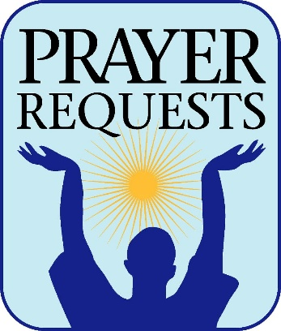
Sylvia Hine, Rees Jenkins, Ray Dempsey, Stephen Patton, Dasha & David Jenkins, Campbell Clark, Bonnie & Joe Herring, John Marshall, Henry Pancione, Katie Pancione, Michael Ann Booth, Andrew Babcock, Haywood Patton, John Schroeder, Sherron Badgett, Rebecca Francis, William Burk, Gina Schmitz, Carlton Family, Camry McCullough, Bonnie Foster, Martha, Jackie Hizel, Leah, Tony, Jim Chisholm, Sue Anderson, Dana Huskins, Chuck Worthington, Julie Herring, Stephen Taylor and those that care for them.

First of each moth the intercessory prayer will be “refreshed”; all names removed. If you wish to add someone, please call, or email the church office. Names will remain on the Prayer List for the entire month.
Military Prayer List:
Phillip Jenkins
Gordon Macy
Charles Lewis
Nolan Kelley
Davis Isley

Andrew Hall
Ted Olney
Michael Blair
Steven Blair
Charlie Hardaker
Justin Yeary

Thomas Keefe
Johnny Crittenden
Sara Carver Thomas
Joshua Ingram
Cherrie Shackelford

Please remember to notify the church office when a service member is no longer on active duty.


April 19th Marshall Jenkins, Prayer

April 26th Bob Berry, End of Life Planning

May 17th Berry Professor, Coleman Fannin,
Environmental Ethics


FAMILY FUN
April 19th 3:30pm
Floyd Bowling & Amusement
$40 a family

Pay in advance with Venmo, Cash, check at the office. RSVP by April 14th
Includes 1 hour of lane time and shoe rental.
SHIRTS REMAINING….

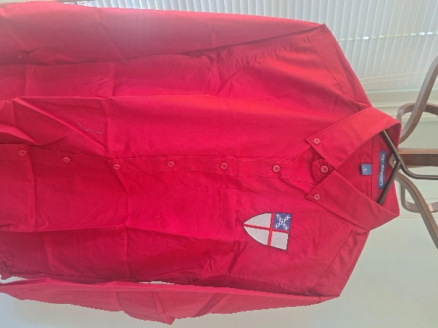
Deep red long sleeve button down shirt $45
Small, Large and XLarge sizes available.

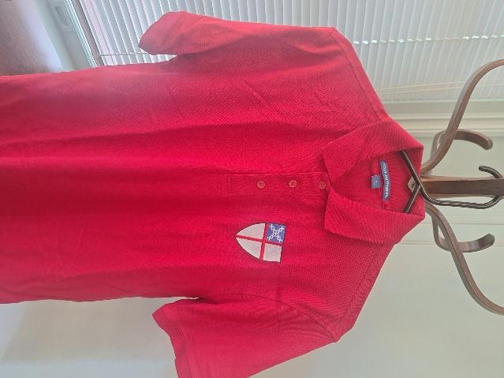

Deep red short sleeve cotton polo shirt $25
Small and Large sizes available

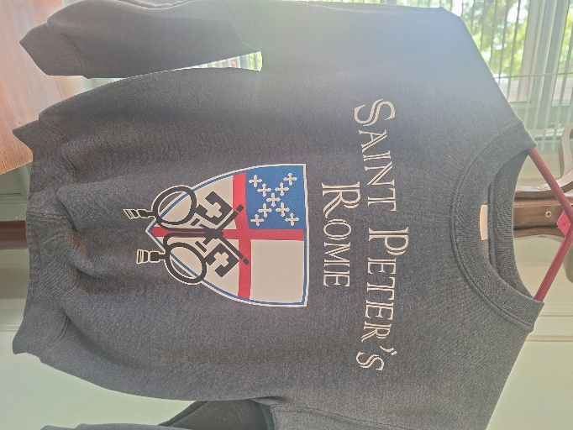

Charcoal grey sweatshirt, size Youth Small. $10

Orangy red short sleeve polo is XL $25

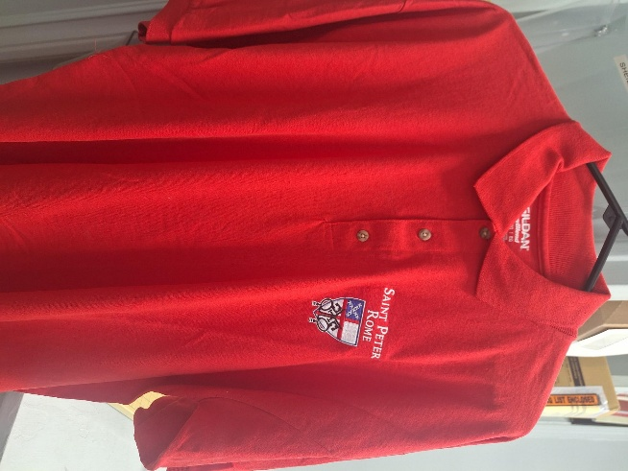

Stephanie Edgar 20th

Anderson Pilgrim 21st
Penelope Taylor 21st
Joseph Holmes, III 21st
Madeline Trammell 22nd
Sarah Edgar 23rd
Ivey Sirmans 25th
Benjamin McElrath 25th
Katelyn Boman 25th
Kyle Strickland 25th

EYC Meal Sign Up Link
https://www.signupgenius.com/go/10C084EACAB2FA5FCC43-50683016-eycsunday

Each Sunday, EYC shares a meal before they begin their study time.

Can you help by preparing, ordering or sponsoring a Sunday Meal?


Church Flower Calendar
OPEN DATES:

Chapel – May 3rd, May 24th, 31st

Honor a loved one or friend by donating flowers for one of the church altars. Contact the church office, 706.291.9111 or elizabeth@stpetersrome.org to choose your date.

Living Compass Study Group
New Series

Monday, 4.13.2026
2pm at 401 E. 4th Avenue

Contact D’Ann Downey, 706.266.3444

April 26th Game Night at the Pilgrims House
  - 6-7:30pm
  - EYC Jr. High & 4th & 5th graders.

Church Office needs a volunteer from 9am till Noon on:
MONDAY May 11th

Call, 706.291.911 OR email elizabeth@stpetersrome.org
if you can help answer phones,
THANK YOU


Sunday May 3rd is YOUTH SUNDAY

Our seniors will be recognized. If you have a graduate send bio, photo and their future plans to the church office by 4.29.2026 to be included.

St. Peter’s VOLUNTEERs are needed from 9am till noon. HOWEVER, if you are not able to work the full 3 hours, any time you can share is greatly appreciated.

2026 Schedule
Friday Tuesday
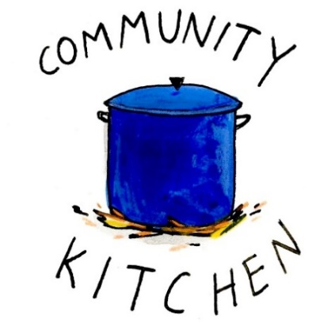
April 24 28
May 22 26
June -- 23
July 24 28
August 21 25
September 25 29
October 23 27
November 20 24
December -- 29

Contact Nancy Hunter to volunteer to help, 706.506.3889. THANK YOU



SAVE THE DATE
VBS 2026
A Wrinkle in Time

July 13th – 16th
9am-12pm

Children 3 years through 5th grade


2026 – St. Peter’s Host Church. The expectation is that the group will meet for 24 weeks, ending the program around June 18th.

This is the first time our parish will be hosting the group in our building. It is a wonderful opportunity for this ministry to be engaged with the parish in a meaningful way!

There are several aspects of the program that need to be supported by volunteers for Bridges to be a success.

Need 4-6 drivers each week for residents of Davies Shelters (men’s and women’s houses) & Next Door who are participating. Investigators (the participants in the group) will need to be delivered to Daniel Hall by 6pm and picked up at 8:30pm. We would like to ask men to transport men and women to transport women.

Meal for 15 every Thursday evening. This can be as simple as soup, salad, and dessert. The meal needs to be ready to be served at 6pm. We will utilize the Bridges Sign-Up Genuis for this, see link below.

Childcare if any of the investigators have children. At least one person needs to be Safeguard trained. These children will be ages 1-12 years old.

Questions/Volunteer in any of these capacities contact:
Devon Smyth, 770.714.2361 OR David Peters, 770.262.6017

Sign up Bridges Out of Poverty Volunteers Spring 2025: 2026 Getting Ahead Volunteers

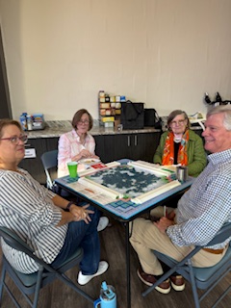
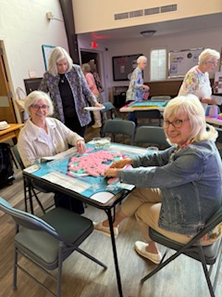
Mahjong

2nd Friday each month,
6pm in Daniel Hall.
Virginia Hunter, 770.530.0079

Come join our fun!


Children’s Chapel
Sundays, 9:50am

We depart as a group from the nave and return during the Peace to share Eucharist with our families.
Children’s Chapel is available for children aged Pre-K through 2nd grade.

April Leader Schedule:
4.5 – Easter NO Children’s Chapel
4.12 – Katie Smyth & Victoria Andrade
4.19 – Margaret Louttit & Lee Morris
4.26 – Katherine Patterson & Jennifer Bressette


Junior Choir ~Wednesday Nights
6:30-7pm
Children’s Chapel Room
3rd Floor


ROOTS
Wednesday Nights~6-6:30pm

PreK-1st grade – Children’s Chapel room, 3rd floor.
2nd & 3rd grade – Roots room, 4th floor.
4th & 5th grade – Jr. EYC room 4th floor.


Wish List for Children’s Ministry
https://www.amazon.com/hz/wishlist/ls/LOS24YTKY6Y4?ref_=wl_share


Adults $10 - Kids $4 - Family Maximum $25
Vegetarian/Gluten Free $8: Sides with rotating meatless burger or egg.
Gluten Free $10 entrée sides, see notes below when ordering.

April 22
Adults: Salisbury Steak, mashed potatoes, peas/carrots, salad. If Gluten Free no flour burger patty served without gravy.
Kids: Chicken Strips, mashed potatoes, fruit, cookie
Vegetarian & Gluten Free: salad with hard boiled eggs

April 29
Adults/Kids: Taco Bar with seasoned taco beef and all the trimmings, chips/salsa
Gluten Free, please note when placing your order. Taco Seasoning is gluten free.

NAME:
Drop this in the collection plate, by the church office or snap a photo and email to elizabeth@stpetersrome.org.

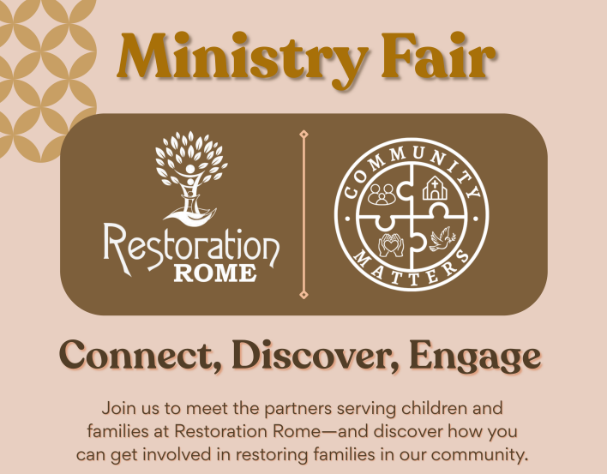

May 4th 5:30-7pm
Cafeteria @ Restoration Rome
1400 Crane Street
706.528.4033

Discover ways YOU can get involved!


Contact the church office if you want digital OR hardcopy of the…..

APRIL | Monday | Tuesday | Wednesday | Thursday | Friday | Saturday
5  9-1pm Nursery provided  9 & 11:15 Easter Services in Nave  Breakfast between services  Egg Hunt between services | 6  Office Closed  2pm Living Compass | 7  JSL D. Hall 5:30-8:30  3 Rivers 7-8:30pm Nave | 8  10:30 Stephen Ministry R. Wyatt room  5:30pm Celtic Service | 9  3:30pm Stephen Ministry R. Wyatt room  6-8:30 Bridges D. Hall, Kitchen  6:30pm 3 Rivers R. Wyatt | 10  6pm Mah Jong | 11
12  8:15-11:45 Nursery provided  9:50am Children’s Chapel  8:30am – Rite I Chapel  9-10 Breakfast  10am – Rite II Nave, WLAQ/You tube  11:15am Adult Forum  3-4pm Game Time, 3rd-5th grades  4-5:30 Backpack Buddies, Everyone! | 13  Noon RSVP Wed. Dinner  1pm Centering Prayer  2pm Living Compass  12pm Peer Group,  D. Hall & R. Wyatt | 14  4-8pm ESP D. Hall  7-8:30 Indivisible R. Wyatt  7:30pm 3 Rivers, Nave | 15  Noon – Living Proof R. Wyatt  5:30pm Dinner begins  5:30pm Celtic Service  6-6:30pm Roots  CATECHUMENATE, 6-7pm  6:30-7pm Jr. Choir  7pm Adult Choir | 16  10am Bible Study  6-8:30 Bridges D. Hall, Kitchen | 17  8-11am Compassion Resilience  Rhodes Wyatt | 18  5-8pm Devon Smyth,  R. Wyatt
19  8:15-11:45 Nursery provided  9:50am Children’s Chapel  8:30am – Rite I Chapel  9-10 Breakfast  10am – Rite II Nave, WLAQ/You tube  11:15am Adult Forum  3:30pm Family Bowling  EYC – Six Flags | 20  Noon – RSVP for Wednesday Dinner  1pm Centering Prayer  2pm Living Compass | 21  5:30pm Vestry Meeting  JSL D. Hall 5:30-8:30  3 Rivers 7-8:30pm Nave | 22  5:30pm Dinner begins  5:30pm Celtic Service  6-6:30pm Roots  CATECHUMENATE, 6-7pm  6:30-7pm Jr. Choir  7pm Adult Choir | 23  10am Bible Study  3:30pm Stephen Ministry Meeting, R. Wyatt  6-8:30 Bridges D. Hall, Kitchen | 24  9-Noon Community Kitchen | 25  9-Noon R. Wyatt Delta Kappa Gama
26  8:15-11:45 Nursery provided  9:50am Children’s Chapel  8:30am – Rite I Chapel  9-10 Breakfast  10am – Rite II Nave, WLAQ/You tube  11:15am Adult Forum  GAME NIGHT, Pilgrims House  EYC for Sr High students | 27  Noon – RSVP for Wednesday Dinner  1pm Centering Prayer  2pm Living Compass | 28  9-Noon Community Kitchen  3 Rivers 7-8:30pm Nave | 29  5:30pm Dinner begins  5:30pm Celtic Service  6-6:30pm Roots  CATECHUMENATE, 6-7pm  6:30-7pm Jr. Choir  7pm Adult Choir | 30  10am Bible Study  6-8:30 Bridges D. Hall, Kitchen | May 1 | 2
3 YOUTH SUNDAY  8:15-11:45 Nursery provided  9:50am Children’s Chapel  8:30am – Rite I Chapel  9-10 Breakfast  10am – Rite II Nave, WLAQ/You tube  11:15 Senior Reception, Daniel Hall  Grill Out – Children – Sr. High & Family | 4  Noon – RSVP for Wednesday Dinner  1pm Centering Prayer  2pm Living Compass | 5  3 Rivers 7-8:30pm Nave | 6  5:30pm Dinner begins  5:30pm Celtic Service  6-6:30pm Roots  6:30-7pm Jr. Choir  7pm Adult Choir | 7  10am Bible Study  3:30pm S. Ministry Meeting  6-8:30 Bridges D. Hall, Kitchen | 8  8-11am Compassion Resilience  Rhodes Wyatt | 9

