
WELCOME TO ALL OUR VISITORS!
If you are interested in knowing more about St. Peter’s, please see an usher or one of the greeters who stand with the clergy after the service.

4.12.2026 at St. Peter’s
8:15am-11:45am Nursery
8:30am Holy Eucharist Rite I in Chapel
9-10am Breakfast
9:50am Children’s Chapel – Katie Smyth & Victoria Andrade
10:00am Holy Eucharist Rite II in Nave, WLAQ radio & YouTube
11:15am Adult Forum – Memorial Garden & Funeral Pre-planning
3-4pm Game Time at St. Peter’s for 3rd-5th graders
4-5:30pm EVERYONE come pack Backpack Buddies

This week…
Monday April 13th Noon RSVP for Wednesday Dinner
1pm Centering Prayer
2pm Living Compass Study
Wednesday April 14th 5:30pm Celtic Service in the chapel
5:30pm Dinner served in Daniel Hall
6pm EYC Downtown Dinner
6-6:30pm Roots
6-7pm Catechumenate Class
6:30-7pm Jr. Choir
7pm Adult Choir
Thursday April 15th 10am Bible Study
6pm Bridges
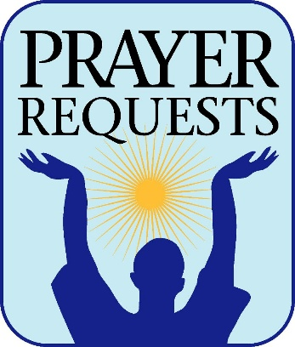
Sylvia Hine, Rees Jenkins, Ray Dempsey, Stephen Patton, Dasha & David Jenkins, Campbell Clark, Bonnie & Joe Herring, John Marshall, Henry Pancione, Katie Pancione, Michael Ann Booth, Andrew Babcock, Haywood Patton, John Schroeder, Sherron Badgett, Rebecca Francis, William Burk, Gina Schmitz, Carlton Family, Camry McCullough, Bonnie Foster, Martha, Jackie Hizel, Leah, Tony and those that care for them.

First of each moth the intercessory prayer will be “refreshed”; all names removed. If you wish to add someone, please call, or email the church office. Names will remain on the Prayer List for the entire month.
Military Prayer List:
Phillip Jenkins
Gordon Macy
Charles Lewis
Nolan Kelley
Davis Isley

Andrew Hall
Ted Olney
Michael Blair
Steven Blair
Charlie Hardaker
Justin Yeary

Thomas Keefe
Johnny Crittenden
Sara Carver Thomas
Joshua Ingram
Cherrie Shackelford

Please remember to notify the church office when a service member is no longer on active duty.


EVERYONE invited to help pack Backpack Buddies TODAY!

Sunday April 12th 4-5:30pm
90 Callahan Street, NE Rome 30161


April 12th at St. Peter’s
3-4pm
3rd through 5th graders


April 19th Marshall Jenkins, Prayer

April 26th Bob Berry, End of Life Planning

May 17th Berry Professor, Coleman Fannin,
Environmental Ethics


Jason Bloom 13th
Sarah hardaker 13th
Amanda Brendel 13th
Judy Caywood 13th
Millie Sirmans 15th
Brian keefe 15th
Jack Wellesley 15th
Donald Flippen 16th
Peggy Nash 16th
Bennett Smyth 16th
Charles Elliott 16th
Becky Jones 18th

EYC Meal Sign Up Link
https://www.signupgenius.com/go/10C084EACAB2FA5FCC43-50683016-eycsunday

Each Sunday, EYC shares a meal before they begin their study time.

Can you help by preparing, ordering or sponsoring a Sunday Meal?


Church Flower Calendar
OPEN DATES:

Nave – May 10th
Chapel – May 3rd, 11th, May 24th, 31st

Honor a loved one or friend by donating flowers for one of the church altars. Contact the church office, 706.291.9111 or elizabeth@stpetersrome.org to choose your date.


Living Compass Study Group
New Series

Monday, 4.13.2026
2pm at 401 E. 4th Avenue

Contact D’Ann Downey, 706.266.3444

April 26th Game Night at the Pilgrims House
  - 6-7:30pm
  - EYC Jr. High & 4th & 5th graders.

St. Peter’s VOLUNTEERs are needed from 9am till noon. HOWEVER, if you are not able to work the full 3 hours, any time you can share is greatly appreciated.

2026 Schedule
Friday Tuesday
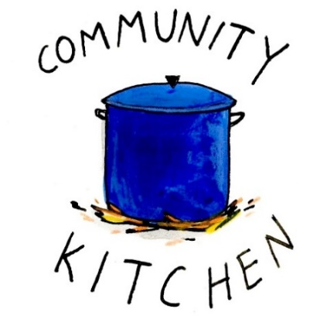
April 24 28
May 22 26
June -- 23
July 24 28
August 21 25
September 25 29
October 23 27
November 20 24
December -- 29

Contact Nancy Hunter to volunteer to help, 706.506.3889. THANK YOU

Church Office needs volunteers for the following days
9am till Noon:


Monday May 11th
Tuesday May 12th
Thursday May 14th

Call, 706.291.911 OR email elizabeth@stpetersrome.org
if you can help answer phones on any of these days,
THANK YOU


FAMILY FUN
April 19th 3:30pm

Floyd Bowling & Amusement
$40 a family

Pay in advance with Venmo, Cash, check at the office. RSVP by April 14th
Includes 1 hour of lane time and shoe rental.


SAVE THE DATE
VBS 2026
A Wrinkle in Time

July 13th – 16th
9am-12pm

Children 3 years through
5th grade


2026 – St. Peter’s Host Church. The expectation is that the group will meet for 24 weeks, ending the program around June 18th.

This is the first time our parish will be hosting the group in our building. It is a wonderful opportunity for this ministry to be engaged with the parish in a meaningful way!

There are several aspects of the program that need to be supported by volunteers for Bridges to be a success.

Need 4-6 drivers each week for residents of Davies Shelters (men’s and women’s houses) & Next Door who are participating. Investigators (the participants in the group) will need to be delivered to Daniel Hall by 6pm and picked up at 8:30pm. We would like to ask men to transport men and women to transport women.

Meal for 15 every Thursday evening. This can be as simple as soup, salad, and dessert. The meal needs to be ready to be served at 6pm. We will utilize the Bridges Sign-Up Genuis for this, see link below.

Childcare if any of the investigators have children. At least one person needs to be Safeguard trained. These children will be ages 1-12 years old.


Questions/Volunteer in any of these capacities contact:
Devon Smyth, 770.714.2361 OR David Peters, 770.262.6017

Sign up Bridges Out of Poverty Volunteers Spring 2025: 2026 Getting Ahead Volunteers


Contact the church office if you want digital OR hardcopy of the…..


Children’s Chapel
Sundays, 9:50am

We depart as a group from the nave and return during the Peace to share Eucharist with our families.
Children’s Chapel is available for children aged Pre-K through 2nd grade.

April Leader Schedule:
4.5 – Easter NO Children’s Chapel
4.12 – Katie Smyth & Victoria Andrade
4.19 – Margaret Louttit & Lee Morris
4.26 – Katherine Patterson & Jennifer Bressette


Junior Choir ~Wednesday Nights
6:30-7pm
Children’s Chapel Room
3rd Floor


ROOTS
Wednesday Nights~6-6:30pm

PreK-1st grade – Children’s Chapel room, 3rd floor.
2nd & 3rd grade – Roots room, 4th floor.
4th & 5th grade – Jr. EYC room 4th floor.


Wish List for Children’s Ministry
https://www.amazon.com/hz/wishlist/ls/LOS24YTKY6Y4?ref_=wl_share


Adults $10 - Kids $4 - Family Maximum $25
Vegetarian/Gluten Free $8: Sides with rotating meatless burger or egg.
Gluten Free $10 entrée sides, see notes below when ordering.

April 15
Adults: Baked Potato bar, Broccoli Alfredo, Shredded BBQ Chicken and all the trimmings, salad
Kids: Cheese Pizza, salad, fruit, cookie
Vegetarian & Gluten free: potato, salad and trimmings that fit your diet choices.

April 22
Adults: Salisbury Steak, mashed potatoes, peas/carrots, salad. If Gluten Free no flour burger patty served without gravy.
Kids: Chicken Strips, mashed potatoes, fruit, cookie
Vegetarian & Gluten Free: salad with hard boiled eggs

April 29
Adults/Kids: Taco Bar with seasoned taco beef and all the trimmings, chips/salsa
Gluten Free, please note when placing your order. Taco Seasoning is gluten free.

NAME:
Drop this in the collection plate, by the church office or snap a photo and email to elizabeth@stpetersrome.org.

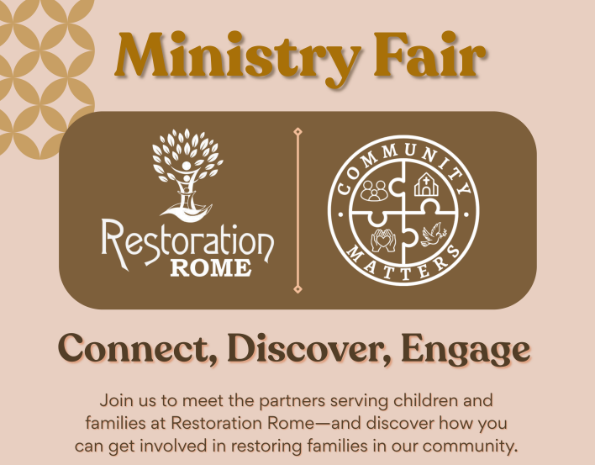
May 4th 5:30-7pm
Cafeteria @ Restoration Rome
1400 Crane Street
706.528.4033

Discover ways YOU can get involved!

APRIL | Monday | Tuesday | Wednesday | Thursday | Friday | Saturday
 |  |  | April 1  Holy Week Community Service Noon @ Lovejoy Baptist  5:30pm Celtic Service  6pm Rehearsal for those being baptized at Vigil.  7pm Adult Choir | 2  Maundy Thursday | 3  Good Friday | 4  Easter Vigil Service  & Reception
5 – EASTER  9-1pm Nursery provided  9 & 11:15 Easter Services in Nave  Breakfast between services  Egg Hunt between services | 6  Office Closed  2pm Living Compass | 7  JSL D. Hall 5:30-8:30  3 Rivers 7-8:30pm Nave | 8  10:30 Stephen Ministry R. Wyatt room  5:30pm Celtic Service | 9  3:30pm Stephen Ministry R. Wyatt room  6-8:30 Bridges D. Hall, Kitchen  6:30pm 3 Rivers R. Wyatt | 10  6pm Mah Jong | 11
12  8:15-11:45 Nursery provided  9:50am Children’s Chapel  8:30am – Rite I Chapel  9-10 Breakfast  10am – Rite II Nave, WLAQ/You tube  11:15am Adult Forum  3-4pm Game Time, 3rd-5th grades  4-5:30 Backpack Buddies, Everyone! | 13  Noon RSVP Wed. Dinner  1pm Centering Prayer  2pm Living Compass  12pm Peer Group,  D. Hall & R. Wyatt | 14  4-8pm ESP D. Hall  7-8:30 Indivisible R. Wyatt  7:30pm 3 Rivers, Nave | 15  Noon – Living Proof R. Wyatt  5:30pm Dinner begins  5:30pm Celtic Service  6-6:30pm Roots  CATECHUMENATE, 6-7pm  6:30-7pm Jr. Choir  7pm Adult Choir | 16  10am Bible Study  6-8:30 Bridges D. Hall, Kitchen | 17  8-11am Compassion Resilience  Rhodes Wyatt | 18  5-8pm Devon Smyth,  R. Wyatt
19  8:15-11:45 Nursery provided  9:50am Children’s Chapel  8:30am – Rite I Chapel  9-10 Breakfast  10am – Rite II Nave, WLAQ/You tube  11:15am Adult Forum  3:30pm Family Bowling | 20  Noon – RSVP for Wednesday Dinner  1pm Centering Prayer  2pm Living Compass | 21  5:30pm Vestry Meeting  JSL D. Hall 5:30-8:30  3 Rivers 7-8:30pm Nave | 22  5:30pm Dinner begins  5:30pm Celtic Service  6-6:30pm Roots  CATECHUMENATE, 6-7pm  6:30-7pm Jr. Choir  7pm Adult Choir | 23  10am Bible Study  3:30pm Stephen Ministry Meeting, R. Wyatt  6-8:30 Bridges D. Hall, Kitchen | 24  9-Noon Community Kitchen | 25
26  8:15-11:45 Nursery provided  9:50am Children’s Chapel  8:30am – Rite I Chapel  9-10 Breakfast  10am – Rite II Nave, WLAQ/You tube  11:15am Adult Forum  GAME NIGHT, Pilgrims House | 27  Noon – RSVP for Wednesday Dinner  1pm Centering Prayer  2pm Living Compass | 28  9-Noon Community Kitchen  3 Rivers 7-8:30pm Nave | 29  5:30pm Dinner begins  5:30pm Celtic Service  6-6:30pm Roots  CATECHUMENATE, 6-7pm  6:30-7pm Jr. Choir  7pm Adult Choir | 30  10am Bible Study  6-8:30 Bridges D. Hall, Kitchen | May 1  8-11am Compassion Resilience  Rhodes Wyatt

