
WELCOME TO ALL OUR VISITORS!
If you are interested in knowing more about St. Peter’s, please see an usher or one of the greeters who stand with the clergy after the service.

3.29.2026 at St. Peter’s
8:15am-11:45am Nursery
8:30am Holy Eucharist Rite I in Chapel
9-10am Breakfast
9:45am Palm Procession gather in Daniel Hall
10:00am Holy Eucharist Rite II in Nave, WLAQ radio & YouTube
11:15am Adult Forum – Episcopal Church Women
6pm EYC

This week…
Monday -Wednesday Noon Holy Week Services - Lovejoy Baptist
1pm Centering Prayer
2pm Living Compass Lenten Study
Wednesday April 1st 5:30pm Celtic Service in the chapel
7pm Adult Choir
Thursday April 2nd 10am Bible Study
7pm Maundy Thursday Service in Nave
Friday April 3rd Noon Good Friday Service in Nave
Saturday April 4th 9pm Easter Vigil & Reception


William Burk, Melissa Rayburn, Joan Silvers, Lynn Smith, Ann Harrison, Carlton Family, Gina Schmitz, Rebecca Francis, Sherron Badgett, John Schroeder, Haywood Patton, Andrew Babcock, Michael Ann Booth, Jimmy Smithson, Henry Pancione, Katie Pancione, Campbell Clark, Chuck Worthington, Dana Huskins, John Marshall, Ratliff Family, Drew Moss, James Mitchell, Camryn McCullough, Brittany Poland, Ame Frease, Bonnie & Joe Herring, John McCard, Dasha & David Jenkins, Stephen Patton, Ray Dempsey, Rees Jenkins, Sylvia Hine and those that care for them.

NEXT WEEK the intercessory prayer will be “refreshed”; all names removed. If you wish to add someone, please call, or email the church office. Names will remain on the Prayer List for the entire month.

Military Prayer List:
Phillip Jenkins
Gordon Macy
Charles Lewis
Nolan Kelley
Davis Isley

Andrew Hall
Ted Olney
Michael Blair
Steven Blair
Charlie Hardaker
Justin Yeary

Thomas Keefe
Johnny Crittenden
Sara Carver Thomas
Joshua Ingram
Cherrie Shackelford

Please remember to notify the church office when a service member is no longer on active duty.

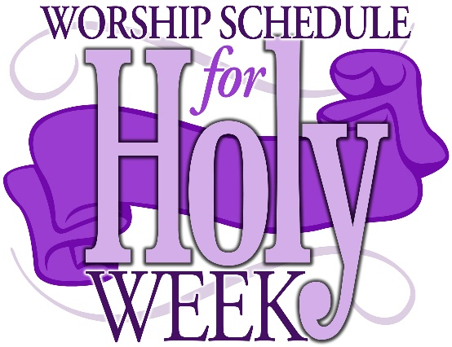
Community Services
Lovejoy Baptist Church Noon Monday – Wednesday

Maundy Thursday Service at 2pm in the Nave

Good Friday Service at Noon in the Nave

Easter Vigil 9pm l 4th in the Nave. Reception in Daniel Hall after the service.

Easter Schedule – April 5th
Services in the Nave at 9am and 11:15am

Breakfast served between the services in Daniel Hall,
with Hot Cross Buns & Mimosas!


April 5th
Between the services
Rite II Service

Birth thru 1st grade – Lawn beside Willingham House

2nd thru 5th grades – Upstairs Green Space.

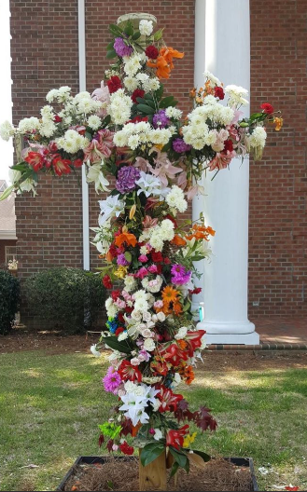
Help make a LIVING Cross on Easter!

Bring fresh cut flowers & greenery to adorn the cross.

Cross form will be located at the front steps of the church.

Bring your flowers on
EASTER MORNING, 4.5.2026



March 29th Diane Nance & Cassandra Crosby, Episcopal Church Women
April 19th End of Life Planning at St. Peter’s, Margaret Louttit
April 26th Bob Berry & Margaret Louttis, End of Life Planning
May 17th Berry Professor, Coleman Fannin, Environmental Ethics

Friday, April 10th, 6pm
At St. Peter’s in Daniel Hall

RSVP to Virginia Hunter, 770.530.0079

This is NOT a teaching class, we will be playing.

Bring beverage of your choice and an appetizer to share, MJ tiles, MJ mat and MJ card

June McAllister 30th

Lottie Mitchell 31st
Christine Brock April 2nd
Caroline Stoll 2nd
Collins Jackson 3rd
David Jackson 3rd
Towns Sawhill, Jr. 3rd
Murphy Grace Moseley 4th
Lee Niedrach 4th

EYC Meal Sign Up Link
https://www.signupgenius.com/go/10C084EACAB2FA5FCC43-50683016-eycsunday


Each Sunday, EYC shares a meal before they begin their study and fun time.

Can you help by preparing, ordering or sponsoring a Sunday Meal?

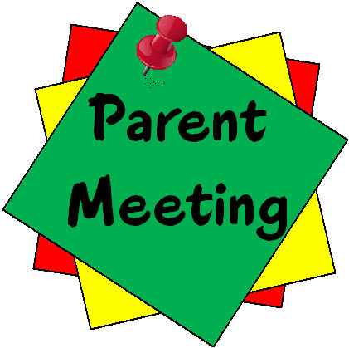
EYC Parents ~ March 29th
11:15am ~ EYC room on 4th Floor

Upcoming Summer and Fall calendar discussion.


Church Flower Calendar
OPEN DATES:

Nave – May 10th OR May 31st

Chapel – May 11th OR May 24th OR 31st

Honor a loved one or friend by donating flowers for one of the church altars. Contact the church office, 706.291.9111 or elizabeth@stpetersrome.org to choose your date.

To All Parishioners,

St. Peter’s Loaves and Fishes Teams organize memorial receptions in Daniel Hall and provide meals for families with newborns or parishioners facing health challenges, such as surgeries or prolonged illnesses.

If you need assistance, please contact the church office directly or ask a friend or fellow parishioner to call on your behalf. We are committed to serving the needs of our parish to the best of our abilities.

Kathy Steinbruegge
Chairperson of Loaves and Fishes

St. Peter’s VOLUNTEERs are needed from 9am till noon. HOWEVER, if you are not able to work the full 3 hours, any time you can share is greatly appreciated.

2026 Schedule
Friday Tuesday
January 23 27
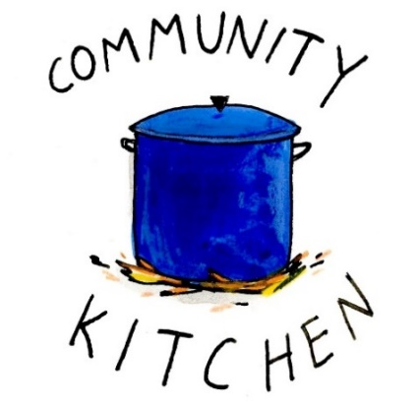
February 20 24
March 20 24
April 24 28
May 22 26
June -- 23
July 24 28
August 21 25
September 25 29
October 23 27
November 20 24
December -- 29

Contact Nancy Hunter to volunteer to help, 706.506.3889. THANK YOU


FAMILY FUN
April 17th 3:30pm

Floyd Bowling & Amusement
$40 a family

Pay in advance with Venmo, Cash, check at the office. RSVP by April 19th
Includes 1 hour of lane time and shoe rental.


SAVE THE DATE
VBS 2026
A Wrinkle in Time

July 13th – 16th
9am-12pm

Children 3 years through
5th grade


The next round of Bridges out of Poverty began on January 8, 2026, at St. Peter's Rome. This will be the first time St. Peter's has hosted. The expectation is that the group will meet for 24 weeks, ending the program around June 18th. It could go more quickly but will not go any longer than that date.

First Baptist Church Rome has hosted this program with financial & volunteer support from St. Peter's for several years. This is the first time our parish will be hosting the group in our building. It is a wonderful opportunity for this ministry to be engaged with the parish in a meaningful way!

There are several aspects of the program that need to be supported for Bridges to be a success.
We need volunteers in all these places/roles.

-First, there will need to be 4-6 drivers each week for residents of Davies Shelters (men’s and women’s houses) & Next Door who are participating. Investigators (the participants in the group) will need to be delivered to Daniel Hall by 6pm and picked up at 8:30pm. We would like to ask men to transport men and women to transport women. Some of the investigators will have their own transportation, so not everyone will need a ride.

-Secondly, there will need to be a meal for 15 every Thursday evening. This can be as simple as soup, salad, and dessert. The meal needs to be ready to be served at 6pm as the investigators arrive at Daniel Hall. We will utilize the Bridges Sign-Up Genuis for this, see link below.

-Third, there will possibly need to be childcare provided (if any of the investigators have children). At this time, we do not know if this will be a need. At least one person needs to be Safeguard trained. These children will be ages 1-12 years old.

Questions or to Volunteer in any of these capacities contact:
Devon Smyth, 770.714.2361 OR David Peters, 770.262.6017


Volunteer Sign up

Bridges Out of Poverty Volunteers Spring 2025: 2026 Getting Ahead Volunteers


Children’s Chapel
Sundays, 9:50am

We depart as a group from the nave and return during the Peace to share Eucharist with our families.
Children’s Chapel is available for children aged Pre-K through 2nd grade.

April Leader Schedule:
4.5 – Easter NO Children’s Chapel
4.12 – Katie Smyth & Victoria Andrade
4.19 – Margaret Louttit & Lee Morris
4.26 – Katherine Patterson & Jennifer Bressette


Junior Choir ~Wednesday Nights
6:30-7pm
Children’s Chapel Room
3rd Floor


ROOTS
Wednesday Nights~6-6:30pm

PreK-1st grade – Children’s Chapel room, 3rd floor.
2nd & 3rd grade – Roots room, 4th floor.
4th & 5th grade – Jr. EYC room 4th floor.


Wish List for Children’s Ministry
https://www.amazon.com/hz/wishlist/ls/LOS24YTKY6Y4?ref_=wl_share

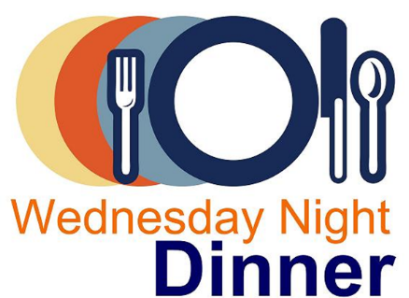
Adults $10 - Kids $4 - Family Maximum $25
Vegetarian/Gluten Free $8: Sides with rotating meatless burger or egg.
Gluten Free $10 entrée sides, see notes below when ordering.

April 1 – NO MEAL

April 8
Adults: Meatloaf, mashed potatoes, green beans, salad. Meatloaf has NOT flour products.
Kids: Chicken nuggets, green beans, fruit, cookie.
Vegetarian/Gluten free: salad with meatless burger patty

April 15
Adults: Baked Potato bar, Broccoli Alfredo, Shredded BBQ Chicken and all the trimmings, salad
Kids: Cheese Pizza, salad, fruit, cookie
Vegetarian & Gluten free: potato, salad and trimmings that fit your diet choices.

April 22
Adults: Salisbury Steak, mashed potatoes, peas/carrots, salad. If Gluten Free no flour burger patty served without gravy.
Kids: Chicken Strips, mashed potatoes, fruit, cookie
Vegetarian & Gluten Free: salad with hard boiled eggs

April 29
Adults/Kids: Taco Bar with seasoned taco beef and all the trimmings, chips/salsa
Gluten Free, please note when placing your order. Taco Seasoning is gluten free.

NAME:
Drop this in the collection plate, by the church office or snap a photo and email to elizabeth@stpetersrome.org.



April 12th
- GAME TIME AT ST. PETER’S
  - 3-4pm for 3rd thru 5th graders
- FAMILY MINISTRY TIME
  - EVERYONE INVITED
  - 4-5:30pm
  - NWGA Hunger Ministries packing Backpack Buddies.

April 26th
- Game Night
  - Pilgrims House
  - 6-7:30pm
  - EYC Jr. High & 4th & 5th graders.

March |  | Monday | Tuesday | Wednesday | Thursday | Friday | Saturday
15  8:15-11:45 Nursery provided  9:50am Children’s Chapel  8:30am – Rite I Chapel  9-10 Breakfast  10am – Rite II Nave, WLAQ/You tube | 16  Noon RSVP Wed. Dinner  1pm Centering Prayer  2pm Living Compass  Lenten Study |  | 17  9am Staff Meeting  5:30pm Stations of the Cross  JSL D. Hall 5:30-8:30  3 Rivers 7-8:30pm Nave | 18  5:30pm Dinner begins  5:30pm Celtic Service  6-6:30pm Roots  CATECHUMENATE, 6-7pm  6:30-7pm Jr. Choir  7pm Adult Choir | 18  10am Bible Study  Stephen Ministry 3:30-5pm R. Wyatt  5:30pm Evening Prayer  6-8:30 Bridges D. Hall, Kitchen | 20  8-11am Compassion Resilience  Rhodes Wyatt  ESP 3:30-8:30  D. Hall | 21  Indivisible  2-5pm D. Hall
22  8:15-11:45 Nursery provided  9:50am Children’s Chapel  8:30am – Rite I Chapel  9-10 Breakfast  10am – Rite II Nave, WLAQ/You tube  11:15am Adult Forum  5:30pm EYC Funday | 23  Noon RSVP Wed. Dinner  1pm Centering Prayer  2pm Living Compass  Lenten Study |  | 24  9am Staff Meeting  5:30pm Stations of the Cross  3 Rivers 7-8:30pm Nave | 25  5:30pm Dinner begins  5:30pm Celtic Service  6-6:30pm Roots  CATECHUMENATE, 6-7pm  6:30-7pm Jr. Choir  7pm Adult Choir | 26  10am Bible Study  9-2pm Habitat in  D. Hall/Kitchen  11am Palm Construction  5:30pm Evening Prayer  6-8:30 Bridges D. Hall, Kitchen | 27  Parents Night Out | 28  Rehearsal for Palm Sunday Passon Readers  11am in nave.
29 PALM SUNDAY  Jr. Choir to Sing & Parade of Palms  8:15-11:45 Nursery provided  9:50am Children’s Chapel  8:30am – Rite I Chapel  9-10 Breakfast  10am – Rite II Nave, WLAQ/You tube  11:15am Adult Forum  11:15am EYC PARENT meeting  5:30pm EYC | 30  Noon RSVP Wed. Dinner  1pm Centering Prayer  Holy Week Community Service Noon @ Lovejoy Baptist |  | 31  9am Staff Meeting  Holy Week Community Service Noon @ Lovejoy Baptist  3 Rivers 7-8:30pm Nave | April 1  Holy Week Community Service Noon @ Lovejoy Baptist  5:30pm Celtic Service  6pm Rehearsal for those being baptized at Vigil.  7pm Adult Choir | 2  Maundy Thursday | 3  Good Friday | 4  Easter Vigil Service  & Reception
5  EASTER  9-1pm Nursery provided  9 & 11:15 Easter Services in Nave  Egg Hunt between services | 6  Office Closed |  | 7  JSL D. Hall 5:30-8:30  3 Rivers 7-8:30pm Nave | 8  5:30pm Dinner begins  5:30pm Celtic Service  6-6:30pm Roots  6:30-7pm Jr. Choir  7pm Adult Choir | 9  10am Bible Study  3:30pm Stephen Ministry R. Wyatt room  6-8:30 Bridges D. Hall, Kitchen  6:30pm 3 Rivers R. Wyatt | 10  6pm Mah Jongg | 11
12  8:15-11:45 Nursery provided  9:50am Children’s Chapel  8:30am – Rite I Chapel  9-10 Breakfast  10am – Rite II Nave, WLAQ/You tube  11:15am Adult Forum | 13  Noon RSVP Wed. Dinner  1pm Centering Prayer  12pm Peer Group, D. Hall & R. Wyatt |  | 14  4-8pm ESP D. Hall  7:30pm Three Rivers, Nave | 15  Noon – Living Proof R. Wyatt  5:30pm Dinner begins  5:30pm Celtic Service  6-6:30pm Roots  CATECHUMENATE, 6-7pm  6:30-7pm Jr. Choir  7pm Adult Choir | 16  10am Bible Study  6-8:30 Bridges D. Hall, Kitchen | 17  Family Bowling  8-11am Compassion Resilience  Rhodes Wyatt | 18  5-8pm Devon Smyth, D. Hall

