
WELCOME TO ALL OUR VISITORS!
If you are interested in knowing more about St. Peter’s, please see an usher or one of the greeters who stand with the clergy after the service.

3.1.2026 at St. Peter’s
8:15am-11:45am Nursery
8:30am Holy Eucharist Rite I in Chapel
9-10am Breakfast
9:50am Children’s Chapel – Kathy Steinbruegge & Katie Smyth
10:00am Holy Eucharist Rite II in Nave, WLAQ radio & YouTube
6pm EYC
This week…
Monday March 2nd Noon RSVP for Wednesday Dinner
1pm Centering Prayer
2pm Living Compass Lenten Study
Tuesday, March 3rd 5:30pm Stations of the Cross in the Nave
Wednesday March 4th 5:30pm Celtic Service in the chapel
5:30pm Dinner service begins in Daniel Hall
6pm EYC Downtown Dinner
6-6:30pm Roots
6-7pm Catechumenate Class
6:30-7pm Jr. Choir
7pm Adult Choir
Thursday March 5th 10am Bible Study
3:30pm Stephen Ministry Meeting
5:30pm Lenten Evening Prayer in the Chapel
6pm Bridges Out of Poverty
Friday – Sunday VESTRY RETREAT, Camp Mikell


Henry Pancione, Katie Pancione, Campbell Clark, Chuck Worthington, Dana Huskins, John Marshall, Ratliff Family, Drew Moss, James Mitchell, Camryn McCullough, Brittany Poland, Ame Frease, Bonnie & Joe Herring, John McCard, Philip, Dasha & David Jenkins, Stephen Patton, Ray Dempsey, Rees Jenkins, Sylvia Hine and those that care for them.

At the Beginning of each month the intercessory prayer is be “refreshed”; all names removed. If you wish to add someone, please call, or email the church office. Names will remain on the Prayer List for the entire month.
Military Prayer List:

Gordon Macy
Charles Lewis
Nolan Kelley
Davis Isley
Cherrie Shackelford

Andrew Hall
Ted Olney
Michael Blair
Steven Blair
Charlie Hardaker
Justin Yeary

Thomas Keefe
Ryan Holman
Johnny Crittenden
Sara Carver Thomas
Joshua Ingram
Jerrod Keplinger

Please remember to notify the church office when a service member is no longer on active duty.

Would you like to place a lily on the altar for

Easter Sunday?

Please complete the form below OR contact office:

Deliver the completed form & gift to the office by: Monday March 23rd

- Mail - 101 East 4th Ave, Rome GA 30161
- Office – elizabeth@stpetersrome.org or 706.291.9111
- Offering plate - with your gift

Checks made payable to St. Peter’s and marked Easter lily. No specific amount is required.
Give whatever is comfortable.

__________________________________________________________________________
Name of Honoree

Circle One:
In Thanksgiving for In Memory In Honor of

_________________________________________________________________________
Name of Donor (for reference only, will not be printed


Living Compass Study 2pm February 16th ~ March 24th
Stations of the Cross 5:30pm February 24th ~ March 24th
Evening Prayer 5:30pm February 19th ~ March 26th
Palm Crosses 11am ~ March 26th in Rhodes Wyatt
Community Services Noon March 30th ~ April 1st, Lovejoy Baptist church
Maundy Thursday 7pm April 2nd in the Nave
Good Friday Noon April 3rd in the Nave
Holy Saturday 9pm April 4th in the Nave.
Reception in Daniel Hall after the service.

Upcoming Adult Forum Topics & Dates:

March 8th – Devon Smyth, Lenten Disciplines

March 22nd – Fred Tarrant, The Hymnal in Episcopal Church History




Nancy Knight 4th
Sherron Mull 4th
David Peters 4th
Mary Sib Banks 5th
Joe Morgan 5th
Greta Dexter 5th
Amber Ware 6th

St. Peter’s VOLUNTEERs are needed from 9am till noon. HOWEVER, if you are not able to work the full 3 hours, any time you can share is greatly appreciated.

2026 Schedule
Friday Tuesday
January 23 27
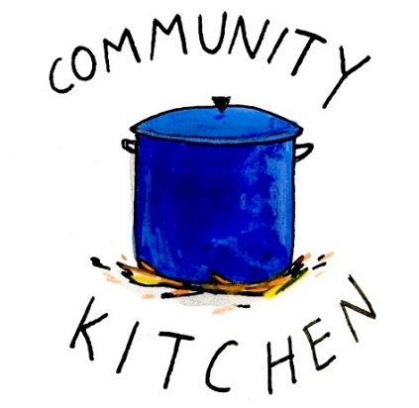
February 20 24
March 20 24
April 24 28
May 22 26
June -- 23
July 24 28
August 21 25
September 25 29
October 23 27
November 20 24
December -- 29

Contact Nancy Hunter to volunteer to help, 706.506.3889. THANK YOU

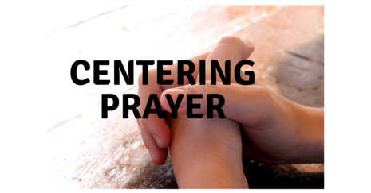
Tuesdays at 1pm
401 East 4th Avenue

Jane Cunningham
706.346.4092 OR missjane1@mac.com


Bible Study
Thursdays 10am

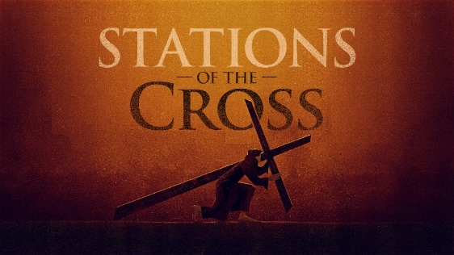
Tuesdays at 5:30pm in the Nave
February 24th ~ March 24th

Commemorate the Passion and death of Jesus Christ as you walk his path from condemnation by Pilate to his burial in the tomb.


Thursdays at 5:30pm in the chapel
February 19th – March 26th

A time of reflection, repentance and drawing closer to God leading the way to Easter!

Join our fun making Palm Crosses for Palm Sunday
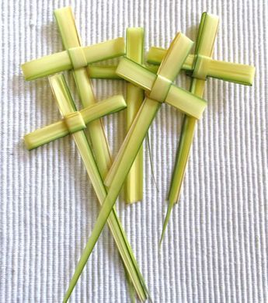

Rhodes Wyatt Room at 11am on Thursday 3.26.2026
No experience necessary.

Available Dates

Chapel Flowers, $100 April 12th, 19th

Call or email church office to reserve your date.


Altar Guild is requesting vases that are no taller than 8 inches that we can use to take flowers to homebound parishioners. Please, no bud vases.
Facilities where many of the sick parishioners stay can’t handle vases larger than that. There’s too little space in their rooms.

Drop your donations off in the Sacristy or church office.


April 5th
after the 11:15am
Rite II Service

Birth thru 1st grade – Lawn beside Willingham House

2nd thru 5th grades – Upstairs Green Space.

The next round of Bridges out of Poverty began on January 8, 2026, at St. Peter's Rome. This will be the first time St. Peter's has hosted. The expectation is that the group will meet for 24 weeks, ending the program around June 18th. It could go more quickly but will not go any longer than that date.

First Baptist Church Rome has hosted this program with financial & volunteer support from St. Peter's for several years. This is the first time our parish will be hosting the group in our building. It is a wonderful opportunity for this ministry to be engaged with the parish in a meaningful way!

There are several aspects of the program that need to be supported for Bridges to be a success.
We need volunteers in all these places/roles.

-First, there will need to be 4-6 drivers each week for residents of Davies Shelters (men’s and women’s houses) & Next Door who are participating. Investigators (the participants in the group) will need to be delivered to Daniel Hall by 6pm and picked up at 8:30pm. We would like to ask men to transport men and women to transport women. Some of the investigators will have their own transportation, so not everyone will need a ride.

-Secondly, there will need to be a meal for 15 every Thursday evening. This can be as simple as soup, salad, and dessert. The meal needs to be ready to be served at 6pm as the investigators arrive at Daniel Hall. We will utilize the Bridges Sign-Up Genuis for this, see link below.

-Third, there will possibly need to be childcare provided (if any of the investigators have children). At this time, we do not know if this will be a need. At least one person needs to be Safeguard trained. These children will be ages 1-12 years old.

Questions or to Volunteer in any of these capacities contact:
Devon Smyth, 770.714.2361 OR David Peters, 770.262.6017


Volunteer Sign up

Bridges Out of Poverty Volunteers Spring 2025: 2026 Getting Ahead Volunteers

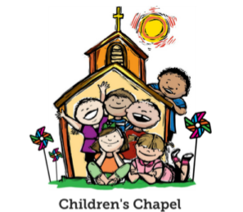
Children’s Chapel
Sundays, 9:50am

We depart as a group from the nave and return during the Peace to share Eucharist with our families.
Children’s Chapel is available for children aged Pre-K through 2nd grade.

March Leader Schedule:
3.1 – Margaret Louttit & Peggy Nash
3.8 – Hollye Smith & Katherine Patterson
3.15 – Nancy Hunter & MJ Chisholm
3.22 – Lee Morris & Jennifer Bressette
3.29 – Katie Smyth & Bonnie Mitchell


Junior Choir ~Wednesday Nights
6:30-7pm
Children’s Chapel Room
3rd Floor


ROOTS
Wednesday Nights~6-6:30pm

PreK-1st grade – Children’s Chapel room, 3rd floor.
2nd & 3rd grade – Roots room, 4th floor.
4th & 5th grade – Jr. EYC room 4th floor.


Wish List for Children’s Ministry
https://www.amazon.com/hz/wishlist/ls/LOS24YTKY6Y4?ref_=wl_share

Hello everyone!
We need volunteers to fill our Children’s Chapel slots.
- YOU choose the Sunday(s) that fit your schedule
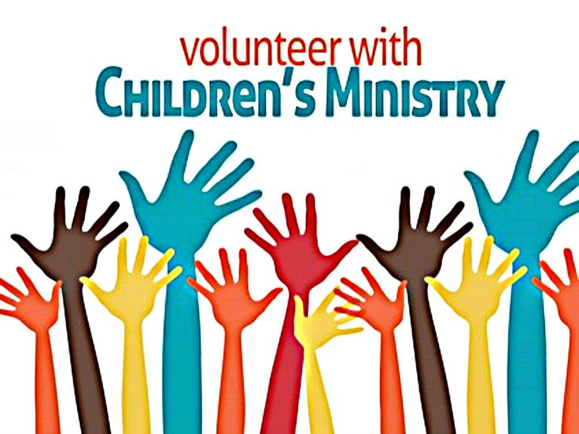
- Volunteers work in teams of 2
- Simple curriculum is provided
- Safeguarding certification is required for all parishioners that work with our children. You do NOT have to have certification to volunteer, just be certain to sign up as soon as possible to complete the training. Certification is completed via a zoom meeting.

If you have any questions about volunteering with the Children's Ministry do not hesitate to reach out to Katie Smyth, 770.714.1825.

Here is the link to volunteer for Children’s Chapel:
https://www.signupgenius.com/go/10C0E4AAAA829A3FFC70-57875256-202526


MARCH 27th
5:30-8:30pm
El Zarape

- Cost $10 per child OR Family Maximum of $20
- Drop your little ones off beginning at 5pm in Daniel Hall. They will be feed and entertained.
- Adults gather at El Zarape for fellowship and Community.
- RSVP to church office or Katy by Monday, 3.23.2026

Sponsored by Children’s Ministry, Katie Smyth 770.714.1825


Adults $10 select 1 ENTRÉE, and 2 Sides
Kids $4 - Family Maximum $25
Vegetarian/Gluten Free $8: Sides with rotating meatless burger or egg.
Gluten Free $10 entrée and 2 chosen sides. Gluten Free Entrée highlighted below

3.4.2026
Chicken & Stuffing Casserole OR Baked Parm Pork Loin
Green Beans, Roasted Carrots, Salad – CHOOSE 2
Adults served with Mississippi Mud Brownies
Kids – Chicken Tenders, carrots, oranges
Vegetarian – All sides with meatless burger patty
Gluten Free

3.11.2026
Meatloaf OR Hawaiian Chicken
Mashed Potatoes, Corn of Cob, Salad - CHOOSE 2,
Adults served with dessert
Kids – Cheese Pizza, Corn on Cob, Fruit
Vegetarian – All sides with hard boiled eggs
Gluten Free –with 2 sides

3.18.2026
Spaghetti with Meatballs OR Ham Steak
Garlicky Broccoli, Fried Cabbage, Salad
Adults served with dessert
Kids – Spaghetti/meatballs, salad, fruit
Vegetarian – All sides with meatless burger patty.
Gluten Free

3.25.2026
Beef Sausage with pepper/onion OR Parmesan Baked Chicken
Turnip Greens, Buttered Rice, Salad- CHOOSE 2
Adults served dessert
Kids – Mini Corn Dog, salad, pudding
Vegetarian – All sides with hard boiled eggs
Gluten Free –with 2 sides.

NAME:
Drop this in the collection plate, by the church office or snap a photo and email to elizabeth@stpetersrome.org.

March | Monday | Tuesday | Wednesday | Thursday | Friday | Saturday
1  8:15-11:45 Nursery provided  9:50am Children’s Chapel  8:30am – Rite I Chapel  9-10 Breakfast  10am – Rite II Nave, WLAQ/You tube  6pm EYC | 2  Noon RSVP Wed. Dinner  1pm Centering Prayer  2pm Living Compass  Lenten Study | 3  9am Staff Meeting  5:30pm Stations of the Cross  JSL 5:30-8:30 D. Hall  3 Rivers 7-8:30pm Nave | 4  5:30pm Dinner begins  5:30pm Celtic Service  6-6:30pm Roots  6pm EYC Downtown Dinner  CATECHUMENATE, 6-7pm  6:30-7pm Jr. Choir  7pm Adult Choir | 5  10am Bible Study  3:30 Stephen Ministry R. Wyatt  5:30pm Evening Prayer  6-8:30 Bridges D. Hall, Kitchen, nursery | 6  Vestry Retreat | 7  Vestry Retreat  Indivisible  11am-6pm D. Hall &  Choir Room.
8  8:15-11:45 Nursery provided  9:50am Children’s Chapel  8:30am – Rite I Chapel  9-10 Breakfast  10am – Rite II Nave, WLAQ/You tube  6pm EYC | 9  Noon RSVP Wed. Dinner  1pm Centering Prayer  2pm Living Compass  Lenten Study | 10  9am Staff Meeting  5:30pm Stations of the Cross  4:30 Alpha Delta D. Hall  3 Rivers 7-8:30pm Nave | 11  5:30pm Dinner begins  5:30pm Celtic Service  6-6:30pm Roots  CATECHUMENATE, 6-7pm  6:30-7pm Jr. Choir  7pm Adult Choir | 12  10am Bible Study  5:30pm Evening Prayer  6-8:30 Bridges D. Hall, Kitchen  6:30 3 Rivers Rhodew Wyatt | 13 | 14
15  8:15-11:45 Nursery provided  9:50am Children’s Chapel  8:30am – Rite I Chapel  9-10 Breakfast  10am – Rite II Nave, WLAQ/You tube | 16  Noon RSVP Wed. Dinner  1pm Centering Prayer  2pm Living Compass  Lenten Study | 17  9am Staff Meeting  5:30pm Stations of the Cross  JSL D. Hall 5:30-8:30  3 Rivers 7-8:30pm Nave | 18  5:30pm Dinner begins  5:30pm Celtic Service  6-6:30pm Roots  CATECHUMENATE, 6-7pm  6:30-7pm Jr. Choir  7pm Adult Choir | 18  10am Bible Study  Stephen Ministry 3:30-5pm R. Wyatt  5:30pm Evening Prayer  6-8:30 Bridges D. Hall, Kitchen | 20  8-11am Compassion Resilience  Rhodes Wyatt  ESP 3:30-8:30  D. Hall | 21  Indivisible  2-5pm D. Hall
22  8:15-11:45 Nursery provided  9:50am Children’s Chapel  8:30am – Rite I Chapel  9-10 Breakfast  10am – Rite II Nave, WLAQ/You tube  6pm EYC | 23  Noon RSVP Wed. Dinner  1pm Centering Prayer  2pm Living Compass  Lenten Study | 24  9am Staff Meeting  5:30pm Stations of the Cross  3 Rivers 7-8:30pm Nave | 25  5:30pm Dinner begins  5:30pm Celtic Service  6-6:30pm Roots  CATECHUMENATE, 6-7pm  6:30-7pm Jr. Choir  7pm Adult Choir | 26  10am Bible Study  9-2pm Habitat in  D. Hall/Kitchen  11am Rhodes Wyatt Palm Construction  5:30pm Evening Prayer  6-8:30 Bridges D. Hall, Kitchen | 27  Parents Night Out | 28
29  PALM SUNDAY  Jr. Choir to Sing  8:15-11:45 Nursery provided  9:50am Children’s Chapel  8:30am – Rite I Chapel  9-10 Breakfast  10am – Rite II Nave, WLAQ/You tube  6pm EYC | 30  Noon RSVP Wed. Dinner  1pm Centering Prayer  Holy Week Community Service Noon Lovejoy Baptist | 31  9am Staff Meeting  Holy Week Community Service Noon Lovejoy Baptist  3 Rivers 7-8:30pm Nave | April 1  5:30pm Dinner begins  5:30pm Celtic Service  6-6:30pm Roots  CATECHUMENATE, 6-7pm  6:30-7pm Jr. Choir  7pm Adult Choir  Holy Week Community Service Noon Lovejoy Baptist | 2  Maundy Thursday | 3  Rodeph Shalom Daniel Hall 3pm | 4  Easter Vigil Service

