
WELCOME TO ALL OUR VISITORS!
If you are interested in knowing more about St. Peter’s, please see an usher or one of the greeters who stand with the clergy after the service.

2.15.2026 at St. Peter’s
8:15am-11:45am Nursery
8:30am Holy Eucharist Rite I in Chapel
9-10am Breakfast
9:50am Children’s Chapel – MJ Chisholm & Nancy Hunter
10:00am Holy Eucharist Rite II in Nave, WLAQ radio & YouTube

This week…
Monday February 16th 1pm Centering Prayer
2pm Living Compass Lenten Study
Tuesday, February 17th 5pm Vestry Meeting, Rhodes Wyatt
5:30pm Shrove Tuesday Pancake Supper
Wednesday February 18th Ash Wednesday Service Schedule
8am in the Chapel
Noon in the Nave
7pm in the Nave, nursery provided
Thursday February 19th 10am Bible Study
5:30pm Lenten Evening Prayer in the Chapel
6pm Bridges Out of Poverty
Friday/February 20th 9am Community Kitchen

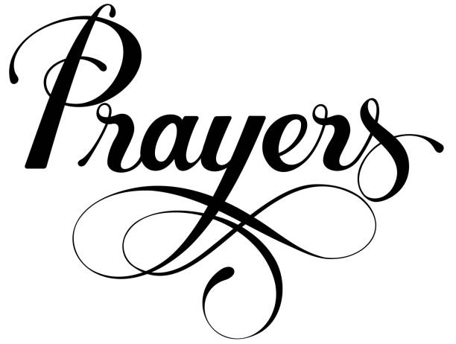
Sylvia Hine, Rees Jenkins, Ray Dempsey. Philip, Dasha & David Jenkins, Michael Ann Booth, Stephen Patton, Campbell Clark, John McCard, Emily Lankford, Jack & Sue Hart, Cathy Varidel, Haywood Patton, Bonnie Herring, Mary Jo Woolcock, Ame Frease, Dagmar Schmitz Carlton, Gina Schmitz, Carlton Family, Jimmy Smithson, John Schroeder, Andrew Babcock, Sherron Badgett, Rebecca Francis, Katie Pancione, Henry Pancione, Peyton and Leo Salit, Woody Smyth, Renee McMillian, Amber Ware and those that care for them.

Beginning of each month the intercessory prayer is “refreshed”; all names removed. If you wish to add someone, please call, or email the church office. Names will remain on the Prayer List for the entire month.
Military Prayer List:

Gordon Macy
Charles Lewis
Nolan Kelley
Davis Isley
Cherrie Shackelford

Andrew Hall
Ted Olney
Michael Blair
Steven Blair
Charlie Hardaker
Justin Yeary

Thomas Keefe
Ryan Holman
Johnny Crittenden
Sara Carver Thomas
Joshua Ingram
Jerrod Keplinger

Please remember to notify the church office when a service member is no longer on active duty.


Pancake supper sponsored by

Canterbury Student Ministries

Tuesday February 17th ~ 5:30pm in Daniel Hall
Adults $5, Kids eat free. Beer & Wine available.
Gluten Free options will be available.

Remit payment at the door: Cash, Check, Credit/Debit cards.

RESERVATIONS appreciated
Call/email the church office OR RSVP on REALM.

Upcoming Adult Forum Topics & Dates:

February 22nd – Ministry Fair
March 8th – Devon Smyth, Lenten Disciplines
March 22nd – Fred Tarrant, The Hymnal in Episcopal Church History

St. Peter’s Ministry Fair
February 22nd, 11:15am
Daniel Hall



Explore the various COMMUNITY MINISTRIES supported by St. Peter’s and how to HELP!

Find out more about MINISTRIES WITHIN THE CHURCH and how you can get involved!
St. Peter’s VOLUNTEERs are needed from 9am till noon. HOWEVER, if you are not able to work the full 3 hours, any time you can share is greatly appreciated.

2026 Schedule
Friday Tuesday
January 23 27
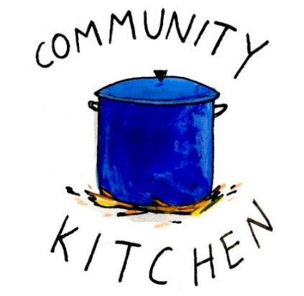
February 20 24
March 20 24
April 24 28
May 22 26
June -- 23
July 24 28
August 21 25
September 25 29
October 23 27
November 20 24
December -- 29

Contact Nancy Hunter to volunteer to help, 706.506.3889. THANK YOU

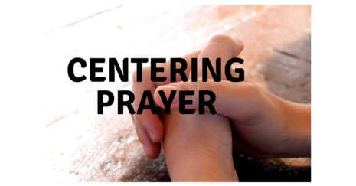
Tuesdays at 1pm
401 East 4th Avenue

Jane Cunningham
706.346.4092 OR missjane1@mac.com


Bible Study
Thursdays 10am

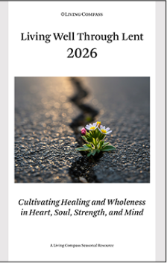
Living Compass
LENTEN study group
2pm at 401 E. 4th Ave
February 16th – March 20th


Service Schedule
8am Chapel at St. Peter’s
Noon – Nave at St. Peter’s
3pm – The Spires
7pm – Nave at St. Peters
February 18, 2026

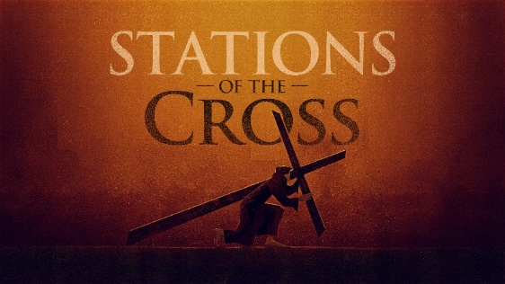
Tuesdays at 5:30pm in the Nave
February 24th ~ March 24th
Commemorate the Passion and death of Jesus Christ as you walk his path from condemnation by Pilate to his burial in the tomb.


Thursdays at 5:30pm in the chapel
February 19th – March 26th
A time of reflection, repentance and drawing closer to God leading the way to Easter!


Available Dates

Candles in Nave for March $65
Chapel Flowers, $100 April 12th, 19th

Call or email church office to reserve your date.


Charlie Pickett 15th
Jim Hobgood 15th
Tom Dasher 16th
David Williams 16th
Jennifer Bressette 16th
Lydia Clark 16th
Bill Hudgins 18th
Jack Knight 19th
Lynda Newsome 20th
Avis King 20th


Tuesday
February 17th
5pm
in Rhodes Wyatt Room

Vestry Retreat – March 6th through 8th at Camp Mikell

The next round of Bridges out of Poverty began on January 8, 2026, at St. Peter's Rome. This will be the first time St. Peter's has hosted. The expectation is that the group will meet for 24 weeks, ending the program around June 18th. It could go more quickly but will not go any longer than that date.

First Baptist Church Rome has hosted this program with financial & volunteer support from St. Peter's for several years. This is the first time our parish will be hosting the group in our building. It is a wonderful opportunity for this ministry to be engaged with the parish in a meaningful way!

There are several aspects of the program that need to be supported for Bridges to be a success.
We need volunteers in all these places/roles.

-First, there will need to be 4-6 drivers each week for residents of Davies Shelters (men’s and women’s houses) & Next Door who are participating. Investigators (the participants in the group) will need to be delivered to Daniel Hall by 6pm and picked up at 8:30pm. We would like to ask men to transport men and women to transport women. Some of the investigators will have their own transportation, so not everyone will need a ride.

-Secondly, there will need to be a meal for 15 every Thursday evening. This can be as simple as soup, salad, and dessert. The meal needs to be ready to be served at 6pm as the investigators arrive at Daniel Hall. We will utilize the Bridges Sign-Up Genuis for this, see link below.

-Third, there will possibly need to be childcare provided (if any of the investigators have children). At this time, we do not know if this will be a need. At least one person needs to be Safeguard trained. These children will be ages 1-12 years old.

Questions or to Volunteer in any of these capacities contact:
Devon Smyth, 770.714.2361 OR David Peters, 770.262.6017


Volunteer Sign up

Bridges Out of Poverty Volunteers Spring 2025: 2026 Getting Ahead Volunteers

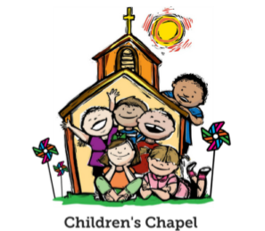
Children’s Chapel
Sundays, 9:50am

We depart as a group from the nave and return during the Peace to share Eucharist with our families.
Children’s Chapel is available for children aged Pre-K through 2nd grade.

February Leader Schedule:
2.1 – Margaret Louttit & Peggy Nash
2.8 – Lee Morris & Kellie Wolfe
2.15 – Nancy Hunter & MJ Chisholm
2.22 – Kathy Steinbruegge & Katie Smyth


Wish List for Children’s Ministry
https://www.amazon.com/hz/wishlist/ls/LOS24YTKY6Y4?ref_=wl_share

Hello everyone!
We need volunteers to fill our Children’s Chapel slots.
- Slots begin in January 2026
- YOU choose the Sunday(s) that fit your schedule
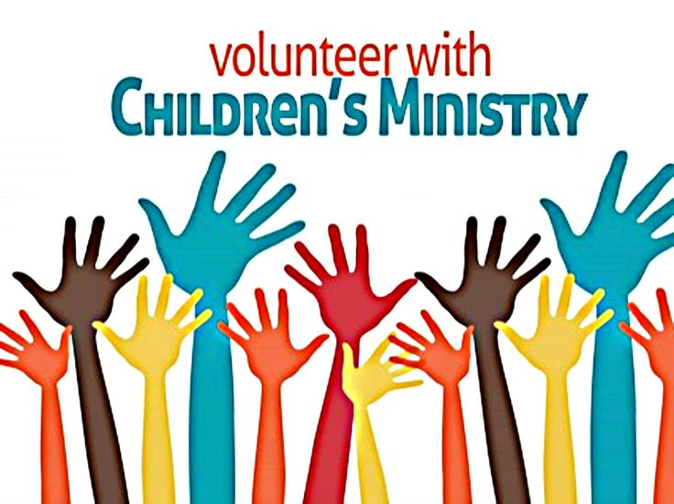
- Volunteers work in teams of 2
- Simple curriculum is provided
- Safeguarding certification is required for all parishioners that work with our children. You do NOT have to have certification to volunteer, just be certain to sign up as soon as possible to complete the training. Certification is completed via a zoom meeting.

If you have any questions about volunteering with the Children's Ministry do not hesitate to reach out to Katie Smyth, 770.714.1825.

Here is the link to volunteer for Children’s Chapel:
https://www.signupgenius.com/go/10C0E4AAAA829A3FFC70-57875256-202526

February | Monday | Tuesday | Wednesday | Thursday | Friday | Saturday
8  8:15-11:45 Nursery provided  9:50am Children’s Chapel  8:30am – Rite I Chapel  9-10 Breakfast  10am – Rite II Nave, WLAQ/You tube  11:15am Adult Forum-David Jahner,  St. Peter’s Basilica in Rome Italy  FAMILY GRILL OUT | 9  Noon RSVP Wed. Dinner  1pm Centering Prayer  2pm Living Compass | 10  9am Staff Meeting  3 Rivers 7-8:30pm Nave | 11  5:30pm Dinner begins  5:30pm Celtic Service  6-6:30pm Roots  CATECHUMENATE, 6-7pm  6:30-7pm Jr. Choir  7pm Adult Choir | 12  10am Bible Study  6-8:30 Bridges D. Hall, Kitchen, nursery | 13 | 14    Jerry Dunwoody funeral & reception, 11am
15  8:15-11:45 Nursery provided  9:50am Children’s Chapel  8:30am – Rite I Chapel  9-10 Breakfast  10am – Rite II Nave, WLAQ/You tube | 16  1pm Centering Prayer  2pm Living Compass Lenten Study | 17  9am Staff Meeting  5pm VESTRY  SHROVE Pancake Supper 5:30pm  3 Rivers 7-8:30pm Nave | 18  ASH WEDNESDAY  8am Chapel  Noon – Nave  7pm Nave | 19  10am Bible Study  Stephen Ministry 3:30-5pm R. Wyatt  5pm Evening Prayer  6-8:30 Bridges D. Hall, Kitchen, nursery | 20  8-11am Rome Council on Children  Rhodes Wyatt | 21
22  8:15-11:45 Nursery provided  9:50am Children’s Chapel  8:30am – Rite I Chapel  9-10 Breakfast  10am – Rite II Nave, WLAQ/You tube  11:15am Adult Forum-MINISTRY FAIR  EYC 6-7:30pm | 23  Noon RSVP Wed. Dinner  1pm Centering Prayer  2pm Living Compass  Lenten Study | 24  9am Staff Meeting  5:30pm Stations of the Cross  3 Rivers 7-8:30pm  D. Hall | 25  5:30pm Dinner begins  5:30pm Celtic Service  6-6:30pm Roots  CATECHUMENATE, 6-7pm  6:30-7pm Jr. Choir  7pm Adult Choir | 26  10am Bible Study  5pm Evening Prayer  6-8:30 Bridges D. Hall, Kitchen, nursery | 27  ESP 3:30-8:30pm D. Hall | 28  10-12 R. Wyatt  Delta Kappa Gamma
March 1  8:15-11:45 Nursery provided  9:50am Children’s Chapel  8:30am – Rite I Chapel  9-10 Breakfast  10am – Rite II Nave, WLAQ/You tube  6pm EYC | 2  Noon RSVP Wed. Dinner  1pm Centering Prayer  2pm Living Compass  Lenten Study | 3  9am Staff Meeting  5:30pm Stations of the Cross  JSL 5:30-8:30 D. Hall  3 Rivers 7-8:30pm Nave | 4  5:30pm Dinner begins  5:30pm Celtic Service  6-6:30pm Roots  CATECHUMENATE, 6-7pm  6:30-7pm Jr. Choir  7pm Adult Choir | 5  10am Bible Study  3:30 Stephen Ministry R. Wyatt  5pm Evening Prayer  6-8:30 Bridges D. Hall, Kitchen, nursery | 6  Vestry Retreat | 7  Vestry Retreat  Indivisible  11am-6pm D. Hall &  Choir Room.
8  8:15-11:45 Nursery provided  9:50am Children’s Chapel  8:30am – Rite I Chapel  9-10 Breakfast  10am – Rite II Nave, WLAQ/You tube  6pm EYC | 9  Noon RSVP Wed. Dinner  1pm Centering Prayer  2pm Living Compass  Lenten Study | 10  9am Staff Meeting  5:30pm Stations of the Cross  4:30 Alpha Delta D. Hall  Indivisible 7-8:30 D. Hall  3 Rivers 7-8:30pm Nave | 11  5:30pm Dinner begins  5:30pm Celtic Service  6pm EYC Downtown Dinner  6-6:30pm Roots  CATECHUMENATE, 6-7pm  6:30-7pm Jr. Choir  7pm Adult Choir | 12  10am Bible Study  5pm Evening Prayer  6-8:30 Bridges D. Hall, Kitchen  6:30 3 Rivers Rhodew Wyatt | 13 | 14

