
WELCOME TO ALL OUR VISITORS!
If you are interested in knowing more about St. Peter’s, please see an usher or one of the greeters who stand with the clergy after the service.

2.1.2026 at St. Peter’s
8:15am-11:45am Nursery
8:30am Holy Eucharist Rite I in Chapel
9-10am Breakfast
9:50am Children’s Chapel
10:00am Holy Eucharist Rite II in Nave, WLAQ radio & YouTube
11:15am ADULT FORUM – Daniel Hall
6-7:30pm EYC

This week…
Monday February 2nd 12 noon – Reservations for Wednesday dinner
1pm Centering Prayer
2pm Living Compass
Wednesday February 4th 5:30pm Celtic Service in the chapel
5:30pm Dinner served in Daniel Hall
6-6:30pm Roots
6pm EYC Downtown Dinner
6-7pm Catechumenate Class
6:30-7pm Jr. Choir
7pm Adult Choir
Thursday February 5th 10am Bible Study
3:30pm Stephen Ministry Meeting
Saturday February 7th 11am Funeral for Peg Arey in Nave, reception after service


Sylvia Hine, Rees Jenkins, Ray Dempsey. Philip, Dasha & David Jenkins, Michael Ann Booth, Stephen Patton, Campbell Clark, John McCard, Emily Lankford, Jack & Sue Hart, Cathy Varidel, Haywood Patton, Bonnie Herring, Mary Jo Woolcock, Ame Frease and those that care for them.

Beginning of each month the intercessory prayer is “refreshed”; all names removed. If you wish to add someone, please call, or email the church office. Names will remain on the Prayer List for the entire month.

Military Prayer List:

Gordon Macy
Charles Lewis
Nolan Kelley
Davis Isley
Cherrie Shackelford

Andrew Hall
Ted Olney
Michael Blair
Steven Blair
Charlie Hardaker
Justin Yeary

Thomas Keefe
Ryan Holman
Johnny Crittenden
Sara Carver Thomas
Joshua Ingram
Jerrod Keplinger

Please remember to notify the church office when a service member is no longer on active duty.



NEW Directory will be printed “in house” sometime in February.
UPDATE your photo or contact information TODAY.

Email photo to church office OR log onto Realm and upload your photo.


Upcoming Adult Forum Topics & Dates:

February 8th – David Jahner, St. Peter’s Basilica in Rome Italy
February 22nd – Ministry Fair

St. Peter’s Ministry Fair
February 22nd, 11:15am
Daniel Hall



Explore the various COMMUNITY MINISTRIES supported by St. Peter’s and how to HELP!

Find out more about MINISTRIES WITHIN THE CHURCH and how you can get involved!
St. Peter’s VOLUNTEERs are needed from 9am till noon. HOWEVER, if you are not able to work the full 3 hours, any time you can share is greatly appreciated.

2026 Schedule
Friday Tuesday
January 23 27
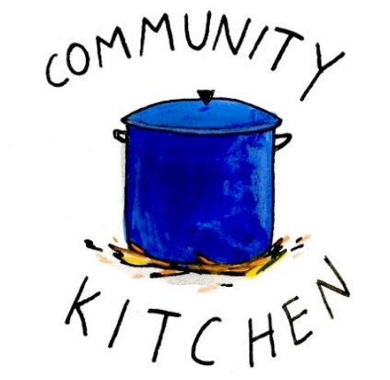
February 20 24
March 20 24
April 24 28
May 22 26
June -- 23
July 24 28
August 21 25
September 25 29
October 23 27
November 20 24
December -- 29

Contact Nancy Hunter to volunteer to help, 706.506.3889. THANK YOU


Living Compass New Book group begins
January 5th
2pm at 401 E. 4th Ave
Etty Hillesum:
An Interrupted Life, the Diaries
1943-1943 & Letters from Westerbork.
"An Interrupted Life" is a poignant collection of diaries and letters by Etty
Hillesum, chronicling her experiences as a Jewish woman during the
Holocaust, reflecting her profound introspection and resilience in the face of adversity.


Available Dates

Candles in Nave for February or March $65
Chapel Flowers, $100 April 12th, 19th
Nave Flowers, $150 April 12th

Call or email church office to reserve your date.


Bible Study
Thursdays 10am


Ronnie Johnson 1st
Toni King 2nd
Janet Morris 2nd
Beth Hughes 2nd
Lauren Ledbetter 3rd
Sam Berry 6th
Billie abney 7th
Wilson Morris 7th

Service Schedule
8am Chapel at St. Peter’s
Noon – Nave at St. Peter’s
3pm – The Spires
7pm – Nave at St. Peters
February 18, 2026

The next round of Bridges out of Poverty began on January 8, 2026, at St. Peter's Rome. This will be the first time St. Peter's has hosted. The expectation is that the group will meet for 24 weeks, ending the program around June 18th. It could go more quickly but will not go any longer than that date.

First Baptist Church Rome has hosted this program with financial & volunteer support from St. Peter's for several years. This is the first time our parish will be hosting the group in our building. It is a wonderful opportunity for this ministry to be engaged with the parish in a meaningful way!

There are several aspects of the program that need to be supported for Bridges to be a success.
We need volunteers in all these places/roles.

-First, there will need to be 4-6 drivers each week for residents of Davies Shelters (men’s and women’s houses) & Next Door who are participating. Investigators (the participants in the group) will need to be delivered to Daniel Hall by 6pm and picked up at 8:30pm. We would like to ask men to transport men and women to transport women. Some of the investigators will have their own transportation, so not everyone will need a ride.

-Secondly, there will need to be a meal for 15 every Thursday evening. This can be as simple as soup, salad, and dessert. The meal needs to be ready to be served at 6pm as the investigators arrive at Daniel Hall. We will utilize the Bridges Sign-Up Genuis for this, see link below.

-Third, there will possibly need to be childcare provided (if any of the investigators have children). At this time, we do not know if this will be a need. At least one person needs to be Safeguard trained. These children will be ages 1-12 years old.

Questions or to Volunteer in any of these capacities contact:
Devon Smyth, 770.714.2361 OR David Peters, 770.262.6017


Volunteer Sign up

Bridges Out of Poverty Volunteers Spring 2025: 2026 Getting Ahead Volunteers


Adults $10 select 1 ENTRÉE, and 2 Sides
Kids $4 - Family Maximum $25
Vegetarian/Gluten Free $8: Sides with rotating meatless burger or egg.
Gluten Free $10 entrée and 2 chosen sides.

2.4.2026
Chicken/Broccoli/Cheese Casserole OR Meatloaf. Carrots, Salad, English Pea-, CHOOSE 2
Adult meals served with Chocolate Cake & Icing
Kids $4 – White Castles, peach cup, carrots
Vegetarian $8 – All sides with meatless burger patty
Gluten Free $10 – Chicken Casserole with 2 sides

2.11.2026
Cesar Chicken OR Brown Sugar & Soy Glazed Pork Loin
Garlic Broccoli, Cesar Salad, Buttered Corn- CHOOSE 2,
Adults served with Pineapple Upside Down Cake
Kids $4– Pepperoni Pizza Hot Pockets, Corn, Pudding
Vegetarian $8 – All sides with hard boiled eggs
Gluten Free $10 – Glazed Pork with 2 sides.

2.18.2026 – ASH WEDNESDAY, NO dinner

2.25.2026
French Onion Chicken OR Beef & Cheese Tortellini Bake
Whole Green Beans, Buttered Noodles, Green Salad- CHOOSE 2
Adults served Blueberry Pound Cake
Kids $4 – Cheese Pizza, salad, pudding cup
Vegetarian – All sides with hard boiled eggs
Gluten Free $10– French Onion Chicken with 2 sides

NAME:
Drop this in the collection plate, by the church office or snap a photo and email to elizabeth@stpetersrome.org.
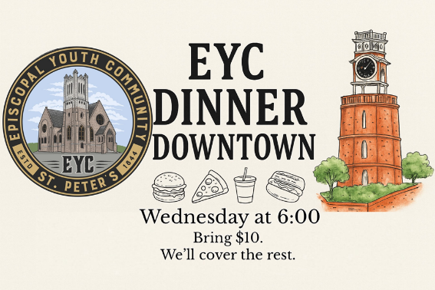
Wednesday 2.4.2026
Meet at St. Peter’s

Children’s Chapel
Sundays, 9:50am
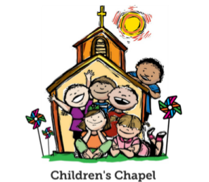
We depart as a group from the nave and return during the Peace to share Eucharist with our families.
Children’s Chapel is available for children aged Pre-K through 2nd grade.

February Leader Schedule:
2.1 – Margaret Louttit & Peggy Nash
2.8 – Lee Morris & Kellie Wolfe
2.15 – Nancy Hunter & MJ Chisholm
2.22 – Kathy Steinbruegge & Katie Smyth


Junior Choir ~Wednesday Nights
6:30-7pm
Children’s Chapel Room
3rd Floor


ROOTS
Wednesday Nights~6-6:30pm

PreK-1st grade – Children’s Chapel room, 3rd floor.
2nd & 3rd grade – Roots room, 4th floor.
4th & 5th grade – Jr. EYC room 4th floor.


Wish List for Children’s Ministry
https://www.amazon.com/hz/wishlist/ls/LOS24YTKY6Y4?ref_=wl_share

Hello everyone!
We need volunteers to fill our Children’s Chapel slots.
- Slots begin in January 2026
- YOU choose the Sunday(s) that fit your schedule
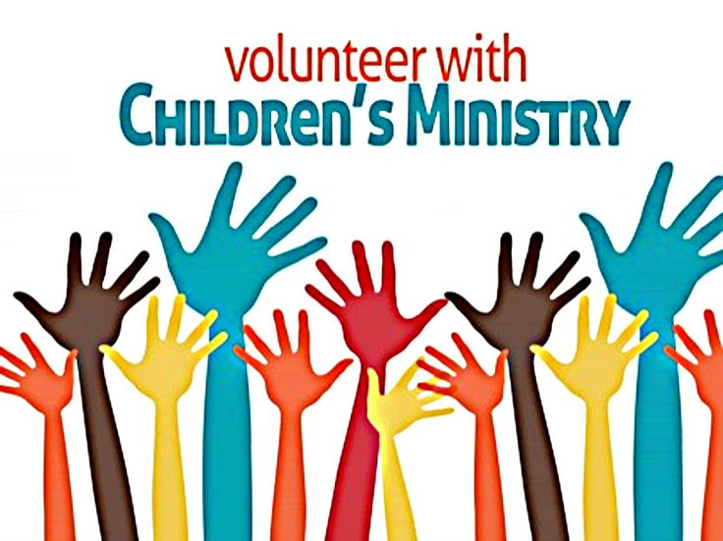
- Volunteers work in teams of 2
- Simple curriculum is provided
- Safeguarding certification is required for all parishioners that work with our children. You do NOT have to have certification to volunteer, just be certain to sign up as soon as possible to complete the training. Certification is completed via a zoom meeting.

If you have any questions about volunteering with the Children's Ministry do not hesitate to reach out to Katie Smyth, 770.714.1825.

Here is the link to volunteer for Children’s Chapel:
https://www.signupgenius.com/go/10C0E4AAAA829A3FFC70-57875256-202526


Pancake supper sponsored by

Canterbury Student Ministries

Tuesday February 17th
5:30pm in Daniel Hall
Adults $5, Kids eat free. Beer & Wine available.
Gluten Free options will be available.

Remit payment at the door: Cash, Check, Credit/Debit cards.

RESERVATIONS appreciated, Call/email the church office OR RSVP on REALM.

February | Monday | Tuesday | Wednesday | Thursday | Friday | Saturday
1  8:15-11:45 Nursery provided  9:50am Children’s Chapel  8:30am – Rite I Chapel  9-10 Breakfast  10am – Rite II Nave, WLAQ/You tube  11:15am Adult Forum – Ann Pullen, Episcopal Church & Missions  EYC 6-7:30pm | 2  Noon RSVP Wed. Dinner  1pm Centering Prayer  2pm Living Compass | 3  9am Staff Meeting  3 Rivers 7-8:30pm Nave  JSL 5:30-8:30 D. Hall | 4  5:30pm Dinner begins  5:30pm Celtic Service  6-6:30pm Roots  6pm EYC Downtown Dinner  CATECHUMENATE, 6-7pm  6:30-7pm Jr. Choir  7pm Adult Choir | 5  10am Bible Study  Stephen Ministry 3:30-5pm R. Wyatt  6-8:30 Bridges D. Hall, Kitchen, nursery | 6 | 7  Funeral 11am in Nave for Peg Arey
8  8:15-11:45 Nursery provided  9:50am Children’s Chapel  8:30am – Rite I Chapel  9-10 Breakfast  10am – Rite II Nave, WLAQ/You tube  11:15am Adult Forum-David Jahner, St. Peter’s Basilica in Rome Italy  FAMILY GRILL OUT | 9  Noon RSVP Wed. Dinner  1pm Centering Prayer  2pm Living Compass | 10  9am Staff Meeting  3 Rivers 7-8:30pm Nave  7-8:30pm Indivisible  R. Wyatt | 11  5:30pm Dinner begins  5:30pm Celtic Service  6-6:30pm Roots  CATECHUMENATE, 6-7pm  6:30-7pm Jr. Choir  7pm Adult Choir | 12  10am Bible Study  6-8:30 Bridges D. Hall, Kitchen, nursery | 13 | 14  11-6 Indivisible.    D. Hall & Choir Room
15  8:15-11:45 Nursery provided  9:50am Children’s Chapel  8:30am – Rite I Chapel  9-10 Breakfast  10am – Rite II Nave, WLAQ/You tube  EYC 6-7:30pm | 16  1pm Centering Prayer  2pm Living Compass | 17  9am Staff Meeting  5:30pm VESTRY  SHROVE Pancake Supper 5:30pm  3 Rivers 7-8:30pm Nave | 18  ASH WEDNESDAY  8am Chapel  Noon – Nave  7pm Nave | 19  10am Bible Study  Stephen Ministry 3:30-5pm R. Wyatt  6-8:30 Bridges D. Hall, Kitchen, nursery | 20  8-11am Rome Council on Children  Rhodes Wyatt | 21
22 LENT BEGINS  8:15-11:45 Nursery provided  9:50am Children’s Chapel  8:30am – Rite I Chapel  9-10 Breakfast  10am – Rite II Nave, WLAQ/You tube  11:15am Adult Forum-MINISTRY FAIR  EYC 6-7:30pm | 23  Noon RSVP Wed. Dinner  1pm Centering Prayer  2pm Living Compass | 24  9am Staff Meeting  3 Rivers 7-8:30pm  D. Hall | 25  5:30pm Dinner begins  5:30pm Celtic Service  6-6:30pm Roots  CATECHUMENATE, 6-7pm  6:30-7pm Jr. Choir  7pm Adult Choir | 26  10am Bible Study  6-8:30 Bridges D. Hall, Kitchen, nursery | 27  ESP 3:30-8:30pm D. Hall | 28  10-12 D. Hall  Delta Kappa Gamma
March 1  8:15-11:45 Nursery provided  9:50am Children’s Chapel  8:30am – Rite I Chapel  9-10 Breakfast  10am – Rite II Nave, WLAQ/You tube | 2  Noon RSVP Wed. Dinner  1pm Centering Prayer  2pm Living Compass | 3  9am Staff Meeting  JSL 5:30-8:30 D. Hall  3 Rivers 7-8:30pm Nave | 4  5:30pm Dinner begins  5:30pm Celtic Service  6-6:30pm Roots  CATECHUMENATE, 6-7pm  6:30-7pm Jr. Choir  7pm Adult Choir | 5  10am Bible Study  3:30 Stephen Ministry R. Wyatt  6-8:30 Bridges D. Hall, Kitchen, nursery | 6  Vestry Retreat | 7  Vestry Retreat

