
WELCOME TO ALL OUR VISITORS!
If you are interested in knowing more about St. Peter’s, please see an usher or one of the greeters who stand with the clergy after the service.

1.25.2026 at St. Peter’s
8:15am-11:45am Nursery
8:30am Holy Eucharist Rite I in Chapel
9-10am Breakfast
9:50am Children’s Chapel
10:00am Holy Eucharist Rite II in Nave, WLAQ radio & YouTube
6-7:30pm EYC

This week…
Monday January 26th 12 noon – Reservations for Wednesday dinner
1pm Centering Prayer
2pm Living Compass
Tuesday January 27th 9-Noon Community Kitchen Volunteers
Wednesday January 28st 5:30pm Celtic Service in the chapel
5:30pm Dinner served in Daniel Hall
6-6:30pm Roots
6:30-7pm Jr. Choir
7pm Adult Choir
Thursday January 29th 10am Bible Study

Cathy Varidel, Jack & Sue Hart, Emily Lankford,
John McCard, Carlton Family, Gina Schmitz, Dagmar Carlton, Roger Bowen, Mary Jo Woolcock, Jimmy Smithson,
Jerry Dunwoody, Andrew Babcock, John Schroeder,
Sherron Badgett, Rebecca Francis, Campbell Clark,
Peyton Salit & Leo Salit, Jan Woody, John Marshall,
Emily Millstead, Esther & John Hussers, Stephen Patton, Julie Herring, Michael Ann Booth, Philip, Dasha & David Jenkins, Henry Pancione, Katie Pancione, Denny Hachenberg,
Ray Dempsey, Rees Jenkins, Sylvia Hine and those that care for them.

Beginning of each month the intercessory prayer is “refreshed”; all names removed. If you wish to add someone, please call, or email the church office. Names will remain on the Prayer List for the entire month.

Military Prayer List:

Gordon Macy
Charles Lewis
Nolan Kelley
Davis Isley
Cherrie Shackelford

Andrew Hall
Ted Olney
Michael Blair
Steven Blair
Charlie Hardaker
Justin Yeary

Thomas Keefe
Ryan Holman
Johnny Crittenden
Sara Carver Thomas
Joshua Ingram
Jerrod Keplinger

Please remember to notify the church office when a service member is no longer on active duty.



NEW Directory will be printed “in house” sometime in February.
UPDATE your photo or contact information TODAY.

Email photo to church office OR log onto Realm and upload your photo.


Upcoming Adult Forum Topics & Dates:
February 1st – Ann Pullen, Episcopal Church & Missions
February 8th – David Jahner, St. Peter’s Basilica in Rome Italy
February 22nd – Ministry Fair

St. Peter’s Ministry Fair
February 22nd, 11:15am
Daniel Hall



Explore the various COMMUNITY MINISTRIES supported by St. Peter’s and how to HELP!

Find out more about MINISTRIES WITHIN THE CHURCH and how you can get involved!
Keeping Everyone Safe at
St. Peter’s

Everyone volunteering to work with children or adults as well as Vestry Members are required to complete Safeguarding classes.

Classes are offered via ZOOM by the Diocese.
Zoom sessions are approximately 2 hrs.
Certification is refreshed every 3 years.

Safeguarding God's Children: Scheduled Zoom Training Dates
- Saturday, February 21, 2026: 10:00 AM - 12:00 PM
- Monday, February 23, 2026: 6:30 PM - 8:30 PM
- Thursday, March 19, 2026: 6:30 PM - 8:30 PM
Safeguarding God's People: Scheduled Zoom Training Dates
- Thursday, January 29, 2026: 6:30 PM - 8:30 PM
- Friday, February 20, 2026: 10:00 AM - 12:00 PM
- Monday, March 23, 2026: 6:30 PM - 8:30 PM
Once you choose the class that fits your schedule register via this link: Safeguarding Training Registration

There are also a few IN PERSON training sessions on the schedule:
- Saturday 1.24.2026 St James, Marietta GA. Children training 9:30-12:30 & People 1pm-4pm
- Thursday 2.5.2026 Holy Innocents, Atlanta GA. Children training 9-12pm
- Thursday 2.26.2026 Holy Innocents, Atlanta GA. People training 9-12pm
If you wish to utilize one of the IN-PERSON training sessions, contact the church office, 706.291.9111 to register.
St. Peter’s VOLUNTEERs are needed from 9am till noon. HOWEVER, if you are not able to work the full 3 hours, any time you can share is greatly appreciated.

2026 Schedule
Friday Tuesday
January 23 27
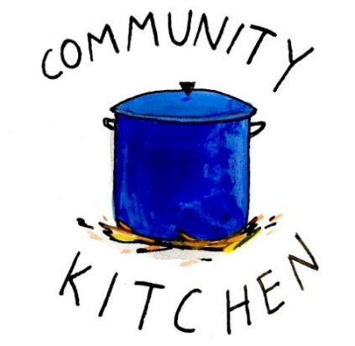
February 20 24
March 20 24
April 24 28
May 22 26
June -- 23
July 24 28
August 21 25
September 25 29
October 23 27
November 20 24
December -- 29

Contact Nancy Hunter to volunteer to help, 706.506.3889. THANK YOU


Living Compass New Book group begins
January 5th
2pm at 401 E. 4th Ave
Etty Hillesum:
An Interrupted Life, the Diaries
1943-1943 & Letters from Westerbork.
"An Interrupted Life" is a poignant collection of diaries and letters by Etty
Hillesum, chronicling her experiences as a Jewish woman during the
Holocaust, reflecting her profound introspection and resilience in the face of adversity.


Junior Choir ~Wednesday Nights

6:30-7pm
Children’s Chapel Room
3rd Floor



ROOTS
Wednesday Nights~6-6:30pm

PreK-1st grade – Children’s Chapel room, 3rd floor.
2nd & 3rd grade – Roots room, 4th floor.
4th & 5th grade – Jr. EYC room 4th floor.

Steve Shaws 25th

Natalie Murphy 25th
Sherry Hudgins 25th
Maddox Wentz 25th
Emily Johnson 26th
Jan Routledge 26th
Wendy Williams 27th
Keith Lewallen 28th
Gregory Thomas 29th
Mary Burke Smith 30th
Diane Nance 30th
Cheryl Bishop 30th


The next round of Bridges out of Poverty began on January 8, 2026, at St. Peter's Rome. This will be the first time St. Peter's has hosted. The expectation is that the group will meet for 24 weeks, ending the program around June 18th. It could go more quickly but will not go any longer than that date.

First Baptist Church Rome has hosted this program with financial & volunteer support from St. Peter's for several years. This is the first time our parish will be hosting the group in our building. It is a wonderful opportunity for this ministry to be engaged with the parish in a meaningful way!

There are several aspects of the program that need to be supported for Bridges to be a success.
We need volunteers in all these places/roles.

-First, there will need to be 4-6 drivers each week for residents of Davies Shelters (men’s and women’s houses) & Next Door who are participating. Investigators (the participants in the group) will need to be delivered to Daniel Hall by 6pm and picked up at 8:30pm. We would like to ask men to transport men and women to transport women. Some of the investigators will have their own transportation, so not everyone will need a ride.

-Secondly, there will need to be a meal for 15 every Thursday evening. This can be as simple as soup, salad, and dessert. The meal needs to be ready to be served at 6pm as the investigators arrive at Daniel Hall. We will utilize the Bridges Sign-Up Genuis for this, see link below.

-Third, there will possibly need to be childcare provided (if any of the investigators have children). At this time, we do not know if this will be a need. At least one person needs to be Safeguard trained. These children will be ages 1-12 years old.

Questions or to Volunteer in any of these capacities contact:
Devon Smyth, 770.714.2361 OR David Peters, 770.262.6017


Volunteer Sign up

Bridges Out of Poverty Volunteers Spring 2025: 2026 Getting Ahead Volunteers


Adults $10 select 1 ENTRÉE, and 2 Sides
Kids $4 - Family Maximum $25
Vegetarian/Gluten Free $8: Sides with rotating meatless burger or egg.
Gluten Free $10 entrée and 2 chosen sides.

1.28.2026 – Taco Bar
Seasoned Ground Beef OR Seasoned Chicken. All served with Black Beans, Mexican Rice, Corn & Flour Tortilla and all the fixings. Tres Leche Cake
Vegetarian/Gluten Free $8 – Meatless burger patty and gluten free Mexican Seasoning
Gluten Free $10 – Either Seasoned chicken or Beef with Gluten Free Mexican Seasoning

2.4.2026
Chicken/Broccoli/Cheese Casserole OR Meatloaf. Carrots, Salad, English Pea-, CHOOSE 2
Adult meals served with Chocolate Cake & Icing
Kids $4 – White Castles, peach cup, carrots
Vegetarian $8 – All sides with meatless burger patty
Gluten Free $10 – Chicken Casserole with 2 sides

2.11.2026
Cesar Chicken OR Brown Sugar & Soy Glazed Pork Loin
Garlic Broccoli, Cesar Salad, Buttered Corn- CHOOSE 2,
Adults served with Pineapple Upside Down Cake
Kids $4– Pepperoni Pizza Hot Pockets, Corn, Pudding
Vegetarian $8 – All sides with hard boiled eggs
Gluten Free $10 – Glazed Pork with 2 sides.

2.18.2026
Baked Parmesan Pork Loin OR Chicken N’ Stuffing Casserole
Mashed Potatoes, Turnip Greens, Green Salad- CHOOSE 2
Adults served Brownies
Kids – Chicken Tenders, Mashed Potatoes, Fruit Cup
Vegetarian – All sides with meatless burger patty
Gluten Free – Baked Parmesan Pork Loin with 2 sides.

NAME:
Drop this in the collection plate, by the church office or snap a photo and email to elizabeth@stpetersrome.org.

St. Paula’s Guild



Osaka Japanese Fusion Restaurant
1015 Martha Berry Blvd, NE
4:30 pm
Saturday January 31st
RSVP by responding to Diane Nance by text at 706-936-6006.


Wish List for Children’s Ministry
https://www.amazon.com/hz/wishlist/ls/LOS24YTKY6Y4?ref_=wl_share


Available Dates

Candles in Nave for February or March $65
Chapel Flowers, $100 April 12th, 19th
Nave Flowers, $150 April 12th

Call or email church office to reserve your date.


Bible Study
Thursdays 10am

Children’s Chapel
Sundays, 9:50am

We will depart as a group from the nave and return during Peace to share Eucharist with our families.
Children’s Chapel is available for children aged Pre-K through 2nd grade.

February Leader Schedule:
2.1 – Margaret Louttit & Peggy Nash
2.8 – Lee Morris & Kellie Wolfe
2.15 – Nancy Hunter & MJ Chisholm
2.22 – Kathy Steinbruegge & Katie Smyth

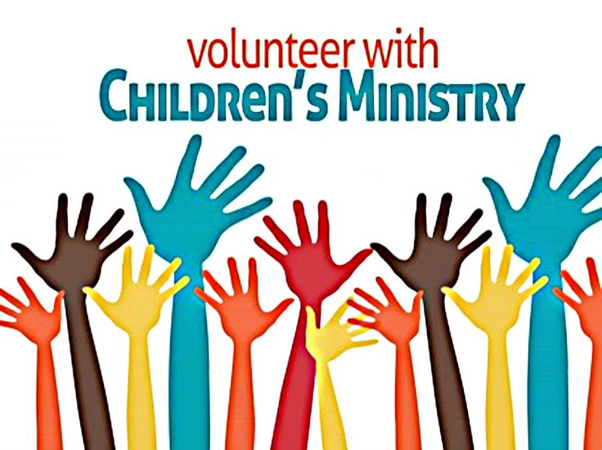
Hello everyone!
We need volunteers to fill our SPRING Children’s Chapel slots.

- Slots begin in January 2026
- YOU choose the Sunday(s) that fit your schedule
- Volunteers work in teams of 2
- Simple curriculum is provided
- Safeguarding certification is required for all parishioners that work with our children. You do NOT have to have certification to volunteer, just be certain to sign up as soon as possible to complete the training. Certification is completed via a zoom meeting.

If you have any questions about volunteering with the Children's Ministry do not hesitate to reach out to Katie Smyth, 770.714.1825.

Here is the link to volunteer for Children’s Chapel:
https://www.signupgenius.com/go/10C0E4AAAA829A3FFC70-57875256-202526

~USE REALM~
Joining Realm is NOT mandatory.
By signing up for Realm you can…

- Schedule gifts or pledge payments by credit card or debit to your bank account.
- Register for events at the church
- PREPAY for events before you arrive
- Upload current individual or family photos for the church directory
- Keep your contact information current

If you are not currently signed up for Realm, simply contact the church office and an invite will be emailed to you.
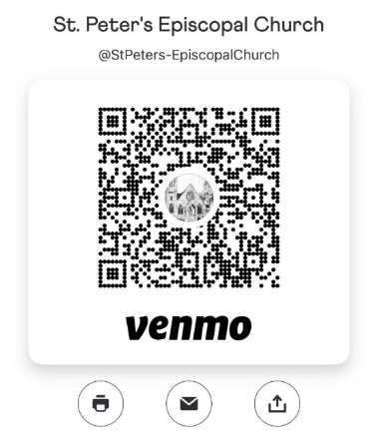
Remember to always include a note/memo on all
Venmo payments to ensure proper credit. For example, tithe, pledge, Wednesday dinner, Breakfast, etc.


Payments via Paypal and the church website, www.stpetersrome.org.
Select Giving on the top banner then stewardship. Follow the Instructions to remit via ACH or Credit Card using Paypal. The fees associated with using Paypal are paid by the church. If you wish to share in this cost simply increase the amount of your gift (2.2% of the given amount plus .30 per transaction).

Link directly to PayPal giving on website Stewardship | St. Peter's Episcopal Church

January/February | Monday | Tuesday | Wednesday | Thursday | Friday | Saturday
25  8:15-11:45 Nursery provided  9:50am Children’s Chapel  8:30am – Rite I Chapel  9-10 Breakfast  10am – Rite II Nave, WLAQ/You tube  EYC 6-7:30pm | 26  Noon RSVP Wed. Dinner  1pm Centering Prayer  2pm Living Compass | 27  3 Rivers 7-8:30pm Nave | 28  5:30pm Dinner begins  5:30pm Celtic Service  6-6:30pm Roots  6:30-7pm Jr. Choir  7pm Adult Choir | 29  10am Bible Study  6-8:30 Bridges D. Hall, Kitchen, nursery | 30 | 31  St. Paula’s Guild  4:30pm Osaka Japanese Restaurant
February 1  8:15-11:45 Nursery provided  9:50am Children’s Chapel  8:30am – Rite I Chapel  9-10 Breakfast  10am – Rite II Nave, WLAQ/You tube  11:15am Adult Forum – Ann Pullen, Episcopal Church & Missions  EYC 6-7:30pm | 2  Noon RSVP Wed. Dinner  1pm Centering Prayer  2pm Living Compass | 3  9am Staff Meeting  3 Rivers 7-8:30pm Nave  JSL 5:30-8:30 D. Hall | 4  5:30pm Dinner begins  5:30pm Celtic Service  6-6:30pm Roots  CATECHUMENATE, 6-7pm  6:30-7pm Jr. Choir  7pm Adult Choir | 5  10am Bible Study  Stephen Ministry 3:30-5pm R. Wyatt  6-8:30 Bridges D. Hall, Kitchen, nursery | 6 | 7  Funeral 11am in Nave for Peg Arey
8  8:15-11:45 Nursery provided  9:50am Children’s Chapel  8:30am – Rite I Chapel  9-10 Breakfast  10am – Rite II Nave, WLAQ/You tube  11:15am Adult Forum-David Jahner, St. Peter’s Basilica in Rome Italy  EYC 6-7:30pm | 9  Noon RSVP Wed. Dinner  1pm Centering Prayer  2pm Living Compass | 10  9am Staff Meeting  3 Rivers 7-8:30pm Nave  7-8:30pm Indivisible  R. Wyatt | 11  5:30pm Dinner begins  5:30pm Celtic Service  6-6:30pm Roots  CATECHUMENATE, 6-7pm  6:30-7pm Jr. Choir  7pm Adult Choir | 12  10am Bible Study  6-8:30 Bridges D. Hall, Kitchen, nursery | 13 | 14  11-6 Indivisible.    D. Hall & Choir Room
15  8:15-11:45 Nursery provided  9:50am Children’s Chapel  8:30am – Rite I Chapel  9-10 Breakfast  10am – Rite II Nave, WLAQ/You tube  EYC 6-7:30pm | 16  Noon RSVP Wed. Dinner  1pm Centering Prayer  2pm Living Compass | 17  9am Staff Meeting  3 Rivers 7-8:30pm Nave  JSL 5:30-8:30 D. Hall | 18  5:30pm Dinner begins  5:30pm Celtic Service  6-6:30pm Roots  CATECHUMENATE, 6-7pm  6:30-7pm Jr. Choir  7pm Adult Choir | 19  10am Bible Study  Stephen Ministry 3:30-5pm R. Wyatt  6-8:30 Bridges D. Hall, Kitchen, nursery | 20  8-11am Rome Council on Children  Rhodes Wyatt | 21
22  8:15-11:45 Nursery provided  9:50am Children’s Chapel  8:30am – Rite I Chapel  9-10 Breakfast  10am – Rite II Nave, WLAQ/You tube  11:15am Adult Forum-MINISTRY FAIR  EYC 6-7:30pm | 23  Noon RSVP Wed. Dinner  1pm Centering Prayer  2pm Living Compass | 24  9am Staff Meeting  3 Rivers 7-8:30pm Nave | 25  5:30pm Dinner begins  5:30pm Celtic Service  6-6:30pm Roots  CATECHUMENATE, 6-7pm  6:30-7pm Jr. Choir  7pm Adult Choir | 26  10am Bible Study  6-8:30 Bridges D. Hall, Kitchen, nursery | 27  ESP 3:30-8:30pm D. Hall | 28

