
WELCOME TO ALL OUR VISITORS!
If you are interested in knowing more about St. Peter’s, please see an usher or one of the greeters who stand with the clergy after the service.

1.18.2026 at St. Peter’s
8:15am-11:45am Nursery
8:30am Holy Eucharist Rite I in Chapel
9-10am Breakfast
9:50am Children’s Chapel
10:00am Holy Eucharist Rite II in Nave, WLAQ radio & YouTube

This week…
Monday January 19th 11am MLK Freedom March, lunch at Schroeders
12 noon – Reservations for Wednesday dinner
1pm Centering Prayer
2pm Living Compass
Tuesday January 20^{h} 9am Staff Meeting
Wednesday January 21st 5:30pm Celtic Service in the chapel
5:30pm Dinner served in Daniel Hall
6-6:30pm Roots NEW TIME
6-7pm Catechumenate Class
6:30-7pm Jr. Choir NEW TIME
7pm Adult Choir
Thursday January 22nd 10am Bible Study

Emily Lankford, John McCard, Carlton Family, Gina Schmitz, Dagmar Carlton, Roger Bowen, Mary Jo Woolcock, Jimmy Smithson, Jerry Dunwoody, Andrew Babcock, John Schroeder, Sherron Badgett, Rebecca Francis, Campbell Clark, Peyton Salit & Leo Salit, Jan Woody, John Marshall, Emily Millstead, Esther & John Hussers, Stephen Patton, Julie Herring, Michael Ann Booth, Philip, Dasha & David Jenkins, Henry Pancione, Katie Pancione, Denny Hachenberg, Ray Dempsey, Rees Jenkins, Sylvia Hine and those that care for them.

Beginning of each month the intercessory prayer is “refreshed”; all names removed. If you wish to add someone, please call, or email the church office. Names will remain on the Prayer List for the entire month.

Military Prayer List:

Gordon Macy
Charles Lewis
Nolan Kelley
Davis Isley
Cherrie Shackelford

Andrew Hall
Ted Olney
Michael Blair
Steven Blair
Charlie Hardaker
Justin Yeary

Thomas Keefe
Ryan Holman
Johnny Crittenden
Sara Carver Thomas
Joshua Ingram
Jerrod Keplinger

Please remember to notify the church office when a service member is no longer on active duty.



Parish Wide Freedom March
January 19th

Meet at corner of 1st Ave & Broad Street
Gather at 11am, Walk at 11:30am

Lunch at Schroeder’s afterward

Office & Church closed on Monday, 1.19.2026

Upcoming Adult Forum Topics & Dates:
February 1st – Ann Pullen, Episcopal Church & Missions
February 8th – David Jahner, St. Peter’s Basilica in Rome Italy
February 22nd – Ministry Fair

St. Peter’s Ministry Fair
February 22nd, 11:15am
Daniel Hall



Explore the various COMMUNITY MINISTRIES supported by St. Peter’s and how to HELP!

Find out more about MINISTRIES WITHIN THE CHURCH and how you can get involved!
Keeping Everyone Safe at
St. Peter’s

Everyone volunteering to work with children or adults as well as Vestry Members are required to complete Safeguarding classes.

Classes are offered via ZOOM by the Diocese.
Zoom sessions are approximately 2 hrs.
Certification is refreshed every 3 years.

Safeguarding God's Children: Scheduled Zoom Training Dates
- Tuesday, January 27, 2026: 6:30 PM - 8:30 PM
- Saturday, February 21, 2026: 10:00 AM - 12:00 PM
- Monday, February 23, 2026: 6:30 PM - 8:30 PM
- Thursday, March 19, 2026: 6:30 PM - 8:30 PM
Safeguarding God's People: Scheduled Zoom Training Dates
- Thursday, January 29, 2026: 6:30 PM - 8:30 PM
- Friday, February 20, 2026: 10:00 AM - 12:00 PM
- Monday, March 23, 2026: 6:30 PM - 8:30 PM
Once you choose the class that fits your schedule register via this link: Safeguarding Training Registration

There are also a few IN PERSON training sessions on the schedule:
- Saturday 1.24.2026 St James, Marietta GA. Children training 9:30-12:30 & People 1pm-4pm
- Thursday 2.5.2026 Holy Innocents, Atlanta GA. Children training 9-12pm
- Thursday 2.26.2026 Holy Innocents, Atlanta GA. People training 9-12pm
If you wish to utilize one of the IN-PERSON training sessions, contact the church office, 706.291.9111 to register.
St. Peter’s VOLUNTEERs are needed from 9am till noon. HOWEVER, if you are not able to work the full 3 hours, any time you can share is greatly appreciated.

2026 Schedule
Friday Tuesday
January 23 27
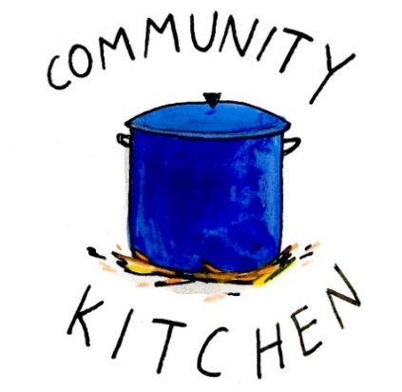
February 20 24
March 20 24
April 24 28
May 22 26
June -- 23
July 24 28
August 21 25
September 25 29
October 23 27
November 20 24
December -- 29

Contact Nancy Hunter to volunteer to help, 706.506.3889. THANK YOU


Living Compass New Book group begins
January 5th
2pm at 401 E. 4th Ave
Etty Hillesum:
An Interrupted Life, the Diaries
1943-1943 & Letters from Westerbork.
"An Interrupted Life" is a poignant collection of diaries and letters by Etty
Hillesum, chronicling her experiences as a Jewish woman during the
Holocaust, reflecting her profound introspection and resilience in the face of adversity.


Junior Choir ~Wednesday Nights

6:30-7pm
Children’s Chapel Room
3rd Floor



ROOTS
Wednesday Nights~6-6:30pm

PreK-1st grade – Children’s Chapel room, 3rd floor.
2nd & 3rd grade – Roots room, 4th floor.
4th & 5th grade – Jr. EYC room 4th floor.


Laura Frederick 19th
Charles Hight 20th
Mary McGuffey 20th
Mike Barron 21st
Linda Jennings 22nd
Michael Ann Booth 23rd
Andre Berry 23rd
Mary Alston Steeves 23rd
Oakley Smith 23rd


to my Stephen Minister colleague for providing the reception and for the large turnout of the congregation at my recital on Sunday afternoon, January 11. I enjoy sharing my love of music with others, and I am grateful to be a member of the St. Peter's family. For those of you who missed the performance, here is a link to the recording: https://youtu.be/h-1NR0Tr47s?si=U1NPTuZQiw1fKc2O
David Jahner

The next round of Bridges out of Poverty will begin on January 8, 2026, at St. Peter's Rome. This will be the first time St. Peter's has hosted. The expectation is that the group will meet for 24 weeks, ending the program around June 18th. It could go more quickly but will not go any longer than that date.

First Baptist Church Rome has hosted this program with financial & volunteer support from St. Peter's for several years. This is the first time our parish will be hosting the group in our building. It is a wonderful opportunity for this ministry to be engaged with the parish in a meaningful way!

There are several aspects of the program that need to be supported for Bridges to be a success.
We need volunteers in all these places/roles.

-First, there will need to be 4-6 drivers each week for residents of Davies Shelters (men’s and women’s houses) & Next Door who are participating. Investigators (the participants in the group) will need to be delivered to Daniel Hall by 6pm and picked up at 8:30pm. We would like to ask men to transport men and women to transport women. Some of the investigators will have their own transportation, so not everyone will need a ride.

-Secondly, there will need to be a meal for 15 every Thursday evening. This can be as simple as soup, salad, and dessert. The meal needs to be ready to be served at 6pm as the investigators arrive at Daniel Hall. We will utilize the Bridges Sign-Up Genuis for this and will share the link with you. David & I will cover the first couple of weeks.

-Third, there will possibly need to be childcare provided (if any of the investigators have children). At this time, we do not know if this will be a need. At least one person needs to be Safeguard trained. These children will be ages 1-12 years old.

Questions or to Volunteer in any of these capacities contact:
Devon Smyth, 770.714.2361 OR David Peters, 770.262.6017


Volunteer Sign up

Bridges Out of Poverty Volunteers Spring 2025: 2026 Getting Ahead Volunteers


Adults $10 select 1 ENTRÉE, and 2 Sides
Kids $4 - Family Maximum $25
Vegetarian/Gluten Free $8: Sides with rotating meatless burger or egg.
Gluten Free $10 with entrée and chosen sides.

1.21.2026
Marry Me Chicken OR Vegetable Ziti
Garlic/Parmesan Roasted Broccoli, Honey Glazed Carrots, Green salad – choose 2
Adult meal served with Honey Bun Cake
Kids – pepperoni Pizza, carrots, fruit
Vegetarian/Gluten Free $8– All sides with hard boiled eggs
Gluten Free $10– Marry Me Chicken with 2 sides

1.28.2026 – Taco Bar
Seasoned Ground Beef OR Seasoned Chicken. All served with Black Beans, Mexican Rice, Corn & Flour Tortilla and all the fixings. Tres Leche Cake
Vegetarian/Gluten Free $8 – with meatless burger patty and gluten free Mexican Seasoning
Gluten Free $10 – Either Seasoned chicken or Beef with Gluten Free Mexican Seasoning

NAME:
Drop this in the collection plate, by the church office or snap a photo and email to elizabeth@stpetersrome.org.

NEW Directory will be printed in house sometime in February.
UPDATE your photo TODAY.


Email photo to church office OR log onto Realm and upload your photo.


Wish List for Children’s Ministry
https://www.amazon.com/hz/wishlist/ls/LOS24YTKY6Y4?ref_=wl_share


Available Dates

Candles in Nave for February or March $65
Chapel Flowers, $100 April 12th, 19th
Nave Flowers, $150 April 12th

Call or email church office to reserve your date.


Bible Study
Thursdays 10am
will resume on
January 15th

Children’s Chapel
Sundays, 9:50am
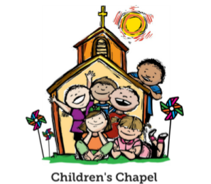
We will depart as a group from the nave and return during Peace to share Eucharist with our families.
Children’s Chapel is available for children aged Pre-K through 2nd grade.

January Leader Schedule:
1.4 – Margaret Louttit & Peggy Nash
1.11 – Lee Morris & Kellie Wolf
1.18 – Katie Smyth & Suzanne Roberts
1.25 – Katie Smyth & Gayle Keith

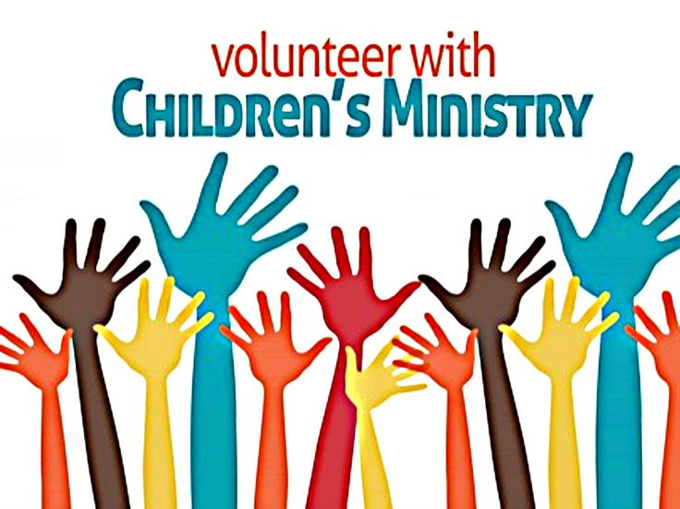
Hello everyone!
We need volunteers to fill our SPRING Children’s Chapel slots.

- Slots begin in January 2026
- YOU choose the Sunday(s) that fit your schedule
- Volunteers work in teams of 2
- Simple curriculum is provided
- Safeguarding certification is required for all parishioners that work with our children. You do NOT have to have certification to volunteer, just be certain to sign up as soon as possible to complete the training. Certification is completed via a zoom meeting.

If you have any questions about volunteering with the Children's Ministry do not hesitate to reach out to Katie Smyth, 770.714.1825.

Here is the link to volunteer for Children’s Chapel:
https://www.signupgenius.com/go/10C0E4AAAA829A3FFC70-57875256-202526
~USE REALM~
Joining Realm is NOT mandatory.
By signing up for Realm you can…

- Schedule gifts or pledge pymts by credit card or debit to your bank account.
- Register for events at the church
- PREPAY for events before you arrive
- Upload current individual or family photos for the church directory
- Keep your contact information current

If you are not currently signed up for Realm, simply contact the church office and an invite will be emailed to you.
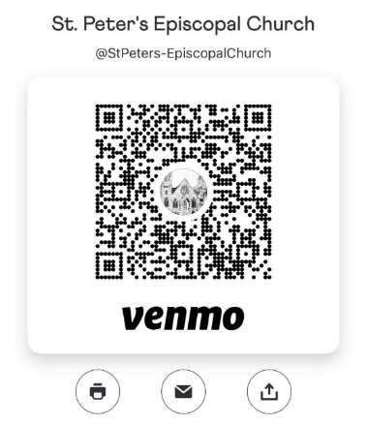
Remember to always include a note/memo on all
Venmo payments to ensure proper credit. For example, tithe, pledge, Wednesday dinner, Breakfast, etc.


Payments via Paypal and the church website, www.stpetersrome.org.
Select Giving on the top banner then stewardship. Follow the Instructions to remit via ACH or Credit Card using Paypal. The fees associated with using Paypal are paid by the church. If you wish to share in this cost simply increase the amount of your gift (2.2% of the given amount plus .30 per transaction).

Link directly to PayPal giving on website Stewardship | St. Peter's Episcopal Church

December | Monday | Tuesday | Wednesday | Thursday | Friday | Saturday
 |  |  |  | January 1  2026  Office Closed | 2  Office Closed | 3
4  8:15-11:45 Nursery provided  9:50am Children’s Chapel  8:30am – Rite I Chapel  9-10 Breakfast  10am – Rite II Nave, WLAQ/You tube  11:15am Children’s Ministry Volunteers Meeting in Daniel Hall | 5  1pm Centering Prayer  2pm Living Compass  Backpack Buddies Parish Wide Service Day  10am | 6  9am Staff Meeting  3 Rivers 7-8:30pm Nave  JSL 5:30-8:30 D. Hall | 7  5:30pm Dinner begins  5:30pm Celtic Service  6-6:30pm Roots  6pm EYC Downtown Dinner  6:30-7pm Jr. Choir  CATECHUMENATE, 6-7pm  7pm Adult Choir | 8  6-8:30 Bridges D. Hall, Kitchen, nursery  6:30-3 Rivers R. Wyatt | 9  3:30-8:30 ESP  D. Hall/Kitchen | 10
11 - Baptisms  8:15-11:45 Nursery provided  9:50am Children’s Chapel  8:30am – Rite I Chapel  9-10 Breakfast  10am – Rite II Nave, WLAQ/You tube  11:15am ADULT FORUM –  Michael Papazian  2-4pm Recital David Jahner, nave  EYC 6-7:30pm | 12  1pm Centering Prayer  2pm Living Compass | 13  9am Staff Meeting  7-8:30pm Indivisible R. Wyatt  7-8:30pm Nave 3 Rivers | 14  5:30pm Dinner begins  5:30pm Celtic Service  6-6:30pm Roots  CATECHUMENATE, 6-7pm  6:30-7pm Jr. Choir  7pm Adult Choir | 15  10am Bible Study  6-8:30 Bridges D. Hall, Kitchen, nursery | 16  FAMILY NIGHT OUT  5-8:30pm  D. Hall | 17  9am -2pm  D. Hall/Kitchen  Delta Kappa Gamma
18  8:15-11:45 Nursery provided  9:50am Children’s Chapel  8:30am – Rite I Chapel  9-10 Breakfast  10am – Rite II Nave, WLAQ/You tube | 19  11am MLK WALK  1pm Centering Prayer  2pm Living Compass  Office/Church closed | 20  9am Staff Meeting  3 Rivers 7-8:30pm Nave  JSL 5:30-8:30 D. Hall | 21  5:30pm Dinner begins  5:30pm Celtic Service  6-6:30pm Roots  CATECHUMENATE, 6-7pm  6:30-7pm Jr. Choir  7pm Adult Choir | 22  10am Bible Study  6-8:30 Bridges D. Hall, Kitchen, nursery | 23  Vestry Retreat  8-11am Rome Council on Children  Rhodes Wyatt | 24  Vestry Retreat
25  8:15-11:45 Nursery provided  9:50am Children’s Chapel  8:30am – Rite I Chapel  9-10 Breakfast  10am – Rite II Nave, WLAQ/You tube  EYC 6-7:30pm | 26  1pm Centering Prayer  2pm Living Compass | 27  3 Rivers 7-8:30pm Nave | 28  5:30pm Dinner begins  5:30pm Celtic Service  6-6:30pm Roots  CATECHUMENATE, 6-7pm  6:30-7pm Jr. Choir  7pm Adult Choir | 29  10am Bible Study  6-8:30 Bridges D. Hall, Kitchen, nursery | 30 | 21

