
WELCOME TO ALL OUR VISITORS!
If you are interested in knowing more about St. Peter’s, please see an usher or one of the greeters who stand with the clergy after the service.

12.7.2025 at St. Peter’s
8:15am-11:45am Nursery
8:30am Holy Eucharist Rite I in Chapel
9-10am Breakfast
9:50am Children’s Chapel
10:00am Holy Eucharist Rite II in Nave, WLAQ radio & YouTube
4:30pm Gingerbread house decorating, Daniel Hall
6-7:30pm EYC

This week…
Monday/December 8th Noon – RSVP for Wednesday Dinner
1pm Centering Prayer
2pm Living Compass ADVENT STUDY group
Tuesday/December 9th 9am Staff Meeting
Wednesday/December 10th 5:30pm Celtic Service in Chapel
5pm Dinner Service begins
6pm Christmas Pageant in Nave
7pm Adult Choir
Thursday/December 11th 3:30-5pm Stephen Ministry Supervision meeting
Friday/December 12th 4pm Gathering to honor Brad Roberts, Daniel Hall

Sylvia Hine, Rees Jenkins, Ray Dempsey, Denny Hachenberg, Carlton Family, Gina Schmitz, Katie Pancione, Henry Pancione, Philip, Dasha and David Jenkins, Michael Ann Booth, Dagmar Schmitz Carlton, Jackie Hizel, Marcia Smith, Campbell Clark, Roger Bowen, John Marshall, Julie Herring, John Schroeder, Andrew Babcock, Jerry Dunwoody, Jimmy Smithson, Callie & Matt Owen, Mae Bradberry, James Fernandez and those that care for them.

Last week the intercessory prayer was “refreshed”; all names removed. If you wish to add someone, please call, or email the church office. Names will remain on the Prayer List for the entire month.

Military Prayer List:

Gordon Macy
Charles Lewis
Nolan Kelley
Davis Isley
Cherrie Shackelford

Andrew Hall
Ted Olney
Michael Blair
Steven Blair
Charlie Hardaker
Justin Yeary

Thomas Keefe
Ryan Holman
Johnny Crittenden
Sara Carver Thomas
Joshua Ingram
Jerrod Keplinger

Please remember to notify the church office when a service member is no longer on active duty.


Poinsettias will be placed on the altars on Christmas Eve through January 4th.

If you wish to donate a poinsettia, please contact church office with the name(s) of your honorees.

Simply drop a check in mail, collection plate or remit electronically any amount and memo it Poinsettias.

Wish List for Children’s Ministry
https://www.amazon.com/hz/wishlist/ls/LOS24YTKY6Y4?ref_=wl_share

St Paula’s Guild


The widows of Maplewood, Marny Busbin, Barbara Dixon, Virginia Hunter, Kitty Johnston, Diann Kothe, Karen Smith & Frieda Yeary invite you to a

Christmas gathering
at the Maplewood Lodge.
Sunday, December 14 from 5-7 PM.
The gate will open at 4:30 PM.

Please bring an appetizer for the table and a beverage of your choice.

If you are attending for the first time, please be our guest. No need to bring anything but yourself.

RSVP to Diane Nance only at 706-936-6006 by December 8.


Lelia Mullis 7th
Rachel Roberts 8th
Emily Robinson 10th
Lynnette Bonner 10th
Tim Johnson 11th
Jackie Mooney 12th
Sopia June 12th
Anna Nichols 13th


Have some sweet fun decorating a Gingerbread House.
Sunday, December 7th 4:30pm
$20 for each house.
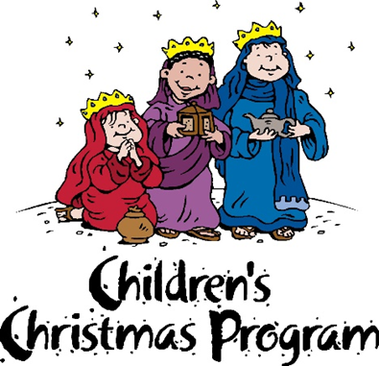

Christmas Pageant
Wednesday, December 10th
6pm in the Nave.

Dinner service begins at 5pm in Daniel Hall.
RSVP by Monday:
Choose 1: Brunswick Stew or Baked Potato Bar
Both served with salad, cornbread.
Kids choose either Hotdog or Baked Potato bar.

Eve of the Nativity Services
5pm and 11pm
Both services held in the Nave.

Christmas Day Service

10am
In the chapel

St. Peter’s VOLUNTEERs are needed from 9am till noon. HOWEVER, if you are not able to work the full 3 hours, any time you can share is greatly appreciated.

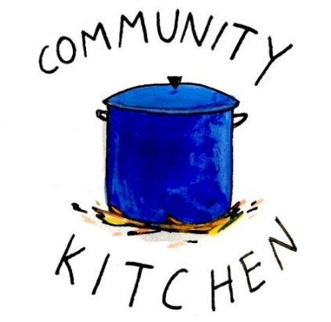
2025 Schedule
Friday Tuesday
August 22 26
September 26 30
October 24 28
November 21 25
December 26 30

Contact Nancy Hunter to volunteer to help, 706.506.3889. THANK YOU

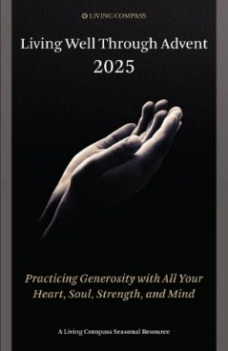
Living Compass Advent Study
Mondays 2pm at 401 E. 4th Avenue
December 1st
Pick up booklet in Daniel Hall or Nave

Time to UPDATE your family or individual PHOTO in Realm!

If you snap a great shot during the coming holidays don’t forget to text or email it to the church office.

We will update your photo in Realm.

Got a new address or contact info. Be certain to let the office know.
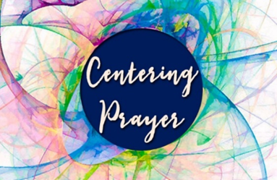
Centering Prayer
Mondays 1pm 401 East 4th Ave.
Available via Zoom as well.
Questions Contact Jane Cunningham, 706.346.4091 OR missjane1@mac.com


BIBLE STUDY
Thursday mornings 10-11am
The Gospel of John

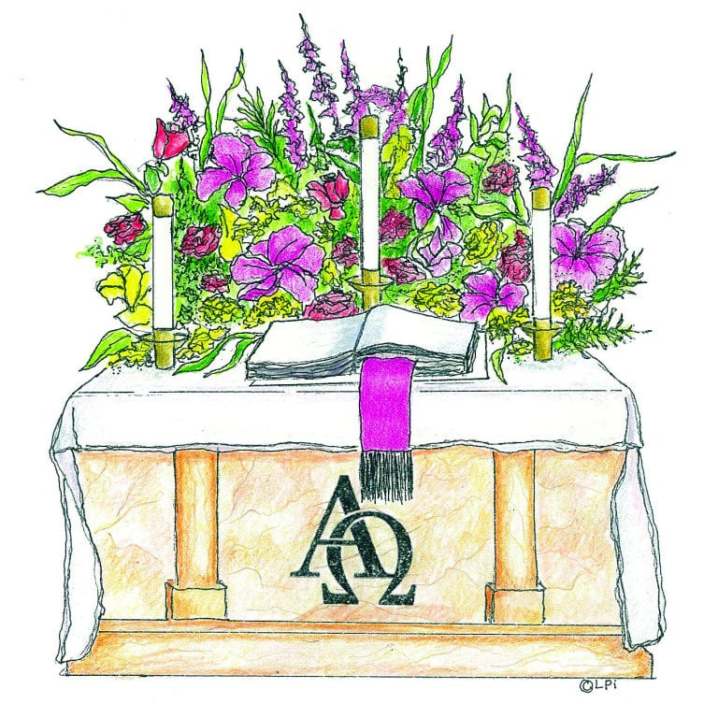
Advent Candles given to the Glory of God and in memory of Roy N. West by Mattie & Breck Paris.

Flowers on the Chapel altar given to the Glory of God and in honor of Lynnette, my Northern Star by Hugh Bonner.

Flowers on the Nave altar given to Glory of God and in memory of Moses Wright Dunwoody, II by Jerry Dunwoody.

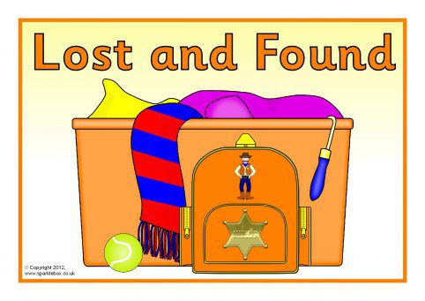
Leave Something at church by mistake?

Contact the church office
to see if it landed in the
LOST & FOUND.


Children’s Chapel ~ Sundays, 9:50am.

We will depart as a group from the nave and return during Peace to share Eucharist with our families.
Children’s Chapel is available for children aged Pre-K through 2nd grade.

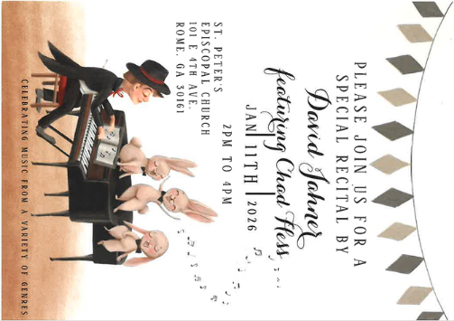
Please Join us for a Special Recital by

David Jahner
Featuring Chad Hess

January 11, 2026 ~ 2-4pm
Nave at St. Peter’s

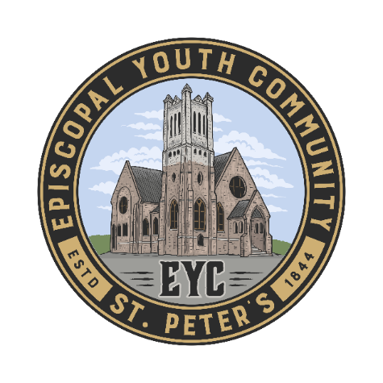
EYC Progressive Dinner
December 14th

Parishioners,
if you would like to help, use the link below to sign up.

https://www.signupgenius.com/go/10C084EACAB2FA5FCC43-60897404-eycprogressive

THANK YOU FOR YOUR KINDNESS AND SUPPORT!


Wednesday Night Menu
General Dinner served 5:30-6:30pm in Daniel Hall

IF YOU NEED/WANT to eat at 5pm NO PROBLEM, just let us know when you make your reservation. Your plate will be ready!

Adults $10, Vegetarian $8, Kids menu $4
Family Maximum $25

Vegetarian/Gluten Free: Salad and rotating meatless burger patty OR hard-boiled egg. $8
Vegetarian: All 3 sides and rotating meatless burger patty OR hardboiled egg. $8

RESERVATIONS by NOON on Monday each week.
Call/email office, register on REALM, or sign and drop menu in offering plate.

12.10.2025 – No Rehearsal Christmas Pageant – Dinner served at 5pm for the pageant.
Adult meal $8 Brunswick Stew OR Bake Potato Bar.
Both served with Green Salad, cornbread, cookies
Kids meal $4 – Hotdogs OR Baked Potato with cookies

12.17.2025
Brown Sugar Bourbon Baked Ham OR Champagne glazed Cornish Hen half with lemon.
Green Bean Bundles – Sweet Potato Casserole – Salad - Dinner roll –Coconut Cake
Kids – Mac N Cheese OR Pepperoni Pizza. Gingerbread cookie, Fruit, salad
Vegetarian or Vegetarian/Gluten Free meals served with hard boiled eggs

Name:
Drop in Collection plate OR deliver to church office.

Vestry 2026

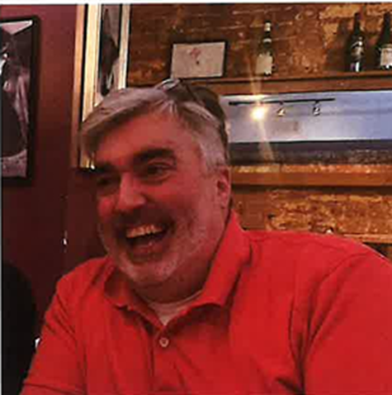

Nat Massey, Sr. Warden

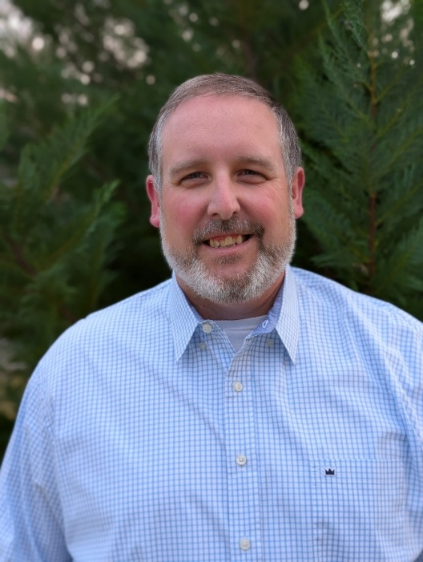

Mark Jones, Jr. Warden

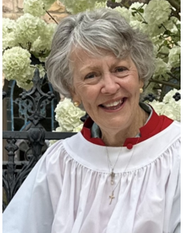

Anne Kerr, Pastoral Care

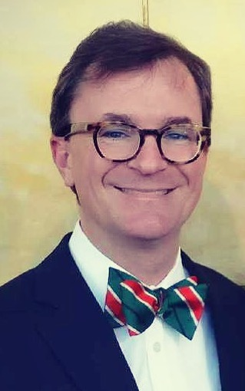

Steve Morris, Stewardship

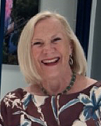

Jean Stutts, Finance

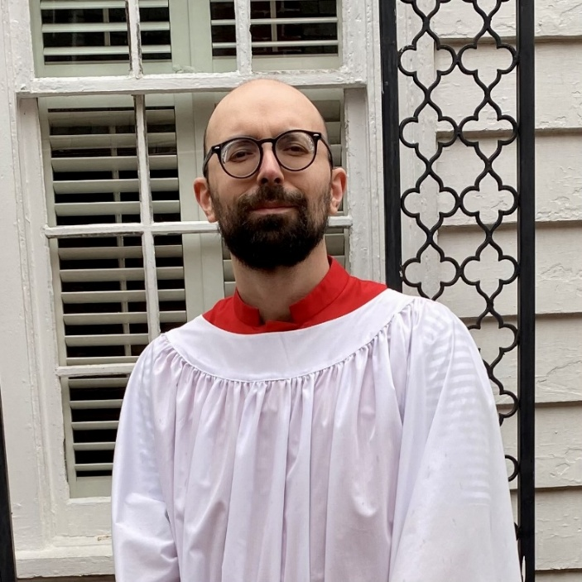

David Williams, Communications



Lisa Bell, Parish Life

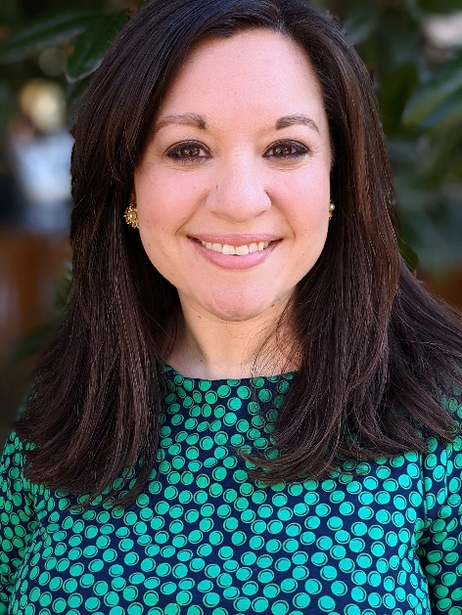

Christine Pilgrim, Youth & Children Formation



Stephen Taylor, Communications

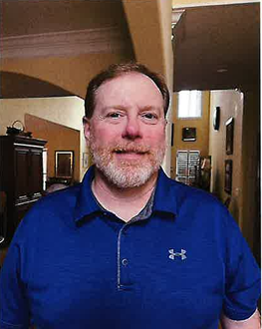

Greg Tarter, Building & Grounds

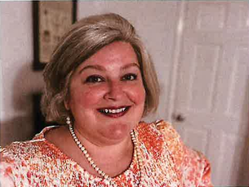

Margaret Louttit,
Adult Formation

December | Monday | Tuesday | Wednesday | Thursday | Friday | Saturday
 | 1  1pm Centering Prayer  2pm Living Compass Advent Study | 2  3 Rivers Nave,  7-8:30pm | 3  5:30pm Dinner begins  5:30pm Celtic Service  6pm EYC Downtown Dinner  6-6:30 Jr. Choir  ROOTS 6:30-7:30  CATECHUMENATE, 6-7pm  7pm Adult Choir | 4  11am Bible Study | 5  8:30-11am Rome Council on Children  R Wyatt  11am Protz Funeral  4-8:30 ESP  D. Hall | 6  11am Anne Culpepper Funeral and Reception
7 ADVENT 1I  8:15-11:45 Nursery provided  9:50am Children’s Chapel  8:30am – Rite I Chapel  9-10 Breakfast  10am – Rite II Nave, WLAQ/You tube  4:30pm Gingerbread Houses | 8  1pm Centering Prayer  2pm Living Compass Advent Study | 9  3 Rivers Nave,  7-8:30pm | 10  5pm Dinner begins  5:30pm Celtic Service  6pm Christmas Pageant in Nave  7pm Adult Choir | 11  11am Bible Study  3:30-5pm Stephen Ministry Supervision Meeting  3 Rivers 6:30pm  R. Wyatt | 12  4pm Gathering in honor of Brad Roberts in D. Hall | 13  11am – 1pm Habitat for Humanity  D. Hall & Kitchen
14 ADVENT 1II  8:15-11:45 Nursery provided  9:50am Children’s Chapel  8:30am – Rite I Chapel  9-10 Breakfast  10am – Rite II Nave, WLAQ/You tube  6pm EYC Progressive Dinner | 15  1pm Centering Prayer  2pm Living Compass Advent Study | 16  5:30pm Vestry Meeting  3 Rivers Nave,  7-8:30pm | 17  5:30pm Dinner begins  5:30pm Celtic Service  CATECHUMENATE, 6-7pm  7pm Adult Choir | 18  11am Bible Study | 19 | 20  Noon – 5pm  3 Rivers Concert  Nave
21 ADVENT IV  8:15-11:45 Nursery provided  9:50am Children’s Chapel  8:30am – Rite I Chapel  9-10 Breakfast  10am – Rite II Nave, WLAQ/You tube | 22  1pm Centering Prayer  2pm Living Compass Advent Study | 23  3 Rivers Nave,  7-8:30pm | 24  EVE OF THE NATIVITY  5pm & 11pm | 25  10am Christmas Day Service in the Chapel | 26  Office Closed | 27
28  8:15-11:45 Nursery provided  9:50am Children’s Chapel  8:30am – Rite I Chapel  9-10 Breakfast  10am – Rite II Nave, WLAQ/You tube | 29  1pm Centering Prayer  2pm Living Compass Advent Study | 30  3 Rivers Nave,  7-8:30pm | 31  5:30pm Celtic Service  7pm Adult Choir | January 1  2026  Office Closed | 2 | 3

