
WELCOME TO ALL OUR VISITORS!
If you are interested in knowing more about St. Peter’s, please see an usher or one of the greeters who stand with the clergy after the service.

12.28.2025 at St. Peter’s
8:15am-11:45am Nursery
8:30am Holy Eucharist Rite I in Chapel
9:50am Children’s Chapel
10:00am Holy Eucharist Rite II in Nave, WLAQ radio & YouTube

This week…
Tuesday/December30th 9am Staff Meeting
Thursday/Friday Office/Church closed

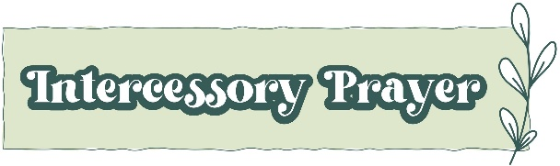

Sylvia Hine, Rees Jenkins, Ray Dempsey, Denny Hachenberg, Carlton Family, Gina Schmitz, Katie Pancione, Henry Pancione, Philip, Dasha and David Jenkins, Michael Ann Booth, Dagmar Schmitz Carlton, Jackie Hizel, Campbell Clark, Roger Bowen, John Marshall, Julie Herring, John Schroeder, Andrew Babcock, Jerry Dunwoody, Jimmy Smithson, Callie & Matt Owen, Mae Bradberry, James Fernandez, Stephen Patton, Scott McDaniel, Cathy Varidel, Esther & John Hussers and those that care for them.

NEXT WEEK the intercessory prayer will be “refreshed”; all names removed. If you wish to add someone, please call, or email the church office. Names will remain on the Prayer List for the entire month.

Military Prayer List:

Gordon Macy
Charles Lewis
Nolan Kelley
Davis Isley
Cherrie Shackelford

Andrew Hall
Ted Olney
Michael Blair
Steven Blair
Charlie Hardaker
Justin Yeary

Thomas Keefe
Ryan Holman
Johnny Crittenden
Sara Carver Thomas
Joshua Ingram
Jerrod Keplinger

Please remember to notify the church office when a service member is no longer on active duty.

Parish Wide ~ Service Day ~ Monday January 5th

Packing Backpack Buddies, partnering with Northwest Georgia Hunger Ministries
10am at 90 E. Callahan Street.
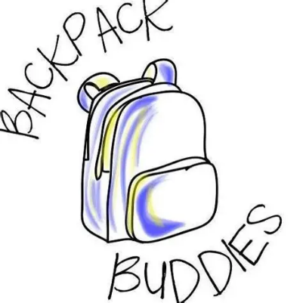

Backpack Buddies provide food for kid in school over weekend who may otherwise not have a meal.

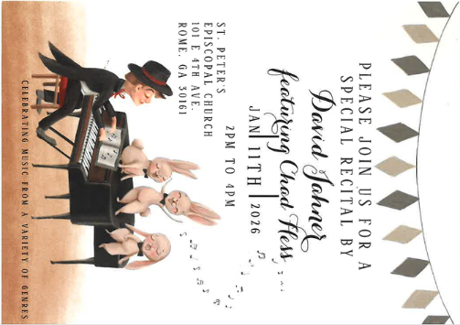
Please Join us for a Special Recital by

David Jahner
Featuring Chad Hess

January 11, 2026 ~ 2-4pm
Nave at St. Peter’s


Living Compass New Book group begins
January 5th
2pm at 401 E. 4th Ave

Etty Hillesum:
An Interrupted Life, the Diaries
1943-1943 & Letters from Westerbork.

"An Interrupted Life" is a poignant collection of diaries and letters by Etty Hillesum, chronicling her experiences as a Jewish woman during the Holocaust, reflecting her profound introspection and resilience in the face of adversity.



The next round of Bridges out of Poverty will begin on January 8, 2026, at St. Peter's Rome. This will be the first time St. Peter's has hosted. The expectation is that the group will meet for 24 weeks, ending the program around June 18th. It could go more quickly but will not go any longer than that date.
First Baptist Church Rome has hosted this program with financial & volunteer support from St. Peter's for several years. This is the first time our parish will be hosting the group in our building. It is a wonderful opportunity for this ministry to be engaged with the parish in a meaningful way!

There are several aspects of the program that need to be supported for Bridges to be a success.
We need volunteers in all these places/roles.

-First, there will need to be 4-6 drivers each week for residents of Davies Shelters (men’s and women’s houses) & Next Door who are participating. Investigators (the participants in the group) will need to be delivered to Daniel Hall by 6pm and picked up at 8:30pm. We would like to ask men to transport men and women to transport women. Some of the investigators will have their own transportation, so not everyone will need a ride.

-Secondly, there will need to be a meal for 15 every Thursday evening. This can be as simple as soup, salad, and dessert. The meal needs to be ready to be served at 6pm as the investigators arrive at Daniel Hall. We will utilize the Bridges Sign-Up Genuis for this and will share the link with you. David & I will cover the first couple of weeks.

-Third, there will possibly need to be childcare provided (if any of the investigators have children). At this time, we do not know if this will be a need. At least one person needs to be Safeguard trained. These children will be ages 1-12 years old.

Questions or to Volunteer in any of these capacities contact:
Devon Smyth, 770.714.2361
David Peters, 770.262.6017


Molly Steeves 28th
David Jauregui 28th
Allison Sheilds 29th
Grace Wooddell 29th
Gin Gunther 30th
Skye Wellesley 30th
Bill Banks 31st
Hannah Knowles 31st
Keri Smith 31st
Stephen Lewis 31st
Jimmy Kelley January 1st
Christopher Livesay 1st
Annalyn McPherson 1st
Garrett McPherson 1st
Sage Bell Jauregui 1st
Susan Dunwoody 2nd

St. Peter’s VOLUNTEERs are needed from 9am till noon. HOWEVER, if you are not able to work the full 3 hours, any time you can share is greatly appreciated.

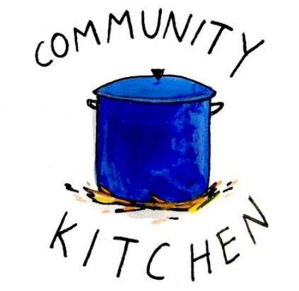
2025 Schedule
Friday Tuesday
August 22 26
September 26 30
October 24 28
November 21 25
December 26 30

Contact Nancy Hunter to volunteer to help, 706.506.3889. THANK YOU

Sponsored by Children’s Ministry


January 16th ~ 5:30-8pm
Drop off Daniel Hall, 5:25pm

Adults gather at Moes BBQ for Fellowship & Community
after you drop your children (infant – 5th grade) at the church.

Cost $10 per child OR $20 Family Maximum

RSVP by 1.12.2026 – church office or Katie, 770.714.1825.


Wish List for Children’s Ministry
https://www.amazon.com/hz/wishlist/ls/LOS24YTKY6Y4?ref_=wl_share


JANUARY 4th 11:15am in Daniel Hall
Children’s Ministry
VOLUNTEERS meeting

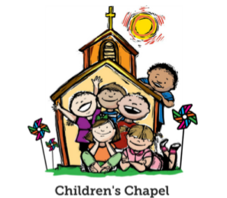
Children’s Chapel
Sundays, 9:50am

We will depart as a group from the nave and return during Peace to share Eucharist with our families.
Children’s Chapel is available for children aged Pre-K through 2nd grade.

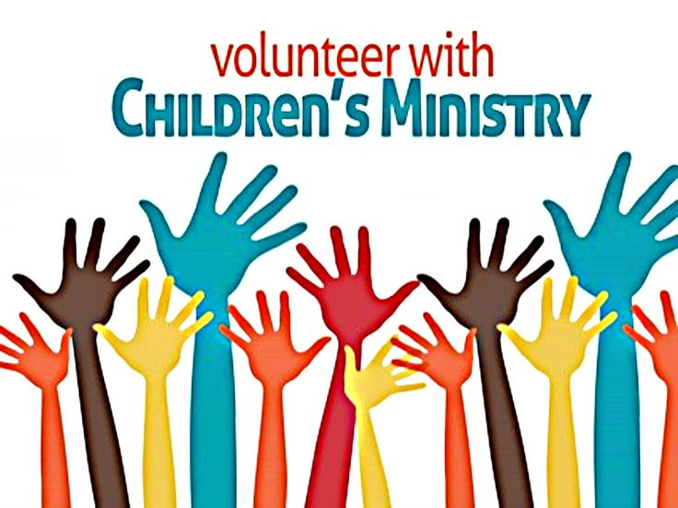
Hello everyone!
We need volunteers to fill our SPRING Children’s Chapel slots.

- Slots begin in January 2026
- YOU choose the Sunday(s) that fit your schedule
- Volunteers work in teams of 2
- Simple curriculum is provided
- Safeguarding certification is required for all parishioners that work with our children. You do NOT have to have certification to volunteer, just be certain to sign up as soon as possible to complete the training. Certification is completed via a zoom meeting.

If you have any questions about volunteering with the Children's Ministry do not hesitate to reach out to Katie Smyth, 770.714.1825.

Here is the link to volunteer for Children’s Chapel:
https://www.signupgenius.com/go/10C0E4AAAA829A3FFC70-57875256-202526

December | Monday | Tuesday | Wednesday | Thursday | Friday | Saturday
14 ADVENT 1II  8:15-11:45 Nursery provided  9:50am Children’s Chapel  8:30am – Rite I Chapel  9-10 Breakfast  10am – Rite II Nave, WLAQ/You tube  6pm EYC Progressive Dinner | 15  1pm Centering Prayer  2pm Living Compass Advent Study | 16  5:30pm Vestry Meeting  3 Rivers Nave,  7-8:30pm | 17  5:30pm Dinner begins  5:30pm Celtic Service  CATECHUMENATE, 6-7pm  7pm Adult Choir | 18  11am Bible Study | 19 | 20  4pm  3 Rivers Concert  Nave
21 ADVENT IV  8:15-11:45 Nursery provided  9:50am Children’s Chapel  8:30am – Rite I Chapel  10am – Rite II Nave, WLAQ/You tube | 22  1pm Centering Prayer  2pm Living Compass Advent Study | 23 | 24  EVE OF THE NATIVITY  5pm & 11pm | 25  10am Christmas Day Service in the Chapel | 26  Office Closed | 27
28  8:15-11:45 Nursery provided  9:50am Children’s Chapel  8:30am – Rite I Chapel  10am – Rite II Nave, WLAQ/You tube | 29 | 30  9am Staff Meeting | 31 | January 1  2026  Office Closed | 2  Office Closed | 3
4  8:15-11:45 Nursery provided  9:50am Children’s Chapel  8:30am – Rite I Chapel  9-10 Breakfast  10am – Rite II Nave, WLAQ/You tube  11:15am Children’s Ministry Volunteers Meeting in Daniel Hall | 5  1pm Centering Prayer  2pm Living Compass  Backpack Buddies Parish Wide Service Day  10am | 6  9am Staff Meeting  3 Rivers 7-8:30pm Nave  JSL 5:30-8:30 D.Hall | 7  5:30pm Dinner begins  5:30pm Celtic Service  6pm Jr. Choir  6:30-7:30pm ROOTS  CATECHUMENATE, 6-7pm  7pm Adult Choir | 8  6:30-3 Rivers R. Wyatt  6-8:30 Bridges D. Hall, Kitchen, nursery | 9  3:30-8:30 ESP D. Hall/Kitchen | 10
11  8:15-11:45 Nursery provided  9:50am Children’s Chapel  8:30am – Rite I Chapel  9-10 Breakfast  10am – Rite II Nave, WLAQ/You tube  2-4pm Recital David Jahner | 12  1pm Centering Prayer  2pm Living Compass | 13  7-8pm D. Jahner Meeting D. Hall  7-8:30pm Indivisible R. Wyatt  7-8:30pm Nave 3 Rivers | 14  5:30pm Dinner begins  5:30pm Celtic Service  6pm Jr. Choir  6:30-7:30pm ROOTS  CATECHUMENATE, 6-7pm  7pm Adult Choir | 15  6-8:30 Bridges D. Hall, Kitchen, nursery | 16  FAMILY NIGHT OUT  5-8:30pm  D. Hall | 17  2pm D.Hall/Kitchen Virginia McChesney

