
WELCOME TO ALL OUR VISITORS!
If you are interested in knowing more about St. Peter’s, please see an usher or one of the greeters who stand with the clergy after the service.

12.21.2025 at St. Peter’s
8:15am-11:45am Nursery
8:30am Holy Eucharist Rite I in Chapel
9:50am Children’s Chapel
10:00am Holy Eucharist Rite II in Nave, WLAQ radio & YouTube

This week…
Monday/December 22nd 1pm Centering Prayer
2pm Living Compass Advent Study group

Tuesday/December 23rd 9am Staff Meeting

Wednesday/December 24th 5pm Eve of the Nativity Service, nave
11pm Eve of the Nativity Service, nave

Thursday/December 25th 10am Christmas Service in the Chapel


Sylvia Hine, Rees Jenkins, Ray Dempsey, Denny Hachenberg, Carlton Family, Gina Schmitz, Katie Pancione, Henry Pancione, Philip, Dasha and David Jenkins, Michael Ann Booth, Dagmar Schmitz Carlton, Jackie Hizel, Marcia Smith, Campbell Clark, Roger Bowen, John Marshall, Julie Herring, John Schroeder, Andrew Babcock, Jerry Dunwoody, Jimmy Smithson, Callie & Matt Owen, Mae Bradberry, James Fernandez, Stephen Patton, Scott McDaniel, Cathy Varidel, Esther & John Hussers and those that care for them.

Beginning of each month the intercessory prayer was “refreshed”; all names removed. If you wish to add someone, please call, or email the church office. Names will remain on the Prayer List for the entire month.

Military Prayer List:

Gordon Macy
Charles Lewis
Nolan Kelley
Davis Isley
Cherrie Shackelford

Andrew Hall
Ted Olney
Michael Blair
Steven Blair
Charlie Hardaker
Justin Yeary

Thomas Keefe
Ryan Holman
Johnny Crittenden
Sara Carver Thomas
Joshua Ingram
Jerrod Keplinger

Please remember to notify the church office when a service member is no longer on active duty.

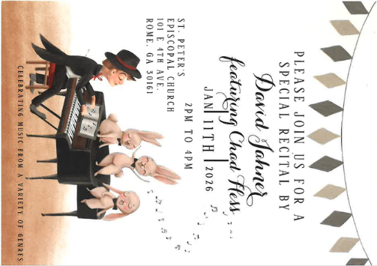
Please Join us for a Special Recital by

David Jahner
Featuring Chad Hess

January 11, 2026 ~ 2-4pm
Nave at St. Peter’s


Shelter Meal Teams

Once a month a team of 3 volunteers deliver a meal to one of our local shelters to feed those in need.

Won’t you consider being a SUBSTITUTE “on call” if needed?

Contact the church office OR Margaret Louttit if you are willing to give once a month to help those in need.
THANK YOU

Lisa Horton 21st

Larry Head 22nd
Cate Duvall 22nd
Gabe Van Meter 23rd
Marshall Jenkins 24th
Jean Stutts 25th
Sara Dangerfield 27th

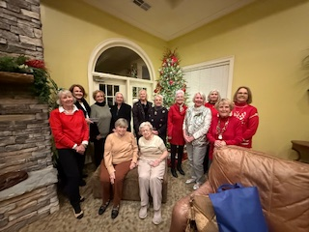
St. Paula’s Guild Christmas Gathering
12.14.2025

Time to UPDATE your family or individual PHOTO in Realm!

If you snap a great shot during the coming holidays don’t forget to text or email it to the church office.
We will update your photo in Realm.

Got a new address or contact info. Be certain to let the office know.
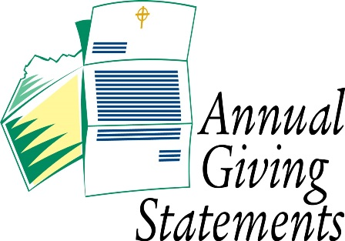
Pledge Balance needed?

Just contact the church office for your Annual or Capital Pledge balance.

Sponsored by Children’s Ministry


January 16th ~ 5:30-8pm
Drop off Daniel Hall, 5:25pm

Adults gather at Moes BBQ
for Fellowship & Community
after you drop your children (infant – 5th grade)
at the church.

Cost $10 per child OR $20 Family Maximum

RSVP by 1.12.2026 – church office or Katie, 770.714.1825.



Wish List for Children’s Ministry
https://www.amazon.com/hz/wishlist/ls/LOS24YTKY6Y4?ref_=wl_share



Eve of the Nativity Services
5pm and 11pm
Both services held in the Nave.

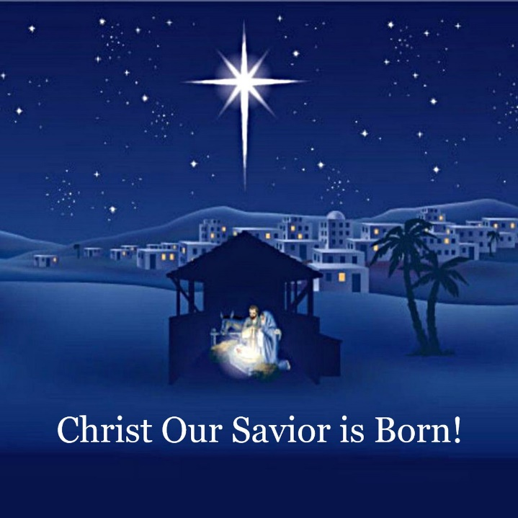

Christmas Day Service

10am
In the chapel

Office Closed Thursday, 12.25.2025 & Friday, 12.26.2026
St. Peter’s VOLUNTEERs are needed from 9am till noon. HOWEVER, if you are not able to work the full 3 hours, any time you can share is greatly appreciated.

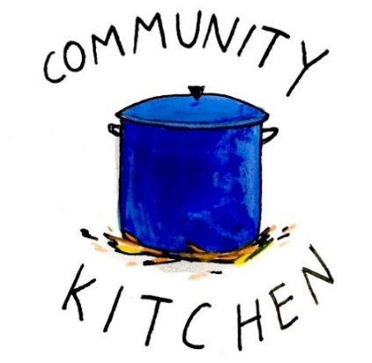
2025 Schedule
Friday Tuesday
August 22 26
September 26 30
October 24 28
November 21 25
December 26 30

Contact Nancy Hunter to volunteer to help, 706.506.3889. THANK YOU

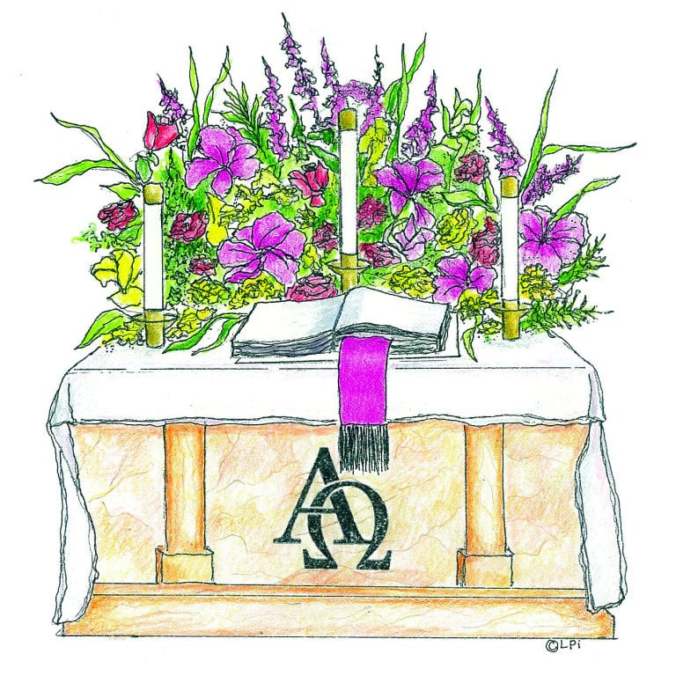
Advent Candles given to the Glory of God and in memory of Roy N. West by Mattie & Breck Paris.

Flowers on the Chapel altar given to the Glory of God and in memory of Randy Warley by D’Ann Downey.

Flowers on the Nave altar given to Glory of God.

Living Compass WILL meet 12.22.2025 but NOT on 12.29.2025

Centering Prayer WILL meet on 12.22.2025 but NOT on 12.29.2025.

Bible Study will NOT meet 12.25.2025 or 1.1.2026
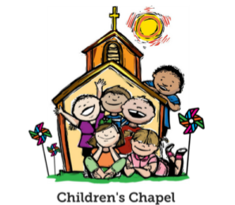
Children’s Chapel
Sundays, 9:50am

We will depart as a group from the nave and return during Peace to share Eucharist with our families.
Children’s Chapel is available for children aged Pre-K through 2nd grade.

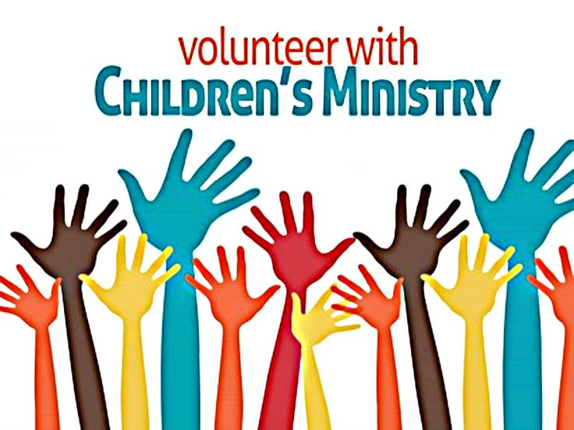
Hello everyone!
We need volunteers to fill our SPRING Children’s Chapel slots.

- Slots begin in January 2026
- YOU choose the Sunday(s) that fit your schedule
- Volunteers work in teams of 2
- Simple curriculum is provided
- Safeguarding certification is required for all parishioners that work with our children. You do NOT have to have certification to volunteer, just be certain to sign up as soon as possible to complete the training. Certification is completed via a zoom meeting.

If you have any questions about volunteering with the Children's Ministry do not hesitate to reach out to Katie Smyth, 770.714.1825.

Here is the link to volunteer for Children’s Chapel:
https://www.signupgenius.com/go/10C0E4AAAA829A3FFC70-57875256-202526

Fun with EYC at their Progressive Dinner last Sunday!
THANKS to everyone that prepared food or opened their home

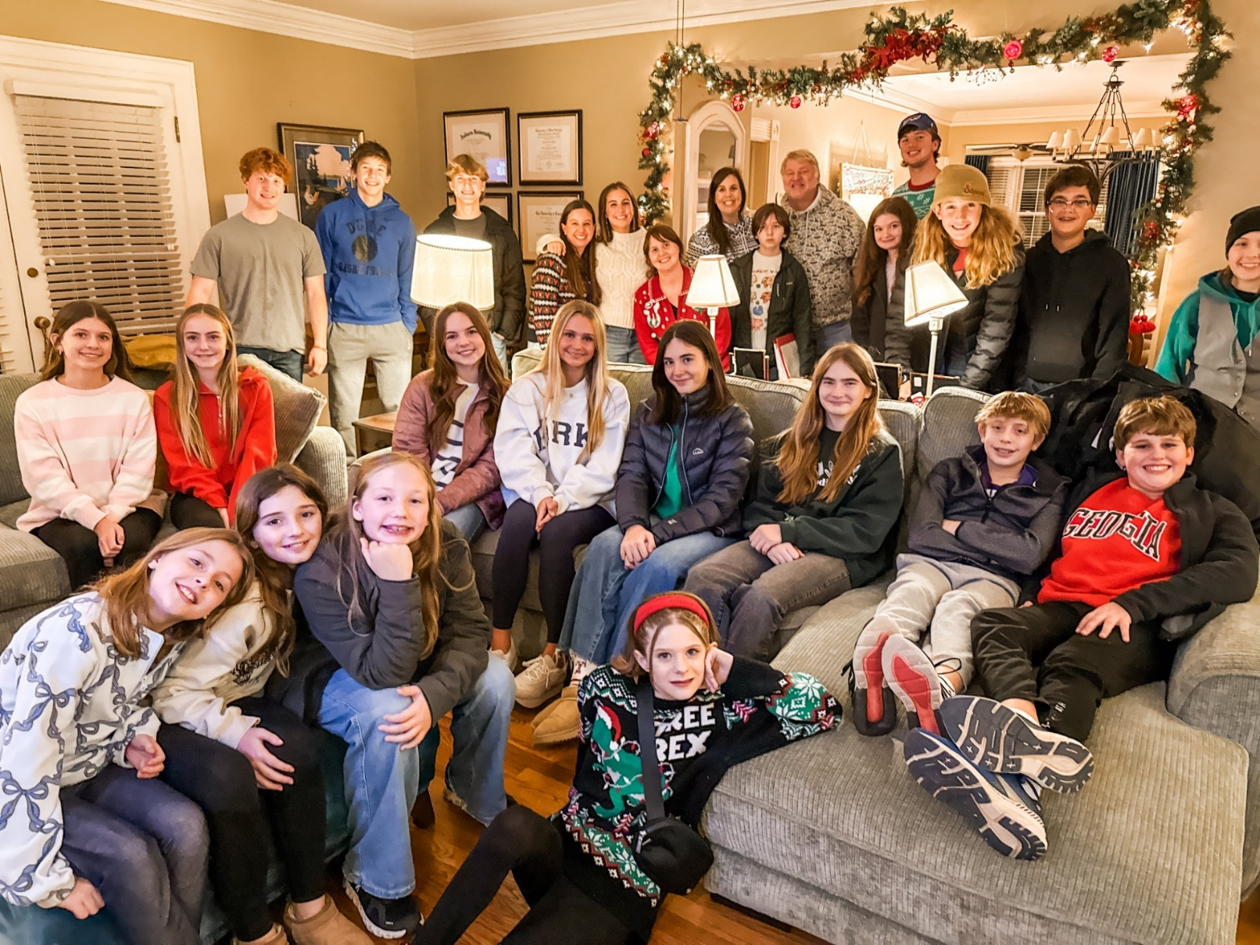

December | Monday | Tuesday | Wednesday | Thursday | Friday | Saturday
 | 1  1pm Centering Prayer  2pm Living Compass Advent Study | 2  3 Rivers Nave,  7-8:30pm | 3  5:30pm Dinner begins  5:30pm Celtic Service  6pm EYC Downtown Dinner  6-6:30 Jr. Choir  ROOTS 6:30-7:30  CATECHUMENATE, 6-7pm  7pm Adult Choir | 4  11am Bible Study | 5  8:30-11am Rome Council on Children  R Wyatt  11am Protz Funeral  4-8:30 ESP  D. Hall | 6  11am Anne Culpepper Funeral and Reception
7 ADVENT 1I  8:15-11:45 Nursery provided  9:50am Children’s Chapel  8:30am – Rite I Chapel  9-10 Breakfast  10am – Rite II Nave, WLAQ/You tube  4:30pm Gingerbread Houses | 8  1pm Centering Prayer  2pm Living Compass Advent Study | 9  ESP 4-7:30pm D. Hall  3 Rivers Nave,  7-8:30pm | 10  5pm Dinner begins  5:30pm Celtic Service  6pm Christmas Pageant in Nave  6:30pm Catechumenate  7pm Adult Choir | 11  11am Bible Study  3:30-5pm Stephen Ministry Supervision Meeting  3 Rivers 6:30pm  R. Wyatt | 12  4pm Gathering in honor of Brad Roberts in D. Hall | 13  11am – 1pm Habitat for Humanity  D. Hall & Kitchen
14 ADVENT 1II  8:15-11:45 Nursery provided  9:50am Children’s Chapel  8:30am – Rite I Chapel  9-10 Breakfast  10am – Rite II Nave, WLAQ/You tube  6pm EYC Progressive Dinner | 15  1pm Centering Prayer  2pm Living Compass Advent Study | 16  5:30pm Vestry Meeting  3 Rivers Nave,  7-8:30pm | 17  5:30pm Dinner begins  5:30pm Celtic Service  CATECHUMENATE, 6-7pm  7pm Adult Choir | 18  11am Bible Study | 19 | 20  4pm  3 Rivers Concert  Nave
21 ADVENT IV  8:15-11:45 Nursery provided  9:50am Children’s Chapel  8:30am – Rite I Chapel  10am – Rite II Nave, WLAQ/You tube | 22  1pm Centering Prayer  2pm Living Compass Advent Study | 23 | 24  EVE OF THE NATIVITY  5pm & 11pm | 25  10am Christmas Day Service in the Chapel | 26  Office Closed | 27
28  8:15-11:45 Nursery provided  9:50am Children’s Chapel  8:30am – Rite I Chapel  10am – Rite II Nave, WLAQ/You tube | 29 | 30 | 31 | January 1  2026  Office Closed | 2 | 3

