
WELCOME TO ALL OUR VISITORS!
If you are interested in knowing more about St. Peter’s, please see an usher or one of the greeters who stand with the clergy after the service.

12.14.2025 at St. Peter’s
8:15am-11:45am Nursery
8:30am Holy Eucharist Rite I in Chapel
9-10am Breakfast
9:50am Children’s Chapel
10:00am Holy Eucharist Rite II in Nave, WLAQ radio & YouTube
6pm EYC Progressive Dinner

This week…
Monday/December 15th Noon – RSVP for Wednesday Dinner
1pm Centering Prayer
2pm Living Compass Advent Study group
Tuesday/December 16th 9am Staff Meeting
5:30pm Vestry Meeting
Wednesday/December 10th 5:30pm Celtic Service in Chapel
5:30pm Dinner Service begins
6:30pm Catechumenate class in Rhodes Wyatt
7pm Adult Choir
Saturday/December 20th 5pm Three Rivers Singers Christmas Concert in Nave

Sylvia Hine, Rees Jenkins, Ray Dempsey, Denny Hachenberg, Carlton Family, Gina Schmitz, Katie Pancione, Henry Pancione, Philip, Dasha and David Jenkins, Michael Ann Booth, Dagmar Schmitz Carlton, Jackie Hizel, Marcia Smith, Campbell Clark, Roger Bowen, John Marshall, Julie Herring, John Schroeder, Andrew Babcock, Jerry Dunwoody, Jimmy Smithson, Callie & Matt Owen, Mae Bradberry, James Fernandez, Stephen Patton, Scott McDaniel, Cathy Varidel and those that care for them.

Beginning of each month the intercessory prayer was “refreshed”; all names removed. If you wish to add someone, please call, or email the church office. Names will remain on the Prayer List for the entire month.

Military Prayer List:

Gordon Macy
Charles Lewis
Nolan Kelley
Davis Isley
Cherrie Shackelford

Andrew Hall
Ted Olney
Michael Blair
Steven Blair
Charlie Hardaker
Justin Yeary

Thomas Keefe
Ryan Holman
Johnny Crittenden
Sara Carver Thomas
Joshua Ingram
Jerrod Keplinger

Please remember to notify the church office when a service member is no longer on active duty.


Poinsettias will be placed on the altars on Christmas Eve through January 4th.

If you wish to donate a poinsettia, please contact church office with the name(s) of your honorees.

Simply drop a check in mail, collection plate or remit electronically any amount and memo it Poinsettias.

Last Sunday at the Cathedral of St Philip
The following were presented:

Ridgley Hardaker Confirmation
Peggy Reiners Reception
John Reiners Reception

St Paula’s Guild


The widows of Maplewood, Marny Busbin, Barbara Dixon, Virginia Hunter, Kitty Johnston, Diann Kothe, Karen Smith, Frieda Yeary $ Beth Starnes invite you to a

Christmas gathering
at the Maplewood Lodge.
Sunday, December 14 from 5-7 PM.
The gate will open at 4:30 PM.

Please bring an appetizer for the table and a beverage of your choice.

If you are attending for the first time, please be our guest. No need to bring anything but yourself.

RSVP to Diane Nance only at 706-936-6006 by December 8.
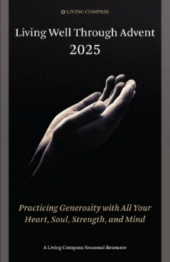
Living Compass Advent Study
Mondays 2pm at 401 E. 4th Avenue
December 1st
Pick up booklet in Daniel Hall or Nave


Joy Wooddell 14th
Meredith Cole 15th
Roger Smith 15th
Arly DuVall 15th
Mary Dixon 17th
Melissa Edwards 17th
Brian Kinder 18th
Thayer Manis 18th
Amelia Gilreath-Harvey 18th
Beth Starnes 19th
Drew Moss 19th
Sharon Norman 19th
Dale Carroll 20th
Lilli Tucker 20th
Diann Kothe 20th

Time to UPDATE your family or individual PHOTO in Realm!

If you snap a great shot during the coming holidays don’t forget to text or email it to the church office.
We will update your photo in Realm.

Got a new address or contact info. Be certain to let the office know.



Eve of the Nativity Services
5pm and 11pm
Both services held in the Nave.

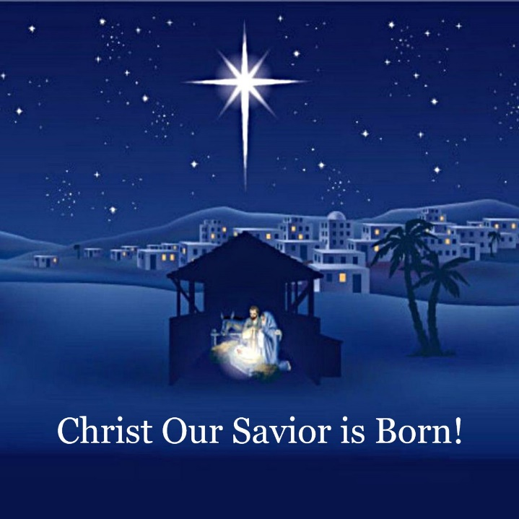
Christmas Day Service

10am
In the chapel

St. Peter’s VOLUNTEERs are needed from 9am till noon. HOWEVER, if you are not able to work the full 3 hours, any time you can share is greatly appreciated.

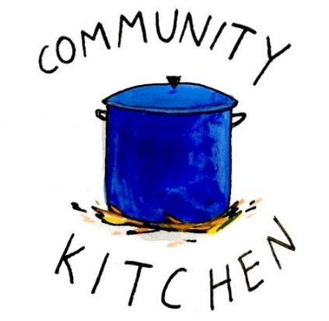
2025 Schedule
Friday Tuesday
August 22 26
September 26 30
October 24 28
November 21 25
December 26 30

Contact Nancy Hunter to volunteer to help, 706.506.3889. THANK YOU

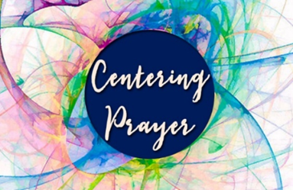
Centering Prayer
Mondays 1pm 401 East 4th Ave.
Available via Zoom as well.
Questions Contact Jane Cunningham, 706.346.4091 OR missjane1@mac.com


BIBLE STUDY
Thursday mornings 10-11am
The Gospel of John

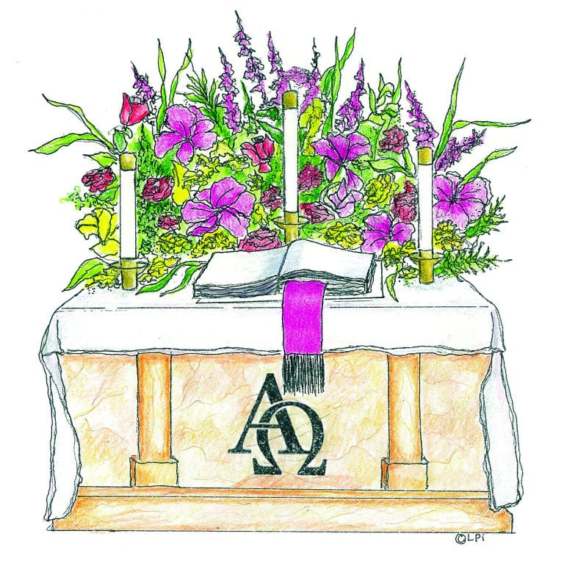
Advent Candles given to the Glory of God and in memory of Roy N. West by Mattie & Breck Paris.

Flowers on the Chapel altar given to the Glory of God and in memory of Jean & George Anderson, Everett Anderson, John Anderson, William Peter Anderson by Avis Anderson & Sam King.

Flowers on the Nave altar given to Glory of God and in memory of parents & grandparents of Mary & Stephen Patton.

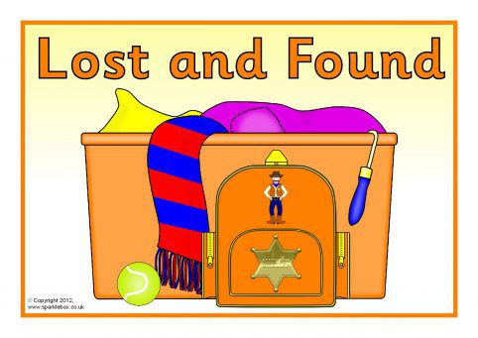
Leave Something at church by mistake?

Contact the church office
to see if it landed in the
LOST & FOUND.

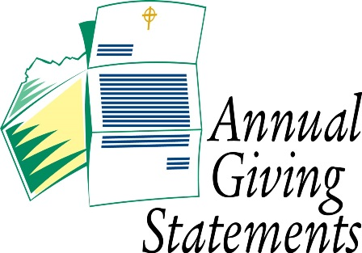
Pledge Balance needed?

Just contact the church office for your Annual or Capital Pledge balance.

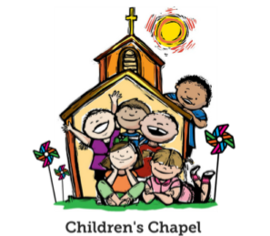
Children’s Chapel
Sundays, 9:50am

We will depart as a group from the nave and return during Peace to share Eucharist with our families.
Children’s Chapel is available for children aged Pre-K through 2nd grade.


Hello everyone!
We need volunteers to fill our SPRING Children’s Chapel slots.

- Slots begin in January 2026
- YOU choose the Sunday(s) that fit your schedule
- Volunteers work in teams of 2
- Simple curriculum is provided
- Safeguarding certification is required for all parishioners that work with our children. You do NOT have to have certification to volunteer, just be certain to sign up as soon as possible to complete the training. Certification is completed via a zoom meeting.

If you have any questions about volunteering with the Children's Ministry do not hesitate to reach out to Katie Smyth, 770.714.1825.

Here is the link to volunteer for Children’s Chapel:
https://www.signupgenius.com/go/10C0E4AAAA829A3FFC70-57875256-202526


Wish List for Children’s Ministry
https://www.amazon.com/hz/wishlist/ls/LOS24YTKY6Y4?ref_=wl_share
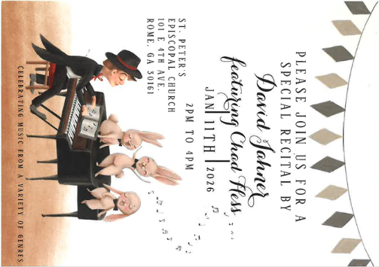
Please Join us for a Special Recital by

David Jahner
Featuring Chad Hess

January 11, 2026 ~ 2-4pm
Nave at St. Peter’s

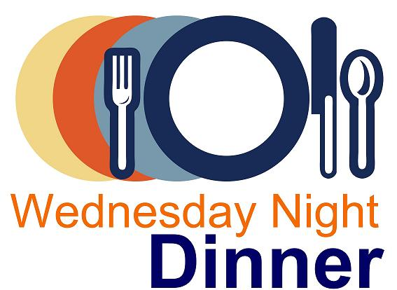
Wednesday Night Menu
General Dinner served 5:30-6:30pm in Daniel Hall

IF YOU NEED/WANT to eat at 5pm NO PROBLEM, just let us know when you make your reservation. Your plate will be ready!

Adults $10, Vegetarian $8, Kids menu $4
Family Maximum $25

Vegetarian/Gluten Free: Salad and rotating meatless burger patty OR hard-boiled egg. $8
Vegetarian: All 3 sides and rotating meatless burger patty OR hardboiled egg. $8

RESERVATIONS by NOON on Monday each week.
Call/email office, register on REALM, or sign and drop menu in offering plate.

12.17.2025
Brown Sugar Bourbon Baked Ham OR Champagne glazed Cornish Hen half with lemon.
Green Bean Bundles – Sweet Potato Casserole – Salad - Dinner roll –Coconut Cake
Kids – Mac N Cheese OR Pepperoni Pizza. Gingerbread cookie, Fruit, salad
Vegetarian or Vegetarian/Gluten Free meals served with hard boiled eggs

Name:
Drop in Collection plate OR deliver to church office.

December | Monday | Tuesday | Wednesday | Thursday | Friday | Saturday
 | 1  1pm Centering Prayer  2pm Living Compass Advent Study | 2  3 Rivers Nave,  7-8:30pm | 3  5:30pm Dinner begins  5:30pm Celtic Service  6pm EYC Downtown Dinner  6-6:30 Jr. Choir  ROOTS 6:30-7:30  CATECHUMENATE, 6-7pm  7pm Adult Choir | 4  11am Bible Study | 5  8:30-11am Rome Council on Children  R Wyatt  11am Protz Funeral  4-8:30 ESP  D. Hall | 6  11am Anne Culpepper Funeral and Reception
7 ADVENT 1I  8:15-11:45 Nursery provided  9:50am Children’s Chapel  8:30am – Rite I Chapel  9-10 Breakfast  10am – Rite II Nave, WLAQ/You tube  4:30pm Gingerbread Houses | 8  1pm Centering Prayer  2pm Living Compass Advent Study | 9  ESP 4-7:30pm D. Hall  3 Rivers Nave,  7-8:30pm | 10  5pm Dinner begins  5:30pm Celtic Service  6pm Christmas Pageant in Nave  6:30pm Catechumenate  7pm Adult Choir | 11  11am Bible Study  3:30-5pm Stephen Ministry Supervision Meeting  3 Rivers 6:30pm  R. Wyatt | 12  4pm Gathering in honor of Brad Roberts in D. Hall | 13  11am – 1pm Habitat for Humanity  D. Hall & Kitchen
14 ADVENT 1II  8:15-11:45 Nursery provided  9:50am Children’s Chapel  8:30am – Rite I Chapel  9-10 Breakfast  10am – Rite II Nave, WLAQ/You tube  6pm EYC Progressive Dinner | 15  1pm Centering Prayer  2pm Living Compass Advent Study | 16  5:30pm Vestry Meeting  3 Rivers Nave,  7-8:30pm | 17  5:30pm Dinner begins  5:30pm Celtic Service  CATECHUMENATE, 6-7pm  7pm Adult Choir | 18  11am Bible Study | 19 | 20  5pm  3 Rivers Concert  Nave
21 ADVENT IV  8:15-11:45 Nursery provided  9:50am Children’s Chapel  8:30am – Rite I Chapel  9-10 Breakfast  10am – Rite II Nave, WLAQ/You tube | 22  1pm Centering Prayer  2pm Living Compass Advent Study | 23 | 24  EVE OF THE NATIVITY  5pm & 11pm | 25  10am Christmas Day Service in the Chapel | 26  Office Closed | 27
28  8:15-11:45 Nursery provided  9:50am Children’s Chapel  8:30am – Rite I Chapel  9-10 Breakfast  10am – Rite II Nave, WLAQ/You tube | 29  1pm Centering Prayer | 30 | 31 | January 1  2026  Office Closed | 2 | 3

