
WELCOME TO ALL OUR VISITORS!
If you are interested in knowing more about St. Peter’s, please see an usher or one of the greeters who stand with the clergy after the service.

11.23.2025 at St. Peter’s
8:15am-11:45am Nursery
8:30am Holy Eucharist Rite I in Chapel
9-10am Breakfast
9:50am Children’s Chapel
10:00am Holy Eucharist Rite II in Nave, WLAQ radio & YouTube
11:15am ADULT FORUM – “Christ & Culture”

This week…
Tuesday/November 25 9am Staff Meeting
5:30pm Vestry Meeting, in Chapel
Wednesday/November 26 5:30pm Celtic Service in Chapel
Thursday & Friday Office Closed, Happy Thanksgiving

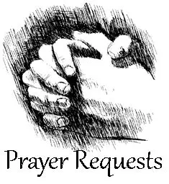
Sylvia Hine, Rees Jenkins, Ray Dempsey, Denny Hachenberg, Carlton Family, Gina Schmitz, Drew Moss, Stephen Patton,
Stoll Family, Amy, Robin, Katie Pancione, Henry Pancione, Philip, Dasha and David Jenkins, Bob Evans, Michale Ann Booth, Jackie Hizel, Marcia Smith, Jimmy Smithson,
John Schroeder, Andrew Babock, Jerry Dunwoody,
Campbell Clark, Callie & Matt Owen, Lisa Howse,
Rebecca Roberts, Julie Herring, Dina Penn, Lisa Frierson and those that care for them.

Beginning of each month the intercessory prayer is “refreshed”; all names removed. If you wish to add someone, please call, or email the church office. Names will remain on the Prayer List for the entire month.

Military Prayer List:

Gordon Macy
Charles Lewis
Nolan Kelley
Davis Isley
Cherrie Shackelford

Andrew Hall
Ted Olney
Michael Blair
Steven Blair
Charlie Hardaker
Justin Yeary

Thomas Keefe
Ryan Holman
Johnny Crittenden
Sara Carver Thomas
Joshua Ingram
Jerrod Keplinger

Please remember to notify the church office when a service member is no longer on active duty.

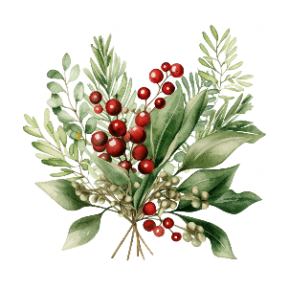
LIVE Greenery needed for
Advent wreaths.
Bring clippings from your garden NEXT SUNDAY, 11.30.2025
place in tub on stage of Daniel Hall.

Gifts of stock

If you are planning a STOCK gift to St. Peter’s for 2025 please begin the transfer process EARLY to ensure the final check is in the office by noon on 12.31.2025.

Gifts received after that date regardless of when you started the transaction will be posted as a 2026 gift.

St Paula’s Guild

The widows of Maplewood, Marny Busbin, Barbara Dixon, Virginia Hunter, Kitty Johnston, Diann Kothe, Karen Smith & Frieda Yeary invite you to a


Christmas gathering
at the Maplewood Lodge.
Sunday, December 14 from 5-7 PM.
The gate will open at 4:30 PM.

Please bring an appetizer for the table and a beverage of your choice.

If you are attending for the first time, please be our guest. No need to bring anything but yourself.

RSVP to Diane Nance only at 706-936-6006 by December 8.
Children’s Ministry
offers activities for everyone during the season of Advent….

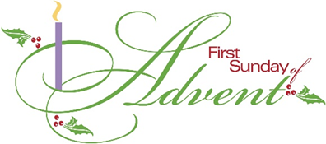
Make an Advent Wreath
Sunday, November 30th 4:30pm
Full kits (live or forever greenery)- $25
Candle sets only $10

FAMILY MOVIE NIGHT – November 30th for the entire parish. Elf will be shown in the EYC rooms and kid friendly movies/activities in Daniel Hall beginning at 5:30pm


Have some sweet fun decorating a Gingerbread House.
Sunday, December 7th 4:30pm
$20 for each house.

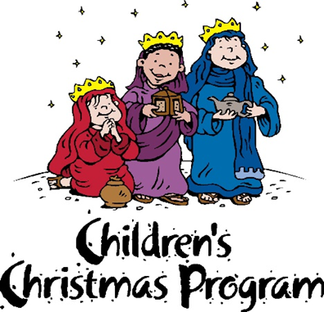
Christmas Pageant
Wednesday, December 10th
6pm in the Nave.

Dinner service begins at 5pm in Daniel Hall.
RSVP by Monday for Brunswick Stew or Baked Potato Bar with salad, cornbread. Kids Hotdog or Baked Potato bar.

Place your UNWRAPPED toys and books in the donation bin located in Daniel Hall.

SPECIAL NEED for boys & girls ages 10-12.

Thank you for making Christmas brighter for children in our community.


Donations needed for regular size tubes of toothpaste, BAR bath soap, and shampoo.
Bin located in Daniel Hall for donations. THANK YOU


Annette Morris-Banks 23rd
Ashton Stroud 24th
Peggy Rainer 25th
Patrick Wilson 26th
Nancy Lewis 26th
David Hicks 27th


2026 Pledge cards may be mailed, dropped in collection plate or simply EMAIL the church office with your annual pledge for 2026

St. Peter’s VOLUNTEERs are needed from 9am till noon. HOWEVER, if you are not able to work the full 3 hours, any time you can share is greatly appreciated.

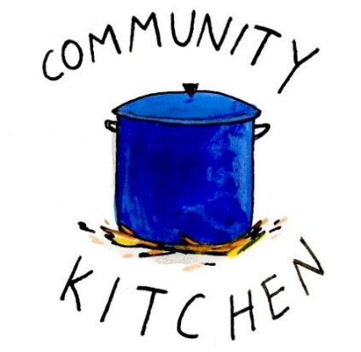
2025 Schedule
Friday Tuesday
August 22 26
September 26 30
October 24 28
November 21 25
December 26 30

Contact Nancy Hunter to volunteer to help, 706.506.3889. THANK YOU

If you need a current giving statement contact the church office, the final statements of the year will be emailed in early January.


November 23rd
Daniel Hall at 11:15am

“Christ and Culture”
Do the tasks and distractions of everyday life sometimes seem at odds with the guidance of Gospel lessons?
How does your faith influence your lifestyle and perspective?
Much of it comes down to how you relate your faith to secular culture.

According to Richard Niebuhr in his 20th Century classic, Christ and Culture, five basic orientations to living the Christian life in the world emerged over the course of two millennia.

In two Adult Forum sessions, Dr. Marshall Jenkins will lead participants in a brief overview of those orientations. Participants will learn to better understand the perspectives of Christians in differing traditions and appreciate the gifts each offers to everyone. Reflection on their own orientation to living the Christian life in a secular world will help participants identify the gifts they have to offer as well as growing edges in their spiritual formation.

COME JOIN OUR DISCUSSION

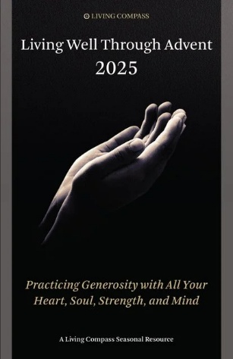
Living Compass Advent Study
Mondays 2pm at 401 E. 4th Avenue
December 1st

Pick up booklet in Daniel Hall or Nave

Junior Choir
Wednesday Nights

6-6:30pm in the Children’s Chapel
on 3rd Floor.

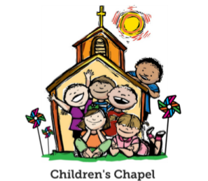
Children’s Chapel
Each Sunday, 9:50am.

We will depart as a group from the nave and return during Peace to share Eucharist with our families.
Children’s Chapel is available for children aged Pre-K through 2nd grade.


Volunteer as a Children’s Chapel Teacher.
Full curriculum provided.

Select the Sunday(s) that fit your schedule:
https://www.signupgenius.com/go/10C0E4AAAA829A3FFC70-57875256-202526
If you have questions, please contact: Katie Smyth, Children’s Ministry Coordinator. 770.714.1825 or kaydubs26@gmail.com

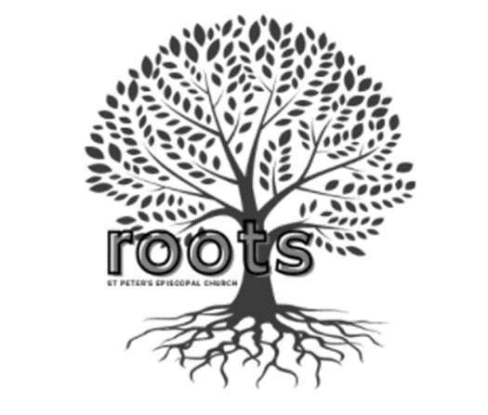
ROOTS~Wednesday Nights~6:30-7:30pm

PreK-1st grade – Wendy Williams & Margaret Louttit. Children’s Chapel room, 3rd floor.
2nd & 3rd grade – Katie Smyth & Diane Nance. Roots room, 4th floor.
4th & 5th grade – Bonnie Mitchell, David Smyth, Brian Hampton. Jr. EYC room 4th floor.
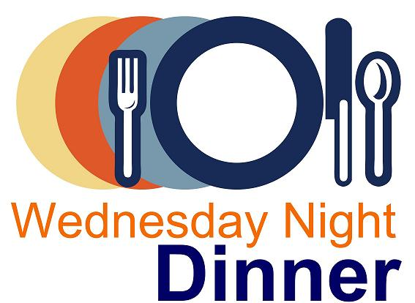
Wednesday Night Menu
General Dinner served 5:30-6:30pm in Daniel Hall

IF YOU NEED/WANT to eat at 5pm NO PROBLEM, just let us know when you make your reservation. Your plate will be ready!

Adults $10, Vegetarian $8, Kids menu $4
Family Maximum $25

Vegetarian/Gluten Free: Salad and rotating meatless burger patty OR hard-boiled egg. $8
Vegetarian: All 3 sides and rotating meatless burger patty OR hardboiled egg. $8

RESERVATIONS by NOON on Monday each week.
Call/email office, register on REALM, or sign and drop menu in offering plate.

12.3.2025
Fried Chicken OR Bacon Wrapped Pork Tenderloin
Pinto Beans – Buttered Rice – Collards. Corn Bread – Dessert, Pumpkin Crunch Cake
Kids – Mac N Cheese OR Pizza Balls. Fruit, Dessert
Vegetarian or Vegetarian/Gluten Free meals served with meatless burger patty

12.10.2025 – No Rehearsal Christmas Pageant
Brunswick Stew OR Bake Potato Bar. Both served with Green Salad, cornbread, cookies
Kids – Hotdogs OR Baked Potato with cookies

12.17.2025
Brown Sugar Bourbon Baked Ham OR Champagne glazed Cornish Hen half with lemon.
Green Bean Bundles – Sweet Potato Casserole – Salad - Dinner roll –Coconut Cake
Kids – Mac N Cheese OR Pepperoni Pizza. Gingerbread cookie, Fruit, salad
Vegetarian or Vegetarian/Gluten Free meals served with hard boiled eggs

Name:
Drop in Collection plate OR deliver to church office.
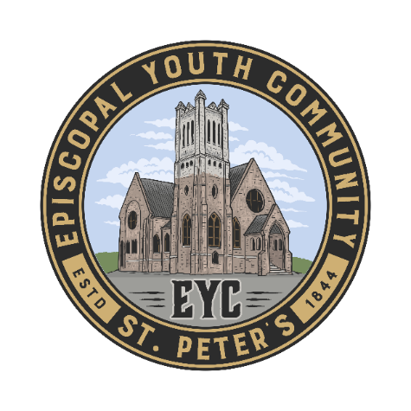
MEALS for EYC on Sunday Nights:

We have really enjoyed starting every EYC Sunday night by breaking bread together, and we would love to continue! You have been so kind to offer meals throughout the year. If you would like to cook, order or sponsor a meal, please sign up!

Use the link below to sign up.
https://www.signupgenius.com/go/10C084EACAB2FA5FCC43-50683016-eycsunday

THANK YOU FOR YOUR KINDNESS AND SUPPORT!

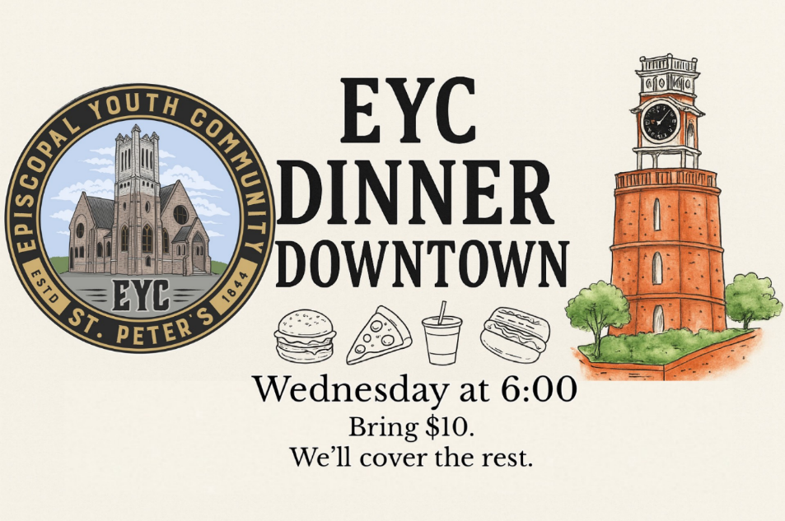
EYC DOWNTOWN DINNER

1st Wednesday each month.

Our next gathering will be December 3rd

6pm at the church and we will walk to our dinner designation.


Candles in the Nave given to the Glory of God by Sara Clark in loving memory of Rubin Clark and Chris Dendy.

Flowers on the Chapel altar given to the Glory of God and in memory of Willie Starnes.

Flowers on the Nave altar given to Glory of God by Charles & Lee Hight in memory of Alberta & Charles Hight, Esther & Charles Kimbrell and Anne Culpepper.

OPEN DATES Altar flowers/Candles:

Nave: Advent Candles for season $65
December Altar Candles $65
Chapel: Advent Candles for season, $65

Call or email church office to select your date.

Poinsettias will be placed on the altars on Christmas Eve through January 4th.

If you wish to donate a poinsettia, please contact church office with the name(s) of your honorees.

Simply drop a check in mail, collection plate or remit electronically any amount and memo it Poinsettias.

November | Monday | Tuesday | Wednesday | Thursday | Friday | Saturday
16  8:15-11:45 Nursery provided  9:50am Children’s Chapel  8:30am – Rite I Chapel  9-10 Breakfast  10am – Rite II Nave, WLAQ/You tube  11:15am Adult Forum – Christ & Culture  6-7:30pm EYC | 17  1pm Centering Prayer  2pm Living Compass  Canterbury Student Ministry meeting at Berry | 18  Vestry Meeting 5:30pm  JSL 5:30-8:30 D. Hall  3 Rivers Nave,  7-8:30pm | 19  5:30pm Dinner begins  5:30pm Celtic Service  6-6:30 Children’s Choir  ROOTS 6:30-7:30  CATECHUMENATE, 6-7pm  7pm Adult Choir | 20  10-11am Bible Study  3:30-5pm Stephen Ministry Supervision Meeting  JSL Sip & Paint  D. Hall 6-8pm | 21  8:30-11am Rome Council on Children  R Wyatt  4-8:30 ESP  D. Hall | 22  9am-12:30 ESP D. Hall
23  8:15-11:45 Nursery provided  9:50am Children’s Chapel  8:30am – Rite I Chapel  9-10 Breakfast  10am – Rite II Nave, WLAQ/You tube  11:15am Adult Forum – Christ & Culture | 24 | 25  3 Rivers Nave,  7-8:30pm | 26  5:30pm Celtic Service | 27  Happy Thanksgving  Office Closed | 28  Office Closed | 29
30 ~ ADVENT 1  8:15-11:45 Nursery provided  9:50am Children’s Chapel  8:30am – Rite I Chapel  9-10 Breakfast  10am – Rite II Nave, WLAQ/You tube  4:30pm Advent Wreaths  5:30pm Family Movie - Elf | December 1  1pm Centering Prayer  2pm Living Compass Advent Study | 2  3 Rivers Nave,  7-8:30pm | 3  5:30pm Dinner begins  5:30pm Celtic Service  6pm EYC Downtown Dinner  6-6:30 Children’s Choir  ROOTS 6:30-7:30  CATECHUMENATE, 6-7pm  7pm Adult Choir | 4 | 5  8:30-11am Rome Council on Children  R Wyatt  4-8:30 ESP  D. Hall | 6  11am Anne Culpepper Funeral and Reception
7 ADVENT 1I  8:15-11:45 Nursery provided  9:50am Children’s Chapel  8:30am – Rite I Chapel  9-10 Breakfast  10am – Rite II Nave, WLAQ/You tube  4:30pm Gingerbread Houses | 8  1pm Centering Prayer  2pm Living Compass Advent Study | 9  3 Rivers Nave,  7-8:30pm | 10  5:30pm Dinner begins  5:30pm Celtic Service  6pm Christmas Pageant in Nave  7pm Adult Choir | 11  3:30-5pm Stephen Ministry Supervision Meeting  3 Rivers 6:30pm  R. Wyatt | 12  4pm Gathering in honor of Brad Roberts in D. Hall | 13  11am – 1pm Habitat for Humanity  D. Hall & Kitchen
14 ADVENT 1II  8:15-11:45 Nursery provided  9:50am Children’s Chapel  8:30am – Rite I Chapel  9-10 Breakfast  10am – Rite II Nave, WLAQ/You tube  6pm EYC Progressive Dinner | 15  1pm Centering Prayer  2pm Living Compass Advent Study | 16  5:30pm Vestry Meeting  3 Rivers Nave,  7-8:30pm | 17  :30pm Dinner begins  5:30pm Celtic Service  6-6:30 Children’s Choir  ROOTS 6:30-7:30  CATECHUMENATE, 6-7pm  7pm Adult Choir | 18 | 19 | 20  Noon – 5pm  3 Rivers Concert  Nave

