
WELCOME TO ALL OUR VISITORS!
If you are interested in knowing more about St. Peter’s, please see an usher or one of the greeters who stand with the clergy after the service.

10.12.2025 at St. Peter’s
8:15am-11:45am Nursery
8:30am Holy Eucharist Rite I in Chapel
9-10am Breakfast in Daniel Hall
9:50am Children’s Chapel
10:00am Holy Eucharist Rite II in Nave, WLAQ radio & YouTube

This week…
Monday/October 13 Noon – RSVP CONSECRATION BRUNCH
1pm Centering Prayer, 401 E. 4th Ave
2pm Living Compass, 401 E. 4th Ave.
Tuesday/October 14 9am Staff Meeting
Wednesday/October 15 5:30pm Celtic Service in Chapel
7pm Adult Choir

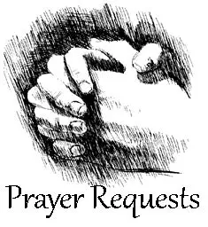
Thayer Manis, Henry Pancione, Katie Pancione, John Schroeder, Andre Babcock, Jerry Dunwoody, Robin, Amy, Stoll Family, Mary & Stephen Patton, Dina Pen, Drew Moss, Norman Fletcher, John Michael Criswell, John Marshall, Brad Roberts, Roy Alford, Lisa Frieerson, Duke Borchardt, Gina Schmitz, Carlton Family, Jimmy Smithson, Michael Ann Booth, Campbell Clark, Denny Hachenberg, Ray Dempsey, Rees Jenkins, Sylvia Hine and those that care for them.

First of each Month the intercessory prayer is “refreshed”; all names removed. If you wish to add someone, please call, or email the church office. Names will remain on the Prayer List for the entire month.

Wednesday dinner, roots & parenting conversations – Cancelled for 10.15.2025
Military Prayer List:

Gordon Macy
Charles Lewis
Nolan Kelley
Davis Isley
Cherrie Shackelford

Andrew Hall
Ted Olney
Michael Blair
Steven Blair
Charlie Hardaker
Justin Yeary

Thomas Keefe
Ryan Holman
Johnny Crittenden
Sara Carver Thomas
Joshua Ingram
Jerrod Keplinger

Please remember to notify the church office when a service member is no longer on active duty.


October 24th
5-8pm
Drop off in Daniel Hall.

Dinner, childcare & activities provided for infants-5th grade.
PARENTS meet at MOES BBQ for fellowship & community.
$10 per child OR $20 Maximum
RSVP by October 19th – Katie, 770.714.1825 OR church office

VOLUNTEERS NEEDED
St. Peter’s volunteers provide a meal for local shelters once a month.

WE NEED YOUR HELP


- Volunteer in this ministry and you will be placed on a TEAM that will plan a meal and coordinate the delivery to Ruth & Naomi or Davies Shelter.
- YOU only serve ONE TIME per year.

If you could help us out, please contact
Diane Nance at 706-936-6006.

Wednesday October 29th
5:30-7:30pm

Dinner reservations by noon Monday, 10.27.2025
Grilled Cheese sandwiches with Tomato Soup OR
Baked Potato Bar with all the fixings. Kids do not have a separate menu.

EYC will have their annual Haunted House
Children’s Ministry will have ceramic and foam pumpkin crafts
Carnival games: go fish, pin the paper on the mummy

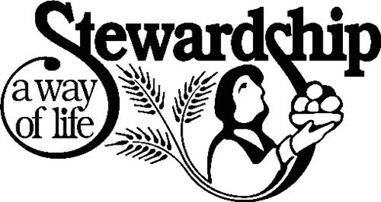
2025 Stewardship
in memory of
John Hine

Dates to remember:
10.12.2025 Sunday Stewardship Presentation by Gary Voccio

10.13.2025 RSVP’s for Consecration Brunch due by NOON MONDAY.
- Call or email church office to make your reservation
- No charge for brunch
- Cheesy egg casserole
- Sausage & Bacon
- Regular and GF Sweet Potato Pancakes
- Omelet bar with onions, peppers, spinach fillings
- Biscuit bar with butter, honey and Wicked Pimento Cheese.

10.19.2025 Stewardship Presentation – Emily Holcombe

10.26.2025 Consecration Sunday
- Speaker – Robert Nash
- Pledge cards are handed out for completion during both services.
- 11:15am Brunch served in Daniel Hall.
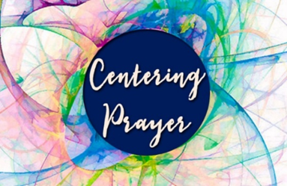
Centering Prayer
Mondays 1pm 401 East 4th Ave.
Available via Zoom as well.
Questions Contact Jane Cunningham, 706.346.4091 OR missjane1@mac.com


LIVING COMPASS
Mondays
2pm at 401 E. 4th Ave.


Russ Jennings 12th
Marni Neal 12th
Ronald Brendel 13th
John Kwist 15th
Ann Pullen 16th
Claudia Torres 16th
Meg Eberhart 18th
Clint Hubbard 18th
Kitty Johnston 18th

St. Peter’s VOLUNTEERs are needed from 9am till noon. HOWEVER, if you are not able to work the full 3 hours, any time you can share is greatly appreciated.

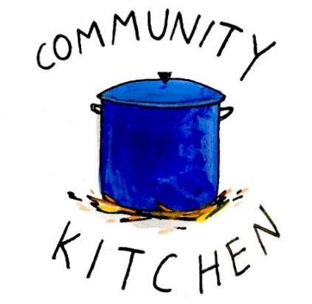
2025 Schedule
Friday Tuesday
August 22 26
September 26 30
October 24 28
November 21 25
December 26 30

Contact Nancy Hunter to volunteer to help, 706.506.3889. THANK YOU


Third Quarter Giving
Statements

Were emailed or mailed last week.

Review carefully, notify office of any problems. This is your LAST statement before the end of the year.

Considering membership or Baptism?

Mark your calendar to attend
Catechumenate classes

November 5th – 19th
All welcome
See what Catechumenate is about.

Actual classes begin December 3rd
6-7pm on Wednesday Nights
For Adults considering….

- Membership through Confirmation
- Membership through Reception
- Re-Affirmation
- Baptism for themselves or their children


BIBLE STUDY
Thursday mornings 10-11am
The Gospel of John

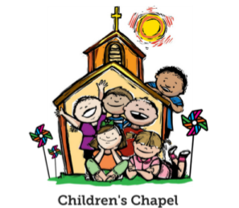
Children’s Chapel
Each Sunday, 9:57am.

We will depart as a group from the nave and return during Peace to share Eucharist with our families.

Children’s Chapel is available for children aged Pre-K through 2nd grade.


Volunteer as a Children’s Chapel Teacher.

Full curriculum provided.

Select the Sunday(s) that fit your schedule:
https://www.signupgenius.com/go/10C0E4AAAA829A3FFC70-57875256-202526

If you have questions, please contact: Katie Smyth, Children’s Ministry Coordinator. 770.714.1825 or kaydubs26@gmail.com


MEN’s restroom on the 1st floor of the Hight Building next to Daniel Hall will be CLOSED through the end of September to complete the remodel plans.

EVERYONE uses the Women’s during this time.

ROOTS – Wednesday Nights
6:30-7:30pm

PreK-1st grade – Wendy Williams & Margaret Louttit. Children’s Chapel room, 3rd floor.
2nd & 3rd grade – Katie Smyth & Diane Nance. Roots room, 4th floor.
4th & 5th grade – Bonnie Mitchell, David Smyth, Brian Hampton. Jr. EYC room 4th floor.


Junior Choir
Wednesday Nights

6-6:30pm in the Children’s Chapel on 3rd Floor.

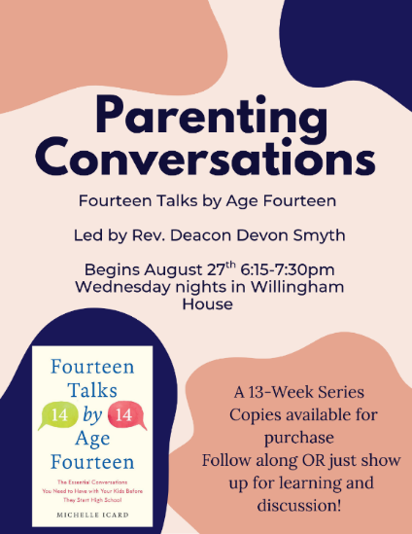
A NEW OFFERING
for adults on
Wednesday Nights

Will NOT meet
October 15th and October 29th

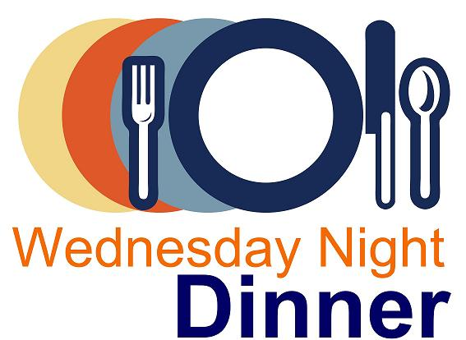
Wednesday Night Menu
General Dinner served 5:30-6:30pm in Daniel Hall

IF YOU NEED/WANT to eat at 5pm NO PROBLEM, just let us know when you make your reservation. Your plate will be ready!

Adults $10, Vegetarian $8, Kids menu $4
Family Maximum $25

Vegetarian/Gluten Free: Salad and rotating meatless burger patty OR hard-boiled egg. $8
Vegetarian: All 3 sides and rotating meatless burger patty OR hard boiled egg. $8

RESERVATIONS by NOON on Monday each week.
Call/email office, register on REALM, or sign and drop menu in offering plate.

10.15.2025 CANCELLED due to cancellation of Roots, Parenting classes.

10.22.2025
Chicken/Sausage Jambalaya OR Stuffed Peppers. Salad, Corn Maque Choux (corn/onions/peppers/tomatoes), Roasted Asparagus with cheese & tomatoes
Cuban Garlic Bread – Dessert, Bread Pudding
Kids – Pepperoni Pizza OR Chicken nuggets. Carrot chips/ranch, fruit
Vegetarian or Vegetarian/Gluten Free meals served with hard boiled eggs

10.29.2025 – All Hallows Eve Celebration
Grilled Cheese with Tomato Soup OR Baked Potato with all the fixings on the side. Dessert
NO separate kids menu. Vegetarian/gluten free Baked Potato with meatless burger patty.

11.5.2025
Chicken N Dressing with poultry gravy OR Hamburger Steak, choose 1
Southern Green Beans – Candid Yams – Dressing – Cranberry Sauce, choose 2
Dinner Roll – Dessert, Pecan Pie
Kids – Chicken Tenders OR PBJ Sandwich. Fruit, Green Beans, dessert fruit
Vegetarian or Vegetarian/Gluten Free meals served with hard boiled eggs

Name:
Drop in Collection plate OR deliver to church office.
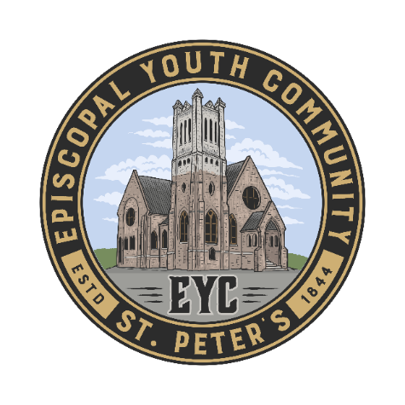
MEALS for EYC on Sunday Nights:

We have really enjoyed starting every EYC Sunday night by breaking bread together, and we would love to continue! You have been so kind to offer meals throughout the year. If you would like to cook, order or sponsor a meal, please sign up!

Use the link below to sign up.
https://www.signupgenius.com/go/10C084EACAB2FA5FCC43-50683016-eycsunday

THANK YOU FOR YOUR KINDNESS AND SUPPORT!

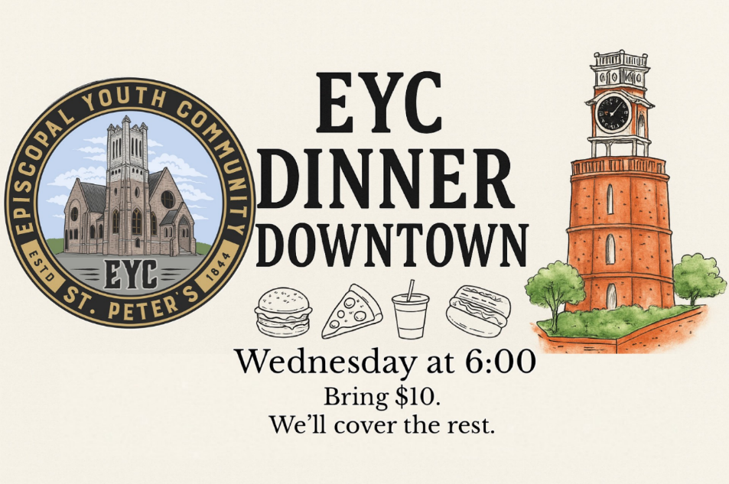
EYC DOWNTOWN DINNER

1st Wednesday each month.

Our next gathering will be November 5th

6pm at the church and we will walk to our dinner designation.

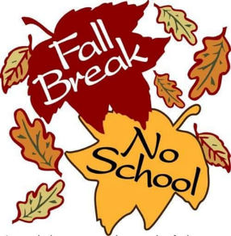

EYC will NOT meet October 12th due to Fall Break!


Candles in the Nave given to the Glory of God and in loving memory of William A. Byars, Sr., Janice A. Byars and William M. Byars, Jr. by Lee and Becky Jones.

Flowers on the Chapel altar given to the Glory of God.

Flowers on the Nave altar given to Glory of God Belinda Martin in Thanksgiving for Carolyn and Barry Shinall.

OPEN DATES for altar flowers:

Chapel: October 19th or November 30th
Cost $100.00
Nave: November 30th Cost $150.00

Call or email church office to select your date.


Eucharistic Visitors are trained parishoners who provide communion to those in the parish that are homebound.

If you know of anyone that would benefit from a visit please contact the church office or Hugh Bonner, 315.491.3838


Capital Campagin
Project List

Thank you to everyone that supported and continue to support the Capital Campaign.

- New Roof on nave, chapel and Daniel Hall
- New windows installed in the Hight Building and Daniel Hall
- Re-Plumbing of galvanized pipes in Church & Willingham House
- New Ceiling Tiles in Hight Building
- Scrapping and painting of Nave
- Painting of interior of Hight Building
- Cleaning of the exterior stone
- New cabinets and counter tops in kitchen and beverage bar

Still to come…..
- New Flooring in Hight Building
- Facelift of the Hight Building Bathrooms.
  - MEN’s restroom on 1st floor CLOSED
- Replace flooring in Daniel Hall

During the process we would like to ask for everyone to be patient, gracious and understanding!

Allien McNair & Greg Tarter, chairs of Building & Grounds


Join us online if you are unable to worship in person…..

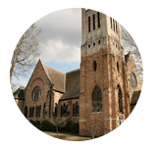
Youtube channel @StPetersRomeGA1844.

Click the picture of the church.
Then simply choose LIVE and then select the service you wish to view.


Do YOU have a VENMO Account?
You may use it to remit payments to the church.

ALWAYS include a note/memo to identify how to credit the payment, for example:
- Annual Pledge payment
- Wednesday Dinner
- Easter Lily
- Capital Pledge payment
https://venmo.com/u/StPeters-EpiscopalChurch


MEMO all payments with instructions to ensure proper designation of your gift.

For example, Capital OR Annual pledge, Altar flowers, etc. THANK YOU

October | Monday | Tuesday | Wednesday | Thursday | Friday | Saturday
 |  |  | 1  5:30pm Dinner begins  5:30pm Celtic Service  6-6:30 Children’s Choir  6pm EYC Schroeders  ROOTS 6:30-7:30  Parenting Conversations  6:15-7:30pm  7pm Adult Choir | 2  10-11am Bible Study  4-6pm Stephen Ministry Supervision meeting R. Wyatt | 3 | 4
5  8:15-11:45 Nursery provided  9-10am BREAKFAST in Daniel Hall  9:57am Children’s Chapel  8:30am – Rite I Chapel  10am – Rite II Nave, WLAQ/You tube  4pm Blessing of the Animals  6-7:30pm EYC  STEWARDSHIP – David Ledbetter | 6  Canterbury Student Ministry meeting at Berry | 7  Bridges 10:30-12:30 D.Hall/Kitchen  3 Rivers 7-8:30 Nave  Indivisible 4-8:30  Daniel Hall | 8  5:30pm Dinner begins  5:30pm Celtic Service  ROOTS 6pm  Parenting Conversations 6pm | 9  10am Bible Study  3 Rivers 6:30 R. Wyatt | 10 | 11
12  8:15-11:45 Nursery provided  9-10am BREAKFAST in Daniel Hall  9:57am Children’s Chapel  8:30am – Rite I Chapel  10am – Rite II Nave, WLAQ/You tube  STEWARDSHIP – Gary Voccio | 13  Canterbury Student Ministry meeting at Berry  Reservations Due for Consecration Brunch on 10.26.2025 | 14  Bridges 10:30-12:30 D.Hall/Kitchen | 15  :305pm Dinner begins  5:30pm Celtic Service  6-6:30 Children’s Choir  ROOTS 6:30-7:30  Parenting Conversations  6:15-7:30pm  7pm Adult Choir | 16  10-11am Bible Study | 17 | 18  RSVP’s DUE for Parents Night Out
19  8:15-11:45 Nursery provided  9-10am BREAKFAST in Daniel Hall  9:57am Children’s Chapel  8:30am – Rite I Chapel  10am – Rite II Nave, WLAQ/You tube  6-7:30pm EYC  STEWARDSHIP – Emily Holcombe | 20  Canterbury Student Ministry meeting at Berry | 21  JSL 5:30-8:30 D. Hall  Bridges 10:30-12:30 D.Hall/Kitchen | 22  5:30pm Dinner begins  5:30pm Celtic Service  6-6:30 Children’s Choir  ROOTS 6:30-7:30  Parenting Conversations  6:15-7:30pm  7pm Adult Choir | 23  10-11am Bible Study  4-6pm Stephen Ministry Supervision Mtg  ESP 4-7:30pm D. Hall | 24  Parents Night Out  5-8pm | 25  Wright Wedding 4pm in Nave
26  CONSECRATION SUNDAY  8:15-11:45 Nursery provided  9:57am Children’s Chapel  8:30am – Rite I Chapel, pledge cards  10am – Rite II Nave, pledge cards  WLAQ/You tube  11:15 BRUNCH – Daniel Hall  6-7:30pm EYC | 27  Canterbury Student Ministry meeting at Berry | 28 | 29  ALL HALLOWS EVE  5:30-7:30pm | 30 | 31  8:30-11am Rome Council on Children  R Wyatt

