
WELCOME TO ALL OUR VISITORS!
If you are interested in knowing more about St. Peter’s, please see an usher or one of the greeters who stand with the clergy after the service.

9.28.2025 at St. Peter’s
8:15am-11:45am Nursery
8:30am Holy Eucharist Rite I in Chapel
9-10am Breakfast in Daniel Hall
9:57am Children’s Chapel
10:00am Holy Eucharist Rite II in Nave, WLAQ radio & YouTube
11:15am Episcopal Community Foundation information, Daniel Hall

This week…
Monday/September 29 NOON Reservations for Wed. Dinner Due
1pm Centering Prayer, 401 E. 4th Ave
2pm Living Compass, 401 E. 4th Ave.
Tuesday/September 30 9-Noon Community Kitchen Volunteers
9am Staff Meeting
Wednesday/October 1 5pm Dinner service begins in Daniel Hall
5:30pm Celtic Service in Chapel
6pm EYC dinner at Schroeders
6-6:30pm Junior Choir
6:15-7:30pm Parenting Conversations – Willingham house
6:30-7:30pm Roots
7pm Adult Choir
Thursday/October 2 10am Bible Study in Daniel Hall, Gospel of John
4-6pm Stephen Ministry Supervision meeting

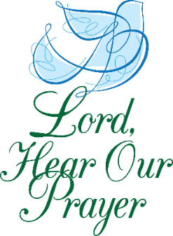
Sylvia Hine, Rees Jenkins, Ray Dempsey, Mary Louise Lever, Denny Hachenbrg, Campbell Clark, Michael Ann Booth, Jimmy Smithson, Jerry Dunwoody, Andrew Babcock, Katie Pancione, Henry Pancione, Craig Justice, Lisa Howse, Carlton Family, Dagmar Schmitz Carlton, Gina Schmitz, Carl Neal, Jennifer Neal, Skip Howse, John Schroeder, Duke Borchardt, Lisa Frierson, Roy Alford, Brad Roberts, John Marshall, John Michael Criswell, Norman Fletcher and those that care for them.
NEXT WEEK the intercessory prayer will be “refreshed”; all names removed. If you wish to add someone, please call, or email the church office. Names will remain on the Prayer List for the entire month.

Military Prayer List:

Gordon Macy
Charles Lewis
Nolan Kelley
Davis Isley
Cherrie Shackelford

Andrew Hall
Ted Olney
Michael Blair
Steven Blair
Charlie Hardaker
Justin Yeary

Thomas Keefe
Ryan Holman
Johnny Crittenden
Sara Carver Thomas
Joshua Ingram
Jerrod Keplinger

Please remember to notify the church office when a service member is no longer on active duty.


October 24th
5-8pm
Drop off in Daniel Hall.

Dinner, childcare & activities provided for infants-5th grade.
PARENTS meet at MOES BBQ for fellowship & community.
$10 per child OR $20 Maximum
RSVP by October 19th – Katie, 770.714.1825 OR church office

2025 Stewardship
in memory of
John Hine

Dates to remember:
9.28.2025 Sunday Stewardship Presentation by Mark Jones

10.5.2025 Sunday Stewardship Presentation by David Ledbetter

10.12.2025 Sunday Stewardship Presentation by Gary Voccio

10.13.2025 RESERVATIONS for Consecration Bruch due by NOON. No charge for brunch.

10.19.2025 Stewardship Presentation – Emily Holcombe

10.26.2025 Consecration Sunday
- Speaker – Robert Nash
- Pledge cards handed out for completion during both services.
- 11:15am Brunch served in Daniel Hall.


Congratulations of the Parish extended on the birth of Charles “Charlie” Alan Knight on September 11, 2025. He is the Great-grandson of Frances Knight, grandson of Nancy & Jack Knight, nephew to Katherine & Will Patterson, and
parents are Lilly and Cliff Knight.


VOLUNTEERS NEEDED
St. Peter’s volunteers provide a meal for local shelters once a month.

WE NEED YOUR HELP

- Volunteer in this ministry and you will be placed on a TEAM that will plan a meal and coordinate the delivery to Ruth & Naomi or Davies Shelter.
- YOU only serve ONE TIME per year.


If you could help us out, please contact
Diane Nance at 706-936-6006.


BIBLE STUDY
Thursday mornings 10-11am
The Gospel of John

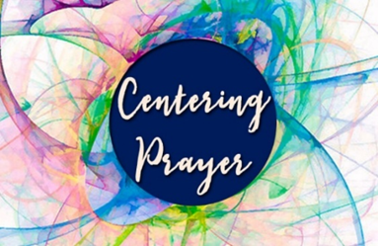
Centering Prayer
Mondays 1pm 401 East 4th Ave.
Available via Zoom as well.
Questions Contact Jane Cunningham, 706.346.4091 OR missjane1@mac.com


LIVING COMPASS
begins a NEW STUDY
September 15th
2pm at 401 E. 4th Ave.


Stephen Patton 28th
Jen Cromer 28th
Emi Grace Wood 29th
Daniel Pugh 30th
David Hunter October 1st
Jesse Stoll 1st
Ryan Murphy 2nd
Patti Brown 3rd
Lucas Herring 4th


Wednesday October 29th
Dinner and more!

Save the Date

Considering membership or Baptism ?

Mark your calendar to attend
Catechumenate classes

November 5th – 19th
All welcome
See what Catechumenate is about.

Actual classes begin December 3rd
6-7pm on Wednesday Nights
For adults considering….

- Membership through Confirmation
- Membership through Reception
- Re-Affirmation
- Baptism for themselves or their children


Sunday, 9.28.2025, the Episcopal Community Foundation for Middle and North Georgia will lead an informational session on the spiritual and material importance of supporting the poor and oppressed through legacy giving.

Join us at 11:15am in Daniel Hall to learn more about how ECF and St. Peter’s can continue serving the least among us through bequests, gifts from IRAs, life income gifts, and more. Everyone needs an estate strategy, and estates of every size can make a lasting contribution to help the church continue loving like Jesus.

St. Peter’s VOLUNTEERs are needed from 9am till noon. HOWEVER, if you are not able to work the full 3 hours, any time you can share is greatly appreciated.

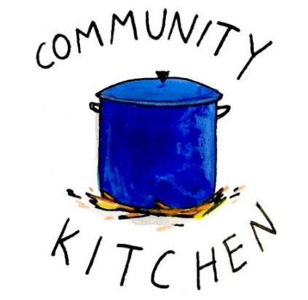
2025 Schedule
Friday Tuesday
August 22 26
September 26 30
October 24 28
November 21 25
December 26 30

Contact Nancy Hunter to volunteer to help, 706.506.3889. THANK YOU

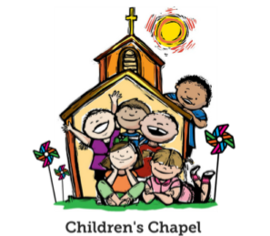
Children’s Chapel
Each Sunday, 9:57am.

We will depart as a group from the nave and return during Peace to share Eucharist with our families.

Children’s Chapel is available for children aged Pre-K through 2nd grade.


Volunteer as a Children’s Chapel Teacher.

Full curriculum provided.

Select the Sunday(s) that fit your schedule:
https://www.signupgenius.com/go/10C0E4AAAA829A3FFC70-57875256-202526

If you have questions, please contact: Katie Smyth, Children’s Ministry Coordinator. 770.714.1825 or kaydubs26@gmail.com


MEN’s restroom on the 1st floor of the Hight Building next to Daniel Hall will be CLOSED through the end of September to complete the remodel plans.

EVERYONE uses the Women’s during this time.

ROOTS – Wednesday Nights
6:30-7:30pm

PreK-1st grade – Wendy Williams & Margaret Louttit. Children’s Chapel room, 3rd floor.
2nd & 3rd grade – Katie Smyth & Diane Nance. Roots room, 4th floor.
4th & 5th grade – Bonnie Mitchell, David Smyth, Brian Hampton. Jr. EYC room 4th floor.


Junior Choir
Wednesday Nights,

6-6:30pm in the Children’s Chapel on 3rd Floor.

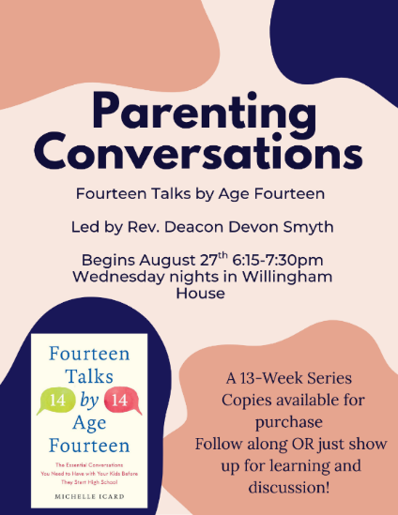
A NEW OFFERING
for adults on
Wednesday Nights

Will NOT meet on October 8th
or October 29th


Wednesday Night Menu
Dinner served 5:30-6:30pm in Daniel Hall
Adults $10, Vegetarian $8, Kids menu $4
Family Maximum $25

Vegetarian/Gluten Free: Salad and rotating meatless burger patty OR hard-boiled egg. $8
Vegetarian: All 3 sides and rotating meatless burger patty OR hard boiled egg. $8

RESERVATIONS by NOON on Monday each week.
Call/email office, register on REALM, or sign and drop menu in offering plate.

10.1.2025
Braised Beef Brisket OR Smoked Chicken
Salad – Braised Cabbage/Onions – German Potato Salad
Garlic Bread – Dessert, German Chocolate Cake
Kids – Ham & Cheese Sandwich OR Meatballs with pasta. Carrot Chips, Fruit
Vegetarian or Vegetarian/Gluten Free meals served with meatless burger patty.

10.8.2025
Grilled Beer Brats OR Stuffed Chicken
Cucumber Salad – Sauerkraut – Herb Roasted Veggies
Beer Bread – Dessert, Apple Strudel
Kids – Hot dog OR Chicken Tenders. Fruit, celery w/ranch
Vegetarian or Vegetarian/Gluten Free meals served with hard-boiled eggs

10.15.2025
Pork Schnitzel OR Alice Spring Chicken (bacon, cheese & BBQ sauce)
Salad – Sweet n Sour red cabbage – Spaetzle. Dinner Roll – Dessert, Brownies
Kids – Cheese Pizza OR Pasta with red sauce. Pudding, fruit, salad
Vegetarian or Vegetarian/Gluten Free meals served with meatless burger patty

10.22.2025
Chicken/Sausage Jambalaya OR Stuffed Peppers. Salad, Corn Maque Choux (corn/onions/peppers/tomatoes), Roasted Asparagus with cheese & tomatoes
Cuban Garlic Bread – Dessert, Bread Pudding
Kids – Pepperoni Pizza OR Chicken nuggets. Carrot chips/ranch, fruit
Vegetarian or Vegetarian/Gluten Free meals served with hard boiled eggs

Name:
Drop in Collection plate OR deliver to church office.
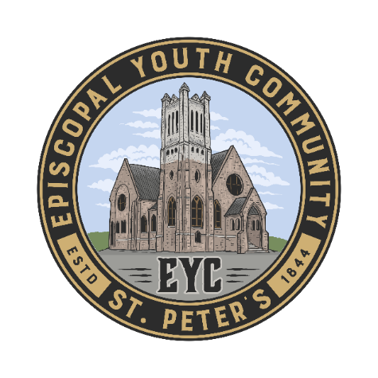
MEALS for EYC on Sunday Nights:

We have really enjoyed starting every EYC Sunday night by breaking bread together, and we would love to continue! You have been so kind to offer meals throughout the year. If you would like to cook, order or sponsor a meal, please sign up!

Use the link below to sign up.
https://www.signupgenius.com/go/10C084EACAB2FA5FCC43-50683016-eycsunday

THANK YOU FOR YOUR KINDNESS AND SUPPORT!

NEXT WEDNESDAY October 3rd

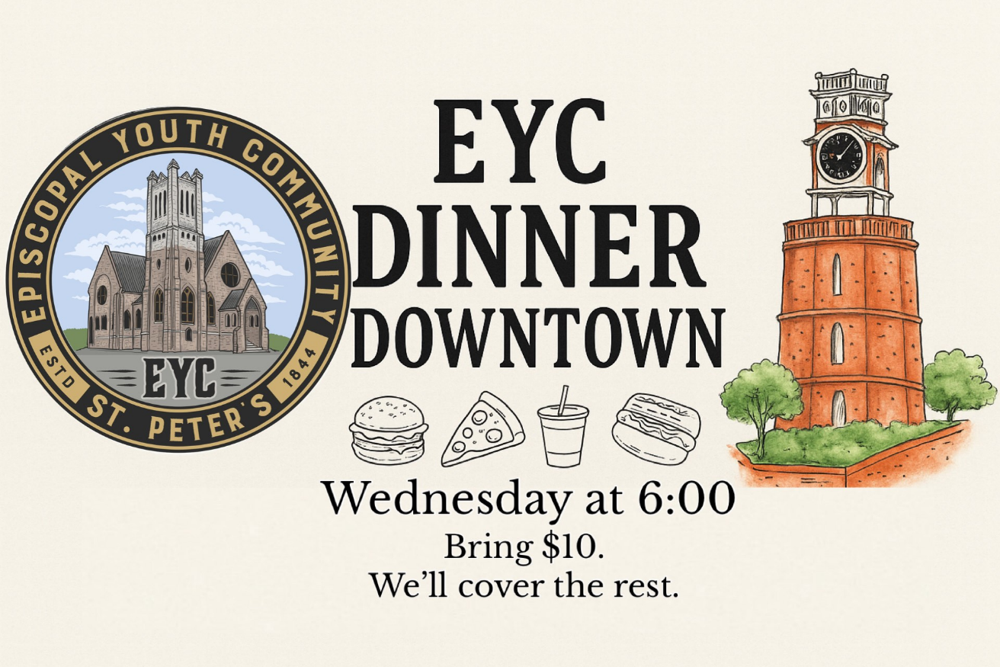


Candles in the Nave given to the Glory of God by Peggy Nash in appreciation for Father John, the Youth & Children’s Coordinators who provide opportunities for parishioners to learn about God and Jesus.

Flowers on the Chapel altar given to the Glory of God by Helen & Jim Keaten.

Flowers on the Nave altar given to Glory of God by Mary & Jack McGuffey in thanksgiving for the blessings of Family.


Sympathy of the Parish extended to Marie Middlemas, friends and family on the death of her husband, Rob Middlemas on September 22, 2025.
Sympathy of the Parish extended to Frances Herron and family on the death of her sister, Mary Louise Lever on September 25, 2025.

OPEN DATES for flowers in October:

Nave: October 5th cost $150.00
Chapel: October 12th, & 19th. Cost $100.00

Call or email church office to select your date.


Capital Campagin
Project List

Thank you to everyone that supported and continue to support the Capital Campaign.

- New Roof Completed on nave, chapel and Daniel Hall
- New windows installed in the Hight Building and Daniel Hall
- Re-Plumbing of galvanized pipes in Church & Willingham House
- New Ceiling Tiles in Hight Building
- Scrapping and painting of Nave
- Painting of interior of Hight Building
- Replace flooring in dining area of Daniel Hall

Still to come…..
- New Flooring in Hight Building
- New cabinets and counter tops in kitchen and beverage bar
- Facelift of the Hight Building Bathrooms. Work began 9.11.2025
  - MEN’s restroom on 1st floor CLOSED
- Replacement of all galvanized plumbing in Hight Building
- Cleaning of the exterior stone

During the process we would like to ask for everyone to be patient, gracious and understanding!

Allien McNair & Greg Tarter, chairs of Building & Grounds


Join us online if you are unable to worship in person…..

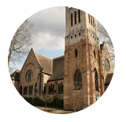
Youtube channel @StPetersRomeGA1844.

Click the picture of the church.
Then simply choose LIVE and then select the service you wish to view.


Do YOU have a VENMO Account?
You may use it to remit payments to the church.

ALWAYS include a note/memo to identify how to credit the payment, for example:
- Annual Pledge payment
- Wednesday Dinner
- Easter Lily
- Capital Pledge payment
https://venmo.com/u/StPeters-EpiscopalChurch


MEMO all payments with instructions to ensure proper designation of your gift.

For example, Capital OR Annual pledge, Altar flowers, etc. THANK YOU

September | Monday | Tuesday | Wednesday | Thursday | Friday | Saturday
21  8:15-11:45 Nursery provided  9-10am BREAKFAST in Daniel Hall  9:57am Children’s Chapel  8:30am – Rite I Chapel  10am – Rite II Nave, WLAQ/You tube  EYC to SIX FLAGS | 22  Canterbury Student Ministry meeting at Berry | 23  3 Rivers 7-8:30 Nave | 24  5pm Dinner begins  5:30pm Celtic Service  6-6:30 Children’s Choir  ROOTS 6:30-7:30  Parenting Conversations  6:15-7:30pm  7pm Adult Choir | 25  10-11am Bible Study | 26  9-Noon Community Kitchen  4-8:30pm ESP D. Hall | 27
28  8:15-11:45 Nursery provided  9-10am BREAKFAST in Daniel Hall  9:57am Children’s Chapel  8:30am – Rite I Chapel  10am – Rite II Nave, WLAQ/You tube  11:15am Episcopal Charities Adult Forum  STEWARDSHIP – Mark Jones | 29  Canterbury Student Ministry meeting at Berry | 30  9-Noon Community Kitchen  10:30-12:30 Bridges D.Hall/Kitchen  3 Rivers 7-8:30 Nave | OCTOBER 1  5:30pm Dinner begins  5:30pm Celtic Service  6-6:30 Children’s Choir  6pm EYC Schroeders  ROOTS 6:30-7:30  Parenting Conversations  6:15-7:30pm  7pm Adult Choir | 2  10-11am Bible Study  4-6pm Stephen Ministry Supervision meeting R. Wyatt | 3 | 4
5  8:15-11:45 Nursery provided  9-10am BREAKFAST in Daniel Hall  9:57am Children’s Chapel  8:30am – Rite I Chapel  10am – Rite II Nave, WLAQ/You tube  6-7:30pm EYC  STEWARDSHIP – David Ledbetter | 6  Canterbury Student Ministry meeting at Berry | 7  Bridges 10:30-12:30 D.Hall/Kitchen  3 Rivers 7-8:30 Nave  Indivisible 4-8:30  Daniel Hall | 8  5:30pm Dinner begins  5:30pm Celtic Service  6-6:30 Children’s Choir  ROOTS 6:30-7:30  7pm Adult Choir | 9  10am Bible Study  3 Rivers 6:30 R. Wyatt | 10 | 11
12  8:15-11:45 Nursery provided  9-10am BREAKFAST in Daniel Hall  9:57am Children’s Chapel  8:30am – Rite I Chapel  10am – Rite II Nave, WLAQ/You tube  6-7:30pm EYC  STEWARDSHIP – Gary Voccio | 13  Canterbury Student Ministry meeting at Berry  Reservations Due for Consecration Brunch on 10.26.2025 | 14  Bridges 10:30-12:30 D.Hall/Kitchen | 15  :305pm Dinner begins  5:30pm Celtic Service  6-6:30 Children’s Choir  6pm EYC Schroeders  ROOTS 6:30-7:30  Parenting Conversations  6:15-7:30pm  7pm Adult Choir | 16  10-11am Bible Study | 17 | 18  RSVP’s DUE for Parents Night Out
19  8:15-11:45 Nursery provided  9-10am BREAKFAST in Daniel Hall  9:57am Children’s Chapel  8:30am – Rite I Chapel  10am – Rite II Nave, WLAQ/You tube  6-7:30pm EYC  STEWARDSHIP – Emily Holcombe | 20  Canterbury Student Ministry meeting at Berry | 21  JSL 5:30-8:30 D. Hall  Bridges 10:30-12:30 D.Hall/Kitchen | 22  5:30pm Dinner begins  5:30pm Celtic Service  6-6:30 Children’s Choir  6pm EYC Schroeders  ROOTS 6:30-7:30  Parenting Conversations  6:15-7:30pm  7pm Adult Choir | 23  10-11am Bible Study  4-6pm Stephen Ministry Supervision Mtg  ESP 4-7:30pm D. Hall | 24  Parents Night Out  5-8pm | 25  Wright Wedding 4pm in Nave

