
WELCOME TO ALL OUR VISITORS!
If you are interested in knowing more about St. Peter’s, please see an usher or one of the greeters who stand with the clergy after the service.

8.17.2025 at St. Peter’s
8:15am-11:45am Nursery
8:30am Holy Eucharist Rite I in Chapel
9:57am Children’s Chapel in Daniel Hall
10:00am Holy Eucharist Rite II in Nave, WLAQ radio & YouTube

This week…
Monday/August 18th 1pm Centering Prayer, 401 E. 4th Ave
2pm Living Compass, 401 E. 4th Ave.

Tuesday/August 19th 9am Staff Meeting
5:30pm Vestry Meeting

Wednesday/August 20th 5:30pm Celtic Service in Chapel

Thursday/August 21st 10-11am Yoga in Daniel Hall
4-6pm Stephen Ministry Supervision Meeting, R. Wyatt

Friday/August 22nd 9am – Noon Community Kitchen Volunteers


Lisa Frierson, Carl Neal, Jennifer Neal, Morgan Rigsby, Carlton Family, Gina Schmitz, Andy Gentry, Sharon Badgett, Jerry Dunwoody, John Schroeder, Jimmy Smithson, Andrew Babcock, Michael Ann Booth, Campbell Clark, Henry Pancione, Katie Pancione, Marcie Smith, Jackie Hizel, Denny Hachenberg, Mary Louise Lever, Terry Hughes, Ray Dempsey, Rees Jenkins, Sylvia Hine and those that care for them.

At the beginning of each month the intercessory prayer will be “refreshed”; all names removed. If you wish to add someone, please call, or email the church office. Names will remain on the Prayer List for the entire month.
Military Prayer List:

Charles Lewis
Nolan Kelley
Davis Isley
Cherrie Shackelford

Andrew Hall
Ted Olney
Michael Blair
Steven Blair
Charlie Hardaker
Justin Yeary

Thomas Keefe
Ryan Holman
Johnny Crittenden
Sara Carver Thomas
Joshua Ingram
Jerrod Keplinger

Please remember to notify the church office when a service member is no longer on active duty.


AUGUST 24th
Canterbury needs your help to prepare homemade baked goods for students at the upcoming Back-To-School Ministry Fair.

Simple bake your goodies, package them individually and drop off at the church office on Friday, 22nd OR Devon can collect them in Daniel Hall on the morning of the 24th.

Usually have up to 300 students base by during the event.

Please let the church office know if you will sign up for this event!


Habitat For Humanity,
a local charity supported by
St. Peter’s with volunteers and financial gifts…..



Drive one FORE Habitat – 2025
Golf tournament to support local Habitat for Humanity
October 6th - 4 Man Scramble
Check-in 10:45am-11:45am. Start Time 12noon
Meadow lakes Golf Course

Team and Hole Sponsor $500.00
4 man entry team and company name on tee box sign
Hole Sponsor $150.00
Company name on tee box sign
Mulligans $100.00
Pay for your team to start with and advantage. Fee buys you 3 mulligans per person.
Team Entry $400.00
4 person team (includes lunch)

LINK to Register:
https://habitatcoosavalley.charityproud.org/EventRegistration/Index/24016


Members of the St. Peter’s Card ministry send cards to those within the parish.

Donation of blank notecards needed to help with this ministry to provide thoughts and greetings to our parishioners.

Basket located in Daniel Hall for your donations, please NO greeting cards.
THANK YOU


St. Paula’s Guild

5pm
August 23rd
Roma Mia

RSVP or Questions contact Diane Nance, 706.936.6006

Mission & Outreach News…


Bridges Out of Poverty will graduate its 8th cohort in late August.

The Getting Ahead in a Just-Gettin'-By World model is to pair each graduate with a Success Coach.

A Success Coach's role is to help guide the graduate as they apply the principles from Getting Ahead and continue their life journey. The coach's role is both challenging and rewarding.

If you are interested in becoming a Success Coach, please contact Keith Phillips, 678.293.1671 and he can answer any questions you may have.

A Success Coach orientation will be held in the Dining Room on Saturday August 16th from 10:00am to noon.


September 7th
Breakfast Returns

Join us for breakfast & fellowship at 9am in Daniel Hall.

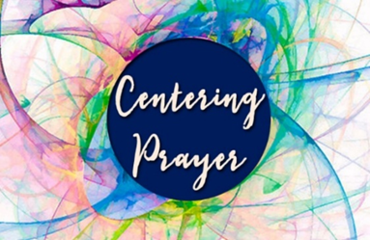
Centering Prayer

NEW DAY/TIME/LOCATION
Mondays beginning August 4th
1pm
401 East 4th Ave.
Available via Zoom as well.

Questions Contact Jane Cunningham, 706.346.4091 OR missjane1@mac.com


Please schedule all meetings/gatherings through the church office to ensure your gathering does NOT overlap with another group or outside groups that use the buildings.

Email, elizabeth@stpetersrome.org or Call, 706.291.9111. THANK YOU

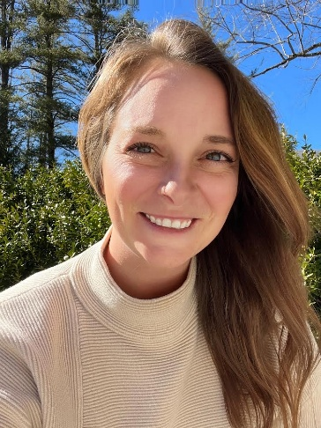

NEXT SUNDAY August 24th

Gather in Daniel Hall after the 10am service for a presentation from Jessica LeFiles, Executive Director of Camp Mikell.
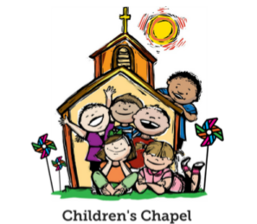
Children’s Chapel
Each Sunday, 9:57am.

We will depart as a group from the nave and return during the Peace to share Eucharist with their families.

Children’s Chapel is available for children ages Pre-K thru 2nd grade and during the summer will be held in Daniel Hall.


Volunteer as a Children’s Chapel Teacher.

Full curriculum provided.

Select the Sunday(s) that fit your schedule:
https://www.signupgenius.com/go/10C0E4AAAA829A3FFC70-57875256-202526

If you have questions, please contact:
- Katie Smyth, Children’s Ministry Coordinator. 770.714.1825 or kaydubs26@gmail.com
- Bonnie Mitchell, Assistant Children’s Ministry Coordinator. 706.936.9833 or bewmitchell@gmail.com
St. Peter’s VOLUNTEERs are needed from 9am till noon. HOWEVER, if you are not able to work the full 3 hours, any time you can share is greatly appreciated.

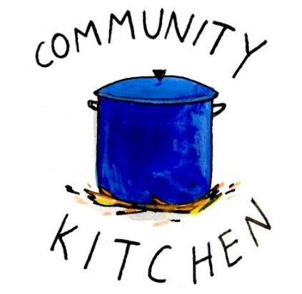
2025 Schedule
Friday Tuesday
August 22 26
September 23 30
October 24 28
November 21 25
December 26 30

Contact Nancy Hunter to volunteer to help, 706.506.3889. THANK YOU



Living Compass
Study Group

2pm
401 East 4th Ave.
D’Ann Downey, 706.266.3444


Junior Choir
Wednesday Nights,
Beginning August 27th
6-6:30pm.

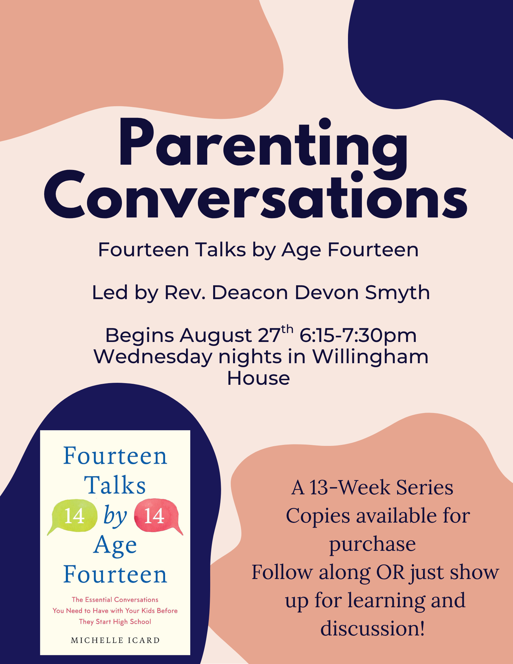

A NEW OFFERING for Adults begins Wednesday Nights August 27th.
Will NOT meet on October 8th or October 29th


EYC
POOL PARTY August 23rd

Sunday August 24th


8:15-9:45am JAVA JOY will be on site with iced & hot coffee, hot chocolate and sweets.

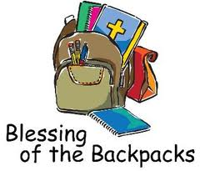

10am service! Bring your backpacks, computers, whatever you use for school, work etc.


FALL PROGRAMS & ACTIVITIES…

August 23rd
- EYC pool party 5-7:30pm at the Kelley’s home

August 24th
- Java Joy 8:15-9:45am
- Blessing of the Backpacks 10am service in the nave.

August 27th
- Wednesday Dinner service begins at 5pm in Daniel Hall. Adults $10, Kids $4, Family Maximum $25. Vegetarian $8
- Parenting Conversations 6:15-7:30. Fourteen Talks by Age Fourteen, by Michelle Icard. Led by Rev Deacon Devon Smyth.
- ROOTS for children Pre-K through 5th grades. 6:30-7:30pm.
- Junior Choir 6-6:30pm. Generally, grades 1-5, but all those willing to commit to practice/performance are WELCOME.
- Adult Choir Practice 7pm

September 7th
- Breakfast served in Daniel Hall 9am
- Adult Forum – The Pilgrim Report from the 2025 Pilgrims in Daniel Hall after 10am service concludes. Come to hear & see all about their pilgrimage this summer.
- EYC meetings will be held on Sundays 6-7:30pm
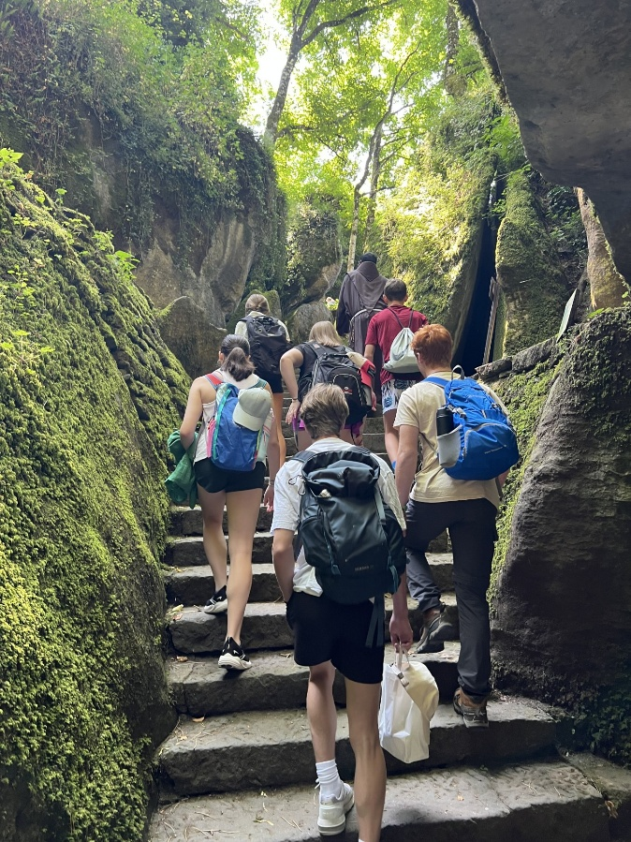
You are Invited…..

EYC Pilgrimage Reception

Sunday September 7th
After the 10am service
Daniel Hall
Join us as our youth share about their experiences on Pilgrimage to Italy.

MEALS for EYC on Sunday Nights:
EYC will resume their Sunday meetings on September 7^{th.}

We have really enjoyed starting every EYC Sunday night by breaking bread together, and we would love to continue! You have been so kind to offer meals throughout the year. If you would like to cook, order or sponsor a meal, please sign up!

Use the link below to sign up.
https://www.signupgenius.com/go/10C084EACAB2FA5FCC43-50683016-eycsunday

THANK YOU FOR YOUR KINDNESS AND SUPPORT!
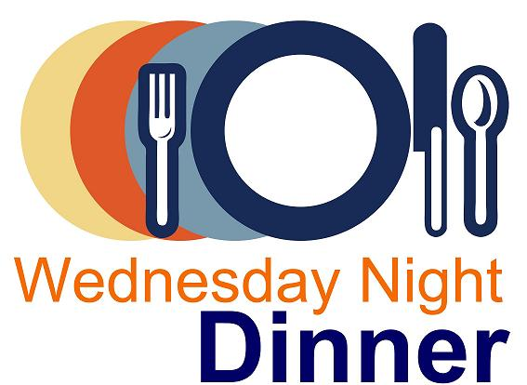
Wednesday Night Menu
Dinner service begins at 5pm in Daniel Hall
Adults $10, child menu $4
Family Maximum $24

Vegetarian/Gluten Free meal of salad and either meatless burger patty or hard-boiled egg also available for $8

RESERVATIONS by NOON on Monday each week.
Call/email office, register on REALM, or sign and drop menu in offering plate.

8.27.2025
Crab/Shrimp Manicotti Alfredo Bake OR Lemon Butter Caper Chicken Quarters
Salad – Steamed veggies – Zucchini boats with tomatoes & mozzarella
Cuban Garlc Bread – Dessert, Key Lime Pie
Kids – Cheese Pizza OR PBJ sandwich. Carrot chips/ranch, fruit, cookie

9.3.2025
Hawaiian Chicken with pineapple, peppers & onions OR French Onion Pork Chop
Salad – Yellow Rice – Black Beans
Hawaiian rolls – Dessert Pineapple Upside Down Cake
Kids – Chicken Nuggets OR Mini Corn Dog. Apple Sauce, grapes, cookie.

9.10.2025
Mexican Beef Casserole OR Vegetable Ziti
Salad - Confetti corn – Roasted tomatoes
Dessert, Tres Leches Cake
Kids – Hot dog OR Pasta with red sauce. Fruit, Carrot Chips/ranch

9.17.2025
Meatloaf OR Parmesan Chicken
Salad – Mashed Potatoes – Green Beans
Dinner Roll – Dessert, Peach Cobbler
Kids – Pepperoni Pizza OR Mac N Cheese. Fruit, pudding, salad

9.24.2025
Low Country Boil with Shrimp/Sausage/Potatoes/Onions OR BBQ Chicken
Salad – Cole slaw – Collards
Garlic Bread – Dessert, Watermelon
Kids – Burger Sliders OR Pizza Rolls. Fruit, cookie.

Cameron Jackson 21st
Kelly Mills 21st
Susan Geddes 21st
Devon Smyth 21st
Stephen Smith 22nd
C.O. Pilgrim 22nd
Collier Murphy 23rd


Candles in the Nave given to the Glory of God by Trisha Richards in memory of her departed loved ones.

Flowers on the Chapel altar given to the Glory of God by Lee & Charles Hight in memory of Alberta and Charles Hight and Irene Matthews Hight.

Flowers on the Nave altar given to Glory by Laura Frederick in loving memory of Donald Frederick and Randy Muller.


Capital Campagin Project List

Thank you to everyone that supported and continue to support the Capital Campaign.

- New Roof Completed on nave, chapel and Daniel Hall
- New windows installed in the Hight Building and Daniel Hall
- Re-Plumbing of galvanized pipes in Church & Willingham House
- New Ceiling Tiles in Hight Building
- Scrapping and painting of Nave
- Painting of interior of Hight Building

Still to come…..
- New Flooring in Hight Building
- Replace flooring in dining area of Daniel Hall
- New cabinets and counter tops in kitchen and beverage bar
- Facelift of the Hight Building Bathrooms
- Replacement of all galvanized plumbing in Hight Building
- Cleaning of the exterior stone

During the process we would like to ask for everyone to be patient, gracious and understanding!

Allien McNair & Greg Tarter, chairs of Building & Grounds


Join us online if you are unable to worship in person…..

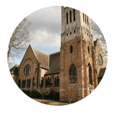
Youtube channel @StPetersRomeGA1844.

Click the picture of the church.
Then simply choose LIVE and then select the service you wish to view.


Do YOU have a VENMO Account?
You may use it to remit payments to the church.

ALWAYS include a note/memo to identify how to credit the payment, for example:
- Annual Pledge payment
- Wednesday Dinner
- Easter Lily
- Capital Pledge payment
https://venmo.com/u/StPeters-EpiscopalChurch


MEMO all payments with instructions to ensure proper designation of your gift.

For example, Capital OR Annual pledge, Altar flowers, etc. THANK YOU

August | Monday | Tuesday | Wednesday | Thursday | Friday | Saturday
3  8:15-11:45 Nursery provided  9:57am Children’s Chapel, D. Hall  8:30am – Rite I Chapel  10am – Rite II Nave, WLAQ/You tube  Children’s Ministry Volunteer Meeting – Daniel Hall | 4  1pm Centering Prayer at 401 E. 4th Ave.  Living Compass 2pm at 401 E. 4th Ave. | 5  10-11am Yoga  10-11am Stephen Ministry Counseling Willingham Office  7-8:30pm Nave, 3 Rivers Singers | 6  5:30pm Evening Prayer | 7  4-6pm Stephen Ministry Supervision mtg. R. Wyatt room | 8 | 9
10  8:15-11:45 Nursery provided  9:57am Children’s Chapel, D. Hall  8:30am – Rite I Chapel  10am – Rite II Nave, WLAQ/You tube | 11  1pm Centering Prayer at 401 E. 4th Ave.  Living Compass 2pm at 401 E. 4th Ave.  ESP 4-11pm Daniel Hall | 12  10-11am Yoga  10-11am Stephen  Ministry Counseling Willingham Office  Indivisible 7-8:30pm  D. Hall  7-8:30pm Nave, 3 Rivers Singers | 13  5:30pm Celtic Service | 14  3 Rivers, R. Wyatt 6:30 | 15  8:30-11am Rome Floyd Council on Children  PARENTS Night Out  5:30-8:30pm | 16
17  8:15-11:45 Nursery provided  9:57am Children’s Chapel, D. Hall  8:30am – Rite I Chapel  10am – Rite II Nave, WLAQ/You tube  11:15am EYC Parent Meeting – Daniel Hall | 18  1pm Centering Prayer at 401 E. 4th Ave.  Living Compass 2pm at 401 E. 4th Ave. | 19  5:30 pm Vestry  10-11am Stephen Ministry Counseling  7-8:30pm Nave, 3 Rivers Singers | 20  5:30pm Celtic Service | 21  10-11am Yoga  4-6pm Stephen Ministry Supervision mtg. R. Wyatt room | 22 | 23  EYC POOL PARTY  5-7:30pm  St. Paula Guild, 5pm Roma Mia
24  Java Joy 8:15-9:45am  8:15-11:45 Nursery provided  9:57am Children’s Chapel, D. Hall  8:30am – Rite I Chapel  10am – Rite II Nave, WLAQ/You tube  Blessing of the Backpaks  Camp Mikell Presentation in Daniel Hall | 25  1pm Centering Prayer at 401 E. 4th Ave.  Living Compass 2pm at 401 E. 4th Ave. | 26  10-11am Stephen Ministry Counseling Willingham Office  Indivisible 7-8:30pm  D. Hall  7-8:30pm Nave, 3 Rivers Singers | 27  5:30pm Celtic Service  5pm Dinner begins  6-6:30 Children’s Choir  ROOTS 6:30-7:30  Parenting Conversations  6:15-7:30pm  7pm Adult Choir | 28  10-11am Yoga | 29 | 30
31  8:15-11:45 Nursery provided  9:57am Children’s Chapel  8:30am – Rite I Chapel  10am – Rite II Nave, WLAQ/You tube  EYC 6-7:30pm | September 1 | 2  JSL 5:30-8:30 D. Hall  3 Rivers 7-8:30 Nave | 3  5:30pm Celtic Service  5pm Dinner begins  6-6:30 Children’s Choir  ROOTS 6:30-7:30  Parenting Conversations  6:15-7:30pm  7pm Adult Choir | 4  4-6pm Stephen Ministry Supervision mtg. R. Wyatt  ESP 4-7:30 D. Hall | 5 | 6

