
WELCOME TO ALL OUR VISITORS!
If you are interested in knowing more about St. Peter’s, please see an usher or one of the greeters who stand with the clergy after the service.

7.20.2025 at St. Peter’s
8:15am-11:45am Nursery
8:30am Holy Eucharist Rite I in Chapel
9:57am Children’s Chapel in Daniel Hall
10:00am Holy Eucharist Rite II in Nave, WLAQ radio & YouTube

This week…
Monday/July 21st 10am Mid-Day Mission Project
1pm Living Compass NEW study group
5pm MOVIE NIGHT
Tuesday/July 22nd 9am Staff Meeting
Wednesday/July 23rd 5:30pm Celtic Service in Chapel
Friday/July 25th Community Kitchen Volunteers 9am till Noon

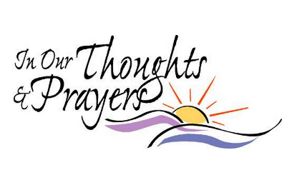
Sylvia Hine, Rees Jenkins, Ray Dempsey, Lisa Frierson, John Marshall, Courtney North, Katie Pancione, Henry Pancione, Jan Woody, Morgan Rigsby, Sherron Badgett, Andrew Babcock, Jimmy Smithson, John Schroeder, Jerry Dunwoody, Carlton Family, Gina Schmitz, Jackie Hizel, Michael Ann Booth, Beth Virden, Marcie Smith, Harrison Steeves, Roger Bowen, Cissy Rogers, Campbell Clark and those that care for them.

Beginning of each month the intercessory prayer will be “refreshed”; all names removed. If you wish to add someone, please call, or email the church office. Names will remain on the Prayer List for the entire month.

Military Prayer List:

Charles Lewis
Nolan Kelley
Davis Isley
Cherrie Shackelford

Andrew Hall
Ted Olney
Michael Blair
Steven Blair
Charlie Hardaker
Justin Yeary

Thomas Keefe
Ryan Holman
Johnny Crittenden
Sara Carver Thomas
Joshua Ingram
Jerrod Keplinger

Please remember to notify the church office when a service member is no longer on active duty.


Yoga with Jennifer Kelley in July
Daniel Hall at St. Peter’s | $10 per class (cash or Venmo)
Please bring a yoga mat and water bottle.
Jennifer will provide blankets and blocks.

🧘‍♀️ Class Dates:
- Tuesday, July 29 | 10:00–11:00 AM

Yoga will generally meet on Tuesdays from 10:00–11:00 AM, except for the first session, which will take place on Monday, July 7 at 10am.

Jennifer Kelley is a licensed yoga instructor and will be offering a gentle, grounding class open to all levels. Each session includes 40–45 minutes of accessible movement and breathwork, followed by 15–20 minutes of guided meditation and rest. Whether you're new to yoga or simply seeking a quiet, centering space, this class offers time to reset and restore.

If you're interested in yoga but can’t make a morning class, feel free to reach out to Jennifer at jenkelley013@gmail.com or 706-266-1131. If there’s enough interest, she may offer an evening class as well.

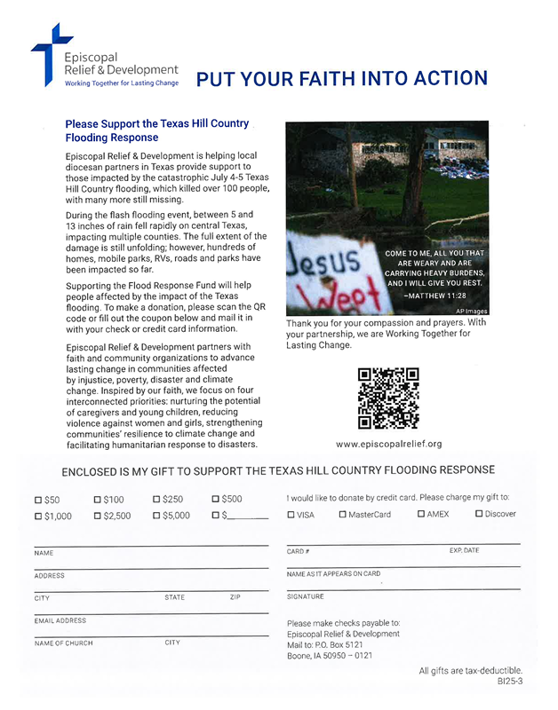


Loaves and Fishes is a ministry established to support parishioners requiring temporary assistance due to accidents, sudden illnesses, hospitalizations, the birth of a new baby, or the loss of a loved one.

Volunteers of Loaves and Fishes are organized into six teams, each led by a team leader, and commit their time for two months annually.

The monthly team members support parishioners by supplying meals (does not have to be homemade) to identified families, as designated by the clergy, by setting up meal trains for specific situations, and by organizing and hosting memorial receptions when required.

We are seeking volunteers to join our monthly teams or to serve as team captains with experienced members who have years of service in this ministry. We also need help identifying parishioners who need support. If you know anyone in need of a meal, please contact the church office.

To volunteer or inquire further, contact Kathy Steinbruegge at 706-238-2301 or the church office.

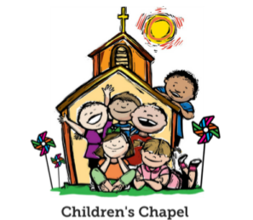
Children’s Chapel
Each Sunday, 9:57am.

We will depart as a group from the nave and return during the Peace to share Eucharist with their families.

Children’s Chapel is available for children ages Pre-K thru 2nd grade and during the summer will be held in Daniel Hall.

SAFEGUARDING Classes will be held
ON SITE at St. Peter’s
Saturday August 2nd

Safeguarding God’s CHILDREN 10am till 1pm
Safeguarding God’s PEOPLE 1:30pm till 4:30pm

Register online to attend https://forms.gle/HykbrHPJghQR9zXk9

Classes for EVERYONE working with children or adults in any capacity are required every 3 yrs for Safe Children and every 5 yrs for safe People.

St. Peter’s VOLUNTEERs are needed from 9am till noon. HOWEVER, if you are not able to work the full 3 hours, any time you can share is greatly appreciated.

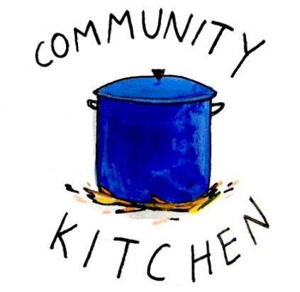
2025 Schedule
Friday Tuesday
July 25 29
August 22 26
September 23 30
October 24 28
November 21 25
December 26 30

Contact Nancy Hunter to volunteer to help, 706.506.3889. THANK YOU


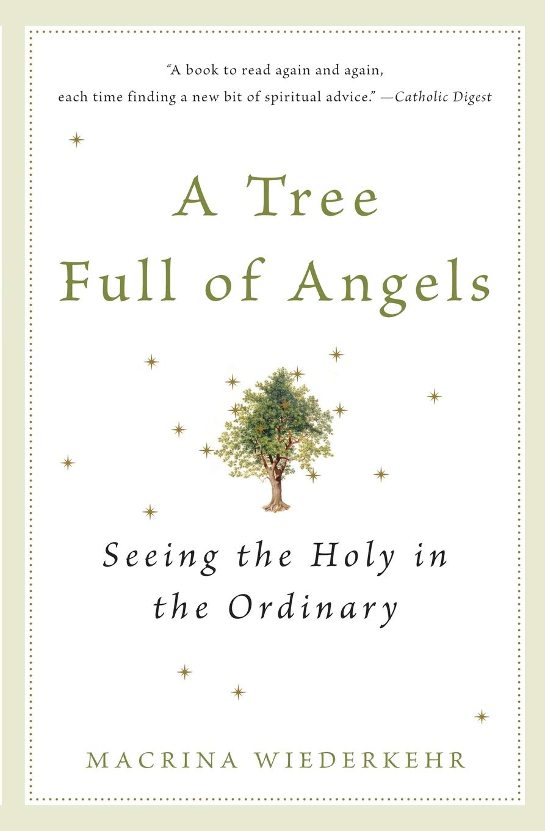
Living Compass

NEW
Study Group

Begins Monday, 7.21.2025
1pm
401 East 4th Avenue

Pick up copies wherever you purchase books.

D’Ann Downey, 706.266.3444

July 21st – Daniel Hall – 5pm


Movie Encanto
Dinner El Zarape
Cost $5 per Person
$20 per Family

REGISTER/RSVP by July 18th

Katie Smyth – 770.714.1825
Bonnie Mitchell – 706.936.9833
Church office – 706.291.9111
elizabeth@stpetersrome.org
Realm

Parish Wide Event hosted by Children’s Ministry


From Children’s Ministry

JULY 21st
- Mid-Day Mission Project for 3rd through 5th graders. 10am till 1pm we will work at Bloom Closet as a group then lunch as a group at Schroeders. Please bring $20 for lunch.
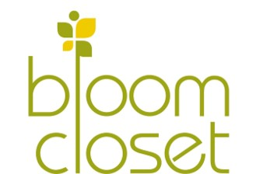


Katie Smyth, 770.714.1825
Bonnie Mitchell, 706.936.9833




August 15th ~ 5:30pm- 8:30pm
Children’s Ministry will provide childcare
while you treat yourself to dinner at
Blossom Hill and enjoy fellowship
with other St. Peter’s parents.

Childcare, Activities & Dinner provided for your student’s infant – 5th grades. Simply drop them off at Daniel Hall beginning at 5pm.

RSVP by August 11th:
Katie Smyth – 770.714.1825 OR Bonnie Mitchell – 706.936.9833
Church office – 706.291.9111 OR elizabeth@stpetersrome.org OR Realm

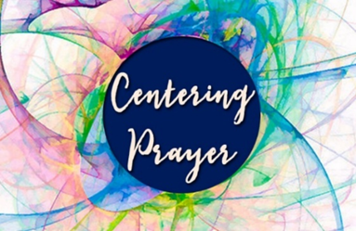
Will not meet during June and July.

See you back in August,
Jane Cunningham, 706.346.4091 or missjane1@mac.com

Gina Schmitz 13th

Anne Culpepper 20th
Andy Bressette 20th
Jay Louttit 20th
Kathie Disney 21st
Courtney Walley 22nd
Brian Hampton 22nd
Maggie Johnson 22nd
David Jahner 22nd
John Reiners 22nd
Rana Andrews 23rd
Anne Shields 23rd
Maria Middlemas 23rd
Jessica Weaver-Stoll 23rd
Kathleen Bergman 25th
Gordon Lee Hight 26th
Allien McNair 26th


OPEN dates on the flower calendar:
Nave – August 31st

Candles in the Nave given to the Glory of God by Mary and John Kirkland in memory of their departed loved ones.

Flowers on the Chapel altar given to the Glory of God by Janet Byington in loving memory of Arch & Emily Nixon Farrar, Challis Nixon and Penn Nixon.

Flowers on the Nave altar given to Glory by Thayer Manis in loving memory of her father, M. Garrett Larrimore.

Flowers on the Nave altar given to Glory by Leamon Scott and Family in loving memory of Suzanne Widener Scott.

MISSION & OUTREACH
FINAL WEEKS - Collecting School Supplies
Drop off your donations in the collection bin located in
Daniel Hall through end of July



MARK YOUR CALENDAR – Sunday August 24th at the 10am service ….
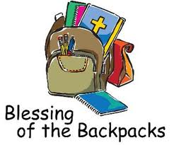


Join us online if you are unable to worship in person…..

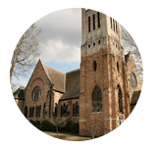
Youtube channel @StPetersRomeGA1844.

Click the picture of the church.
Then simply choose LIVE and then select the service you wish to view.


Do YOU have a VENMO Account?
You may use it to remit payments to the church.
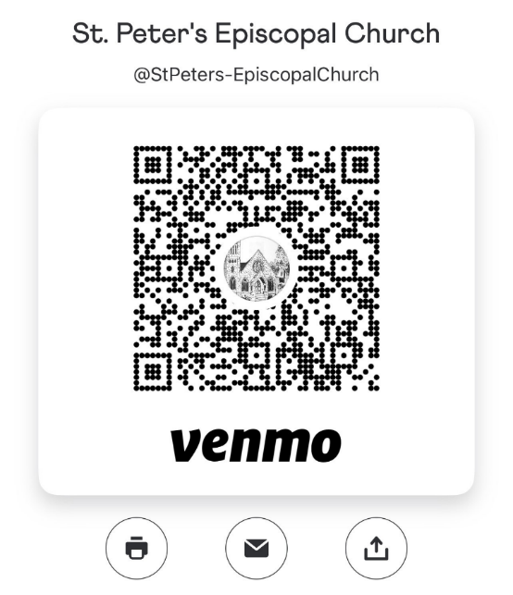
ALWAYS include a note/memo to identify how to credit the payment, for example:
- Annual Pledge payment
- Wednesday Dinner
- Easter Lily
- Capital Pledge payment
https://venmo.com/u/StPeters-EpiscopalChurch



CAMP MIKELL OFFERINGS
Fall 2025 – Homeschool Days
Wednesday, 11.5.2025 – Backcountry Basics $10
Monday, 9.22.2025 – Aquatic Adventure $10
Mindfulness at Mikell – Reconnect with Nature- Sept. 9th -Oct. 2nd
Allan Folk School – October 24-26, 2025, Registration open August 1st

Check out details on bulletin board in stairwell, website: Camp Mikell or amanda@campmikell.com

July/August | Monday | Tuesday | Wednesday | Thursday | Friday | Saturday
20  8:15-11:45 Nursery provided  9:57am Children’s Chapel, D. Hall  8:30am – Rite I Chapel  10am – Rite II Nave, WLAQ/You tube | 21  1pm Living Compass  Movie Night for the Parish  5pm | 22  9am Staff Meeting  7pm, D. Hall 3 Rivers Singers Practice | 23  5:30pm Celtic Service | 24  4-8pm ESP  D. Hall | 25  9-Noon Community Kitchen | 26
27  8:15-11:45 Nursery provided  9:57am Children’s Chapel, D. Hall  8:30am – Rite I Chapel  10am – Rite II Nave, WLAQ/You tube | 28  1pm Living Compass | 29  9am Staff Meeting  10-11am Yoga with Jennifer Kelley in Daniel Hall  9-Noon Community Kitchen  7-8:30pm Nave, 3 Rivers Singers | 30  5:30pm Celtic Service | 31 | August 1 | 2  Safeguarding Classes in D. Hall  10-4:30pm
3  8:15-11:45 Nursery provided  9:57am Children’s Chapel, D. Hall  8:30am – Rite I Chapel  10am – Rite II Nave, WLAQ/You tube | 4  1pm Living Compass | 5  9am Staff Meeting  7-8:30pm Nave, 3 Rivers Singers | 6  5:30pm Celtic Service | 7 | 8 | 9
10  8:15-11:45 Nursery provided  9:57am Children’s Chapel, D. Hall  8:30am – Rite I Chapel  10am – Rite II Nave, WLAQ/You tube | 11  1pm Living Compass  ESP 4-11pm Daniel Hall | 12  9am Staff Meeting  Indivisible 7-8:30pm Daniel Hall  7-8:30pm Nave, 3 Rivers Singers | 13  5:30pm Celtic Service | 14 | 15  PARENTS NIGHT OUT 5:30pm | 16
17  8:15-11:45 Nursery provided  9:57am Children’s Chapel, D. Hall  8:30am – Rite I Chapel  10am – Rite II Nave, WLAQ/You tube | 18  1pm Living Compass | 19  5:30pm Vestry meeting  7-8:30pm Nave, 3 Rivers Singers | 20  5:30pm Celtic Service | 21 | 22 | 23

