
WELCOME TO ALL OUR VISITORS!
If you are interested in knowing more about St. Peter’s, please see an usher or one of the greeters who stand with the clergy after the service.

6.29.2025 at St. Peter’s
8:15am-11:45am Nursery
8:30am Holy Eucharist Rite I in Chapel
9:57am Children’s Chapel in Daniel Hall
10:00am Holy Eucharist Rite II in Nave, WLAQ radio & YouTube

This week…
Monday/June 30th 1pm Living Compass study group

Tuesday/July 1st 9am Staff Meeting

Wednesday/July 2nd 5:30pm Celtic Service in Chapel

Friday/July 4th Office & Church Closed


Lisa Frierson, Sherrie Hudgins, Sherron Badgett, Bill Burk, Henry Pancione, Katie Pancione, Craig Justice, Shelby Shinkle, Roger Bowen, Allison Owens, Roberto Puac, Jackie Hizel, Mary Nance, Courtney North, Beth and Stan Virden, Tommy Aaron, Cathy Varidel, Jerry Dunwoody, Carl Neal, Jennifer Neal, Bill Newton, Campbell Clark, Mary Flanigen, Terry Hughes, Jim Mullis, Marable Family, Andrew Babcock, Jimmy Smithson, Carlton Family, Michael Ann Booth, Sage Hoare, Emily Colon, John Schroeder, Ray Dempsey, Rees Jenkins, Sylvia Hine, Gina Schmitz, and those that care for them.

THIS WEEK the intercessory prayer will be “refreshed”; all names removed. If you wish to add someone, please call, or email the church office. Names will remain on the Prayer List for the entire month.
Military Prayer List:

Charles Lewis
Nolan Kelley
Davis Isley
Cherrie Shackelford

Andrew Hall
Ted Olney
Michael Blair
Steven Blair
Charlie Hardaker
Justin Yeary

Thomas Keefe
Ryan Holman
Johnny Crittenden
Sara Carver Thomas
Joshua Ingram
Jerrod Keplinger

Please remember to notify the church office when a service member is no longer on active duty.


St. Paula Guild
July 19^{th ~} 4:30-7:30pm

Gather at St. Peter’s in the Rhodes Wyatt Room.


Volunteers needed in the office
9am till Noon:
Monday July 21st
Tuesday July 22nd
Wednesday July 23rd
Thursday July 24th

Contact the office if you can take a day, THANKS.

Sympathy of the Parish extended to:

~ Leamon Scott and family on the death of Suzanne Widener
Scott on 6.21.2025. Funeral service at 1pm on 7.19.2025 in nave at St. Peter’s. Reception in Daniel Hall after the committal.

~ Friends and Family of Meg Alexander who died on
6.22.2025.

~ Elayne Winters, Rick Flanigen and their family on the death
of their aunt, Mary Flanigen on 6.22.2025.

~ Audrey Smith and her family on the death of her mother, Cheryl Smith on Tuesday, June 24, 2025.

May their souls, and the souls of all the departed, through the mercy of God, rest in peace, Amen.


Children’s Chapel
Each Sunday, 9:57am.

We will depart as a group from the nave and return during the Peace to share Eucharist with their families.

Children’s Chapel is available for children ages Pre-K thru 2nd grade and during the summer will be held in Daniel Hall.


Mission & Outreach School Supply Drive

Notebook paper, Pencils, Pens, Crayons 8 pk, Markers 8pk, 3 ring binders 1”, Notebook dividers, Composition notebooks, Rulers, Glue Sticks, Scissors, Highlighters.

Drop your donations in the bin located in Daniel Hall.

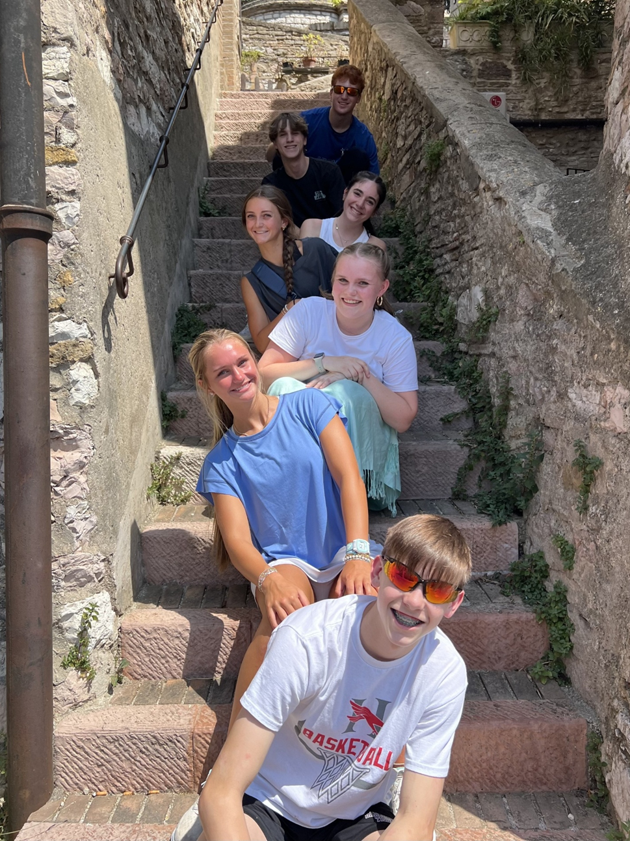
2025 Pilgrimage
Nicholas Bell

Lucas Herring

Cate DuVall

Callie Dempsey

Caroline Sawhill

Molly Ledbetter

Grant Molnar

St. Peter’s VOLUNTEERs are needed from 9am till noon. HOWEVER, if you are not able to work the full 3 hours, any time you can share is greatly appreciated.


2025 Schedule
Friday Tuesday
June 20 24
July 25 29
August 22 26
September 23 30
October 24 28
November 21 25
December 26 30

Contact Nancy Hunter to volunteer to help, 706.506.3889. THANK YOU


Patti Barron 29th
Belinda Martin 29th
Myrtle Marshall 29th
Russell Brock 29th
Leah Sherwin 30th
Tricia Richards July 1st
Buster Wright 1st
Jackie Trammell 2nd
Karlene Spencer 3rd
Linda Voccio 4th
Ford Knight 4th

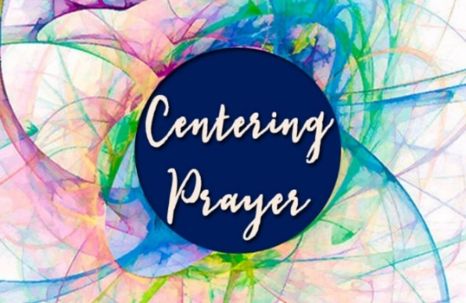
Will not meet during June and July.
See you back in August, Jane Cunningham,
706.346.4091 or missjane1@mac.com


Funeral Service for Olen Delano “Jim” Mullis will be held at 11am in the nave at St. Peter’s on July 5th.

The reception will be hosted and held at The Spires after the funeral service.


Wednesday Night Dinners are currently on SUMMER BREAK.

Share your thoughts…
Are there dinners you dislike?
Do you like having a meal choice?
Meals you would like to request?

Let the office know & we will work to accommodate your ideas.



Offered to you from Children’s Ministry

June 30th
- Mid-Day Mission Project for 3rd through 5th graders. 10am till 1pm we will work at Bloom Closet as a group then lunch as a group at Schroeders. Please bring $20 for lunch.



JULY 21st
- Mid-Day Mission Project for 3rd through 5th graders. 10am till 1pm we will work at Bloom Closet as a group then lunch as a group at Schroeders. Please bring $20 for lunch.

Katie Smyth, 770.714.1825 OR Bonnie Mitchell, 706.936.9833



Contact Margaret Louttit, 678.641.5895
to sign up and donate ice cream.


Join us online if you are unable to worship in person…..

Youtube channel @StPetersRomeGA1844.

Click the picture of the church.
Then simply choose LIVE and then select the service you wish to view.


Do YOU have a VENMO Account?
You may use it to remit payments to the church.


ALWAYS include a note/memo to identify how to credit the payment, for example:
- Annual Pledge payment
- Wednesday Dinner
- Easter Lily
- Capital Pledge payment

https://venmo.com/u/StPeters-EpiscopalChurch


Living Compass
Meet on Monday’s
1pm at 401 East 4th Avenue.

Questions, contact D’Ann Downey, ddowneywarley@comcast.net



OPEN dates on the flower calendar:
Chapel – July 13th & 27th

Candles in the Nave given to the Glory of God by Melissa & Brian Keefe in memory of departed loved ones.

Flowers on the Nave altar given to the Glory of God by Joe Morgan in memory of Jane Morgan, Dean Morgan and Morgan Sisley.

Flowers on the Chapel altar given to the Glory and in honor of Randall M. Anderson, Sr. and all members of the US Armed Forces by Sue Anderson.


ESP
Friendly Friday
July 18th
8:30am till 10am

Come to Georgia Highlands
and share your time with these Extra Special People

Adults and Kids
are all Welcome

Questions Contact
Hollye Smith, 706.512.9193

SAFEGUARDING Classes will be held ON SITE at St. Peter’s
Saturday August 2nd

Safeguarding God’s CHILDREN 10am till 1pm
Safeguarding God’s PEOPLE 1:30pm till 4:30pm

Register online to attend https://forms.gle/HykbrHPJghQR9zXk9
Classes for EVERYONE working with children or adults in any capacity are required every 3 yrs.

June/July | Monday | Tuesday | Wednesday | Thursday | Friday | Saturday
29  8:15-11:45 Nursery provided  9:57am Children’s Chapel, D. Hall  8:30am – Rite I Chapel  10am – Rite II Nave, WLAQ/You tube | 30  1pm Living Compass study group | July 1  9am Staff Meeting  10:30am Stephen Ministry Leader Meeting Rhodes Wyatt Room.  Pilgrims Return | 2  5:30pm Celtic Service | 3 | 4  Office Closed | 5  11am Funeral for Jim Mullis in the Nave
6  8:15-11:45 Nursery provided  9:57am Children’s Chapel, D. Hall  8:30am – Rite I Chapel  10am – Rite II Nave, WLAQ/You tube | 7  1pm Living Compass study group | 8  9am Staff Meeting  7-8:30pm Indivisible meeting in Daniel Hall. | 9  5:30pm Celtic Service  6pm ICE CREAM SOCIAL | 10 | 11 | 12
13  8:15-11:45 Nursery provided  9:57am Children’s Chapel, D. Hall  8:30am – Rite I Chapel  10am – Rite II Nave, WLAQ/You tube | 14  1pm Living Compass study group | 15  9am Staff Meeting | 16  5:30pm Celtic Service | 17  Stephen Ministry Supervision Meeting 4pm Rhodes Wyatt | 18 | 19  Funeral for Suzanne Scott  1pm, reception following.  St. Paula Guild 4:30-7:30
20  8:15-11:45 Nursery provided  9:57am Children’s Chapel, D. Hall  8:30am – Rite I Chapel  10am – Rite II Nave, WLAQ/You tube | 21  1pm Living Compass study group | 22  9am Staff Meeting  7pm, Nave 3 Rivers Singers Practice | 23  5:30pm Celtic Service | 24  4-8pm ESP D. Hall | 25  9-Noon Community Kitchen | 26
27  8:15-11:45 Nursery provided  9:57am Children’s Chapel, D. Hall  8:30am – Rite I Chapel  10am – Rite II Nave, WLAQ/You tube | 28  1pm Living Compass study group | 29  9am Staff Meeting  9-Noon Community Kitchen | 30  5:30pm Celtic Service | 31

