
WELCOME TO ALL OUR VISITORS!
If you are interested in knowing more about St. Peter’s, please see an usher or one of the greeters who stand with the clergy after the service.

6.15.2025 at St. Peter’s
8:15am-11:45am Nursery
8:30am Holy Eucharist Rite I in Chapel
9:57am Children’s Chapel
10:00am Holy Eucharist Rite II in Nave, WLAQ radio & YouTube

This week…
Monday/June 16th 1pm Living Compass study group
5-7pm FAMILY MOVIE NIGHT

Tuesday/June 17th 9am Staff Meeting
5:30pm Vestry Meeting in Rhodes Wyatt

Wednesday/June 18th 5:30pm Celtic Service in Chapel

Thursday/June 19th 4pm Stephen Ministry Supervision Meeting Rhodes Wyatt

Friday/June 20th 9am till Noon Community Kitchen Volunteers


Sherrie Hudgins, Sherron Badgett, Lynnette Bonner, Bill Burk, Henry Pancione, Katie Pancione, Craig Justice, Shelby Shinkle, Roger Bowen, Allison Owens, Roberto Puac, Jackie Hizel, Mary Nance, Courtney North, Beth and Stan Virden, Tommy Aaron, Cathy Varidel, Jerry Dunwoody, Carl Neal, Jennifer Neal, Bill Newton, Campbell Clark, Mary Flanigen, Terry Hughes, Jim Mullis, Marable Family, Andrew Babcock, Jimmy Smithson, Carlton Family, Michael Ann Booth, Sage Hoare, Emily Colon, John Schroeder, Ray Dempsey, Rees Jenkins, Sylvia Hine, Gina Schmitz, Meg Alexander and those that care for them.

First of each Month the intercessory prayer is “refreshed”; all names removed. If you wish to add someone, please call, or email the church office. Names will remain on the Prayer List for the entire month.

Military Prayer List:

Charles Lewis
Nolan Kelley
Davis Isley
Cherrie Shackelford

Andrew Hall
Ted Olney
Michael Blair
Steven Blair
Charlie Hardaker
Justin Yeary

Thomas Keefe
Ryan Holman
Johnny Crittenden
Sara Carver Thomas
Joshua Ingram
Jerrod Keplinger

Please remember to notify the church office when a service member is no longer on active duty.


Last Sunday we welcomed into the houshold of God …

Bolling Graham Thomas
son of Julia and Gregroy Thomas

Mary Saxon Roberts
daughter of Suzanne & Derek Roberts


Mission & Outreach School Supply Drive

Notebook paper, Pencils, Pens, Crayons 8 pk, Markers 8pk, 3 ring binders 1”, Notebook dividers, Composition notebooks, Rulers, Glue Sticks, Scissors, Highlighters.

Drop your donations in the bin located in Daniel Hall.

THANK YOU for your support with toys for Foster Children.

St. Peter’s VOLUNTEERs are needed from 9am till noon. HOWEVER, if you are not able to work the full 3 hours, any time you can share is greatly appreciated.


2025 Schedule
Friday Tuesday
June 20 24
July 25 29
August 22 26
September 23 30
October 24 28
November 21 25
December 26 30

Contact Nancy Hunter to volunteer to help, 706.506.3889. THANK YOU


Sympathy of the parish extended to Lelia Mullis and her family on the death of her husband, Jim Mullis on Thursday June 12, 2025.
May his soul, and the souls of all the departed, through the mercy of God, rest in peace. Amen.


John Schroeder 15th
Lee Jones 15th
Alexandra Carlton 15th
Amber Hawkins 16th
Declan Hawkins 16th
Josie Niedrach 16th
Brian Roberts 17th
Catherine Seigler 19th
Joshua Bell 20th
Wright Smith 21st
Hudson Lucas 21st


TUESDAY June 17th 5:30pm

Submit reports and agenda items via email by Monday, 6.16.2025



Offered to you from Children’s Ministry



JUNE
- 16th, 5-7pm, ALL FAMILY MOVIE NIGHT. Movie, Pizza and drinks provided by Children’s Ministry.



- 30th, Mid-Day Mission Project for 3rd thru 5th graders. 10am till 1pm we will work at Bloom Closet as a group then lunch as a group at Schroeders. Please bring $20 for lunch.

JULY 21st
- 21st, Mid-Day Mission Project for 3rd thru 5th graders. 10am till 1pm we will work at Bloom Closet as a group then lunch as a group at Schroeders. Please bring $20 for lunch.

Katie Smyth, 770.714.1825 OR Bonnie Mitchell, 706.936.9833



Contact Margaret Louttit, 678.641.5895
to sign up and donate ice cream.


RESERVATIONS contact the church office OR register on Realm.
VOLUNTEERS needed to Bring Sides to accompany the BBQ, help setup, etc. Please contact Margaret Louttit if you will help out, 678.641.5895
Wear ALL your RED!


Join us online if you are unable to worship in person…..

Youtube channel @StPetersRomeGA1844.

Click the picture of the church.
Then simply choose LIVE and then select the service you wish to view.


Do YOU have a VENMO Account?
You may use it to remit payments to the church.

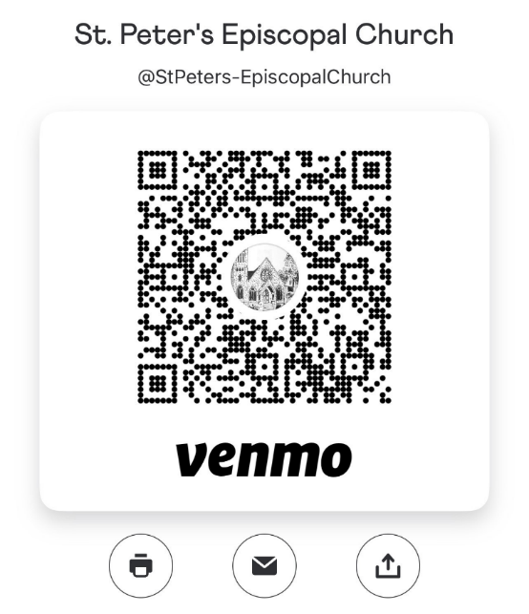
ALWAYS include a note/memo to identify how to credit the payment, for example:
- Annual Pledge payment
- Wednesday Dinner
- Easter Lily
- Capital Pledge payment

https://venmo.com/u/StPeters-EpiscopalChurch


Living Compass
Meet on Monday’s

Weekly meetings at 1pm
at 401 East 4th Avenue.

They will read Richard Rohr’s new book, The Tears of Things: Prophetic Wisdom for an Age of Outrage.

Questions, contact D’Ann Downey, ddowneywarley@comcast.net



Children’s Chapel
Each Sunday, 9:57am.

We will depart as a group from the nave and return during the Peace to share The Eucharist with their families.

Children’s Chapel is available for children ages Pre-K thru 2nd grade that can sit for a short service of songs, creeds, lectionary-based story telling.

OPEN dates on the flower calendar:

Nave – July 6th
Chapel – July 27th

Candles in the Nave given to the Glory of God by Melissa & Brian Keefe in memory of departed loved ones.

Flowers on the Nave altar given to the Glory of God by Norman Fletcher and Paul Dickinson-Fletcher in memory of John Dickinson and Dot Fletcher.

Flowers on the Chapel altar given to the Glory.

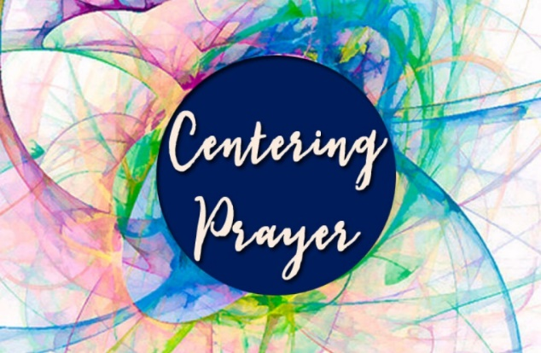
Will not meet during the months of June and July.

See you back in August, Jane Cunningham,
706.346.4091 or missjane1@mac.com


You have been invited by Bridges Out of Poverty to sign up for "2025 Getting Ahead Volunteers." Please click on the button below to view the online sign-up sheet.

https://www.signupgenius.com/go/8050D4CAFAF2AA5F49-2022/129572970#/
The Bridges Out of Poverty Task Force is pleased to announce the launch of the 8th Getting Ahead in a Just-Gettin'-By World program on Thursday May 22. As most of you know, the Bridges program in Rome and Floyd County is a ministry of First Baptist Church and St. Peter's Episcopal Church of Rome. The program is fully funded by these 2 churches and individual contributions, and the Getting Ahead program is 100% supported by volunteers.
For all who have volunteered in the past, or supported us financially, we are deeply grateful. Sharing the love of Jesus as a volunteer, you will have the opportunity to get to know the participants and how they are just people like us-they've just been dealt a bad hand in life, and for the most part cast aside by our community. As we begin the next program, we will need volunteers to provide meals, transportation and childcare on Thursday evenings. If you are interested in serving individuals in our community who are willing to work to improve their life situation and become contributors in our community, by volunteering, please contact Alice Clements (meals), Robin Phillips (transportation) or Marty Willingham (child care) or go to the link to access the volunteer sign up.
Thank you in advance for your continued support of Bridges Out of Poverty Rome-Floyd County as we work to improve the lives of those struggling with poverty in their life!
Bridges Task Force

Robin Phillips 770-853-2767, robinjphillips@me.com

Marty Willingham 706-207-5858, mswillingham@bellsouth.net

Alice Clements 706-766-1847, apclements@comcast.net


ESP
Friendly Friday

June 20th & July 18th
8:30am till 10am (or whatever time you can share)

Come to Georgia Highlands
and share your time with these Extra Special People

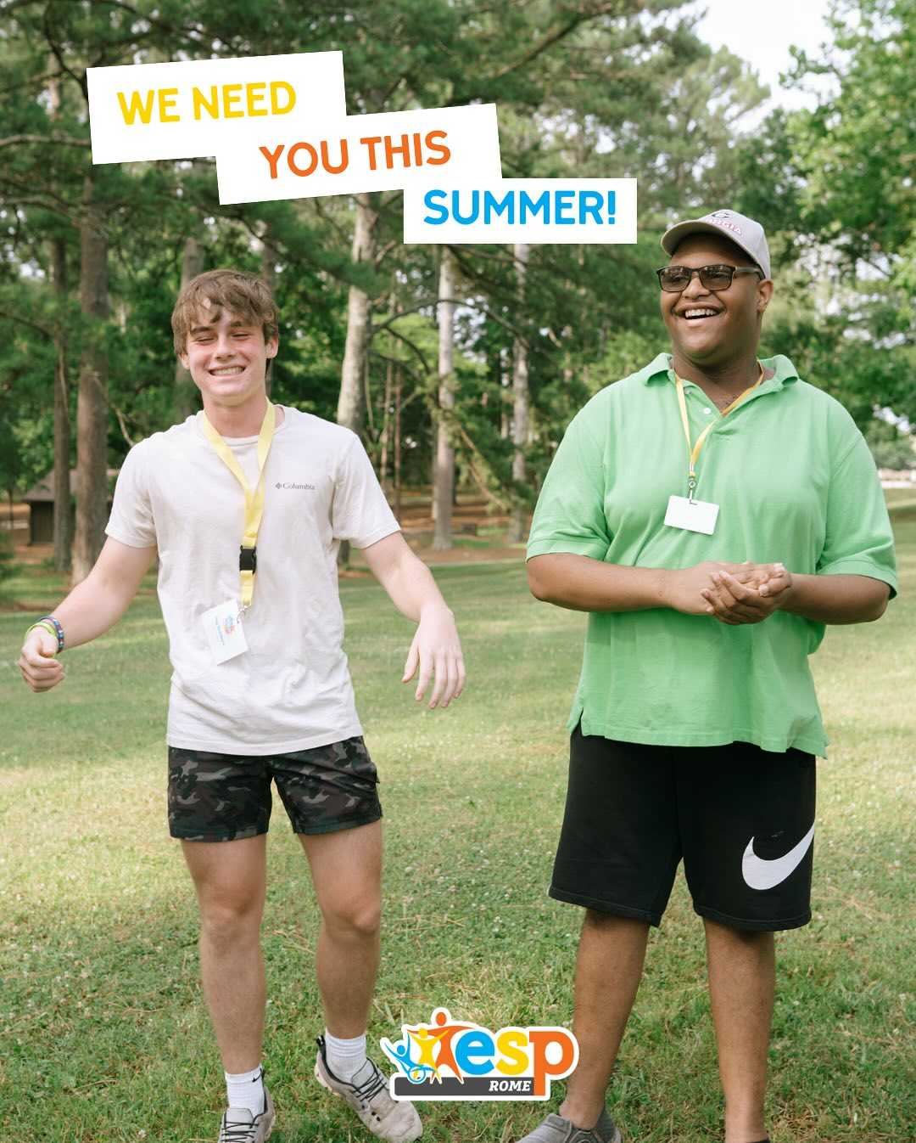
Adults and Kids
are all Welcome

Questions Contact
Hollye Smith, 706.512.9193
Cameron Jackson, 770.823.4782


Wednesday Night Dinners are currently on SUMMER BREAK.

Share your thoughts…

Are there dinners you dislike?
Do you like having a meal choice?

Let the office know & we will work to accommodate your ideas.

JUNE | Monday | Tuesday | Wednesday | Thursday | Friday | Saturday
June 1  8:15-11:45 Nursery provided  9:57am Children’s Chapel  8:30am – Rite I Chapel  10am – Rite II Nave, WLAQ/You tube  Diocean Confirmations, Receptions, Re-Affirmations – 4pm Cathedral of St. Philip | 2  9-noon VBS  1pm Living Compass study group | 3  9-noon VBS  9am Staff Meeting | 4  9-noon VBS  5:30pm Celtic Service | 5  9-noon VBS | 6  9-noon VBS  ESP Friendly Friday  Ga Highlands 8:30-10am | 7
8  8:15-11:45 Nursery provided  9:57am Children’s Chapel  8:30am – Rite I Chapel  10am – Rite II Nave with baptisms, WLAQ/You tube. | 9  1pm Living Compass study group | 10  9am Staff Meeting  7-8:30pm Indivisible Meeting D. Hall | 11  5:30pm Celtic Service | 12 | 13 | 14
15  8:15-11:45 Nursery provided  9:57am Children’s Chapel  8:30am – Rite I Chapel  10am – Rite II Nave, WLAQ/You tube | 16  1pm Living Compass study group  5-7pm FAMILY MOVIE NITE  Pizza & drinks by Children’s Ministry | 17  9am Staff Meeting  5:30pm Vestry Meeting | 18  5:30pm Celtic Service | 19  4pm Stephen Ministry Supervision Meeting Rhodes Wyatt Room | 20  Community Kitchen Volunteers 9am till Noon | 21
22  8:15-11:45 Nursery provided  9:57am Children’s Chapel  8:30am – Rite I Chapel  10am – Rite II Nave, WLAQ/You tube  EYC Pilgrimage to Italy, return July1st | 23  1pm Living Compass study group | 24  9am Staff Meeting  9-Noon Community Kitchen Volunteers  4-8pm ESP D. Hall | 25  5:30pm Celtic Service  ST. PETER’S DAY CELEBRATION  BBQ 6pm | 26 | 27 | 28
29  8:15-11:45 Nursery provided  9:57am Children’s Chapel  8:30am – Rite I Chapel  10am – Rite II Nave, WLAQ/You tube | 30  1pm Living Compass study group | July 1  9am Staff Meeting  10:30am Stephen Ministry Leader Meeting Rhodes Wyatt Room.  Pilgrims Return | 2 | 3 | 4  Office Closed | 5

