In your mercy you came to our help, so that in seeking you we might find you. Again and again you called us into covenant with you, and through the prophets you taught us to hope for salvation.

Father, you loved the world so much that in the fullness of time you sent your only Son to be our Savior. Incarnate by the Holy Spirit, born of the Virgin Mary, he lived as one of us, yet without sin. To the poor he proclaimed the good news of salvation; to prisoners, freedom; to the sorrowful, joy. To fulfill your purpose he gave himself up to death; and, rising from the grave, destroyed death, and made the whole creation new.

And, that we might live no longer for ourselves, but for him who died and rose for us, he sent the Holy Spirit, his own first gift for those who believe, to complete his work in the world, and to bring to fulfillment the sanctification of all.

When the hour had come for him to be glorified by you, his heavenly Father, having loved his own who were in the world, he loved them to the end; at supper with them he took bread, and when he had given thanks to you, he broke it, and gave it to his disciples, and said, “Take, eat: This is my Body, which is given for you. Do this for the remembrance of me.”

After supper he took the cup of wine; and when he had given thanks, he gave it to them, and said, “Drink this, all of you. This is my Blood of the new Covenant, which is shed for you and for many for the forgiveness of sins. Whenever you drink it, do this for the remembrance of me.”

Father, we now celebrate this memorial of our redemption. Recalling Christ’s death and his descent among the dead, proclaiming his resurrection and ascension to your right hand, awaiting his coming in glory; and offering to you, from the gifts you have given us, this bread and this cup, we praise you and we bless you.

Celebrant and People
We praise you, we bless you,
we give thanks to you,
and we pray to you, Lord our God.

The Celebrant continues
Lord, we pray that in your goodness and mercy your Holy Spirit may descend upon us, and upon these gifts, sanctifying them and showing them to be holy gifts for your holy people, the bread of life and the cup of salvation, the Body and Blood of your Son Jesus Christ. Grant that all who share this bread and cup may become one body and one spirit, a living sacrifice in Christ, to the praise
of your Name. Remember, Lord, your one holy catholic and apostolic
Church, redeemed by the blood of your Christ. Reveal its unity, guard its faith, and preserve it in peace.

And grant that we may find our inheritance with the Blessed Virgin Mary, with patriarchs, prophets, apostles, and martyrs, (with _________ ) and all the saints who have found favor with you in ages past. We praise you in union with them and give you glory through your Son Jesus Christ our Lord.

Through Christ, and with Christ, and in Christ, all honor and glory are yours, Almighty God and Father, in the unity of the Holy Spirit, for ever and ever. AMEN.

And now, as our Savior Christ has taught us, we are bold to say,

People and Officiant
Our Father, who art in heaven,  hallowed be thy Name,  thy kingdom come,  thy will be done,  on earth as it is in heaven.  Give us this day our daily bread.  And forgive us our trespasses, | as we forgive those  who trespass against us.  And lead us not into temptation,  but deliver us from evil.  For thine is the kingdom,  and the power, and the glory,  for ever and ever. Amen

The Breaking of the Bread
Fraction Anthem S155

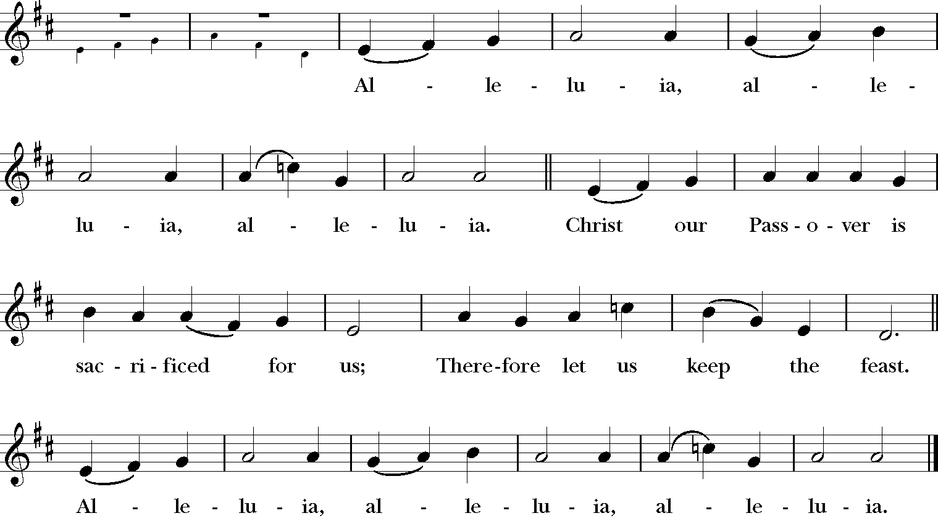

Communion Hymns:

604 “When Christ was lifted from the earth” San Rocco

676 “There is a balm in Gilead” Balm in Gilead

Post Communion Prayer

Officiant and People

Almighty and everliving God, we thank you for feeding us with the spiritual food of the most precious Body and Blood of your Son our Savior Jesus Christ; and for assuring us in these holy mysteries that we are living members of the Body of your Son, and heirs of your eternal kingdom.
And now, Father, send us out to do the work you have given us to do,
to love and serve you as faithful witnesses of Christ our Lord. To him, to you, and to the Holy Spirit, be honor and glory, now and for ever. Amen.

The Blessing

The Dismissal

Procession Hymn 529 “In Christ there is no East or West” McKee

Voluntary “Puer nobis nascitur" Gerald Near

Fifth Sunday in Easter
May 11, 2025

Voluntary "St. Columba" Healey Willan

Procession 475 “God himself is with us” Tysk

Officiant Alleluia. Christ is risen.
People The Lord is risen indeed. Alleluia.

Officiant
Almighty God, to you all hearts are open, all desires known, and from you no secrets are hid: Cleanse the thoughts of our hearts by the inspiration of your Holy Spirit, that we may perfectly love you, and worthily magnify your holy Name; through Christ our Lord. Amen.

Gloria in excelsis S278
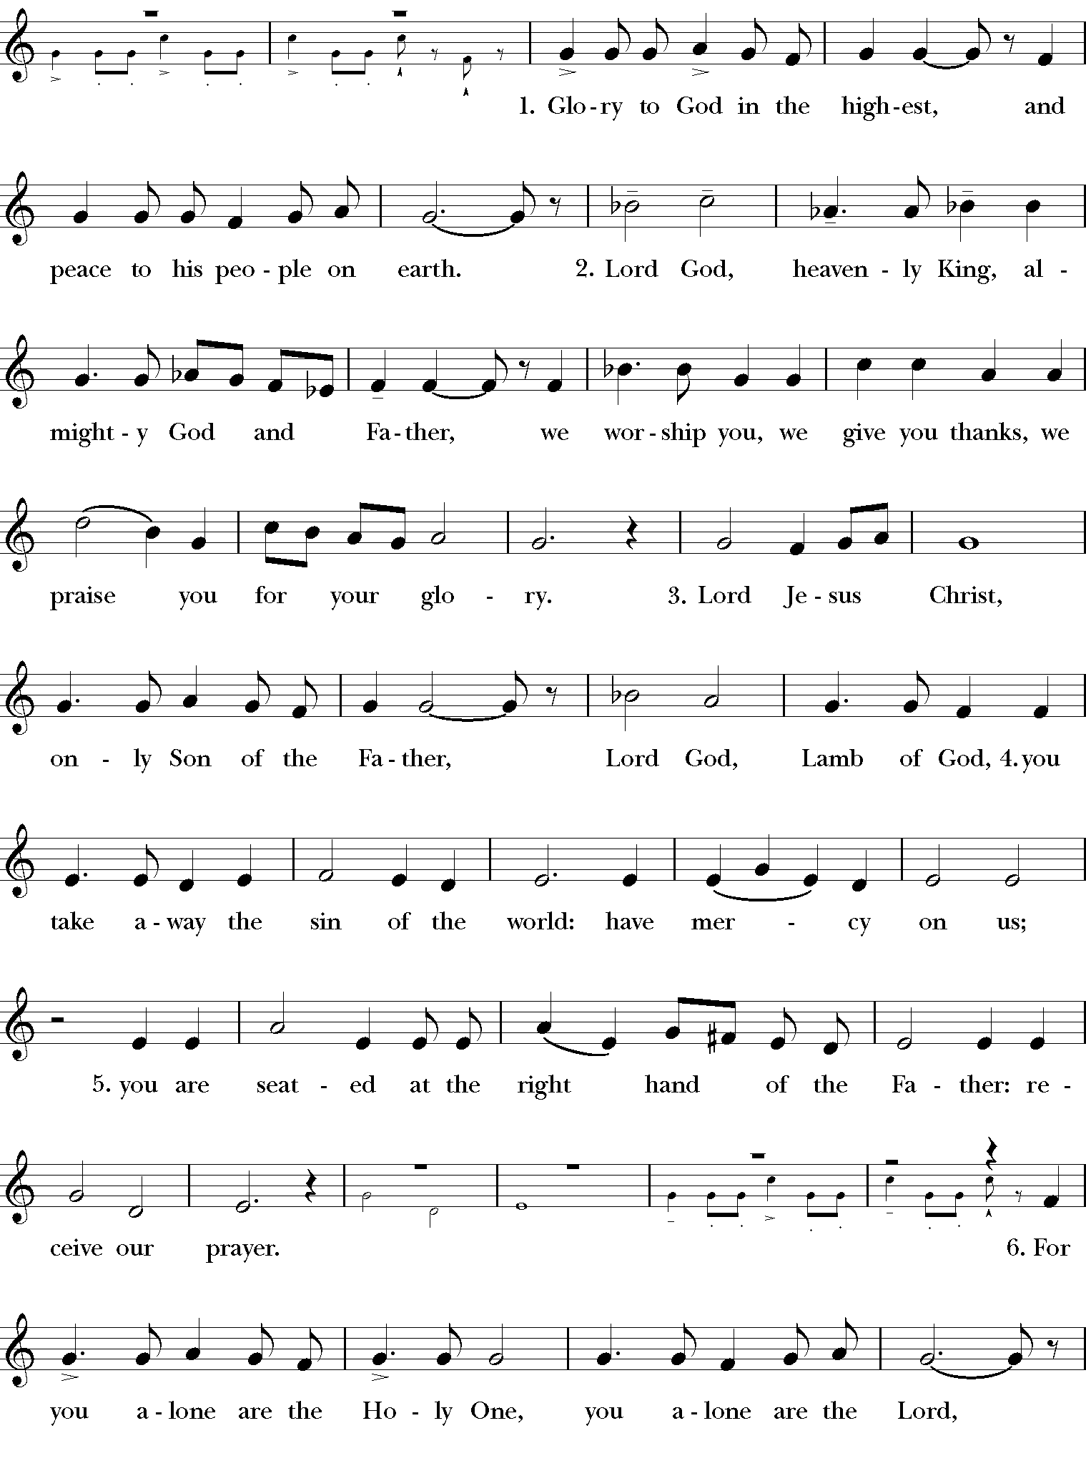

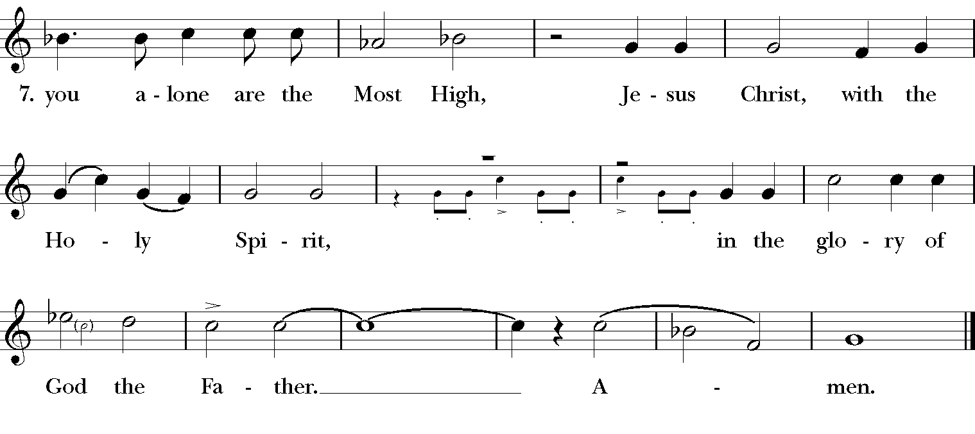
Collect of the Day
Almighty God, whom truly to know is everlasting life: Grant us so perfectly to know your Son Jesus Christ to be the way, the truth, and the life, that we may steadfastly follow his steps in the way that leads to eternal life; through Jesus Christ your Son our Lord, who lives and reigns with you, in the unity of the Holy Spirit, one God, for ever and ever. Amen.

The Lesson: Acts 11:1-18
After the Reading, the reader says
The Word of the Lord.
People Thanks be to God.

Gradual: Psalm 148 (sung by choir) Thomas Attwood Walmisley

The Epistle: Revelation 21:1-6
After the Reading, the reader says
The Word of the Lord.
People Thanks be to God.

Sequence Hymn 487 “Come, my Way, my Truth, my Life” The Call

The Holy Gospel: John 13:31-35
The Holy Gospel of Our Lord Jesus Christ
according to John.
People Glory to you, Lord Christ.

After the Gospel, the Priest says
The Gospel of the Lord.
People Praise to you, Lord Christ.

The Sermon The Reverend John Foster Herring

The Nicene Creed
We believe in one God,
the Father, the Almighty,
maker of heaven and earth,
of all that is, seen and unseen.

We believe in one Lord, Jesus Christ,
the only Son of God,
eternally begotten of the Father,
God from God, Light from Light,
true God from true God,
begotten, not made,
of one Being with the Father.
Through him all things were made.
For us and for our salvation
he came down from heaven:
by the power of the Holy Spirit
he became incarnate from the Virgin Mary,
and was made man.

For our sake he was crucified under Pontius Pilate;
he suffered death and was buried.
On the third day he rose again
in accordance with the Scriptures;
he ascended into heaven
and is seated at the right hand of the Father.
He will come again in glory to judge the living and the dead,
and his kingdom will have no end.
We believe in the Holy Spirit, the Lord, the giver of life,
who proceeds from the Father and the Son.
With the Father and the Son he is worshiped and glorified.
He has spoken through the Prophets.
We believe in one holy catholic and apostolic Church.
We acknowledge one baptism for the forgiveness of sins.
We look for the resurrection of the dead,
and the life of the world to come. Amen.

The Prayers of the People, Form III
The people remain standing

The Leader and People pray responsively
Father, we pray for your holy Catholic Church;
That we all may be one.

Grant that every member of the Church may truly and humbly serve you;
That your Name may be glorified by all people.

We pray for all bishops, priests, and deacons;
That they may be faithful ministers of your Word and Sacraments.

We pray for all who govern and hold authority in the nations of the
world;
That there may be justice and peace on the earth.

Give us grace to do your will in all that we undertake;
That our works may find favor in your sight.

Have compassion on those who suffer from any grief or trouble;
That they may be delivered from their distress.

Give to the departed eternal rest;
Let light perpetual shine upon them.

We praise you for your saints who have entered into joy;
May we also come to share in your heavenly kingdom.

Let us pray for our own needs and those of others.
Silence
The People may add their own petitions.

Officiant adds a concluding Collect.

The Peace

Offertory Anthem “Since by man came death,” from The Messiah
G.F. Handel
Since by man came death, by man came also the resurrection of the dead. For as in Adam all die, even so in Christ shall all be made alive. [I Corinthians 15:21-22]

Doxology
Praise God, from Whom all blessings flow;
Praise Him, all creatures here below;
Praise Him above, ye heavenly host;
Praise Father, Son and Holy Ghost.

The Holy Communion

Eucharistic Prayer D (Gluten Free wafers available)

Celebrant The Lord be with you.
People And also with you.
Celebrant Lift up your hearts.
People We lift them to the Lord.
Celebrant Let us give thanks to the Lord our God.
People It is right to give him thanks and praise.

It is truly right to glorify you, Father, and to give you thanks; for you alone are God, living and true, dwelling in light inaccessible from before time and for ever.

Fountain of life and source of all goodness, you made all things and fill them with your blessing; you created them to rejoice in the splendor of your radiance.

Countless throngs of angels stand before you to serve you night and day; and, beholding the glory of your presence, they offer you unceasing praise. Joining with them, and giving voice to every creature under heaven, we acclaim you,
and glorify your Name, as we sing,

Celebrant and People
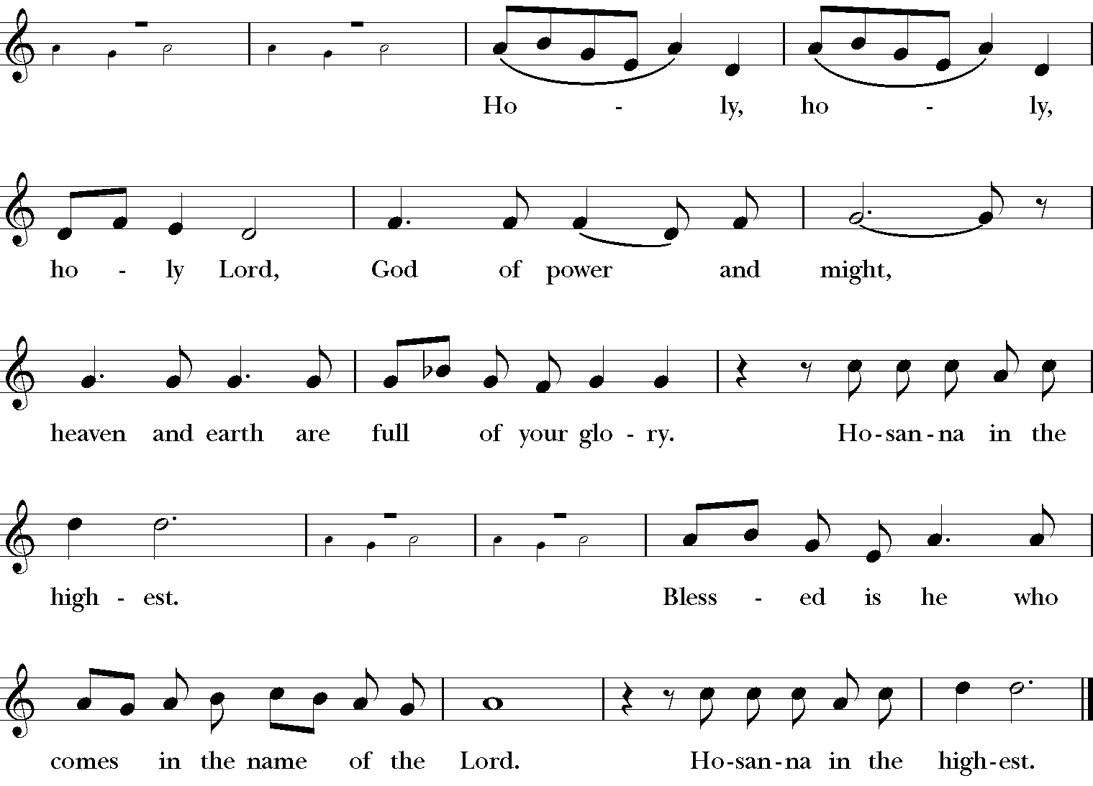
Sanctus S128
We acclaim you, holy Lord, glorious in power. Your mighty works reveal your wisdom and love. You formed us in your own image, giving the whole world into our care, so that, in obedience to you, our Creator, we might rule and serve all your creatures. When our disobedience took us far from you, you did not abandon us to the power of death.

