

**WELCOME TO ALL OUR VISITORS!**

If you are interested in knowing more about St. Peter’s, please see an usher or one of the greeters who stand with the clergy after the service.

**4.6.2025 at St. Peter’s**

8:15am-11:45am Nursery

8:30am Holy Eucharist Rite I in Chapel

9-10am Breakfast

9:57am Children’s Chapel, departing from Nave as a group

10:00am Holy Eucharist Rite II in Nave, WLAQ radio & YouTube

**This week…**

Monday/April 7th **1pm Living Compass Lenten Study Group**

Tuesday/April 8th 10-12:30 Stephen Ministry Meeting, Jr. High Room

**5:30pm Stations of the Cross in the Nave**

Wednesday/April 9th 4pm Centering Prayer

5:30pm Celtic Service in Chapel

7pm Adult Choir Practice

Thursday/April 10th 10am Bible Study – I Samuel

11am Palm Cross Construction in Daniel Hall

**5:30pm Evening Prayer in the Chapel**

Saturday/April 12th 11am Readers for Passion on Sunday, practice

Meg Alexander, Gina Schmitz, Sylvia Hine, Rees Jenkins, Ray Dempsey, John Schroeder, Jane Gray Collier, Emily Colon, Sage Hoare, Michael Ann Booth, The Carlton Family, Campbell Clark, Jimmy Smithson, Andrew Babcock, The Marable Family, Lisa Frierson, John Marshall, Jim Mullis, Henry Pancione, Katie Pancione, Jan Woody, Hannah Nabors, Rob & Jan Gordon and those that care for them.

**Beginning of each month** the intercessory prayer list will be “refreshed”; all names removed. If you wish to add someone, please call, or email the church office. Names will remain on the Prayer List for the entire month.

**Military Prayer List:**

Nolan Kelley

Davis Isley

Cherrie Shackelford

Andrew Hall

Ted Olney

Michael Blair

Steven Blair

Charlie Hardaker

Justin Yeary

Thomas Keefe

Ryan Holman

Johnny Crittenden

Sara Carver Thomas

Joshua Ingram

Jerrod Keplinger

**Please remember to notify the church office when a service member is no longer on active duty.**

April 10th

11am

Daniel Hall

Come Join us to create Palm Crosses!

No prior experience is necessary.

It’s easy and we will show you how.

Bring your friendly, vaccinated dog(s) to Ridge Ferry Park for a time of fun and fellowship.

Questions reach out to Margaret Louttit, 678.641.5895

**ADULT opportunity**

Wednesday evenings 6-7pm.

EYC room

A simple reflection and discussion on the lectionary.

**COME JOIN US!**

Thursday Mornings at 10am

Studying the 1st book of Samuel

Volunteers needed for VBS!

Come share God’s love with our youngest members.

Use the Google link below.

<https://docs.google.com/forms/d/1RV8yDnV33qdxhLFSGsZnAtG9K1-sns7G1B_BW0qz-Ag/viewform?edit_requested=true>

Questions contact Bonnie Mitchell, 706.936.9833

Continue to keep our Stephen Minister trainees in your prayers as they reach the midpoint of their initial training. Last week they learned about “Confidentiality,” a crucial part of Stephen Ministry. Everything a care receiver tells a Stephen Minister, and even the identity of the care receiver, remains strictly confidential, which helps build a safe environment of trust and acceptance that God can use to bring hope and healing.

This week they’re exploring one of the more frequent situations in which they may provide care “Ministering to Those Experiencing Grief.” They’ll learn about the different stages of grief, along with practical ways they can care at each stage. This is a situation everyone is likely to encounter at different times in life, so it’s a crucial way our Stephen Ministers will offer care in our congregation and community.

**St. Paula’s Guild for April**

**Will join the Paint & Sip in support of EYC Pilgrimage.**

**Contact the church office to make your reservations.**

**Paint ONLY $35 ~ Sip & Paint $50**

**Bridges out of Poverty is a joint ministry of St. Peter's**

**and First Baptist**.

The Getting Ahead in a Just-Gettin'-By World model is to pair up each graduate with a Success Coach.

**A Success Coach** role is to help guide the graduate as they apply the principles from Getting Ahead and continue their life journey.  The coach's role is both challenging and rewarding.

**If you are interested in becoming a Success Coach**

**please contact Keith Phillips, 678.296.1671**

**and he can answer any questions you may have.**

Mark Knauss 6th

Ava Belle Holcombe 6th

Molly Ledbetter 7th

Wilson Lucas 8th

Sammy Edgeworth 8th

Christopher Brown 8th

Nell Warren 9th

Sarah McElrath 9th

Lilah Smith 9th

Jimmy Smith 10th

Emily Tarter 10th

**EASTER VIGIL RECEPTION**

**April 19th**

**Need YOUR help to provide food, set up, take down, serving for the reception.**

**Contact Margaret Louttit, 678.641.5895**

**To Allien McNair &**

**Bill Schoepski**

**for putting up the new**

**BASKETBALL GOAL**

Living Compass Lenten Study Group

Mondays March 10th ~ April 14th

1pm at 401 East 4th Ave.

Devotional Books available in the nave & Daniel Hall.

Tuesdays at 5:30pm

in the Nave

March 10th ~ April 15th

**Thursdays at 5:30pm**

**Chapel**

**March 6th ~ April 10th**

Mite boxes are available in Daniel Hall or the nave.

During Lent fill the box with your loose change. Return your filled box on

Easter morning!

Living Compass Study 1pm March 10th ~ April 14th

Stations of the Cross 5:30pm March 11th ~ April 15th

Evening Prayer 5:30pm March 6th ~ April 10th

Palm Crosses 11am ~ April 10th in Daniel Hall

Community Services Noon April 14th -16th

North Broad Baptist

Light lunch served after the service.

Maundy Thursday 7pm April 17th in the Nave

Good Friday Noon April 18th in the Nave

Holy Saturday 9pm April 19th in the Nave.

Reception in Daniel Hall after the service.

Passion Readers for Palm Sunday

Practice on Saturday, 4.12.2025 at 11am in the Nave.

Rachel Jones Joshua Bell Devon Smyth Mary Burke Smith

David Peters Bonnie Mitchell Stephen Taylor Eli Jackson

David Jahner Marshall Jenkins Brian Hampton Nat Massey

**All children** are invited to join the **Procession of the Palms**

Palm Sunday, April 13th.

Please report to the back of the Nave no later than 9:50 to line up. Jr. Choir will also process that day.

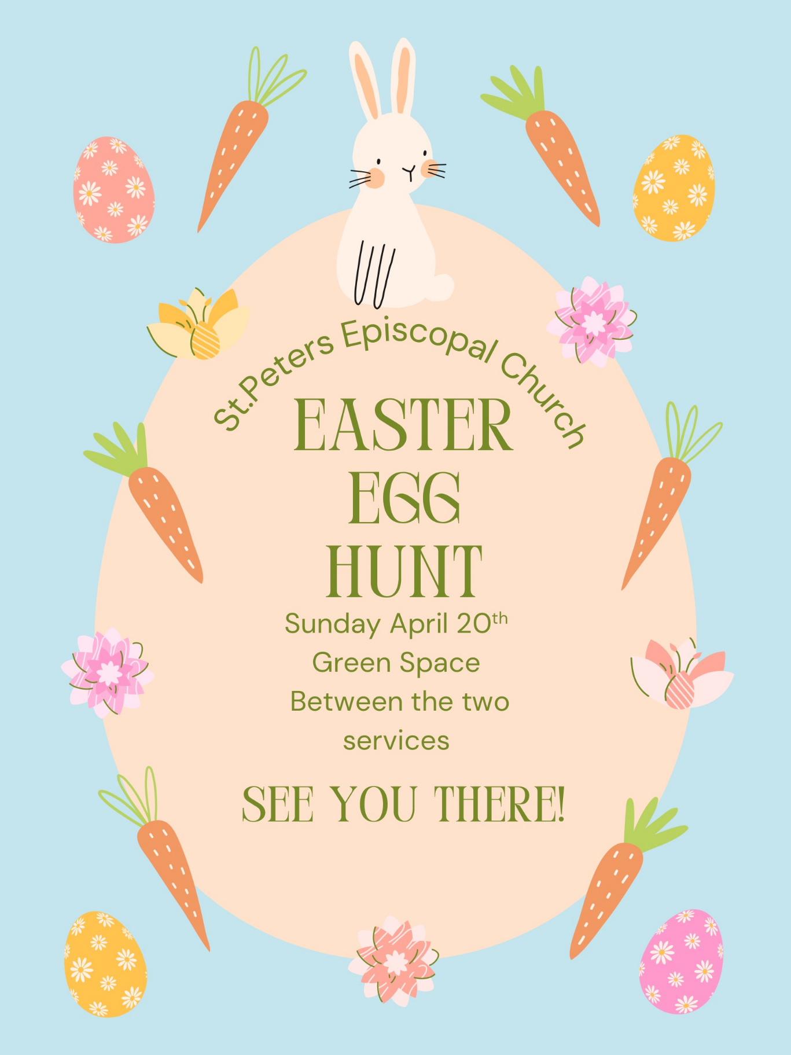

**Gather in Daniel Hall.**

**Bags will be available but feel free to bring your Easter basket if you prefer.**

We gather every Wednesday

at 4pm in the Rhodes Wyatt Room at St. Peter’s.

Contact Jane Cunningham with questions: [missjane1@mac.com](mailto:missjane1@mac.com)

**EYC Meal Sign up**

**Help feed our Youth on Sunday Nights**

We have really enjoyed starting EYC every Sunday night by breaking bread together! If you would like to cook, order, or sponsor a meal, please sign up!

*Thank you for your kindness and support!*

<https://www.signupgenius.com/go/10C084EACAB2FA5FCC43-50683016-eycsunday>

Use the link below to sign up to provide a meal for the Canterbury Students:

<https://www.signupgenius.com/index.cfm?go=w.manageSignUp#/54192107/slots/>

Devon Goddard Smyth, Campus Missioner

770.714.2361 or devongsmyth@gmail.com

Adults join us for a Sip & Paint

(beer & wine)

Reservations on REALM or contact the church office.

**St. Peter’s VOLUNTEERs** are needed from 9am till noon. HOWEVER, if you are not able to work the full 3 hours, any time you can share is greatly appreciated.

**2025 Schedule**

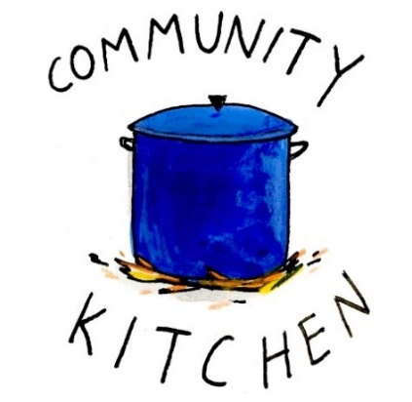 **Friday Tuesday**

**April 25 29**

**May 23 27**

**June 20 24**

**July 25 29**

**August 22 26**

**September 23 30**

**October 24 28**

**November 21 25**

**December 26 30**

Contact Nancy Hunter if you are able to help out, 706.506.3889.

**April Vestry Meeting**

**Tuesday, 4.15.2025**

**5:30pm**

**Rhodes Wyatt Room**

**Submit agenda items/reports via email by Monday, 4.14.2025**

**Would you like to place a lily**

**on the altar for**

**Easter Sunday?**

**Please complete the form below:**

Deliver the completed form & gift to the office by:

**Monday April 14th**

* Mail - 101 East 4th Ave, Rome GA 30161
* Office – [elizabeth@stpetersrome.org](mailto:elizabeth@stpetersrome.org) or 706.291.9111
* Offering plate - with your gift

Checks made payable to St. Peter’s and marked *Easter lily*. No specific amount is requested. Give whatever is comfortable.

**__________________________________________________________________________**

**Name of Honoree**

**Circle One:**

In Thanksgiving for In Memory In Honor of

**________________________________________________________________________**

**Name of Donor (for reference only, will not be printed**

**Do YOU have a VENMO Account?**

**You may use it to remit payments to the church.**

ALWAYS include a note/memo to identify how to credit the payment, for example:

* Annual Pledge payment
* Wednesday Dinner
* Easter Lily
* Capital Pledge payment

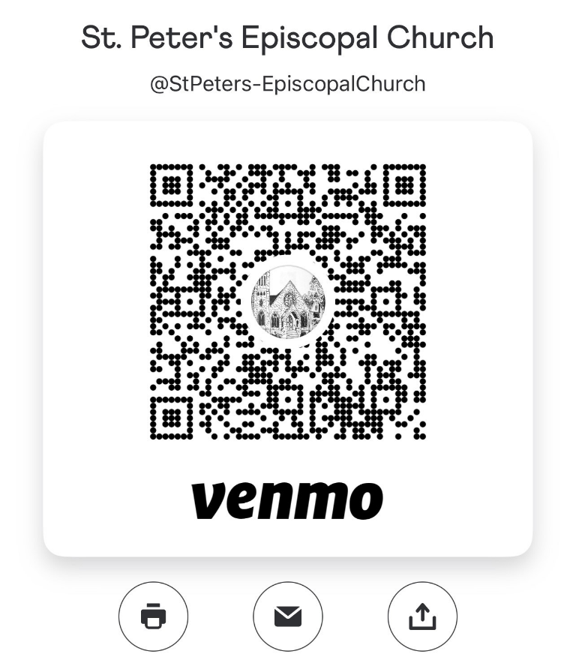

<https://venmo.com/u/StPeters-EpiscopalChurch>

**Children’s Chapel**

For ages 3-7, who can sit for a short service.

Children depart as a group from the nave at 9:57am for their kid size worship service. Returning to the Nave to share the Eucharist with their families.

**All kids up to**

**5th grade come join the party!**

**Parents, check your email for info on the party.**

Wednesdays

5pm

**Dinners continue through May 14th**

Multiple Menu Options

* Adults select ONE Protein & TWO sides.
* Kids (or adults) also have a meal choice.
* VEGETARIAN meals will include all 4 sides & meatless protein.

**Reservations are REQUIRED by Monday at Noon.**

**All meals are customized. Extra meals will not be available.**

**Make your reservation for one night or for multiple nights:**

* Call or email the church office with your reservation by NOON on Monday
* Register on Realm
* Use the following page in your announcements, circle your choice, print your name and turn it in at the church office or in the collection plate.

**Your caterers would be VERY appreciative if someone could assist them, handing complete meals through the serving window to parishioners. If you will help, just check in with Sheila or William when you arrive for dinner. THANK YOU**

Reservations by Noon on the Monday before.

Adults $10, children $4, Family Max $25

April 16 – Dessert, Lemon Cake/Icing

Honey Soy Pork Tenderloin Medallions OR Lemon Caper Chicken – Choose ONE

Vegetarian – All 4 sides with meatless burger patty

Buttered rice, Teriyaki long green beans, Corn on cob, Salad– Choose Two

Kids–Pepperoni Pizza OR Fish Sticks Choose ONE

April 23 – Dessert, Chocolate Cake/Icing

Smothered Cube Steak w/onions OR Fried Chicken White or Dark – Choose ONE

Vegetarian – All 4 sides with meatless boiled eggs

Mashed Potatoes, English Peas, Candid Carrots, Salad – Choose Two

Kids Dino Nuggets OR PBJ –Choose ONE

April 30 – Dessert **Final Roots gathering till Fall.**

Roast Pork Loin OR Million $ Chicken– Choose ONE

Vegetarian – All 4 sides with meatless burger patty

Broccoli Casserole, Speckled Butter Beans, Buttered Corn, Salad– Choose Two

Kids–Mini Corn Dog OR Cheese Pizza Choose ONE

May 7 – Dessert, Banana Pudding

Smoked Chicken quarters OR Smoked Pork Tenderloin– Choose ONE

Vegetarian – All 4 sides with hard boiled eggs

Macaroni Salad, Baked Beans, Baked Potato, Salad– Choose Two

Kids–Chicken Tenders OR Hotdog Choose ONE

**May 14 – Our FINAL Dinner!**

Hand patted 6oz burgers/cheeseburgers OR Hotdogs with all the fixings.

Family Style: Macaroni Salad, Chips, Corn Salad, Watermelon/Feta Salad, Tomato/Cucumber salad.

Dessert, Poundcake with Strawberries/whipped cream

Print your name, thanks

Use a separate form for each meal ordered OR use the back to itemize all orders with names!

|  |  |  |  |  |  |  |
| --- | --- | --- | --- | --- | --- | --- |
| **APRIL** | **Monday** | **Tuesday** | **Wednesday** | **Thursday** | **Friday** | **Saturday** |
|  |  | 1  9am Staff Meeting  Stephen Ministry  10-12:30  **5:30pm Lenten Stations of the Cross** | 2  4pm Centering Prayer  5-5:30pm Children’s Choir  5pm Dinner Served  5:30pm Celtic  6-7pm Roots, Catechumenate &  **Adult Small Group**  7pm Adult Choir | 3  10am Bible Study  **5:30pm Lenten Evening Prayer in Chapel**  5:30pm Stephen Ministry Meeting R. Wyatt  4-8pm ESP Daniel Hall | 4 | 5 |
| 6  8:15-11:45 Nursery provided  8:30am – Rite I Chapel  9-10am Breakfast in Daniel Hall  9:57am Children’s Chapel  10am – Rite II Nave, WLAQ/You tube | 7  **1pm Living Compass Lenten Study** | 8  Stephen Ministry  10-12:30  **5:30pm Lenten Stations of the Cross**  7-8pm Indivisible D. Hall Melissa Keefe | 9  4 pm Centering Prayer  7pm Adult Choir  5:30pm Celtic  All other Wednesday Activities cancelled for the day. | 10  10am Bible Study  **11am Palm Cross Construction**  **5:30pm Lenten Evening Prayer in Chapel**  6:30pm 3 Rivers  R. Wyatt | 11  4-9 ESP Daniel Hall | 12  **Passion Readers, practice 11am in Nave** |
| **13**  **PALM SUNDAY**  8:15-11:45 Nursery provided  8:30am – Rite I Chapel  Children’s Parade of Palms  9:57am Children’s Chapel  9-10am Breakfast in Daniel Hall  10am – Rite II Nave, WLAQ/You tube  EYC – Egg filling  3pm Rodeph Salom Sader Supper – Daniel Hall | 14  Noon Reservations for Wednesday Dinner  **Noon Community Holy Week Service**  **N. Broad Baptist**  **1pm Living Compass Lenten Study** | 15  9am Staff Meeting  Stephen Ministry  10-12:30  **Noon Community Holy Week Service**  **N. Broad Baptist**  **5:30pm Lenten Stations of the Cross** | 16  **Noon Community Holy Week Service**  **N. Broad Baptist**  4pm Centering Prayer  5-5:30pm Children’s Choir  5pm Dinner Served  5:30pm Celtic  6-7pm Roots,  **Adult Small Group**  7pm Adult Choir | 17  5:30pm Stephen Ministry Meeting R. Wyatt  **MAUNDY SERVICE 7PM IN NAVE** | 18  **GOOD FRIDAY SERVICE NOON** | 19  3:30pm Episcopups  **EASTER VIGIL 9PM RECEPTION AFTER THE SERVICE.** |
| 20  **EASTER SUNDAY – Return Mite Box**  8:45-1pm Nursery Provided  9am Rite II in Nave  9:45am Breakfast  10am Egg Hunt, gather on stage in  D. Hall  11:15am Rite II in Nave | 21  Noon Reservations for Wednesday Dinner  Office Closed | 22  9am Staff Meeting  Stephen Ministry  10-12:30 | 23  4pm Centering Prayer  5-5:30pm Children’s Choir  5pm Dinner Served  5:30pm Celtic  6-7pm Roots, Catechumenate  **Adult Small Group**  7pm Adult Choir | 24  10am Bible Study | 25  9am-Noon Community Kitchen Volunteers | 26  **5pm EYC**  **Sip & Paint in Daniel Hall** |
| **27 – Canterbury Sunday**  8:15-11:45 Nursery provided  8:30am – Rite I Chapel  9-10am Breakfast in Daniel Hall  9:57am Children’s Chapel - FINAL  10am – Rite II Nave, WLAQ/You tube  EYC to Six Flags | 28  Noon Reservations for Wednesday Dinner | 29  9am Staff Meeting  9-Noon Community Kitchen  Stephen Ministry  10-12:30 | 30  4pm Centering Prayer  5-5:30pm Children’s Choir  5pm Dinner Served  5:30pm Celtic  6-7pm FINAL Roots, Catechumenate  **Adult Small Group**  7pm Adult Choir |  |  |  |