

**WELCOME TO ALL OUR VISITORS!**

If you are interested in knowing more about St. Peter’s, please see an usher or one of the greeters who stand with the clergy after the service.

**4.27.2025 at St. Peter’s**

8:15am-11:45am Nursery

8:30am Holy Eucharist Rite I in Chapel

9-10am Breakfast

9:57am Children’s Chapel, departing from Nave as a group

10:00am Holy Eucharist Rite II in Nave, WLAQ radio & YouTube

6-7:30pm EYC

**This week…**

Monday/April 28th Noon Reservations for Wednesday Dinner

Tuesday/April 29th 9am Staff Meeting

Wednesday/April 30th 4pm Centering Prayer

5pm Parish Dinner served in Daniel Hall

5-5:30pm Children’s Choir

5:30pm Celtic Service in Chapel

6-7pm **Roots Party** in Daniel Hall

6-7pm Catechumenate Class & Adult Small Group

7pm Adult Choir Practice

Thursday/May 1st 10am Bible Study

5:30pm Stephen Ministry Supervision Meeting

Friday & Saturday Josie Cole Wedding

Meg Alexander, Gina Schmitz, Sylvia Hine, Rees Jenkins, Ray Dempsey, John Schroeder, Jane Gray Collier, Emily Colon, Sage Hoare, Michael Ann Booth, The Carlton Family, Campbell Clark, Jimmy Smithson, Andrew Babcock, The Marable Family, Lisa Frierson, John Marshall, Jim Mullis, Henry Pancione, Katie Pancione, Jan Woody, Hannah Nabors, Rob & Jan Gordon, Terry Hughes, Mary Nance, Jackie Hizel, Jennifer Neal, the Woods Family, Mary Flanigen and those that care for them.

**NEXT WEEK** the intercessory prayer list will be “refreshed”; all names removed. If you wish to add someone, please call, or email the church office. Names will remain on the Prayer List for the entire month.

**Military Prayer List:**

Nolan Kelley

Davis Isley

Cherrie Shackelford

Andrew Hall

Ted Olney

Michael Blair

Steven Blair

Charlie Hardaker

Justin Yeary

Thomas Keefe

Ryan Holman

Johnny Crittenden

Sara Carver Thomas

Joshua Ingram

Jerrod Keplinger

**Please remember to notify the church office when a service member is no longer on active duty.**

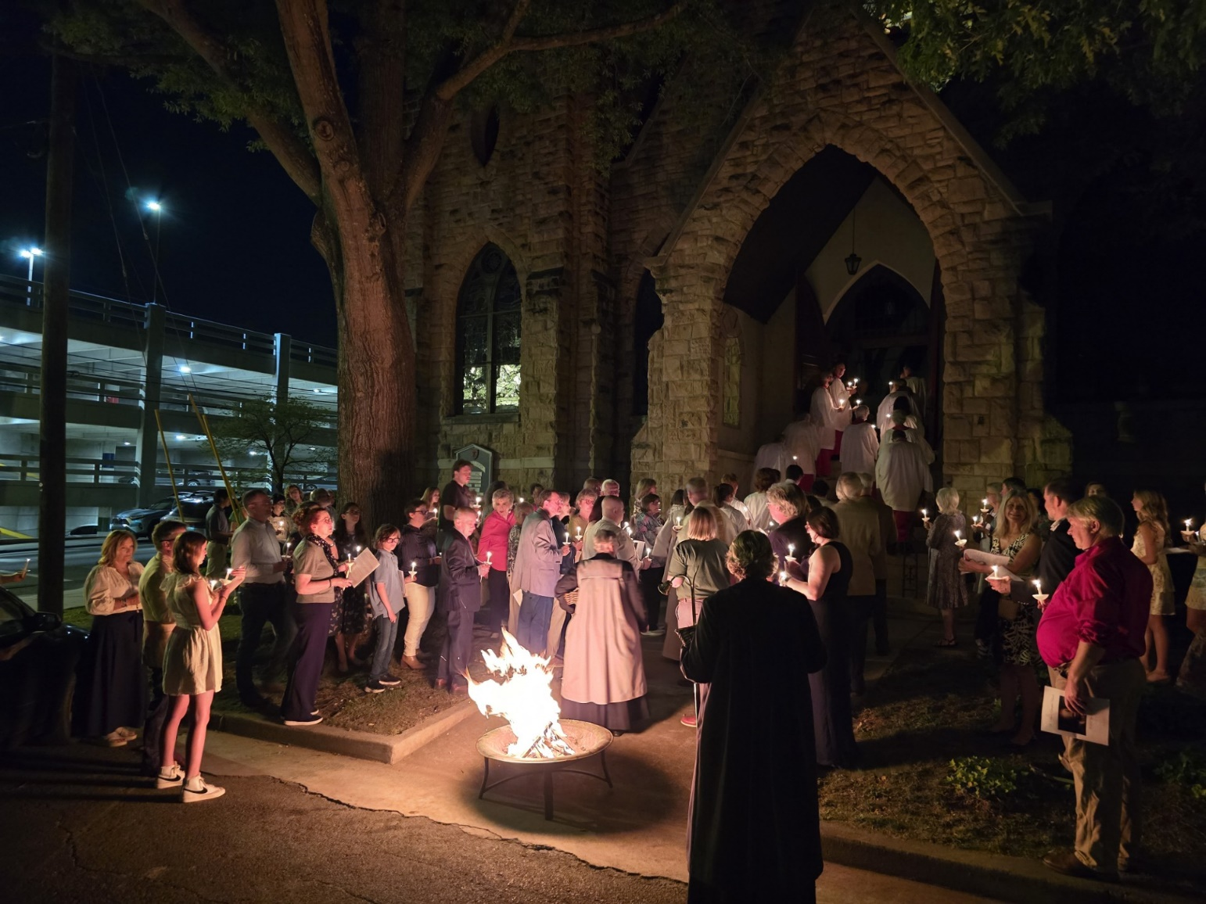

**St. Peter’s VOLUNTEERs** are needed from 9am till noon. HOWEVER, if you are not able to work the full 3 hours, any time you can share is greatly appreciated.

**2025 Schedule**

**Friday Tuesday**

**May 23 27**

June 20 24

July 25 29

August 22 26

September 23 30

October 24 28

November 21 25

December 26 30

Contact Nancy Hunter to volunteer to help, 706.506.3889. THANK YOU

**NEXT SUNDAY**

**May 4th**

**Reception after the 10am service to honor our graduating seniors!**

Come share as our YOUTH lead us in worship.

Volunteers needed for VBS!

Come share God’s love with our youngest members.

Use the Google link below.

Ages “potty trained” 3y olds thru 5th grade.

<https://docs.google.com/forms/d/1RV8yDnV33qdxhLFSGsZnAtG9K1-sns7G1B_BW0qz-Ag/viewform?edit_requested=true>

Questions contact Bonnie Mitchell, 706.936.9833

Barbara Dixon 27th

Julia Thomas 27th

Marissa Rayburn 27th

Keith Summerlin 28th

Sara Harbin Pickett 28th

Rosemary Holcombe 28th

Pam Cordle 28th

Beverly Yancy 29th

Janice Carter May 1st

Caroline Sawhill 1st

Barbara Briley 2nd

Alex Natarella 2nd

Denny Gordon 3rd

Fred Tarrant 3rd

**Available Dates in June**

**Nave – May 11**

**Chapel – May 4, 11 & 25, June 8**

**Place flowers on the church altar in Memory, Thanksgiving or in Honor of a friend or loved one.**

**Contact the church office to select your date.**

Chapel Flowers - $100.00 ~ Nave Flowers - $150.00

**Candles** in the nave given to the Glory of God by Anne Kerr in memory of Fred Kerr.

**Flowers on the Chapel altar** given to the Glory of God by Lynnette & Hugh Bonner in memory of Kathryn Anderson.

**Flowers on the Nave altar** given to the Glory of God in memory of John C. Busbin by his children; Peggy, Laura, Bill, Mary Bridge and his wife, Marny.

**Flowers on the Nave altar** given to the Glory of God by Marshall Jenkins in honor of Wanda Cantrell for 30 years o service as organist at St. Peter’s.

**Sympathy of the Parish extended to Devon Goddard Smyth and her family on the death of her mother, Anna Wimberly Goddard.**

**Office Volunteers Needed**

* 9am till noon
* Monday May 12th & Thursday, May 15th

Duties are easy; simply answer the phones, greet any visitor and stuff a few bulletins.

Please contact the office if you are able to lend a hand.

**Living Compass will begin a**

**new study on**

**Monday, May 5th**

Weekly meetings at 1pm

at 401 East 4th Avenue.

They will read Richard Rohr’s new book, *The Tears of Things: Prophetic Wisdom for an Age of Outrage*.

Purchase the book through your favorite outlet.

Questions, contact D’Ann Downey, [ddowneywarley@comcast.net](mailto:ddowneywarley@comcast.net)

**All kids up to**

**5th grade come join the party!**

**Parents, check your email for info on the party.**

**RMD - Required Minimum Distribution**

St. Peter’s received a check with NO designation as to the donor. It was an RMD from an IRA account.  The check was mailed from National Financial Services, BNY Mellon Trust of Delaware.

IF YOU recently processed an RMD with remittance to St. Peter’s please contact the church office.  We will NOT be able to credit it to the correct parishioners account otherwise.

Reservations by Noon on the Monday before.

Adults $10, children $4, Family Max $25

April 30 – Dessert **Roots Party 6-7pm.**

Roast Pork Loin OR Million $ Chicken– Choose ONE

Vegetarian – All 4 sides with meatless burger patty

Broccoli Casserole, Speckled Butter Beans, Buttered Corn, Salad– Choose Two

Kids–Mini Corn Dog OR Cheese Pizza Choose ONE

May 7 – Dessert, Banana Pudding

Smoked Chicken quarters OR Smoked Pork Tenderloin– Choose ONE

Vegetarian – All 4 sides with hard boiled eggs

Macaroni Salad, Baked Beans, Baked Potato, Salad– Choose Two

Kids–Chicken Tenders OR Hotdog Choose ONE

**May 14 – Our FINAL Dinner!**

Hand patted 6oz burgers/cheeseburgers OR Hotdogs with all the fixings.

Family Style: Macaroni Salad, Chips, Corn Salad, Watermelon/Feta Salad, Tomato/Cucumber salad.

Dessert, Poundcake with Strawberries/whipped cream

Print your name, thanks

Use a separate form for each meal ordered OR use the back to itemize all orders with names!

|  |  |  |  |  |  |  |
| --- | --- | --- | --- | --- | --- | --- |
| **APRIL** | **Monday** | **Tuesday** | **Wednesday** | **Thursday** | **Friday** | **Saturday** |
| 20  EASTER SUNDAY – Return Mite Box  8:45-1pm Nursery Provided  9am Rite II in Nave  9:45am Breakfast  10am Egg Hunt, gather on stage in  D. Hall  11:15am Rite II in Nave | 21  Noon Reservations for Wednesday Dinner  Office Closed | 22  9am Staff Meeting  Stephen Ministry  10-12:30 | 23  4pm Centering Prayer  5-5:30pm Children’s Choir  5pm Dinner Served  5:30pm Celtic  6-7pm Roots, Catechumenate  Adult Small Group | 24  10am Bible Study | 25  9am-Noon Community Kitchen Volunteers | 26  **5pm EYC**  **Sip & Paint in Daniel Hall** |
| **27 – CANTERBURY SUNDAY**  8:15-11:45 Nursery provided  8:30am – Rite I Chapel  9-10am Breakfast in Daniel Hall  9:57am Children’s Chapel - FINAL  10am – Rite II Nave, WLAQ/You tube  EYC to Six Flags | 28  Noon Reservations for Wednesday Dinner | 29  9am Staff Meeting  9-Noon Community Kitchen  Stephen Ministry  10-12:30 | 30  4pm Centering Prayer  5-5:30pm Children’s Choir  5pm Dinner Served  5:30pm Celtic  6-7pm Roots PARTY, Catechumenate  7pm Adult Choir | May 1  10am Bible Study  5:30pm Stephen Ministry Supervision meeting R. Wyatt  3 Rivers Practice D. Hall | 2  Josie Cole Wedding Rehearsal @ 5pm | 3  Josie Cole Wedding @4pm |
| **4 YOUTH SUNDAY**  8:15-11:45 Nursery provided  8:30am – Rite I Chapel  9-10am Breakfast in Daniel Hall  10am – Rite II Nave, WLAQ/You tube  11:15 SENIOR RECEPTION, Daniel Hall  6-7:30pm EYC  3-5pm Delta Kappa Gama – D Hall | 5  Noon Reservations for Wednesday Dinner  1pm Living Compass study group | 6  9am Staff Meeting  Stephen Ministry  10-12:30 | 7  10am Stephen Ministry meeting  4pm Centering Prayer  5pm Dinner Served  5:30pm Celtic  6-7pm Catechumenate  7pm Adult Choir | 8  10am Bible Study  3 Rivers Practice D. Hall | 9 | 10 |
| 11 – Mother’s Day  8:15-11:45 Nursery provided  8:30am – Rite I Chapel  9-10am Breakfast in Daniel Hall  10am – Rite II Nave, WLAQ/You tube | 12  Noon Reservations for Wednesday Dinner  1pm Living Compass study group | 13  9am Staff Meeting  7:30pm Indivisible  D. Hall, Melissa Keefe | 14  4pm Centering Prayer  5pm Dinner Served - FINAL  5:30pm Celtic  6-7pm Catechumenate  7pm Adult Choir | 15  10am Bible Study  5:30 Stephen Ministry Supervision R. Wyatt  3 Rivers Practice D. Hall | 16 | 17 |
| 18  8:15-11:45 Nursery provided  8:30am – Rite I Chapel  9-10am Breakfast in Daniel Hall  10am – Rite II Nave, WLAQ/You tube  **11:15am PARENTS FORUM for children up to 5th grade – Daniel Hall** | 19  1pm Living Compass study group | 20  9am Staff Meeting | 21  4pm Centering Prayer  5:30pm Celtic Service  7pm Adult Choir Practice | 22 | 23  Adam Tarrant Wedding Rehearsal | 24  Adam Tarrant Wedding |