

**WELCOME TO ALL OUR VISITORS!**

If you are interested in knowing more about St. Peter’s, please see an usher or one of the greeters who stand with the clergy after the service.

**4.13.2025 at St. Peter’s**

8:15am-11:45am Nursery

8:30am Holy Eucharist Rite I in Chapel

9-10am Breakfast

9:50am Children gather back of Nave for Procession of the Palms

9:57am Children’s Chapel, departing from Nave as a group

10:00am Holy Eucharist Rite II in Nave, WLAQ radio & YouTube

6-7:30pm EYC, filling Easter Eggs

**This week…**

Monday/April 14th **1pm Living Compass Lenten Study Group**

Tuesday/April 15th 10-12:30 Stephen Ministry Meeting, Jr. High Room

**5:30pm Stations of the Cross in the Nave**

5:30pm Vestry meeting in Rhodes Wyatt

Wednesday/April 16th 5pm Parish Dinner served in Daniel Hall

5-5:30pm Children’s Choir

6-7pm Roots and Adult Small Group

5:30pm Celtic Service in Chapel

7pm Adult Choir Practice

Thursday/April 17th 10am Bible Study – I Samuel

**7pm Maundy Thursday Service in Nave**

Friday/April 18th **Noon Good Friday Service in Nave**

Saturday/April 19th 3:30pm Episcopups at Ridge Ferry Park

**9pm Easter Vigil Service in Nave. Reception in Daniel Hall**

Meg Alexander, Gina Schmitz, Sylvia Hine, Rees Jenkins, Ray Dempsey, John Schroeder, Jane Gray Collier, Emily Colon, Sage Hoare, Michael Ann Booth, The Carlton Family, Campbell Clark, Jimmy Smithson, Andrew Babcock, The Marable Family, Lisa Frierson, John Marshall, Jim Mullis, Henry Pancione, Katie Pancione, Jan Woody, Hannah Nabors, Rob & Jan Gordon, Terry Hughes, Mary Nance, Jackie Hizel and those that care for them.

**Beginning of each month** the intercessory prayer list will be “refreshed”; all names removed. If you wish to add someone, please call, or email the church office. Names will remain on the Prayer List for the entire month.

**Military Prayer List:**

Nolan Kelley

Davis Isley

Cherrie Shackelford

Andrew Hall

Ted Olney

Michael Blair

Steven Blair

Charlie Hardaker

Justin Yeary

Thomas Keefe

Ryan Holman

Johnny Crittenden

Sara Carver Thomas

Joshua Ingram

Jerrod Keplinger

**Please remember to notify the church office when a service member is no longer on active duty.**

**Community Holy Week Services** Monday – Wednesday, noon at North Broad Baptist Church. Light Lunch served after the service.

**Maundy Thursday Service,** 7pm in the nave at St. Peter’s

**Good Friday Service**, noon in the nave at St. Peter’s

**Easter Vigil Service,** Saturday at 9pm in the nave at St. Peter’s. Reception in Daniel Hall after the service.

**Easter Sunday Services** at 9am and 11:15am, both in the nave. Breakfast 10am. Egg Hunt between the services, gather in Daniel Hall.

Volunteers needed for VBS!

Come share God’s love with our youngest members.

Use the Google link below.

Ages “potty trained” 3y olds thru 5th grade.

<https://docs.google.com/forms/d/1RV8yDnV33qdxhLFSGsZnAtG9K1-sns7G1B_BW0qz-Ag/viewform?edit_requested=true>

Questions contact Bonnie Mitchell, 706.936.9833

**St. Peter’s VOLUNTEERs** are needed from 9am till noon. HOWEVER, if you are not able to work the full 3 hours, any time you can share is greatly appreciated.

**2025 Schedule**

**Friday Tuesday**

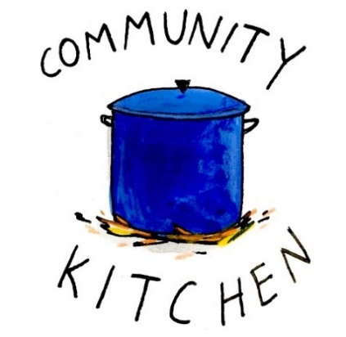March 21 25

**April 25 29**

May 23 27

June 20 24

July 25 29

August 22 26

September 23 30

October 24 28

November 21 25

December 26 30

Contact Nancy Hunter if you are able to help out, 706.506.3889.

THANK YOU

**St. Paula’s Guild for April**

**Will join the Paint & Sip in support of EYC Pilgrimage.**

**Contact the church office to make your reservations.**

**April 26th 5pm – Daniel Hall**

**Paint ONLY $35 ~ Sip & Paint $50**

Jason Bloom 13th

Sarah Hardaker 13th

Amanda Brendel 13th

Judy Caywood 13th

Millie Sirmans 15th

Brian Keefe 15th

Jack Wellesley 15th

Donald Flippen 16th

Peggy Nash 16th

Bennett Smyth 16th

Charles Elliott 16th

Becky Jones 18th

**Do YOU have a VENMO Account?**

**You may use it to remit payments to the church.**

ALWAYS include a note/memo to identify how to credit the payment, for example:

* Annual Pledge payment
* Wednesday Dinner
* Easter Lily
* Capital Pledge payment

<https://venmo.com/u/StPeters-EpiscopalChurch>

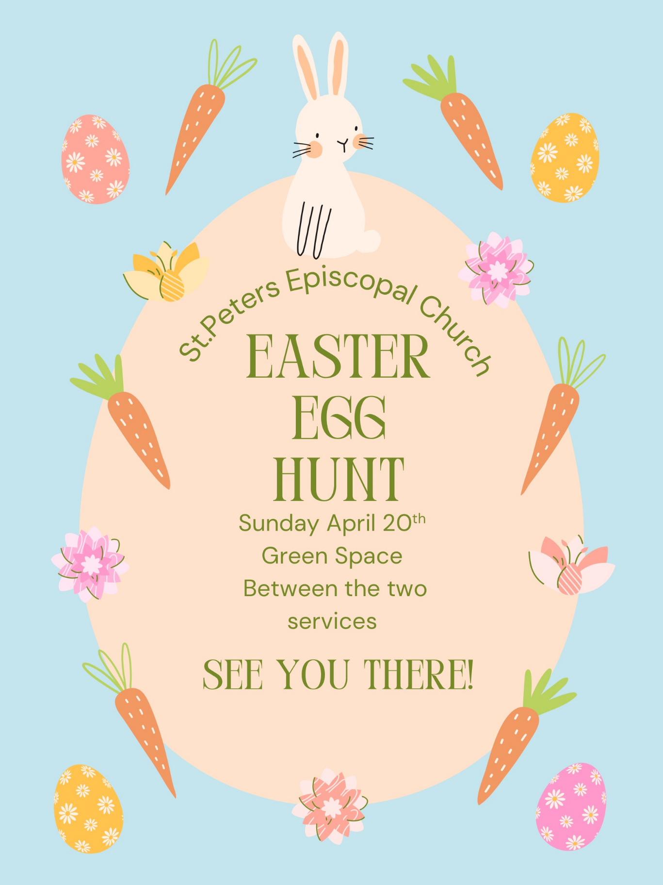

**Gather in Daniel Hall.**

**Bags will be available but feel free to bring your Easter basket if you prefer.**

Adults join us for a Sip & Paint

(beer & wine)

Reservations on REALM or contact the church office.

**All kids up to**

**5th grade come join the party!**

**Parents, check your email for info on the party.**

Roots will meet on Wednesday April 16th and 23rd then party & final gathering on 30th

Centering Prayer

will NOT meet

next week, 4.16.2025.

Reservations by Noon on the Monday before.

Adults $10, children $4, Family Max $25

April 16 – Dessert, Lemon Cake/Icing

Honey Soy Pork Tenderloin Medallions OR Lemon Caper Chicken – Choose ONE

Vegetarian – All 4 sides with meatless burger patty

Buttered rice, Teriyaki long green beans, Corn on cob, Salad– Choose Two

Kids–Pepperoni Pizza OR Fish Sticks Choose ONE

April 23 – Dessert, Chocolate Cake/Icing

Smothered Cube Steak w/onions OR Fried Chicken White or Dark – Choose ONE

Vegetarian – All 4 sides with meatless boiled eggs

Mashed Potatoes, English Peas, Candid Carrots, Salad – Choose Two

Kids Dino Nuggets OR PBJ –Choose ONE

April 30 – Dessert **Final Roots gathering till Fall.**

Roast Pork Loin OR Million $ Chicken– Choose ONE

Vegetarian – All 4 sides with meatless burger patty

Broccoli Casserole, Speckled Butter Beans, Buttered Corn, Salad– Choose Two

Kids–Mini Corn Dog OR Cheese Pizza Choose ONE

May 7 – Dessert, Banana Pudding

Smoked Chicken quarters OR Smoked Pork Tenderloin– Choose ONE

Vegetarian – All 4 sides with hard boiled eggs

Macaroni Salad, Baked Beans, Baked Potato, Salad– Choose Two

Kids–Chicken Tenders OR Hotdog Choose ONE

**May 14 – Our FINAL Dinner!**

Hand patted 6oz burgers/cheeseburgers OR Hotdogs with all the fixings.

Family Style: Macaroni Salad, Chips, Corn Salad, Watermelon/Feta Salad, Tomato/Cucumber salad.

Dessert, Poundcake with Strawberries/whipped cream

Print your name, thanks

Use a separate form for each meal ordered OR use the back to itemize all orders with names!

**Available Dates in June**

**Nave – May 11 & June 29**

**Chapel – may 4 & 25, June 8**

**Place flowers on the church altar in Memory, Thanksgiving or in Honor of a friend or loved one.**

**Contact the church office to select your date and**

**make your flower choice.**

Chapel Flowers - $100.00

Nave Flowers - $150.00

GOOD FRIDAY OFFERING

For 103 years the Good Friday Offering has supported the ministry of The Episcopal Church in Jerusalem and the Middle East.

Your gift on Good Friday will support the ministry of al-Ahli Hospital in Gaza, St. George’s in Baghdad, Iraq and its medical center, an eye clinic at Christ Church in Yemen and the powerful Christian presence of All Saints’ Episcopal churches in Damascus, Syria and Lebanon.

|  |  |  |  |  |  |  |
| --- | --- | --- | --- | --- | --- | --- |
| **APRIL** | **Monday** | **Tuesday** | **Wednesday** | **Thursday** | **Friday** | **Saturday** |
|  |  | 1  9am Staff Meeting  Stephen Ministry  10-12:30  **5:30pm Lenten Stations of the Cross** | 2  4pm Centering Prayer  5-5:30pm Children’s Choir  5pm Dinner Served  5:30pm Celtic  6-7pm Roots, Catechumenate &  **Adult Small Group**  7pm Adult Choir | 3  10am Bible Study  **5:30pm Lenten Evening Prayer in Chapel**  5:30pm Stephen Ministry Meeting R. Wyatt  4-8pm ESP Daniel Hall | 4 | 5 |
| 6  8:15-11:45 Nursery provided  8:30am – Rite I Chapel  9-10am Breakfast in Daniel Hall  9:57am Children’s Chapel  10am – Rite II Nave, WLAQ/You tube | 7  **1pm Living Compass Lenten Study** | 8  Stephen Ministry  10-12:30  **5:30pm Lenten Stations of the Cross**  7-8pm Indivisible D. Hall Melissa Keefe | 9  4 pm Centering Prayer  7pm Adult Choir  5:30pm Celtic  All other Wednesday Activities cancelled for the day. | 10  10am Bible Study  **11am Palm Cross Construction**  **5:30pm Lenten Evening Prayer in Chapel**  6:30pm 3 Rivers  R. Wyatt | 11  4-9 ESP Daniel Hall | 12  **Passion Readers, practice 11am in Nave** |
| **13**  **PALM SUNDAY**  8:15-11:45 Nursery provided  8:30am – Rite I Chapel  Children’s Parade of Palms  9:57am Children’s Chapel  9-10am Breakfast in Daniel Hall  10am – Rite II Nave, WLAQ/You tube  EYC – Egg filling  3pm Rodeph Salom Seder Supper – Daniel Hall | 14  Noon Reservations for Wednesday Dinner  **Noon Community Holy Week Service**  **N. Broad Baptist**  **1pm Living Compass Lenten Study** | 15  9am Staff Meeting  Stephen Ministry  10-12:30  **Noon Community Holy Week Service**  **N. Broad Baptist**  **5:30pm Lenten Stations of the Cross** | 16  **Noon Community Holy Week Service**  **N. Broad Baptist**  5-5:30pm Children’s Choir  5pm Dinner Served  5:30pm Celtic  6-7pm Roots, Adult Small Group  7pm Adult Choir | 17  5:30pm Stephen Ministry Meeting R. Wyatt  **MAUNDY SERVICE 7PM IN NAVE** | 18  **GOOD FRIDAY SERVICE NOON** | 19  3:30pm Episcopups  **EASTER VIGIL 9PM RECEPTION AFTER THE SERVICE.** |
| 20  **EASTER SUNDAY – Return Mite Box**  8:45-1pm Nursery Provided  9am Rite II in Nave  9:45am Breakfast  10am Egg Hunt, gather on stage in  D. Hall  11:15am Rite II in Nave | 21  Noon Reservations for Wednesday Dinner  Office Closed | 22  9am Staff Meeting  Stephen Ministry  10-12:30 | 23  4pm Centering Prayer  5-5:30pm Children’s Choir  5pm Dinner Served  5:30pm Celtic  6-7pm Roots, Catechumenate  Adult Small Group  7pm Adult Choir | 24  10am Bible Study | 25  9am-Noon Community Kitchen Volunteers | 26  **5pm EYC**  **Sip & Paint in Daniel Hall** |
| **27 – Canterbury Sunday**  8:15-11:45 Nursery provided  8:30am – Rite I Chapel  9-10am Breakfast in Daniel Hall  9:57am Children’s Chapel - FINAL  10am – Rite II Nave, WLAQ/You tube  EYC to Six Flags | 28  Noon Reservations for Wednesday Dinner | 29  9am Staff Meeting  9-Noon Community Kitchen  Stephen Ministry  10-12:30 | 30  4pm Centering Prayer  5-5:30pm Children’s Choir  5pm Dinner Served  5:30pm Celtic  6-7pm Roots PARTY, Catechumenate  Adult Small Group  7pm Adult Choir |  |  |  |