The people stand.

Holy and gracious Father: In your infinite love you made us for yourself; and, when we had fallen into sin and become subject to evil and death, you, in your mercy, sent Jesus Christ, your only and eternal Son, to share our human nature, to live and die as one of us, to reconcile us to you, the God and Father of all.

He stretched out his arms upon the cross, and offered himself, in obedience to your will, a perfect sacrifice for the whole world.

On the night he was handed over to suffering and death, our Lord Jesus Christ took bread; and when he had given thanks to you, he broke it, and gave it to his disciples, and said, “Take, eat: This is my Body, which is given for you. Do this for the remembrance of me.”

After supper he took the cup of wine; and when he had given thanks, he gave it to them, and said, “Drink this, all of you: This is my Blood of the new Covenant, which is shed for you and for many for the forgiveness of sins. Whenever you drink it, do this for the remembrance of me.”

Therefore we proclaim the mystery of faith:

Celebrant and People
Christ has died.
Christ is risen.
Christ will come again.

The Celebrant continues

We celebrate the memorial of our redemption, O Father, in this sacrifice of praise and thanksgiving. Recalling his death, resurrection, and ascension, we offer you these gifts.

Sanctify them by your Holy Spirit to be for your people the Body and Blood of your Son, the holy food and drink of new and unending life in him. Sanctify us also that we may faithfully receive this holy Sacrament, and serve you in unity, constancy, and peace; and at the last day bring us with all your saints into the joy of your eternal kingdom.

All this we ask through your Son Jesus Christ. By him, and with him, and in him, in the unity of the Holy Spirit all honor and glory is yours, Almighty Father, now and for ever. AMEN.

And now, as our Savior Christ has taught us, we are bold to say,

Our Father, who art in heaven,
hallowed be thy Name,
thy kingdom come,
thy will be done,
on earth as it is in heaven.
Give us this day our daily bread.
And forgive us our trespasses,
as we forgive those
who trespass against us.
And lead us not into temptation,
but deliver us from evil.
For thine is the kingdom,
and the power, and the glory,
for ever and ever. Amen.

Breaking of the Bread

Fraction Hymn (Service hymns are found in the front of the hymnal) S158
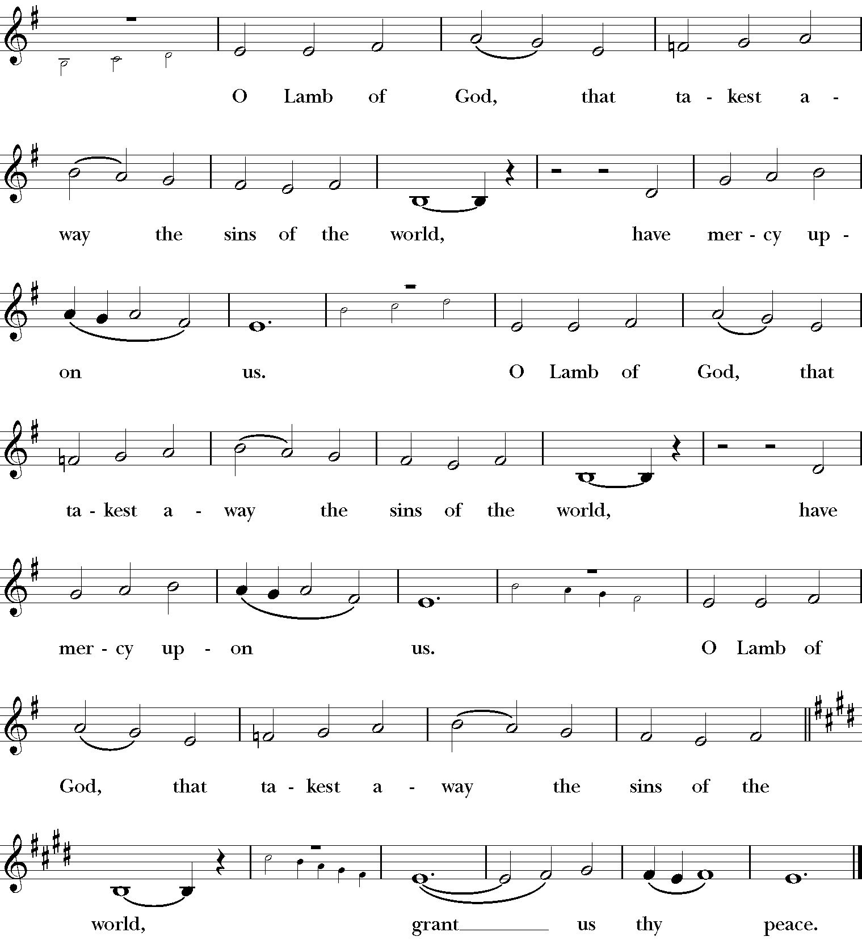
Celebrant: The Gifts of God for the People of God. Take them in
remembrance that Christ died for you, and feed on him in your hearts by
faith, with thanksgiving.

Communion Hymns
309 “O Food to pilgrims given” O Welt, ich muss dich lassen
574 “Before thy throne, O God, we kneel” St. Petersburg

Post Communion Prayer The people stand.
Let us pray.

Eternal God, heavenly Father,
you have graciously accepted us as living members
of your Son our Savior Jesus Christ,
and you have fed us with spiritual food
in the Sacrament of his Body and Blood.
Send us now into the world in peace,
and grant us strength and courage
to love and serve you
with gladness and singleness of heart;
through Christ our Lord. Amen.

The People kneel and the celebrant says a prayer

The Dismissal
People Thanks be to God.

Procession Hymn 344 “Lord, dismiss us with thy blessing” Sicilian Mariners

Voluntary “Wir glauben all an einen Gott” Johann Sebastian Bach
Saint Peter’s Episcopal Church
The Third Sunday in Lent
23 March 2025

Voluntary “Herr, wie du willst” Sigfrid Karg-Elert

Solemn Procession

Celebrant Bless the Lord who forgives all our sins.
People His mercy endures for ever.

Decalogue (kneel) Response after each bidding: Amen. Lord have mercy.

Hear the commandments of God to his people:
I am the Lord your God who brought you out of bondage.
You shall have no other gods but me. Amen. Lord have mercy.
You shall not make for yourself any idol. Amen. Lord have mercy.
You shall not invoke with malice the Name of the Lord your God.
Amen. Lord have mercy.
Remember the Sabbath Day and keep it holy. Amen. Lord have mercy.
Honor your father and your mother. Amen. Lord have mercy.
You shall not commit murder. Amen. Lord have mercy.
You shall not commit adultery. Amen. Lord have mercy.
You shall not steal. Amen. Lord have mercy.
You shall not be a false witness. Amen. Lord have mercy.
You shall not covet anything that belongs to your neighbor.

Amen. Lord have mercy.

Celebrant reads opening sentences.

Let us confess our sins against God and our neighbor.

People and Celebrant
Most merciful God, we confess that we have sinned against you in thought, word, and deed, by what we have done, and by what we have left undone. We have not loved you with our whole heart; we have not loved our neighbors as ourselves. | We are truly sorry and we humbly repent. For the sake of your Son Jesus Christ, have mercy on us and forgive us; that we may delight in your will, and walk in your ways, to the glory of your Name. Amen.

The Priest stands and says
Almighty God have mercy on you, forgive you all your sins through our Lord Jesus Christ, strengthen you in all goodness, and by the power of the Holy Spirit keep you in eternal life. Amen.

Trisagion S102 (Sing three times)
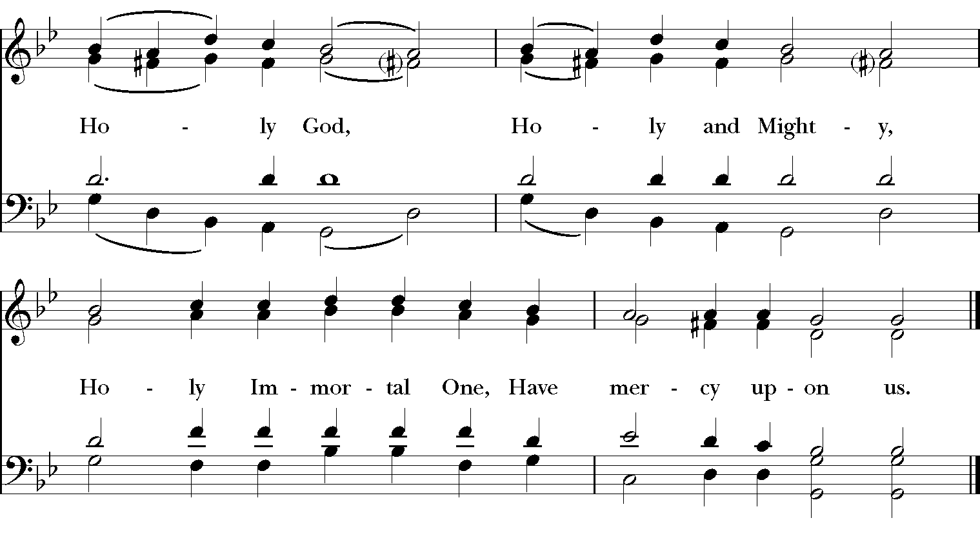

Collect of the Day
Almighty God, you know that we have no power in ourselves to help ourselves: Keep us both outwardly in our bodies and inwardly in our souls, that we may be defended from all adversities which may happen to the body, and from all evil thoughts which may assault and hurt the soul; through Jesus Christ our Lord, who lives and reigns with you and the Holy Spirit, one God, for ever and ever. Amen.

The Lesson: Exodus 3:1-15
The people sit. After the Reading, the reader says
The Word of the Lord.
People Thanks be to God.

Psalm 63:1-8 (Congregation sings the refrain. See lectionary insert) Plainsong

The Epistle: I Corinthians 10:1-13
The Word of the Lord.
People Thanks be to God.

Sequence Hymn 635 “If thou but trust in God to guide thee”
Wer nur den lieben Gott

The Gospel Luke 13:1-9
The Holy Gospel of Our Lord Jesus
Christ according to Luke.
People Glory to you, Lord Christ.

After the Gospel, the Priest says:
The Gospel of the Lord.
People Praise to you, Lord Christ.

The Sermon The Reverend John Foster Herring

The Nicene Creed

We believe in one God,
the Father, the Almighty,
maker of heaven and earth,
of all that is, seen and unseen.

We believe in one Lord, Jesus Christ,
the only Son of God,
eternally begotten of the Father,
God from God, Light from Light,
true God from true God,
begotten, not made,
of one Being with the Father.
Through him all things were made.
For us and for our salvation
he came down from heaven:
by the power of the Holy Spirit
he became incarnate from the Virgin Mary,
and was made man.
For our sake he was crucified under Pontius Pilate;
he suffered death and was buried.
On the third day he rose again
in accordance with the Scriptures;
he ascended into heaven
and is seated at the right hand of the Father.
He will come again in glory to judge the living and the dead,
and his kingdom will have no end.

We believe in the Holy Spirit, the Lord, the giver of life,
who proceeds from the Father and the Son.
With the Father and the Son he is worshiped and glorified.
He has spoken through the Prophets.
We believe in one holy catholic and apostolic Church.
We acknowledge one baptism for the forgiveness of sins.
We look for the resurrection of the dead,
and the life of the world to come. Amen.

The Prayers of the People, Form I The People kneel

Leader
With all our heart and with all our mind, let us pray to the
Lord, saying, Lord, have mercy.

For the peace from above, for the loving kindness of God,
and for the salvation of our souls, let us pray to the Lord.
Lord, have mercy

For the peace of the world, for the welfare of the holy Church
of God, and for the unity of all peoples, let us pray to the Lord.
Lord, have mercy

For Michael, our Presiding Bishop; for Rob, and Don, our Bishops;
for John; and for all the clergy and people, let us pray to the Lord.
Lord, have mercy

For Joe, our President; Brian, our governor; Sundai our Mayor, for the leaders of the nations, and for all in authority, let us pray to the Lord.
Lord, have mercy

For this community, especially _______ , for every city and community, and for those who live in them, let us pray to the Lord.
Lord, have mercy

For seasonable weather, and for an abundance of the fruits of the earth, let us pray to the Lord.
Lord, have mercy

For the good earth which God has given us, and for the wisdom and will to conserve it, let us pray to the Lord.
Lord, have mercy

For those celebrating birthdays this week, ________let us pray to the Lord.
Lord, have mercy

For those who travel on land, on water, or in the air, let us pray to the Lord.
Lord, have mercy

For the aged and infirm, for the widowed and orphans, and
for the sick and the suffering, ___________ let us pray to the Lord.
Lord, have mercy

For ___________ , let us pray to the Lord.
Lord, have mercy

For the poor and the oppressed, for the unemployed and the destitute, for prisoners and captives, and for all who remember and care for them, let us pray to the Lord.
Lord, have mercy

For all who have died ___________in the hope of the resurrection, and for all the departed, let us pray to the Lord.
Lord, have mercy

For deliverance from all danger, violence, oppression, and degradation,
let us pray to the Lord.
Lord, have mercy

That we may end our lives in faith and hope, without suffering and
without reproach, let us pray to the Lord.
Lord, have mercy

Defend us, deliver us, and in your compassion protect us, O
Lord, by your grace.
Lord, have mercy

In the communion of Mary and Peter and of all the saints, let us commend ourselves, and one another, and all our life, to Christ our God.
To you, O Lord our God.

The Peace

Greetings and Announcements

Offertory Anthem: O Lord, my God S. S. Wesley

O Lord my God, hear thou the prayer thy servant prayeth, Have thou respect unto his prayer. Hear thou in heaven thy dwelling place, And when thou hearest, Lord, forgive.[King Solomon’s Prayer based on I Kings 8]

The Doxology Old 100th

The Holy Communion

The Great Thanksgiving: Eucharistic Prayer A

Celebrant The Lord be with you.
People And also with you.
Celebrant Lift up your hearts.
People We lift them to the Lord.
Celebrant Let us give thanks to the Lord our God.
People It is right to give him thanks and praise.

It is right, and a good and joyful thing, always and every where to give thanks to you, Father Almighty, Creator of heaven and earth.

Therefore we praise you, joining our voices with Angels and Archangels and with all the company of heaven, who for ever sing this hymn to proclaim the glory of your Name:

Celebrant and People
Sanctus S114
