.
Celebrant and People S128
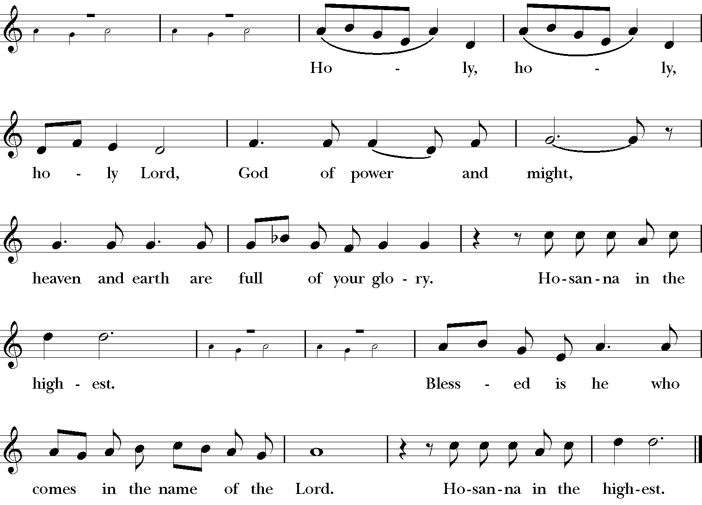

The people stand. Then the Celebrant continues

We give thanks to you, O God, for the goodness and love which you have made known to us in creation; in the calling of Israel to be your people; in your Word spoken through the prophets; and above all in the Word made flesh, Jesus, your Son. For in these last days you sent him to be incarnate from the Virgin Mary, to be the Savior and Redeemer of the world. In him, you have delivered us from evil, and made us worthy to
stand before you. In him, you have brought us out of error into truth, out of sin into righteousness, out of death into life.

On the night before he died for us, our Lord Jesus Christ took bread; and when he had given thanks to you, he broke it, and gave it to his disciples, and said, “Take, eat: This is my Body, which is given for you. Do this for the remembrance of me.”

After supper he took the cup of wine; and when he had given thanks, he
gave it to them, and said, “Drink this, all of you: This is my Blood of the new Covenant, which is shed for you and for many for the forgiveness of sins. Whenever you drink it, do this for the remembrance of me.”

Celebrant and People
We remember his death,
We proclaim his resurrection,
We await his coming in glory;

The Celebrant continues
And we offer our sacrifice of praise and thanksgiving to you, O Lord of all; presenting to you, from your creation, this bread and this wine.

We pray you, gracious God, to send your Holy Spirit upon these gifts that they may be the Sacrament of the Body of Christ and his Blood of the new Covenant. Unite us to your Son in his sacrifice, that we may be acceptable through him, being sanctified by the Holy Spirit. In the fullness of time, put all things in subjection under your Christ, and bring us to that heavenly country where, with all your saints, we may enter the everlasting heritage of your sons and daughters; through Jesus Christ our Lord, the firstborn of all creation, the head of the Church, and the author of our salvation.

By him, and with him, and in him, in the unity of the Holy Spirit all honor and glory is yours, Almighty Father, now and for ever. AMEN.

And now, as our Savior Christ has taught us, we are bold to say,
People and Celebrant
Our Father, who art in heaven,  hallowed be thy Name,  thy kingdom come,  thy will be done,  on earth as it is in heaven.  Give us this day our daily bread.  And forgive us our trespasses, | as we forgive those  who trespass against us.  And lead us not into temptation,  but deliver us from evil.  For thine is the kingdom,  and the power, and the glory,  for ever and ever. Amen.

The Breaking of the Bread
The Celebrant breaks the consecrated Bread. A period of silence is kept.

Celebrant: Alleluia. Christ our Passover is sacrificed for us;
People: Therefore let us keep the feast. Alleluia.

Cantor, Celebrant and People S155
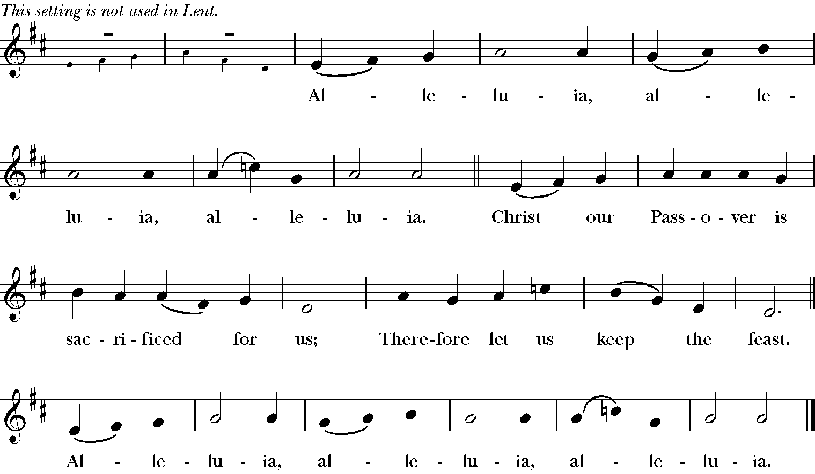

Communion Hymns
317 “This is the hour of banquet and of song” Morestead
126 “The people who in darkness walked” Dundee

Celebrant Let us pray.

Celebrant and People
Almighty and everliving God, we thank you for feeding us with the spiritual food of the most precious Body and Blood of your Son our Savior Jesus Christ; and for assuring us in these holy mysteries that we are living members of the Body of your Son, and heirs of your eternal kingdom.
And now, Father, send us out to do the work you have given us to do,
to love and serve you as faithful witnesses of Christ our Lord. To him, to you, and to the Holy Spirit, be honor and glory, now and for ever. Amen.

The Blessing & Dismissal
The deacon dismisses the people:
People Thanks be to God.

Procession Hymn 599 “Lift Every Voice and Sing?” Lift Every Voice

Voluntary "St. Denio" Gerald Near

The Second Sunday after Epiphany
19 January 2025

Voluntary "Tallis' Ordinal" Healey Willan

Procession Hymn 7 “Christ, whose glory fills the skies” Ratisbon

Celebrant Blessed be God: Father, Son, and Holy Spirit.
People And blessed be his kingdom, now and for ever.
Amen.
Celebrant
Almighty God, to you all hearts are open, all desires known, and from you no secrets are hid: Cleanse the thoughts of our hearts by the inspiration of your Holy Spirit, that we may perfectly love you, and worthily magnify your holy Name; through Christ our Lord. Amen.

People and Celebrant S278
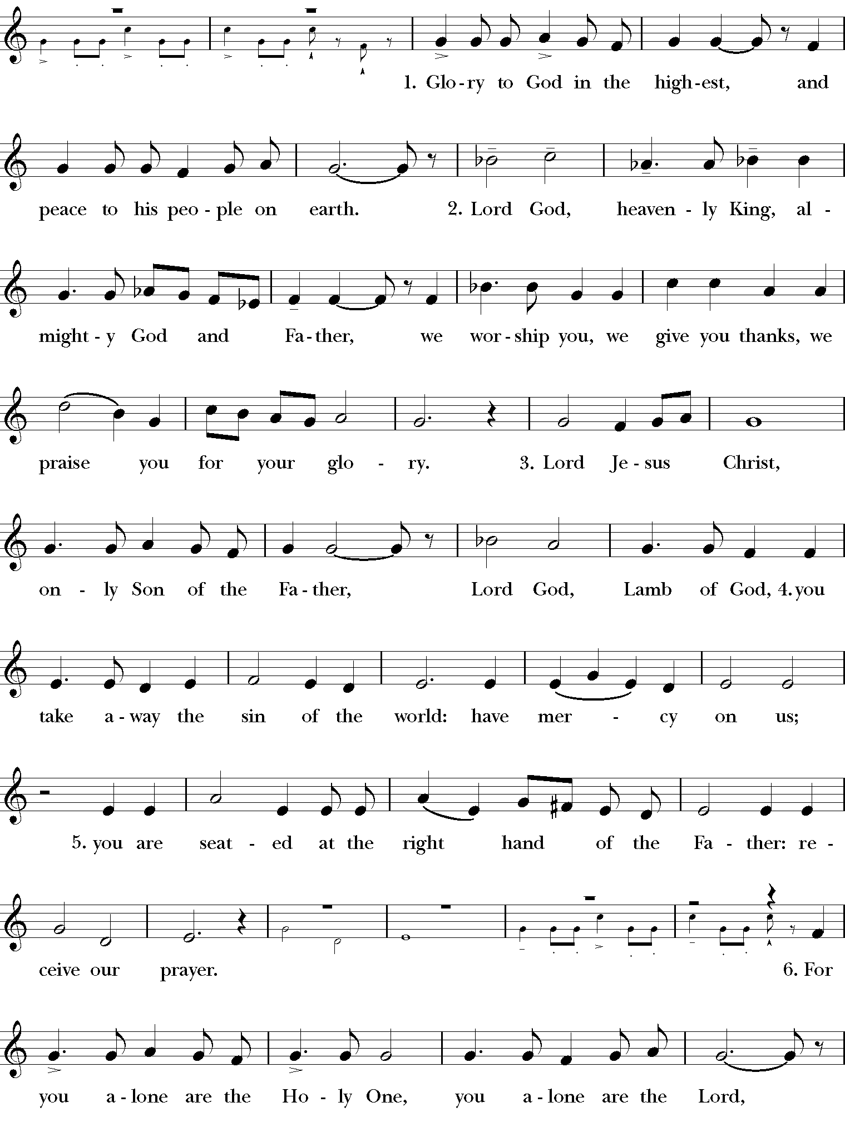
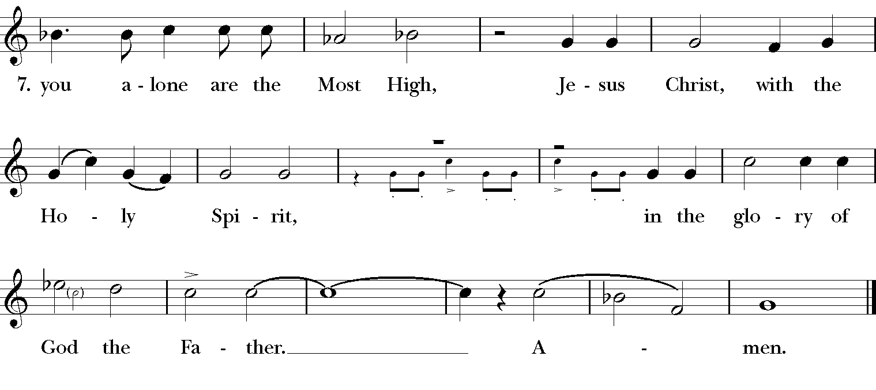
Celebrant The Lord be with you.
People And also with you.
Celebrant Let us pray.

Collect of the Day
Almighty God, whose Son our Savior Jesus Christ is the light of the world: Grant that your people, illumined by your Word and Sacraments, may shine with the radiance of Christ's glory, that he may be known, worshipped, and obeyed to the ends of the earth; through Jesus Christ our Lord, who with you and the Holy Spirit lives and reigns, one God, now and for ever. Amen.

The Lesson: Isaiah 62:1-5
The Word of the Lord.
People Thanks be to God.

The Gradual: Psalm 36:5-10 Robert Knox Kennedy
(Congregation sings with choir)

The Epistle: I Corinthians 12:1-11
The Word of the Lord.
People Thanks be to God.

The Sequence Hymn 505 “O Spirit of Life, O Spirit of God”
O heiliger Geist
The Gospel: John 2:1-11
The Holy Gospel of Our Lord Jesus Christ
according to John.
People Glory to you, Lord Christ.

After the Gospel, the Deacon says
The Gospel of the Lord.
People Praise to you, Lord Christ.

The Sermon The Reverend John Foster Herring

The Nicene Creed

We believe in one God,
the Father, the Almighty,
maker of heaven and earth,
of all that is, seen and unseen.

We believe in one Lord, Jesus Christ,
the only Son of God,
eternally begotten of the Father,
God from God, Light from Light,
true God from true God,
begotten, not made,
of one Being with the Father.
Through him all things were made.

For us and for our salvation

he came down from heaven:
by the power of the Holy Spirit
he became incarnate from the Virgin Mary,
and was made man.
For our sake he was crucified under Pontius Pilate;
he suffered death and was buried.
On the third day he rose again
in accordance with the Scriptures;
he ascended into heaven
and is seated at the right hand of the Father.
He will come again in glory to judge the living and the dead,
and his kingdom will have no end.

We believe in the Holy Spirit, the Lord, the giver of life,
who proceeds from the Father and the Son.
With the Father and the Son he is worshiped and glorified.
He has spoken through the Prophets.
We believe in one holy catholic and apostolic Church.
We acknowledge one baptism for the forgiveness of sins.
We look for the resurrection of the dead,
and the life of the world to come. Amen.

The Prayers of the People III

Leader
Let us pray for the Church and the world

The people kneel

The Leader and People pray responsively
Father, we pray for your holy Catholic Church;
That we all may be one.

Grant that every member of the Church may truly and
humbly serve you;
That your Name may be glorified by all people.

We pray for all bishops, priests, and deacons;
That they may be faithful ministers of your Word and Sacraments.

We pray for all who govern and hold authority in the nations
of the world;
That there may be justice and peace on the earth.

Give us grace to do your will in all that we undertake;
That our works may find favor in your sight.

Have compassion on those who suffer from any grief or
trouble;
That they may be delivered from their distress.

Give to the departed eternal rest;
Let light perpetual shine upon them.

We praise you for your saints who have entered into joy;
May we also come to share in your heavenly kingdom.

Let us pray for our own needs and those of others.
Silence

The Celebrant adds a concluding collect.
Celebrant Let us confess our sins against God and our neighbor.

Celebrant and People

Most merciful God,
we confess that we have sinned against you
in thought, word, and deed,
by what we have done,
and by what we have left undone.
We have not loved you with our whole heart;
we have not loved our neighbors as ourselves.
We are truly sorry and we humbly repent.
For the sake of your Son Jesus Christ,
have mercy on us and forgive us;
that we may delight in your will,
and walk in your ways,
to the glory of your Name. Amen.

Celebrant

Almighty God have mercy on you, forgive you all your sins through our
Lord Jesus Christ, strengthen you in all goodness, and by the power of the Holy Spirit keep you in eternal life. Amen.

The Peace All stand.

Celebrant The peace of the Lord be always with you.
People And also with you.

Greetings and Announcements

The Offertory Anthem "Immortal, invisible, God only wise"
Eric H. Thiman
(See Hymn 423 for text)

The Doxology: “Praise God, from whom all blessings flow” Old 100th
Praise God, from Whom all blessings flow;
Praise Him, all creatures here below;
Praise Him above, ye heavenly host;
Praise Father, Son and Holy Ghost.

The Holy Communion
The people stand while the offerings are presented and placed on the Altar.

The Great Thanksgiving (Eucharistic Prayer B)
The following may be sung or said

Celebrant The Lord be with you.
People And also with you.
Celebrant Lift up your hearts.
People We lift them to the Lord.
Celebrant Let us give thanks to the Lord our God.
People It is right to give him thanks and praise.

It is right, and a good and joyful thing, always and every where to give thanks to you, Father Almighty, Creator of heaven and earth.

Here the Celebrant adds a Proper Preface.

Therefore we praise you, joining our voices with Angels and Archangels and with all the company of heaven, who for ever sing this hymn to proclaim the glory of your Name:

