ANNOUNCEMENTS
Week of September 13, 2020

Tuesday Vestry Meeting 5:30pm via Zoom

Wednesday Celtic Service 5:30pm via Facebook

Thursday Mission & Outreach Donations 2-5 pm

Thursday Bible Study CANCELLED until further notice

Friday Gathering to Grieve 6:30pm

Sunday Service via WLAQ radio station 10am
Adult Forum 11:15 am via Zoom
Gathering to Grieve 1pm
Children’s Sunday School 4pm via Zoom

St. Peter’s Episcopal Church
101 east Fourth Avenue
Rome, GA 30161
706.291.9111
elizabeth@stpetersrome.org

MISSION & OUTREACH
1st and 3rd Thursdays each month
2pm till 5pm

NON Perishable food items – items donated will be shared with our local community food distribution outlets.

Family resource Center

Your Donations may be dropped off between the hours of 2pm and 5pm.
A car will park on 4th avenue in front of the church office with the trunk open to accept your donations.

THANK YOU

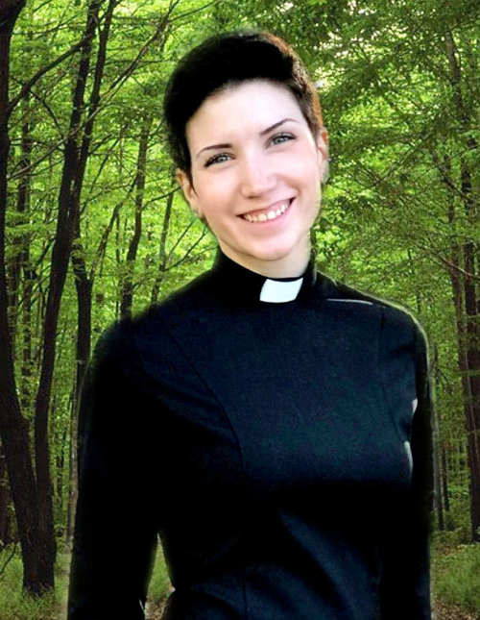
The Reverend Melissa L. Kean, age 30, of Rome, GA, gained her angel wings Saturday, September 12, 2020.
Melissa was born on June 23, 1990, in Colorado Springs, CO. She was raised in the Episcopal Church growing up in Colorado Springs, and went to the University of Colorado in Boulder. She majored in two different fields: Ecology and Evolutionary Biology and Studio Art. After her graduation, Melissa worked in South Korea teaching English for a year and then became the Minister of Formation at the Church of Saint Michael the Archangel in Colorado Springs.
Melissa attended the School of Theology at the University of the South for her Master of Divinity and graduated in May 2019. She was awarded the School of Theology’s prize of excellence in community service for the work she did in creating the Annual Women’s Lecture, which works to raise up more ordained women’s voices. Mother Melissa was ordained to the Diaconate in 2018 and the Priesthood in 2019.
Melissa was an absolute masterpiece. She was intelligent, witty, creative, adventurous, passionate, kind. Melissa could talk your ear off and she could debate you until you were blue in the face, or ideally, Anglo-catholic. She had an eye for beauty that blessed every person who encountered her. Melissa despised limits, both on speed and on people. She had no tolerance for narrow-mindedness or a small view of God. She had no patience for scarcity. Melissa embodied abundance. Abundant good food and good drink. Abundant charity and abundant hospitality. Abundant generosity and abundant creativity. Abundant options and abundant opportunities to entertain guests. Abundant forgiveness and abundant affection for her friends. Melissa’s home was rarely clean, but when it was she threw the most beautiful parties. Her fridge was always full, and she was always giving most of it away. She spoke tenderly to children and pulled 100 pound dogs onto her lap with no regard for the hair coating her immaculate outfits. Melissa never missed an opportunity to be right, and she never missed an opportunity to sing. She was equally comfortable covered in mud and in 6-inch stilettos, and occasionally she was both. Melissa appreciated liturgy for how it gives us glimpses into the vastness of God’s heart, and how it gives structure to the chaos and vulnerability of prayer. She prided herself on being a tough nut to crack, but she was easily moved by a thoughtful sermon delivered by a friend, and she often wept while she sang. When she needed to cry, she sang There Is A Balm In Gilead and talked about Jesus.
Melissa is the daughter of a retired police commander, Bob, and a retired social worker, Linda. She has an older brother and sister-in-law, Chris and Meggie Kean. Also surviving is her pet cat, Sakari and her blind and deaf Great Dane, Bartimaeus.
A memorial celebration of her life will be held in Colorado Springs, CO at a later date.

Gathering to Grieve
Each of us will grieve and process Mother Melissa's death in our own time but gathering with others is one way to begin understanding our loss. There will be a gathering for Sunday, September 20 at 1pm in the church parking lot and on the lawn area in front of the Pet Memorial, just below the parking lot. Devon Smyth and Mother Nikki will provide perspective and spiritual guidance for those in attendance.
In accordance with Diocesan guidelines, 50 parishioners may attend an outdoor event. Masks must be worn and social distancing will be guided by marked spaces for each in attendance. Please bring a chair.
Reservations must be made by calling the church office - 706.291.9111. Reservations are made for individuals NOT family units even though your family unit may is together.
Call the office Monday, Tuesday, Wednesday and Thursday from 8:00-1:00 OR on Friday from 8am till 12:00 to make your reservation.
It is our intention to organize similar gatherings at later times for those who cannot attend on Friday.
May God's love and grace comfort us in this time of need.
ADULT FORUM
September 20 & 27 – Marshall Jenkins will present a two part study of “Life after Suicide: Grief, Forgiveness, Prevention”
October 11, 18 & 25 – Terry Morris to present, stay tuned for details on topics.

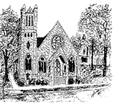
Sacred Gathering
St. Peter's will begin offering an opportunity for prayer and meditation in our beautiful church.

In accordance with Diocesan guidelines, a "Pilgrimage" to our indoor worship space can accommodate 8 members at one time.

We will open the Nave for individual prayer and meditation
Wednesday, Sept. 23
12:00 - 12:20 prayer time, ARRIVE at 11:50am
12:40 - 1pm prayer time, ARRIVE 12:30pm
OR
Wednesday, September 30
5:30pm - 5:50pm prayer time, ARRIVE 5:20pm
6:10pm - 6:30pm prayer time, ARRIVE 6pm
Reservations for a specific date and time must be made by calling the church office, 706.291.9111
Specific guidelines and procedures for attendance are attached in greater detail. Please carefully read the specific guidelines before attending:
- A maximum of 10 people (including ushers) will be allowed into the Nave for a period of 20 minutes on designated days to pray or meditate. Each parishioner will be required to call the church office and make a reservation in advance of their requested date and time. Each person will be assigned a seating number at that time.
- Anyone attending will be required to wear a mask while at St. Peter’s for the gathering and maintain social distancing at all times.
- All parishioners are asked to arrive at the 4th Avenue entrance, 10 minutes before the gathering to allow for check-in and seating. An area in front will be marked with spacing for each person to wait.
- An usher will use a non- contact forehead scanner to take the temperature of each person at the door on arrival. Anyone with a temperature of 100.4 or greater will be advised to see a medical professional and not allowed to enter the building. All ushers will have their temperatures checked before they admit parishioners to the building. Usher will have hand sanitizer available as you enter the church.
- Parishioner’s will go to their assigned seat and remain there until asked to leave the building by the 1st Street exit. Social distancing will be maintained as pews are dismissed from front to back.
- No prayer books will be available so you are encouraged to bring a personal Book of Common Prayer if needed.
The Vestry hopes that this new way to welcome God's presence in our lives will be of comfort to those who wish to participate.
Future dates will be considered depending on interest.

