

**ANNOUNCEMENTS**

**November 3, 2019**

***“Enter reverently, meditate quietly, worship devoutly, leave gratefully, serve Christ faithfully.”***

**WELCOME TO ALL OUR VISITORS!**  If you are interested in knowing more about St. Peter’s, please see an usher or one of the greeters who stand with the clergy after the service.

**TODAY AT ST. PETER'S**

9:00 am Holy Eucharist Rite II

9:45 am Breakfast/reception served until 10:45am

11:15 am Holy Eucharist Rite II

**Nursery available from 9am until 1pm**

**This week…**

Monday – Thursday **8:30am Morning Prayer, Chapel**

Monday/ Nov 4 **1pm Living Compass – Mindful Eating**

Tuesday/Nov 5 **11am** **Chair Yoga**

**12:15 pm Healing Service**

Wednesday/Nov 6 **5:30 pm Celtic Service**

Recharge & Rejoice **5:30 pm Dinner service begins**

**6:00 pm Living Compass – Mindful Eating**

**6:00 pm Women’s Bible Study – Willingham House**

**6:15 pm Jr. Choir**

**6:30 pm EYC Activities**

**7:00 pm Adult Choir Rehearsal**

Thursday/Nov 7 **10:00 am Bible Study**

**Intercessory Prayer List:** Mike Alexander, Jack Edgens, Bo Warren, Beth Starnes Nora Barrientos, Basilia Perez, Ed Johnson, Emily Barba, Debbie Hayes, Meg Alexander, Laura Frederick, Logan Bourbeau, Jeff Williams, Gina Perez, Curt David Yarbrough, Randa Mixon, Gwen Sirmans, Bonnie Herring, and those who serve their needs.

*To add a name to the PRAYER LIST or MILITARY LIST, contact the church office. Once a name is added to the* ***Prayer list*** *it will remain until the end of the month, then it will be removed. If you wish it to be added for another month, please contact the church office. Names added to the* ***Military list*** *will remain until YOU notify the office to remove.*

**Lay Ministers:**

(9:00) 1st Lesson-Randy Muller; 2nd Lesson–Dagmar Carlton, Prayers –Tricia Richards

Chalice Bearers – Mark Jester, Tricia Richards, Tom Dasher, Billie Abney.

**Altar Candles:** Given to the glory of God and in loving memory of Rubin Clark by Sara Clark.

**Flowers on the Altar:** Given to the Glory of God and in loving memory of Suzanne DuPuy Black by The Reverend Dr. G. Donald Black, Matthew DuPuy Black and Edward Purnell Black.

**Happy Birthday** to those celebrating birthdays (November 3 – November 9) Jack Edgens, Terry Hughes, Jon Molnar, Zoe Marr, Dale Holloway, Lillian Baggett, Helen Keaten, Jim Kerscher, Piero Barba, Sue Anderson, Vickie Gilliam, John Paul Cooper, Shane Walley, Rosa Ledbetter, and Curry Teems.

**ADULT FORUM WILL NOT MEET TODAY**

Mark Your calendars!

Sunday, November 17th – two great events!

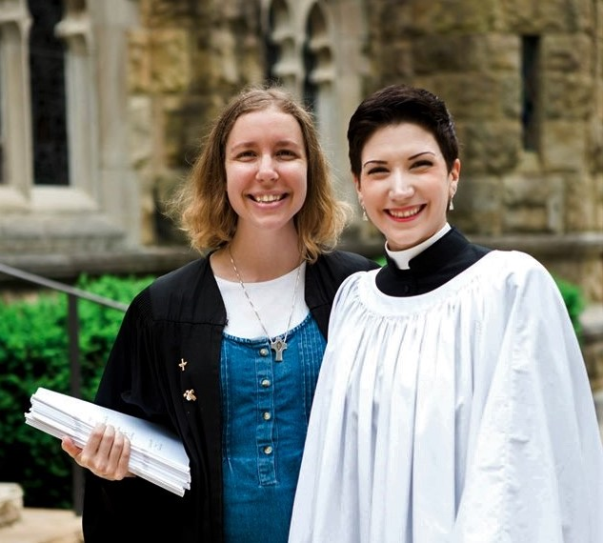

Trey Clegg Singers will Sister Hannah, an Episcopal Nun will

present their music at the preach at both services as well as

10am Worship Service. lead Adult Forum

**MISSION & OUTREACH – NOVEMBER**

**Toys For Tots**

As you know, Toys for Tots provides toys and books to families of children who might not have a Christmas without their help.

We want every child to have an age appropriate book:

* Picture books for the youngest group
* Books that can be read to beginning readers
* Chapter books for independent readers.

The ages are zero to twelve.

Shopping for Toys for Tots is a good time to involve your child(ren) in helping a child have a merry Christmas.

Boxes will be located in Daniel Hall. Checks are always welcome. Reminder that all gifts and books should be UNWRAPPED.

**Toys for Tots Volunteers needed: December 2-11 from 8am until 12noon.**

Community Building at the Coosa Valley Fair Grounds – the building connected to the Palladium. Contact Bob Evans with any questions.



**Community Kitchen for November**

**Friday 11/22 & Tuesday 11/26**

Choose your shift 8:30-10:15 or 10:15-noon

For more information contact Andye Moss:

706.506.4695 or agm614@aol.com

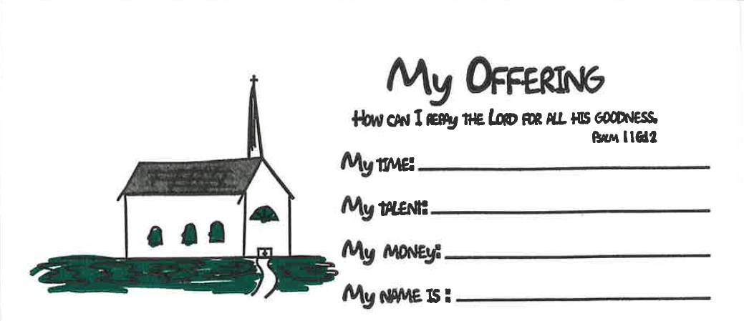

**Children’s Offering Envelopes**

**available as you enter the church**

Do your children see you contribute to the offertory or give of your time and talent at church? Children begin to learn what is important to you and your family from a very early age. If stewardship is important to you, intentionally include your kids with this kid friendly offering envelope.

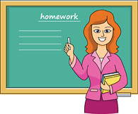

Governor Brian Kemp has declared

November 3, 2019,

**Georgia Retired Educators Day**.

St. Peter’s would like to acknowledge the presence of our many members who are retired educators and all they contribute to our St. Peter’s Family.

Recharge & Rejoice

Wednesday November 6th



[This Photo](https://en.wikipedia.org/wiki/File:New_Orleans_Square_logo.svg) by Unknown Author is licensed under [CC BY-SA](https://creativecommons.org/licenses/by-sa/3.0/)

**Menu this week**: New Orleans jambalaya with chicken & sausage, French bread, tossed green salad and bread pudding

5:30pm Dinner service begins

6:15pm Jr. Choir

6:30pm EYC activities

Call/email the church office by NOON on Tuesday

with your dinner reservation.

Adults $6, Students (school age children) $4, Family maximum $20

**If YOUTH are participating in EYC activities**

**do NOT include them in your family dinner reservation. They will eat but are counted in the EYC reservation**

**made by Mother Melissa.**

**THEOLOGY ON TAP – NOVEMBER 14th at 6pm**

This month we are moving **TOT** up one week. See you on the 14th at Off Broad in the Hawthorn Suites Hotel. Come relax, share a drink and chat with Father John and Mother Melissa.



**Nursery / Toddler care is available** and located on the 2nd floor of the Hight bldg. 9:00 am through noon on Sundays.

**If your younger children are staying with you in the pew during service, we are delighted to have the whole family joining us in worship.**

**Little ones are always welcome**.

**For Busy Little Hands in Church:**

We provide Activity Bags at both entrances to the church. The bags are filled with coloring sheets, crayons, pipe cleaners, finger labyrinth, & a kid friendly book of the service.

**Please RETURN the bags at the end of the service.**



**CHILDREN’S CHAPEL**

**Available for children during the 10am worship service**

**Kid friendly version of “Big Church” where children begin to learn the parts of our service and hear a lesson based on that day’s lectionary.**

**Drop your children off just before 10am on the middle floor,**

**2nd door on right.**



A Year of WONDER

Children’s Sunday School

beginning at 9:15am

**

Canterbury Club collecting **2020 calendars for DFCS though December 10th**

Do you receive promotional calendars in the mail, got more than you need, drop them off in Daniel Hall or the Church Office to be used by DEFCS in the coming year.

*Canterbury Club thanks you for your donations.*

Canterbury LUNCH after the 11:15 service TODAY



EYC is MOVING

Beginning

November 10th

We will meet on SUNDAYs 6:30-8:30pm

We will continue to meet the 1st Wednesday of each month for our traditional Schroeder’s night of Food, Fun & Fellowship



Honoring or Remembering a Loved One?

Open dates in NOVEMBER to place flowers in the CHAPEL.

Contact Sara Clark 706.264.8430 or sclark2010@yahoo. Com



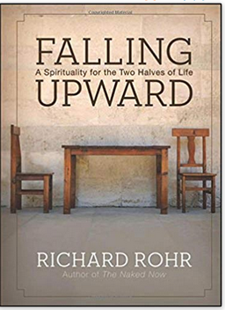

**WOMEN’s Bible Study led by Devon Smyth**

**November 6 – February 19, 2020**

**6pm Wednesday evenings**

**(First 2 meetings will be held in Willingham House living room)**

**Richard Rohr book “Falling Upward,**

**A spirituality for the two halves of life”**

**Purchase the book as well as the companion journal**

**at your preferred book outlet.**

**Will NOT meet: 11/27, 12/18, 12/25, and 1/1**

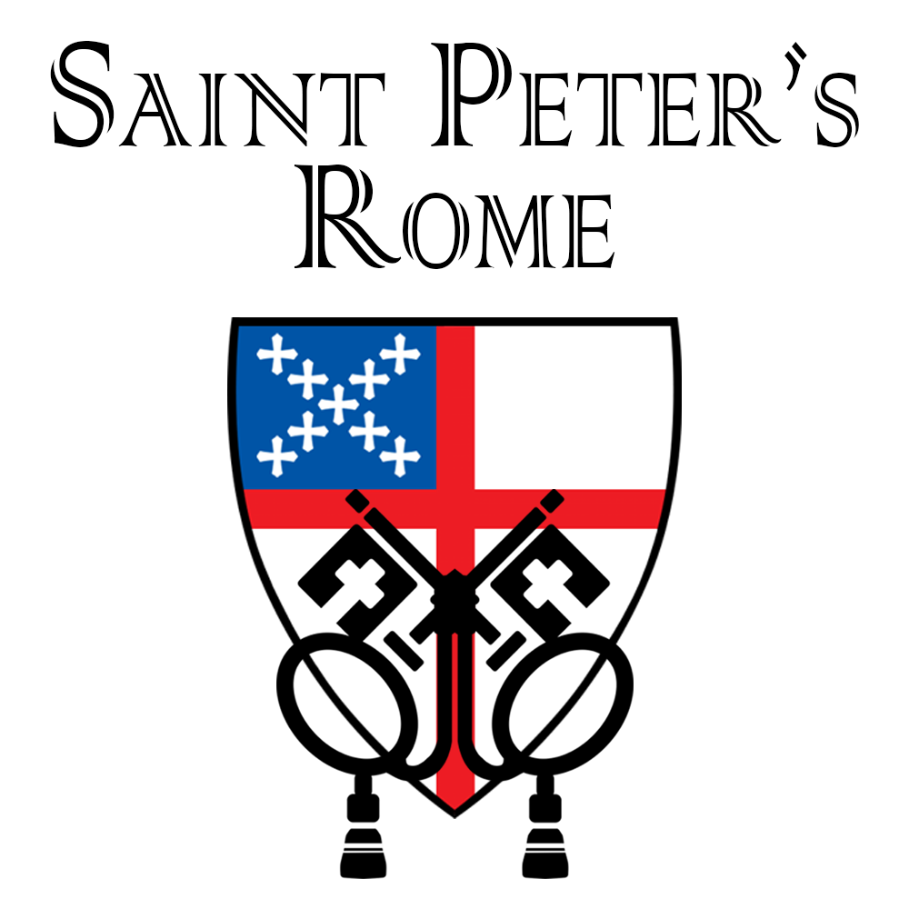

**Church Office**: Phone - 706.291.9111 Fax - 706.232.5007 -

Email: [elizabeth@stpetersrome.org](mailto:elizabeth@stpetersrome.org) - [**www**.stpetersrome.org](http://www.stpetersrome.org)

**Mail Address: 101 East Fourth AVENUE, Rome GA 30161**

**Office Hours:** Monday – Thursday 8am to 4pm.

Fridays 9am -noon

**Connect on Facebook:** St Peter’s Episcopal Church, St Peter’s Sunday School, St. Peter’s Rome EYC, & St. Peter’s Junior Choir

**NOTICE OF ANNUAL MEETING**

**AND VESTRY ELECTION**

**November 10, 2019**

The Annual Parish Meeting will be held on

Sunday November 10, 2019 immediately following the

10 a.m. Eucharist in Daniel Hall.

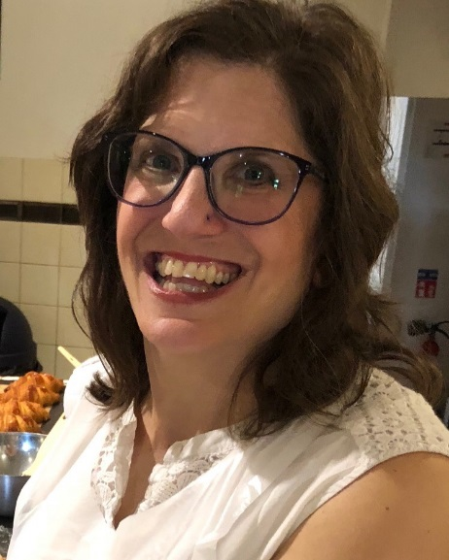Jennifer Bressette and her husband Andrew moved to Rome in 1998 and have been married 25 years. They have four children Elizabeth (22), Andrew Jr (20)., Lili (19) , and Jacob (17). She is a special education teacher at Johnson Elementary School in Floyd County. In her free time Mrs. Bressette enjoys running and has completed five marathons including Boston in 2014, 21 half marathons, and numerous 5K’s and 10K’s.  She also enjoys yoga and is a supporter of Berry College Theater Company and Rome Little Theater.

Jennifer has been involved in children’s ministry at St. Peter’s for the past several years in different capacities (Sunday School Teacher, Children’s Chapel leader, VBS volunteer, and EYC chaperone). She has also helped with Mission and Outreach, cooked for the Canterbury Club, and has been a member of Foyer groups . Jennifer is happy to have found a church home in St. Peter’s. “Even before becoming members my family was drawn to St. Peter’s and its warmth and openness. My children attended VBS and Camp Mikell when they were younger and were so filled with enthusiasm and the Holy Spirit that our family decided to see what wonderful things were going on every Sunday. We immediately felt welcome and spiritually fed.” Jennifer and Andrew officially joined St. Peter’s five years ago and 3 of their children have been confirmed here. She hopes if elected to the Vestry to continue to make St. Peter’s a church where everyone feels that they matter and has a place where they belong.

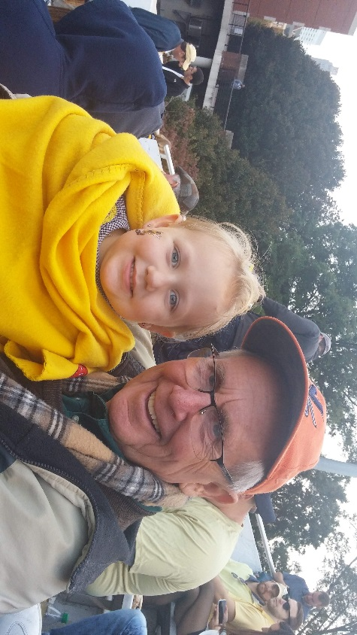Brian Hampton was born in Bournemouth, England. He received a BS in economics from the London School of Economics and a MA in political science, University of Virginia. Brian has been an Assistant professor in political science at Berry College from 1971-1976. He then worked for the State of Georgia in personnel management from 1977-2007, serving in various positions including Manager of Recruitment for the State Merit System 1986-1995 and HR manager for NW Regional Hospital 1995-2007. From 2009 to 2017 he worked at the Murphy Harpst Children's Center. Brian has also done fundraising working with churches of the North Georgia Conference of the United Methodist Church. Brian said he has “ at various times worked as a farm laborer, bartender and English Nanny.” In the Rome community he spent 9 years on the Rome/Floyd Planning Commission, several years as chair of the Summerville Park Neighborhood Association and worked in and managed more local political campaigns than he care to remember. His church life began at an early age as a choir boy and acolyte at St. George's Church of England in Bovington at age 9. After college he took about a 20 year sabbatical from church life. However, “I kept reading CS Lewis and  his persuasions proved irresistible.” Brian has been connected with North Springs UMC, Transfiguration Episcopal Church (where I was a Vestry Member and Senior Warden) and of course with St Peter's since 2009. “At St Peter's you have supported me and encouraged me to a full and rich life in the church: early on as EYC program person, as a youth and adult Sunday school / formation teacher, reader, chalice bearer, and usher. In addition over the last 20 years I have served multiple times as a delegate to Annual Council and served 4 years on the Diocesan Executive Board. My most challenging role at St Peter's is being husband of the Verger. I am blessed to have a wife, 2 sons 6 grandchildren and 4 rescue dogs. I spend my life in retirement with grandchildren, walking dogs, hiking, substitute teaching at St Mary's School, and engaging everything I can at St. Peter's.”

**NOTICE OF ANNUAL MEETING**

**AND VESTRY ELECTION**

**November 10, 2019**

The Annual Parish Meeting will be held on

Sunday November 10, 2019 immediately following the

10 a.m. Eucharist in Daniel Hall.

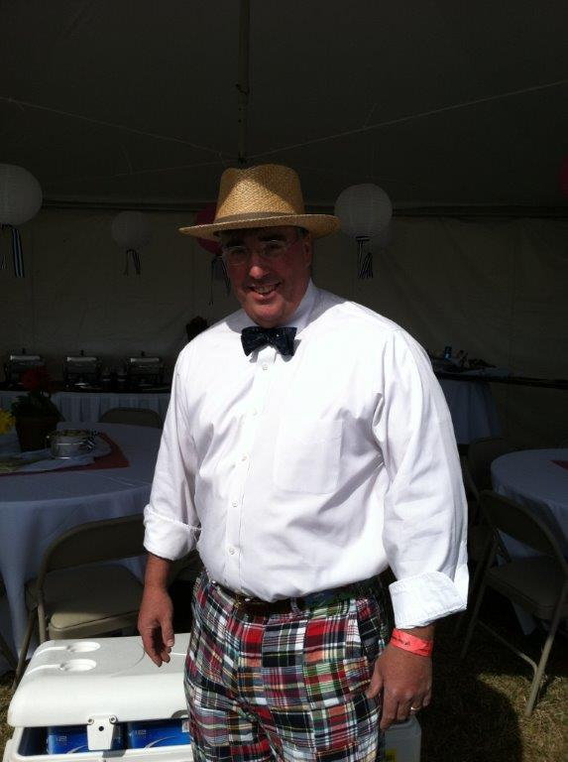

Nathaniel Wilson Massey, III

aka “Nat”

I am one of those cradle Episcopalians as my father was the priest at Transfiguration in the early 70s, when I was very young. I have seen a lot of churches and I love St. Peter’s more than any other. Since moving back to Rome I have received more (spiritual growth, fellowship, love) from my involvement with St Peter’s than I could ever hope to repay. My interest in serving on the vestry is a small attempt to repay that debt. I find these types of writing to be an afront to my well-honed humility. Please forgive this transgression. I first attended St. Peters in 1976 with my mother. Mrs. Jody Selman tells a story that during Easter service that year that I apparently accosted several parishioners with an Easter bunny that I just had to take to church. As was the custom of the time, I was confirmed here in 1979. Following my graduation from Berry and as with so many, I moved away to find my fortune. Having realized that I could just as easily do that in Rome, Amy and I came back to Rome and St. Peters in 2005. I settled in to a job with F & P Georgia (We make parts for Honda, Nissan and Toyota). I am currently the Sr Manager of HR. I have had the pleasure to be involved in a number of things at St. Peters. When we had such a thing, I was on the Wednesday night supper crew. I have been an acolyte since 1982. Dawn never calls me to serve any more (I may not fit in the robes). I worked on a number of Habitat for Humanity Apostles Builds. I have taught Sunday school, spoke at Adult Forum, and changed HVAC filters. I was “co-leader” of EYC for a group of kids that are now adults. I have proudly served on the vestry in 2008-2010, on the search committee for John (I think we got that one right), and on Rebecca’s discernment committee (a chance to work with some of the finest people that I know). Away from Church I have many hobbies. I enjoy restoring old British sports cars. I love to sail, play guitar, and play soccer (although I am very out of shape). My wife likes that I enjoy restoring furniture and cooking. All of that aside, my most favorite thing to do is to spend time with my wonderful family. My beautiful and charming wife, Amy, and I have 2 outstanding children, Wil and Megan. We also have 4 nieces and the baby of the family our Chihuahua, Lilly. Yes, she does show up in the Directory.

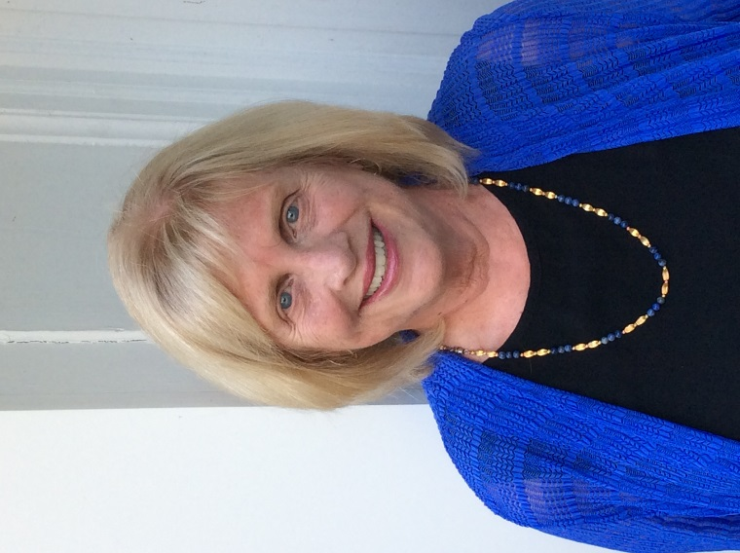**Jacquelyn Wright** has attended St. Peters since moving to Rome in 1996. A native of Chattanooga Tn., she graduated from Emory University with a B.A. in Psychology, and received her Masters in Social Work from the University of Georgia. Jacquelyn was Director of Outpatient Social Services for Scottish Rite Children]s Hospital in Atlanta for several years. After moving to Rome, Jacquelyn became involved in community work. She has been a volunteer at Good Neighbors and the community kitchen. She has served as president of The Open Door Home, the Darlington Parents Association, and Chieftains Museum. At St. Peters, Jacquelyn currently serves on the Altar Guild, as a Greeter, and part of a team providing meals to the homeless shelters. She was a Sunday School teacher for several years. Jacquelyn was also part of the group that accompanied Father John on The Camino de Santiago in 2017. Jacquelyn and her husband Barry are the parents of one daughter, Alicia Wright of Denver, Co.

**NOTICE OF ANNUAL MEETING**

**AND VESTRY ELECTION**

**November 10, 2019**

The Annual Parish Meeting will be held on

Sunday November 10, 2019 immediately following the

10 a.m. Eucharist in Daniel Hall.

**Those being received today into the fellowship of St. Peter’s**

**CONFIRMATION:**

Perla Y. Chavez Borja

Ronald D. Brendel

Jovanny I. Cruz

Amberly Pelico Estala

Shirlyn Pelico Estala

Jasmin Cruz Fonseca

Mariana Barrera Fonseca

Milagros Fonseca

Britaney S. Saucedo Garcia

Elian C. Saucedo Garcia

Angelee M. Rosa Hernandez

Amelia Grace Herring

James Hollister Hobgood, Jr.

Michael Paul Holcombe

Allison Frances King

Megan Elayne Massey

Julissa Flores Piedra

Anthony Pizano

Melissa Pizano

Mariela Leon Reyes

Ector Cruz Rico

Jamie Leigh Cruz Rico

Jose Luis Cruz Rico

Osvaldo Cruz Rico

Paola Robledo

Betzabeth Betancourt Sanchez

Diego A. Cervantes Sanchez

Jaxiry Betancourt Sanchez

Julissa Betancourt Sanchez

Grantham Brian Sikes

James Walker Sirmans

Ariadna Soberanis

Douglas Paul Tarter

Emily Tarter

Nicholas James Tarter

Madeline Gillespie Trammell

Cristian Ortiz Zamudio

Erik Otriz Zamudio

Pedro Ortiz Zamudio

**RECEIVED:**

Katharine Ammons

Russell Brook

Jennifer Carroll

Tim Carroll

Judith Caywood

Abigail Coleman

Kyle Coleman

Jacquelyn J. Eschbaugh

Lou Ella Hobgood

Emily Tedrow Holcombe

Barbara Kuckhoff

Erik J. Kuckhoff

Daniel Pugh

Jennifer Pugh

Loudon Gregory Tarter

Cecilia Williams

**RE-AFFIRM:**

Amanda Christine Brendel

Hollye Smith

Jimmy Smith

Bennett Marcum Smyth

David Alan Smyth

Devon Goddard Smyth



***The Potted Mums***

***in the Memory Garden***

***are given to the Glory of God and***

***In Loving Memory of:***

Sherrie Lanier Bacon

John Charles Busbin

Hazel and Bill Byington

Mary Cooper Caldwell

Joel Culpepper

James Evans Dixon

Emily and Arch Farrar

The Foster Family

Lucille and Jack Grubbs

Virginia Annelle Goings

Coley Culpepper Hendrix

Deceased Family of Diann Kothe

Karl M. Kothe

Mary and Ed Loveday

Juliet Howel Graves Meikleham

Mr. & Mrs. Clarence W. Meyer

Mr. & Mrs. E.R. Moulton

Mr. & Mrs. John L. Moulton

Challis S. Nixon

Penn Nixon

The Patton Family

Robert Pearson

Sammie H. Peirson

George Pullen

Charlie Rutledge

Molly Sawhill

Tom Selman, Jr.

Steve and Joyce Smith

Muriel Hall Turner