

**ANNOUNCEMENTS**

**November 17, 2019**

***“Enter reverently, meditate quietly, worship devoutly, leave gratefully, serve Christ faithfully.”***

**WELCOME TO ALL OUR VISITORS!**  If you are interested in knowing more about St. Peter’s, please see an usher or one of the greeters who stand with the clergy after the service.

**TODAY AT ST. PETER'S**

8:30 am Holy Eucharist Rite I

8:45 am Breakfast served until 10am

9:15 am Kids Formation, Early Bird Adult Class

10:00 am Children’s Chapel

10:00 am Holy Eucharist Rite II

11:15 am Adult Formation in the Chapel

1:00 pm Holy Eucharist in Spanish

6:30 pm EYC

**Nursery available on Sundays from 9am until 12noon**

**This week…**

Monday – Thursday **8:30am Morning Prayer, Chapel**

Tuesday/Nov 19 **11am** **Chair Yoga**

**12:15 pm Healing Service**

Wednesday/Nov 20 **3:30 Centering Prayer**

**5:30 pm Celtic Service**

Recharge & Rejoice **5:30 pm Mindful Eating Pot-Luck Dinner**

**6:00 pm Women’s Bible Study**

**6:15 pm Jr. Choir**

**7:00 pm Adult Choir Rehearsal**

Thursday/Nov 21 **10:00 am Bible Study**

Friday/Nov 22 **8:30-10:15 OR 10:15-noon Community Kitchen**

**Intercessory Prayer List:** Mike Alexander, Jack Edgens, Bo Warren, Beth Starnes, Nora Barrientos, Basilia Perez, Ed Johnson, Emily Barba, Debbie Hayes, Meg Alexander, Laura Frederick, Jeff Williams, Gina Perez, Curt David Yarbrough, Randa Mixon, Gwen Sirmas, Bonnie Herring, Grow, Emily Colón, Kathy O’Mara, Werner Schmitz, Stephen Padgett, Ryan Stubblefield, Xihany, John Woodward, John Hunter, Craig Baker and those who serve their needs.

**Military Prayer List:** Michael Blair, Steven Blair, Mathew Marceau, Charlie Hardaker, Greg Sabol, Joel Pitre, Justin Yeary, Alexander Kupratty, Phillip Jenkins, Nicholas Carlton, Thomas Keefe, Ryan Holman, Jackson Steele, Andrew Hackett, Andres Micha, Kristen & Johnny Crittenden and

Warren Sells.

*To add a name to the PRAYER LIST or MILITARY LIST, contact the church office. Once a name is added to the* ***Prayer list*** *it will remain until the end of the month, then it will be removed. If you wish it to be added for another month, please contact the church office. Names added to the* ***Military list*** *will remain until YOU notify the office to remove.*

**Lay Ministers:**

(8:30) Reader/Prayers/Chalice Bearer – Tricia Richards

(10:00) 1st Lesson-Len Woodward; 2nd Lesson–Betsy Awsumb, Prayers – Wade Carpenter

Chalice Bearers – Hollye Smith, Jennifer Sikes, Rebecca Segrest, Tom Dasher

**Altar Candles:** Given to the glory of God and in loving memory of Rubin Clark by Sara Clark.

**Flowers on the Altar:** Given to the Glory of God and in memory of Dr. John Dickinson by Paula Dickinson.

**Flowers in the Chapel**: Given by Brian and Melissa Keefe to the glory of God and in Thanksgiving for our son, Thomas Keefe.

**Happy Birthday** to those celebrating birthdays (November 17 – November 23) Joy Jones, D’Ann Downey, Harper Smith, Susan Alred, Sam Berry, Rosalee Kelley, Steve Gunther, Christina Hubbard, Allison Hubbard, Annette Morris-Banks.

WELCOME TODAY to…….



Trey Clegg Singers

at our 10 am worship Servcie

Sister Hannah

Preach at both 8:30 and 10am service

Adult Formation in the CHAPEL



**WOMEN’s Bible Study**

**led by Devon Smyth**

**November 6 – February 19, 2020**

**6pm Wednesday evenings**



**Richard Rohr book**

**“Falling Upward,**

**A spirituality for the two halves of life”**

**Purchase the book as well as the companion journal**

**at your preferred book outlet.**

**Will NOT meet: 11/27, 12/18, 12/25, and 1/1**



**Community Kitchen for NOVEMBER**

**Friday 11/22 & Tuesday 11/26**

Choose your shift 8:30-10:15 or 10:15-noon

For more information contact Andye Moss:

706.506.4695 or agm614@aol.com

Did you miss the ANNUAL PARISH meeting?

Copies of the Parish Report are available in the

church office **OR** Daniel Hall, pick one up today.

MISSION & OUTREACH – November



**Toys For Tots**

As you know, Toys for Tots provides toys and books to families of children who might not have a Christmas without their help.

We want every child to have an age appropriate book:

* Picture books for the youngest group
* Books that can be read to beginning readers
* Chapter books for independent readers.

The ages are zero to twelve.

Shopping for Toys for Tots is a good time to involve your child(ren) in helping a child have a merry Christmas.

Boxes will be located in Daniel Hall. Checks are always welcome. Reminder that all gifts and books should be UNWRAPPED.

**Toys for Tots Volunteers needed**

**December 2-11 from 8am until 12noon**

Community Building at the Coosa Valley Fair Grounds – the building connected to the Palladium.

Contact Bob Evans with any questions.

Recharge & Rejoice

Wednesday November 20th



**Living Compass Host: Mindful Eating**

**Pot-Luck**

5:30pm Dinner service begins

6:15pm Jr. Choir

Everyone bring a “healthy” dish to share.

No Cost & No Reservations

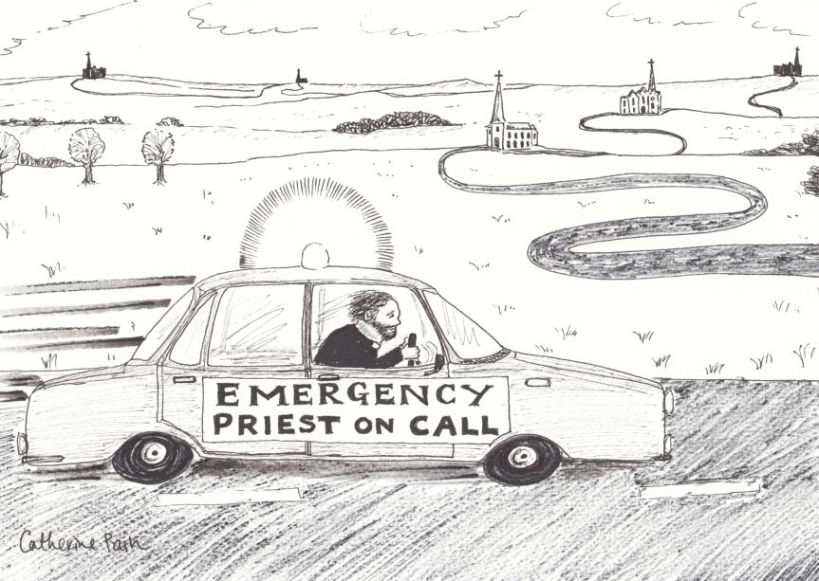**PRIEST ON CALL:**

It’s after hours or the weekend and you have a pastoral EMERGENCY – how to connect with clergy?

Simply call **706.844.5770,** you will be connected with the Priest on Call. One single number to remember.



**Has your address, name, email or phone number changed?**

**Missing or Incorrect NAME TAG for Sunday Morning?**

Please call or email the church office to confirm your contact information/name or to make a change.

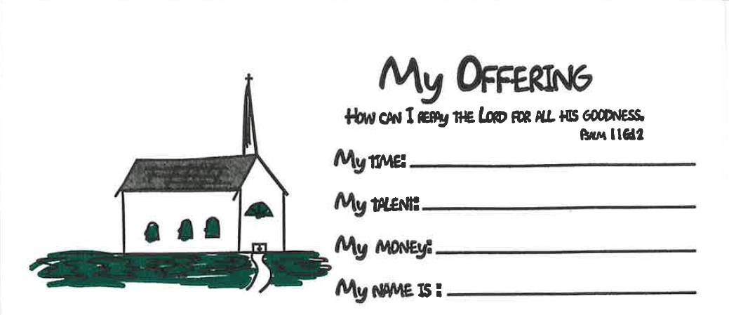

**Children’s Offering Envelopes**

**available as you enter the church**

Do your children see you contribute to the offertory or give of your time and talent at church? Children begin to learn what is important to you and your family from a very early age. If stewardship is important to you, intentionally include your kids with this kid friendly offering envelope.



Photos - Articles - News of Upcoming Events for DECEMBER issue of Letter to the Romans

due 11/18/2019

email to elizabeth@stpetersrome.org

**

Canterbury Club collecting **2020 calendars for DFCS though December 10th**

Do you receive promotional calendars in the mail, got more than you need, drop them off in Daniel Hall or the Church Office to be used by DEFCS in the coming year.

*Canterbury Club thanks you for your donations.*



**Nursery / Toddler care is available** and located on the 2nd floor of the Hight bldg. 9:00 am through noon on Sundays.

**If your younger children are staying with you in the pew during service, we are delighted to have the whole family joining us in worship.**

**Little ones are always welcome**.

**For Busy Little Hands in Church:**

We provide Activity Bags at both entrances to the church. The bags are filled with coloring sheets, crayons, pipe cleaners, finger labyrinth, & a kid friendly book of the service.

**Please RETURN the bags at the end of the service.**



**CHILDREN’S CHAPEL**

**Available for children during the 10am worship service**

**Kid friendly version of “Big Church” where children begin to learn the parts of our service and hear a lesson based on that day’s lectionary.**

**Drop your children off just before 10am on the middle floor,**

**2nd door on right.**



A Year of WONDER

Children’s Sunday School

beginning at 9:15am

ADVENT ACTIVITIES for the entire Family

4-6 pm in Daniel Hall



**Advent I – December 1st**

**Advent Wreaths Cost $10 per wreath,**

**$5 for new candles only**



**Advent II – December 8th**

**Gingerbread Houses Cost $5 per house**



**Advent III – December 15th**

**Gift of the Nutcracker & Advent Service**

**No charge**



**Children’s Pageant – December 18th**

**Dinner served at 5:30**

**Pageant begins 6:30 in Church**

ADVENT CALENDARS will be available on the stage of Daniel Hall beginning 11/24/2019. One per FAMILY please.

FRESH GREENERY – If you are able please cut and deliver fresh greenery to the church on DECEMBER 1st. It will be used in the Advent wreaths. A bucket will be on stage of Daniel Hall for your offerings.

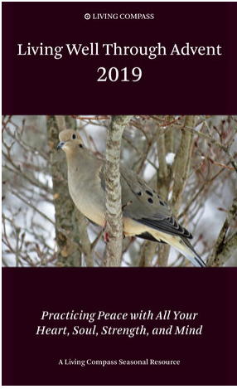

**Living Compass presents**

**ADVENT**

Booklets are available around the church.

**First Session** - offered during Adult Forum

on Sunday, **November 24.**

**Remaining three Sessions of Advent:**

**Mondays at 1 p.m. at 401 East 4th Avenue. Dec. 9th – 23rd**

**Wednesdays at 6:00 p.m. at the church. December 4th -18th**



Appleton – Freedom School Macon

Annual offering for Appleton will be taken

NEXT SUNDAY, November 24, 2019

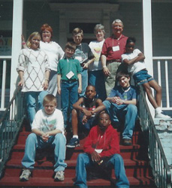Freedom School Macon provides…

* Weekend lunch program
* Multiple Path to Shine programs
* Domestic abuse shelter
* Food pantry & utility support program
* Campus ministry program
* Backpack program
* Arts enrichment program
* Weekly tutoring with campus ministry mentors
* Eight Little Free Libraries
* And other community ministry projects throughout the Middle Georgia Convocation.

Since 1992, Appleton has supported after-school and summer programs for boys as well as girls.

The ability to minister to those in need depends on the generosity of parishes through the Thanksgiving offering, because, unlike other diocesan ministries, they do not receive any financial support through the annual diocesan budget.

**Checks payable to St Peter’s & on the memo write - Appleton**

Appleton Episcopal Ministries – 753 College Street, Macon Georgia 31201 – [www.appletonepiscopal.org](http://www.appletonepiscopal.org)

**Looking for a place to plug in?**

Flower Coordinator NEEDED

beginning in January 2020.

* You do NOT arrange flowers each week.
* You coordinate with parishioners who want to donate flowers for the Altars in memory/honor of a loved one.
* Most of the year’s calendar is already established.
* You order the flowers used in the church & chapel.

If you are interested OR just have questions please contact:

Melissa Keefe – 229.854.5135 or [mvkeefe1@me.com](mailto:mvkeefe1@me.com)



Want to simplify your giving in 2020?

You can setup automatic giving directly from most personal checking accounts.

No need to remember when and how much to give, simply set it up ONCE and your bank does the remittance directly to St. Peter’s for you.



If you prefer to use PAYPAL, you can make that donation via the church website. The fee charged for using Paypal is paid by the church.

Many parishioners utilizing Paypal, remit the fee back to St. Peter’s. The church office can notify you of the exact fee amount when you gift is received if you desire.



**Considering a year end STOCK**

**gift to St. Peter’s?**

Please be certain to have all transactions **COMPLETED** by **December 27th** in order to receive 2019 credit.

Completed = physical check in the possession of the church office



Payments made to the Restore and Renew 175th Birthday campaign should be remitted on a separate check from your regular pledge giving.

Remember to put 175th or b-day or Restore/Renew on the memo line. THANK YOU

**LARGE FONT SERVICE BULLETINS for the 10am worship service available, see an usher for a copy.**



**Church Office**: Phone - 706.291.9111 Fax - 706.232.5007 -

Email: [elizabeth@stpetersrome.org](mailto:elizabeth@stpetersrome.org) - [**www**.stpetersrome.org](http://www.stpetersrome.org)

**Mail Address: 101 East Fourth AVENUE, Rome GA 30161**

**Office Hours:** Monday – Thursday 8am to 4pm. Fridays 9am -noon

**Connect on Facebook:** St Peter’s Episcopal Church, St Peter’s Sunday School, St. Peter’s Rome EYC, & St. Peter’s Junior Choir

**VESTRY OF THE MONTH for NOVEMBER:** Jan Routledge or Allien McNair

**PRIEST ON CALL:** 706.844.5770