

**ANNOUNCEMENTS**

**November 10, 2019**

***“Enter reverently, meditate quietly, worship devoutly, leave gratefully, serve Christ faithfully.”***

**WELCOME TO ALL OUR VISITORS!**  If you are interested in knowing more about St. Peter’s, please see an usher or one of the greeters who stand with the clergy after the service.

**TODAY AT ST. PETER'S**

8:30 am Holy Eucharist Rite I

8:45 am Breakfast served until 10am

9:15 am Kids Formation, Early Bird Adult Class

10:00 am Children’s Chapel

10:00 am Holy Eucharist Rite II

**Annual Parish Meeting in Daniel Hall**

1:00 pm Holy Eucharist in Spanish

6:30 pm  **EYC**

**Nursery available on Sundays from 9am until 12noon**

**This week…**

Monday – Thursday **8:30am Morning Prayer, Chapel**

Monday/ Nov 11 **1pm Living Compass – Mindful Eating**

Tuesday/Nov 12 **11am** **Chair Yoga**

**12:15 pm Healing Service**

Wednesday/Nov 13 **3:30 Centering Prayer**

**5:30 pm Celtic Service**

Recharge & Rejoice **5:30 pm Dinner**

**6:00 pm Women’s Bible Study – Rhodes Wyatt**

**6:15 pm Jr. Choir**

**7:00 pm Adult Choir Rehearsal**

Thursday/Nov 14 **10:00 am Bible Study**

**6:00 pm Theology on Tap – Off Broad**

**Intercessory Prayer List:** Mike Alexander, Jack Edgens, Bo Warren, Beth Starnes, Nora Barrientos, Basilia Perez, Ed Johnson, Emily Barba, Debbie Hayes, Meg Alexander, Laura Frederick, Logan Bourbeau, Jeff Williams, Gina Perez, Curt David Yarbrough, Randa Mixon, Gwen Sirmas, Bonnie Herring, Grow, Emily Colón, Kathy O’Mara, Werner Schmitz, Stephen Padgett, Ryan Stubblefield, Xihany and those who serve their needs.

**Military Prayer List:** Michael Blair, Steven Blair, Mathew Mareceau, Charlie Hardaker, Greg Sabol, Joel Pitre, Justin Yeary, Alexander Kupratty, Phillip Jenkins, Nicholas Carlton, Thomas Keefe, Ryan Holman, Jackson Steele, Andrew Hackett, Andres YamboMicha, Kristen & Johnny Crittenden and

Warren Sells.

*To add a name to the PRAYER LIST or MILITARY LIST, contact the church office. Once a name is added to the* ***Prayer list*** *it will remain until the end of the month, then it will be removed. If you wish it to be added for another month, please contact the church office. Names added to the* ***Military list*** *will remain until YOU notify the office to remove.*

**Lay Ministers:**

(8:30) Reader/Prayers/Chalice Bearer – Rachel Jones

(10:00) 1st Lesson-David Harvey; 2nd Lesson–Emily Johnson, Prayers – Bob Berry

Chalice Bearers – Annette Banks, Andye Moss, Bryan Johnson, Bill Byington

**Altar Candles:** Given to the glory of God and in loving memory of Rubin Clark by Sara Clark.

**Flowers on the Altar:** Given to the Glory of God and in memory of departed loved ones by Ed and Linda Hine.

**Flowers in the Chapel**: Given by Fran and Harris Bagley to the glory of God and memory of their lost loved ones.

**Happy Birthday** to those celebrating birthdays (November 10 – November 16)Paul Holcombe, Lou Ella Hobgood, Jennifer Sikes, Allan Brown, Harriet Owens-Mowry, Babo Segars, Kathryn O’Mara, Sophia Vargo.

**ADULT FORUM WILL NOT MEET TODAY**



**Has your address, name, email or phone number changed?**

**Missing or Incorrect NAME TAG for Sunday Morning?**

Please call or email the church office to confirm your contact information/name or to make a change.



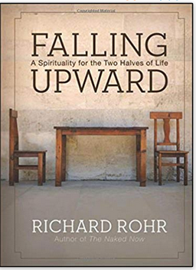

**WOMEN’s Bible Study led by Devon Smyth**

**November 6 – February 19, 2020**

**6pm Wednesday evenings**

**(Meet in Rhodes Wyatt Room - Daniel Hall)**

**Richard Rohr book “Falling Upward,**

**A spirituality for the two halves of life”**

**Purchase the book as well as the companion journal**

**at your preferred book outlet.**

**Will NOT meet: 11/27, 12/18, 12/25, and 1/1**

**MISSION & OUTREACH – November**



**Toys For Tots**

As you know, Toys for Tots provides toys and books to families of children who might not have a Christmas without their help.

We want every child to have an age appropriate book:

* Picture books for the youngest group
* Books that can be read to beginning readers
* Chapter books for independent readers.

The ages are zero to twelve.

Shopping for Toys for Tots is a good time to involve your child(ren) in helping a child have a merry Christmas.

Boxes will be located in Daniel Hall. Checks are always welcome. Reminder that all gifts and books should be UNWRAPPED.

**Toys for Tots Volunteers needed**

**December 2-11 from 8am until 12noon**

Community Building at the Coosa Valley Fair Grounds – the building connected to the Palladium. Contact Bob Evans with any questions.



**Community Kitchen for NOVEMBER**

**Friday 11/22 & Tuesday 11/26**

Choose your shift 8:30-10:15 or 10:15-noon

For more information contact Andye Moss:

706.506.4695 or agm614@aol.com

**LARGE FONT SERVICE BULLETINS for the 10am worship service available, see an usher for a copy.**

Recharge & Rejoice

Wednesday November 13th

**Menu this week**:

Speak Cheesy Gourmet Grilled Cheese Sandwiches, chips, side and dessert.

**YOUR CHOICE of one of the following**:

**Classic Three Cheese\***

**Pepperoni and Mozzarella**

**Spinach & Artichoke\***

**Roasted Tomato & Cheddar\***

(Vegetarian options*)

Those with STANDING reservations contact office with your sandwich choice.

5:30pm Dinner service begins

6:15pm Jr. Choir

Call/email the church by NOON on Tuesday with reservation.

Adults $6, Students (school age children) $4, Family maximum $20



**NEXT WEDNESDAY – November 20th**

**Living Compass will host their Mindful Eating Pot-Luck dinner**

**THEOLOGY ON TAP – NOVEMBER 14th at 6pm**

See you on the 14th at Off Broad in the Hawthorn Suites Hotel. Come relax, share a drink and chat with Father John and

Mother Melissa.

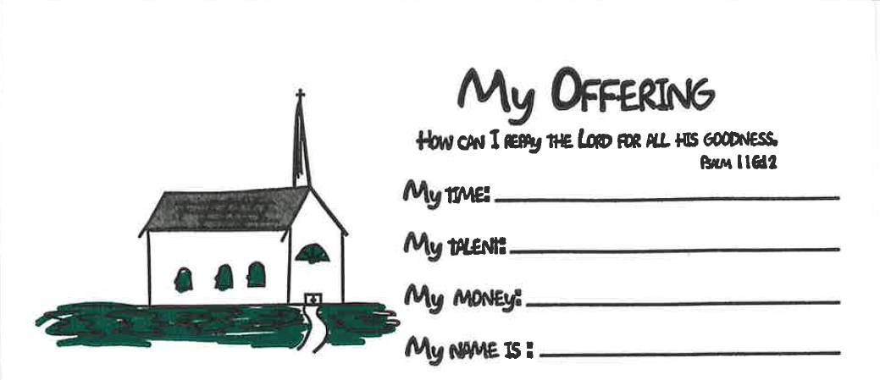

**Children’s Offering Envelopes**

**available as you enter the church**

Do your children see you contribute to the offertory or give of your time and talent at church? Children begin to learn what is important to you and your family from a very early age. If stewardship is important to you, intentionally include your kids with this kid friendly offering envelope.

**

Canterbury Club collecting **2020 calendars for DFCS though December 10th**

Do you receive promotional calendars in the mail, got more than you need, drop them off in Daniel Hall or the Church Office to be used by DEFCS in the coming year.

*Canterbury Club thanks you for your donations.*



**Nursery / Toddler care is available** and located on the 2nd floor of the Hight bldg. 9:00 am through noon on Sundays.

**If your younger children are staying with you in the pew during service, we are delighted to have the whole family joining us in worship.**

**Little ones are always welcome**.

**For Busy Little Hands in Church:**

We provide Activity Bags at both entrances to the church. The bags are filled with coloring sheets, crayons, pipe cleaners, finger labyrinth, & a kid friendly book of the service.

**Please RETURN the bags at the end of the service.**



**CHILDREN’S CHAPEL**

**Available for children during the 10am worship service**

**Kid friendly version of “Big Church” where children begin to learn the parts of our service and hear a lesson based on that day’s lectionary.**

**Drop your children off just before 10am on the middle floor,**

**2nd door on right.**



A Year of WONDER

Children’s Sunday School

beginning at 9:15am

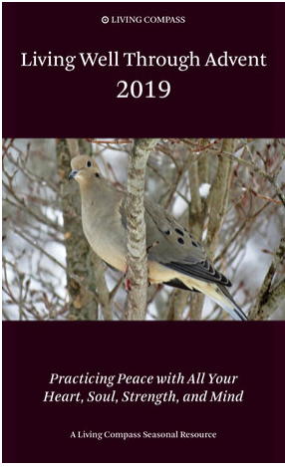

**Living Compass presents**

**ADVENT**

Booklets contain both English/Spanish

Translations.

Booklets are available around the church.

**First Session** - offered at Adult Forum on Sunday, **November 24.**

**Remaining three Sessions of Advent:**

**Mondays at 1 p.m. at 401 East 4th Avenue. Dec. 9th – 23rd**

**Wednesdays at 6:30 p.m. at the church. December 4th -18th**





Want to simplify your giving in 2020?

You can setup automatic giving directly from most personal checking accounts.

No need to remember when and how much to give, simply set it up ONCE and the bank does the remittance directly to St. Peter’s for you.

If you prefer to use PAYPAL, you can make that donation via the church website. The fee charged for using Paypal is paid by the church. Some parishioners that utilize Paypal remit the fee back to St. Peter’s. The church office can notify you of the exact fee amount when you gift is received if you desire.



**Considering a year end STOCK**

**gift to St. Peter’s?**

Please be certain to have all transactions **COMPLETED** by **December 27th** in order to receive 2019 credit.

Completed = physical check in the possession of the church office



EYC is MOVING

Beginning

TODAY

We will meet

6:30-8:30pm

We will continue to meet the 1st Wednesday of each month for our traditional Schroeder’s night of Food, Fun & Fellowship

NEXT SUNDAY!

Sunday, November 17th – two great events!

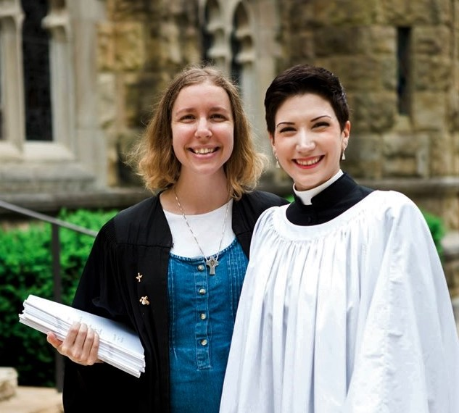

Trey Clegg Singers will Sister Hannah, an Episcopal Nun will

present their music at the preach at both services as well as

10am Worship Service. lead Adult Forum



**Church Office**: Phone - 706.291.9111 Fax - 706.232.5007 -

Email: [elizabeth@stpetersrome.org](mailto:elizabeth@stpetersrome.org) - [**www**.stpetersrome.org](http://www.stpetersrome.org)

**Mail Address: 101 East Fourth AVENUE, Rome GA 30161**

**Office Hours:** Monday – Thursday 8am to 4pm.

Fridays 9am -noon

**Connect on Facebook:** St Peter’s Episcopal Church, St Peter’s Sunday School, St. Peter’s Rome EYC, & St. Peter’s Junior Choir

**VESTRY OF THE MONTH for NOVEMBER:**

Jan Routledge or Allien McNair