**NOTICE OF ANNUAL MEETING**

**AND VESTRY ELECTION**

**November 10, 2019**

The Annual Parish Meeting will be held on

Sunday November 10, 2019 immediately following the

10 a.m. Eucharist in Daniel Hall.

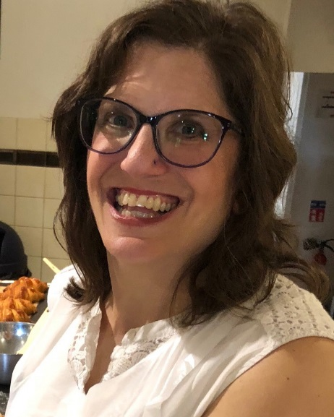

Jennifer Bressette and her husband Andrew moved to Rome in 1998 and have been married 25 years. They have four children Elizabeth (22), Andrew Jr (20)., Lili (19) , and Jacob (17). She is a special education teacher at Johnson Elementary School in Floyd County. In her free time Mrs. Bressette enjoys running and has completed five marathons including Boston in 2014, 21 half marathons, and numerous 5K’s and 10K’s.  She also enjoys yoga and is a supporter of Berry College Theater Company and Rome Little Theater.

Jennifer has been involved in children’s ministry at St. Peter’s for the past several years in different capacities (Sunday School Teacher, Children’s Chapel leader, VBS volunteer, and EYC chaperone). She has also helped with Mission and Outreach, cooked for the Canterbury Club, and has been a member of Foyer groups . Jennifer is happy to have found a church home in St. Peter’s. “Even before becoming members my family was drawn to St. Peter’s and its warmth and openness. My children attended VBS and Camp Mikell when they were younger and were so filled with enthusiasm and the Holy Spirit that our family decided to see what wonderful things were going on every Sunday. We immediately felt welcome and spiritually fed.” Jennifer and Andrew officially joined St. Peter’s five years ago and 3 of their children have been confirmed here. She hopes if elected to the Vestry to continue to make St. Peter’s a church where everyone feels that they matter and has a place where they belong.

**NOTICE OF ANNUAL MEETING**

**AND VESTRY ELECTION**

**November 10, 2019**

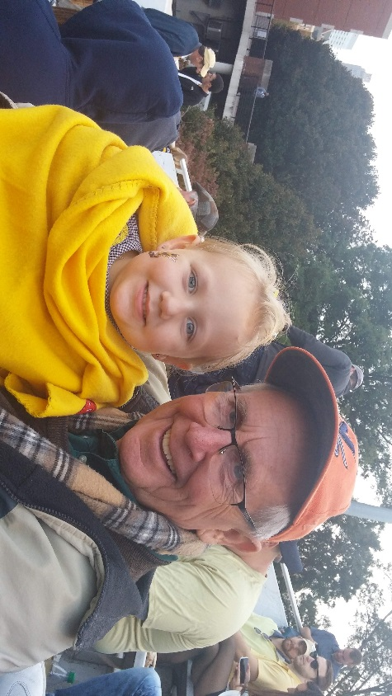The Annual Parish Meeting will be held on

Sunday November 10, 2019 immediately following the

10 a.m. Eucharist in Daniel Hall.

Brian Hampton was born in Bournemouth, England. He received a BS in economics from the London School of Economics and a MA in political science, University of Virginia. Brian has been an Assistant professor in political science at Berry College from 1971-1976. He then worked for the State of Georgia in personnel management from 1977-2007, serving in various positions including Manager of Recruitment for the State Merit System 1986-1995 and HR manager for NW Regional Hospital 1995-2007. From 2009 to 2017 he worked at the Murphy Harpst Children's Center. Brian has also done fundraising working with churches of the North Georgia Conference of the United Methodist Church. Brian said he has “ at various times worked as a farm laborer, bartender and English Nanny.” In the Rome community he spent 9 years on the Rome/Floyd Planning Commission, several years as chair of the Summerville Park Neighborhood Association and worked in and managed more local political campaigns than he care to remember. His church life began at an early age as a choir boy and acolyte at St. George's Church of England in Bovington at age 9. After college he took about a 20 year sabbatical from church life. However, “I kept reading CS Lewis and  his persuasions proved irresistible.” Brian has been connected with North Springs UMC, Transfiguration Episcopal Church (where I was a Vestry Member and Senior Warden) and of course with St Peter's since 2009. “At St Peter's you have supported me and encouraged me to a full and rich life in the church: early on as EYC program person, as a youth and adult Sunday school / formation teacher, reader, chalice bearer, and usher. In addition over the last 20 years I have served multiple times as a delegate to Annual Council and served 4 years on the Diocesan Executive Board. My most challenging role at St Peter's is being husband of the Verger. I am blessed to have a wife, 2 sons 6 grandchildren and 4 rescue dogs. I spend my life in retirement with grandchildren, walking dogs, hiking, substitute teaching at St Mary's School, and engaging everything I can at St. Peter's.”

**NOTICE OF ANNUAL MEETING**

**AND VESTRY ELECTION**

**November 10, 2019**

The Annual Parish Meeting will be held on

Sunday November 10, 2019 immediately following the

10 a.m. Eucharist in Daniel Hall.

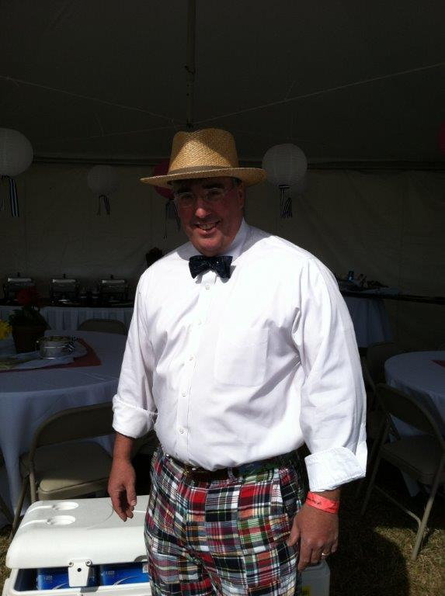Nathaniel Wilson Massey, III

aka “Nat”

I am one of those cradle Episcopalians as my father was the priest at Transfiguration in the early 70s, when I was very young. I have seen a lot of churches and I love St. Peter’s more than any other. Since moving back to Rome I have received more (spiritual growth, fellowship, love) from my involvement with St Peter’s than I could ever hope to repay. My interest in serving on the vestry is a small attempt to repay that debt. I find these types of writing to be an afront to my well-honed humility. Please forgive this transgression. I first attended St. Peters in 1976 with my mother. Mrs. Jody Selman tells a story that during Easter service that year that I apparently accosted several parishioners with an Easter bunny that I just had to take to church. As was the custom of the time, I was confirmed here in 1979. Following my graduation from Berry and as with so many, I moved away to find my fortune. Having realized that I could just as easily do that in Rome, Amy and I came back to Rome and St. Peters in 2005. I settled in to a job with F & P Georgia (We make parts for Honda, Nissan and Toyota). I am currently the Sr Manager of HR. I have had the pleasure to be involved in a number of things at St. Peters. When we had such a thing, I was on the Wednesday night supper crew. I have been an acolyte since 1982. Dawn never calls me to serve any more (I may not fit in the robes). I worked on a number of Habitat for Humanity Apostles Builds. I have taught Sunday school, spoke at Adult Forum, and changed HVAC filters. I was “co-leader” of EYC for a group of kids that are now adults. I have proudly served on the vestry in 2008-2010, on the search committee for John (I think we got that one right), and on Rebecca’s discernment committee (a chance to work with some of the finest people that I know). Away from Church I have many hobbies. I enjoy restoring old British sports cars. I love to sail, play guitar, and play soccer (although I am very out of shape). My wife likes that I enjoy restoring furniture and cooking. All of that aside, my most favorite thing to do is to spend time with my wonderful family. My beautiful and charming wife, Amy, and I have 2 outstanding children, Wil and Megan. We also have 4 nieces and the baby of the family our Chihuahua, Lilly. Yes, she does show up in the Directory.

**NOTICE OF ANNUAL MEETING**

**AND VESTRY ELECTION**

**November 10, 2019**

The Annual Parish Meeting will be held on

Sunday November 10, 2019 immediately following the

10 a.m. Eucharist in Daniel Hall.

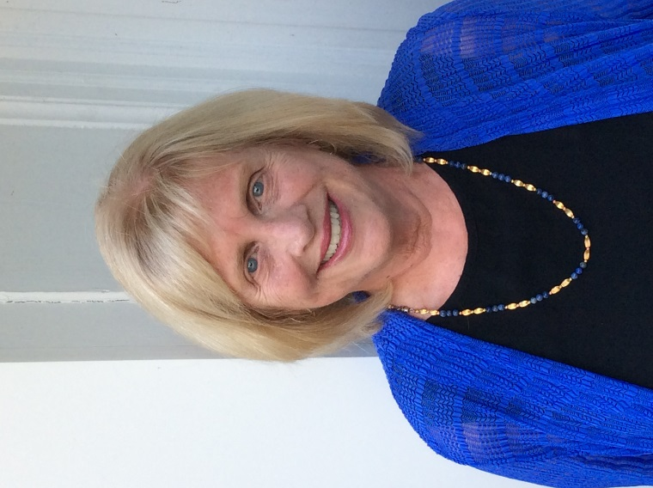**Jacquelyn Wright** has attended St. Peters since moving to Rome in 1996. A native of Chattanooga Tn., she graduated from Emory University with a B.A. in Psychology, and received her Masters in Social Work from the University of Georgia. Jacquelyn was Director of Outpatient Social Services for Scottish Rite Children]s Hospital in Atlanta for several years. After moving to Rome, Jacquelyn became involved in community work. She has been a volunteer at Good Neighbors and the community kitchen. She has served as president of The Open Door Home, the Darlington Parents Association, and Chieftains Museum. At St. Peters, Jacquelyn currently serves on the Altar Guild, as a Greeter, and part of a team providing meals to the homeless shelters. She was a Sunday School teacher for several years. Jacquelyn was also part of the group that accompanied Father John on The Camino de Santiago in 2017. Jacquelyn and her husband Barry are the parents of one daughter, Alicia Wright of Denver, Co.