

**ANNOUNCEMENTS**

**October 20, 2019**

***“Enter reverently, meditate quietly, worship devoutly, leave gratefully, serve Christ faithfully.”***

**WELCOME TO ALL OUR VISITORS!**  If you are interested in knowing more about St. Peter’s, please see an usher or one of the greeters who stand with the clergy after the service.

**TODAY AT ST. PETER'S**

8:30 am Holy Eucharist Rite I

8:45 am Breakfast served until 10am

9:15 am Kids Formation, Early Bird Adult Class

10:00 am Children’s Chapel

10:00 am Holy Eucharist Rite II

11:15 am Adult Forum

1:00 pm Holy Eucharist in Spanish

**Nursery available on Sundays from 9am until 12noon**

**This week…**

Monday – Thursday **8:30am Morning Prayer, Chapel**

Monday/ Oct 21 **1pm Living Compass – Mindful Eating**

Tuesday/Oct 22 **11am** **Chair Yoga**

**12:15 pm Healing Service**

Wednesday/Oct 23 **5:30 pm Celtic Service**

Recharge & Rejoice **5:30 pm Dinner service begins**

**6:00 pm Living Compass – Mindful Eating**

**6:15 pm Jr. Choir**

**6:30 pm EYC Activities**

**6:30 pm Episcopal 101**

**7:00 pm Adult Choir Rehearsal**

Thursday/Oct 24 **10:00 am Bible Study**

**Intercessory Prayer List:** Mike Alexander, Jack Edgens, Bo Warren, Ryan Stubblefield, John Woodward, Bob Berry, Natasha Pendergrass, John Hunter, Dana Edgens, Beth Starnes Nora Barrientos, Basilia Perez, Ed Johnson, Emily Barba, Debbie Hayes, Glenn Segrest, Jackie Eschbaugh, Leila, Meg Alexander, Laura Frederick, Logan Bourbeau, Jeff Williams, Amaya and those who serve their needs.

*To add a name to the PRAYER LIST or MILITARY LIST, contact the church office. Once a name is added to the* ***Prayer list*** *it will remain until the end of the month, then it will be removed. If you wish it to be added for another month, please contact the church office. Names added to the* ***Military list*** *will remain until YOU notify the office to remove.*

**Sympathy of the Parish** extended to Nancy Knight on the death of her father, Hugh McRae, Jr. who died on October 16, 2019

**Lay Ministers:**

(8:30) Reader/Prayers/Chalice Bearer – Tricia Richards

(10:00) 1st Lesson-Peggy Nash; 2nd Lesson–Brian Hampton, Prayers –Devon Smyth.

Chalice Bearers – Bryan Johnson, Bill Byington, Hollye Smith, Jennifer Sikes.

**Altar Candles:** Given to the glory of God and in loving memory of Bill and Janice A. Byars and William M. Byars, Jr. by Lee and Becky Jones and Ben and Abby Stell.

**Flowers on the Altar:** Given to the glory of God and loving memory of Ramona McNair and Robert & Pauline Schoepski by Allien McNair and Bill Schoepski.

**Flowers in the Chapel**: Given by Roger & Ellen Smith to the glory of God in appreciation for all God’s gifts and blessings.

**Happy Birthday** to those celebrating birthdays (October 20 – October 26) Bob Watson, Elizabeth McDaniel, Margaret Ashton, Terry Morris, Kathy Shaws, Len Woodward, Sam Moss, Matt Sirmans, Madeline Herring, Lee Hight, Barbara Kuckhoff, Elisabeth Ashton, Liz Mozley, and Howard Rogers.

**ADULT FORUM TODAY – Fran Bagley**

**“Shares her faith in a crisis journey”**



**Living Compass Presents**

**MINDFUL EATING**

**Wednesdays**, October 16-November 6

6:00 pm, Living Room of Willingham House

**Mondays,** October 21 – November 11

1pm, 401 East Fourth Avenue

**POT LUCK sponsored by Living Compass on Wednesday 11/20/2019 in Daniel Hall**

Monday group led by D’Ann Downey, 706.266.3444 or [ddowneywarley@comcast.net](mailto:ddowneywarley@comcast.net)

Wednesday group led by Beth Hughes, 706.506.9636 or novianhughes@gmail.com

**NEW CONSECRATION SUNDAY**



**Mark Your Calendar**

**Sunday**

**October 27, 2019**

**Sunday Worship 8:30 or 10am**

**AND**

**Catered Celebration Luncheon at The Forrest**

**following the 10am service**

**Bus will be available for those requiring assistance traveling between the church and The Forrest for lunch.**

Contact the church office to make your luncheon reservations OR complete the reservation card in your announcements

& drop in the collection plate.

**Lloyd Griffin, Co-Chairman Stephen Patton, Co-Chairman**

Recharge & Rejoice

Wednesday October 23rd

**Menu this week**: Meatloaf, mac n cheese, green beans, salad,

Louisiana Crunch Cake.

5:30pm Dinner service begins

6:15pm Jr. Choir

6:30pm EYC activities

Call/email the church office by NOON on Tuesday

with your dinner reservation.

Adults $6, Students (school age children) $4, Family maximum $20

**If YOUTH are participating in EYC activities**

**do NOT include them in your family dinner reservation. They will eat but are counted in the EYC reservation**

**made by Mother Melissa.**



**Has your address, name, email or phone number changed?**

**Missing or Incorrect NAME TAG for Sunday Morning?**

Please call or email the church office to confirm your contact information/name or to make a change.



**MISSION & OUTREACH – Spotlight for OCTOBER…..**

**Rome/Floyd County animal shelter, P.A.W.S.**

**in need of the following items:**

Dog Food (Dry)

****Cat Food (Wet)

Puppy & Kitten Food (Wet & Dry)

Horse Pellet Bedding (Used for cat litter)

Medicated Shampoo

Flea & Tick Shampoo

Collars (all sizes)

Harnesses (all sizes)

Kong Easy Treat Canned Cheese

Cat & Dog Treats

Drop your donations in the bins located in Daniel Hall.



**Community Kitchen for OCTOBER**

Friday 10/25 or Tuesday 10/29

Choose your shift 8:30-10:15 or 10:15-noon

For more information contact Andye Moss:

706.506.4695 or agm614@aol.com



**Nursery / Toddler care is available** and located on the 2nd floor of the Hight bldg. 9:00 am through noon on Sundays.

**If your younger children are staying with you in the pew during service, we are delighted to have the whole family joining us in worship.**

**Little ones are always welcome**.

**For Busy Little Hands in Church:**

We provide Activity Bags at both entrances to the church. The bags are filled with coloring sheets, crayons, pipe cleaners, finger labyrinth, & a kid friendly book of the service.

**Please RETURN the bags at the end of the service.**

**Children’s Offering Envelopes**

**available as you enter the church**

Do your children see you contribute to the offertory or give of your time and talent at church? Children begin to learn what is important to you and your family from a very early age. If stewardship is important to you, intentionally include your kids with this kid friendly offering envelope.



**CHILDREN’S CHAPEL**

**Available for children during the 10am worship service**

**Kid friendly version of “Big Church” where children begin to learn the parts of our service and hear a lesson based on that day’s lectionary.**

**Drop your children off just before 10am on the middle floor, 2nd door on right.**



A Year of WONDER

Children’s Sunday School

beginning at 9:15am



**WEDNESDAY October 30th**

* **Carnival Games & Face Painting 5:30-6:30**

**Outdoor area, 3rd floor Hight building**

* **Adult Beverages/Snacks 5:45 in Daniel Hall**
* **Dinner service at 6:15 pm in Daniel Hall**

**Adults $6, Students $4, Family Max $25**

* **Costume Parade & Soul Cakes at 7pm**
* **Crowning of Pie King or Queen, 7pm**

**Prepare your favorite recipe for a chance to be crowned PIE King or Queen.**

**Pies will be enjoyed by all as our dessert.**

We Need YOU….

* Bartending
* Treat Walk
* Game Help
* Clean Up
* Money Collector

Sign up on Children’s Ministry Bulletin Board in Daniel Hall OR

contact church office to lend a hand.

**Harvest inspired meal**

Brats/buns, German roasted pork, apple sausage for our vegetarians, sauerkraut, German potato salad,

green beans, tossed salad, apple spice cake.

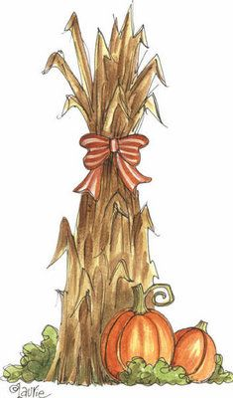

**For the children:**

Hotdogs, chips & carrots

Adults $6, Children under age eleven $4,

Family Maximum $25

**Come join the fun, fellowship & food!**



**Soul Cakes…huh?**

Soul cakes are a tradition that harks back to the old days.  People, young and old, would travel around to houses and beg for food.  In exchange for a simple cake (“soul cake”), the homeowners would ask the beggars to say a prayer for the souls of their departed loved ones.

Sounds a lot like trick or treating doesn’t it?

**At our All Hallows’ Eve celebration, we will do our own version.**

**Reservations needed for dinner by MONDAY 10/28/2019**

706.291.9111 [elizabeth@stpetersrome.org](mailto:elizabeth@stpetersrome.org)



November 3, 2019

* CHANGE IN SERVICE TIMES: **9am** & **11:15am**
* Both Worship Services will be conducted in the church.
* Both services will be Rite II, All Saint Celebrations
* Bishop Wimberly present for the 9am service.
* At the 11:15 service; Bishop Wright & Bishop Wimberly will be present to Confirm, Receive or

Re-affirm approximately 50 youth & adults.

* Jr. Choir will perform at the 11:15 service.
* A brunch/reception will be held between the services.

Mark your calendars so you do not miss celebrating!

**LARGE FONT SERVICE BULLETINS for the 10am worship service available, see an usher for a copy.**

2019 Giving Statements



Third Quarter Giving Statements will be mailed in the coming weeks.

Be certain to check your statement carefully.

Contact the church office if the amount on your statement does NOT agree with your personal records.

This will be your FINAL statement before YEAR END.

Want to simplify your giving in 2020?

You can setup automatic giving directly from most personal checking accounts.

No need to remember when and how much to give, simply set it up ONCE and the bank does the remittance directly to St. Peter’s for you.



**Considering a year end STOCK gift to**

**St. Peter’s?**

Please be certain to have all transactions **COMPLETED** by **December 27th** in order to receive 2019 credit.

Completed = physical check in the possession of the church office

**Join us for Breakfast on Sunday Mornings**

**8:45-10am**

**Adults - $3 Children- $2 up to age 12**

**Interested in helping with this ministry?**

**Contact Jack Niedrach 706.767.1671**



Do you receive the

Weekly Wednesday Email Blast

from St. Peter’s?

If not, give the office a call or email to confirm your contact information in the church database.



**ELECTRONIC GIVING**

Do you remit your tithe/offering electronically?

Cards are located at the church entrance

for you to place in the collection plate

if you desire.

EMPTY SEAT – IS SOMEONE MISSING who sits near you in church, or in a group you attend?

Don’t let their absence go unnoticed, reach out.

If they are hospitalized or in need of prayers, clergy visit, home communion, meals or flowers, please notify the

Church Office 706.291.9111 or e[lizabeth@stpetersrome.org](mailto:lizabeth@stpetersrome.org).



**Potted Mums**

**All Saints’ Sunday November 3rd**

If you are interested in placing a potted mum in the Memory Garden for

All Saints Sunday,

Return the Form:

* Mail - 101 East 4th Ave, Rome GA 30161.
* Place in the collection plate.
* Contact the Office – email [elizabeth@stpetersrome.org](mailto:elizabeth@stpetersrome.org) OR call 706-291-9111. Checks should be made payable to St. Peter’s Episcopal Church and marked for ***Mums.*** No specific amount is required, give whatever is comfortable for you.

Deadline for forms/gifts is **FRIDAY OCTOBER 25th.**

In Memory of

Donor name and phone number (for questions only):

Pull this form out of the announcements, complete and return it to the church office by

FRIDAY October 25th.



EYC is MOVING

Beginning

November 10th

We will meet on SUNDAYs 6:30-8:30pm

We will continue to meet the 1st Wednesday of each month for our traditional Schroeder’s night of Food, Fun & Fellowship

Mark Your calendars!

Sunday, November 17th – two great events!

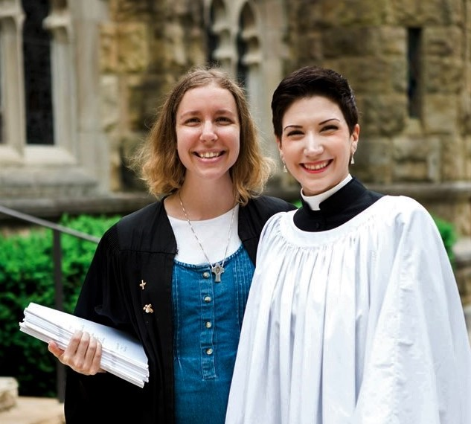

Trey Clegg Singers will Sister Hannah, an Episcopal Nun will

present their music at the preach at both services as well as

10am Worship Service. lead Adult Forum



**Church Office**: Phone - 706.291.9111 Fax - 706.232.5007 -

Email: [elizabeth@stpetersrome.org](mailto:elizabeth@stpetersrome.org) - [**www**.stpetersrome.org](http://www.stpetersrome.org)

**Mail Address: 101 East Fourth AVENUE, Rome GA 30161**

**Office Hours:** Monday – Thursday 8am to 4pm.

Fridays 9am -noon

**Connect on Facebook:** St Peter’s Episcopal Church, St Peter’s Sunday School, St. Peter’s Rome EYC, & St. Peter’s Junior Choir

**VESTRY OF THE MONTH for OCTOBER:**

Janet Byington 706.346.6561