

**ANNOUNCEMENTS**

**August 4, 2019**

***“Enter reverently, meditate quietly, worship devoutly, leave gratefully, serve Christ faithfully.”***

**WELCOME TO ALL OUR VISITORS!**  If you are interested in knowing more about St. Peter’s, please see an usher or one of the greeters who stand with the clergy after the service.

**TODAY AT ST. PETER'S**

8:30 am Holy Eucharist Rite I

10:00 am Holy Eucharist Rite II

1:00 pm Holy Eucharist Rite II in Spanish

4:00 pm Training for Children’s Sunday School teachers

**Nursery available on Sundays from 9am until 12noon**

**This week…**

Monday/August 5 **8:30am Morning Prayer, Chapel**

**9:30am Women’s Bible Study**

Tuesday/August 6 **8:30am Morning Prayer, Chapel**

**11am** **Chair Yoga**

**12:15pm Healing Service**

Wednesday/August 7 **8:30am Morning Prayer, Chapel**

**3:30pm** **Centering Prayer**

**5:30 pm Celtic Service**

Thursday/August 8 **8:30am Morning Prayer, Chapel**

**Intercessory Prayer List:** Mike Alexander, Jack Edgens, Kate Ammons,

Bo Warren, Ryan Stubblefield, Emily Barba, Debbie Hayes, Basilia Perez, Hayden Sizemore, Nora Barrientos, Werner Schmitz, Stephen Padgett, Roman Jones, Ivey Sirmans, Betsy Awsumb, John Flanigan, Kevin Skelly, Walter Coker, Dana Holcombe, Daniel Bump and those that serve their needs.

*To add a name to the PRAYER LIST or MILITARY LIST, contact the church office. Once a name is added to the* ***Prayer list*** *it will remain until the end of the month, then it will be removed. If you wish it to be added for another month, please contact the church office. Names added to the* ***Military list*** *will remain until YOU notify the office to remove.*

**Lay Ministers:**

(8:30) Reader/Prayers/Chalice Bearer – Dawn Hampton

(10:00) 1st Lesson-Len Woodward; 2nd Lesson–Betsy Awsumb;

Prayers –Wade Carpenter

Chalice Bearers – Beth Hughes, Brian Hampton, Jack Niedrach, Dawn Hampton.

**Altar Candles:** given to the Glory of God and in Celebration and Thanksgiving for Father John and Mother Melissa.

**Flowers on the Altar:** given by Nancy and David Hunter to the Glory of God and in loving memory of Lila Smith Everett.

**Flowers in the Chapel**: given to the Glory of God and in celebration of children and grandchildren.



EMPTY SEAT - IS SOMEONE MISSING that sits near you in church, or in a group you attend?

Don’t let their absence go unnoticed, reach out.

If they are hospitalized or in need of prayers, clergy visit, home communion, meals or flowers,

please notify the CHURCH OFFICE

706.291.9111 or e[lizabeth@stpetersrome.org](mailto:lizabeth@stpetersrome.org).

**HAPPY BIRTHDAY** to those celebrating birthdays (August 4-August 10). Jim Noon, Winston Sirmans, Robert Kuckhoff, Chris Edgeworth, Camille Trammell, Cissy Rogers, Jason Tucker, David Carlton, Michelle Lawrence, Kristin Albertson, Matthew Summerlin, Christina Kinder, and Maddox Pyle.

**LARGE FONT SERVICE BULLETINS for the 10am worship service now available, see an usher for a copy.**

**ADULT FORMATION – Resumes August, 25th 11:20am in Daniel Hall**

8/25 – Come spend time with Mother Melissa

9/01 – No Adult Formation, Labor Day Weekend

9/08 – Formation in the Nave, join George Thomason as he takes us through the

historic years of St. Peter’s Church.

Grab your coffee fix BEFORE you join the group.

9/15 – No Adult Formation, St. Peter’s 175th Birthday Celebration

9/22 – No Adult Formation, Trey Clegg Singers

9/29 – Fred Tarrant shares Our Musical History

Join Mother Melissa

8:30am in the Chapel for

**MORNING PRAYER**

Monday through Thursday



**Chefs Needed for Canterbury Club**

**Tuesday evenings at 6pm, beginning August 27**

This semester we will continue to eat vegetarian to make meal preparation less complicated. I have many EASY, AFFORDABLE recipes that I can share with you.

This weekly meal is the highlight for many of our students.

Please contact me if you are able to provide this ministry.

=) Rebecca Segrest, 706.331.6363



**August 6th from 6-8pm at**

**Metropolitan United Methodist Church**

1st House meeting with Metropolitan & St. Peter’s.

We encourage a group of people that represent the diversity of the community to gather and discuss current issues.

Interested in attending? Contact Jan Routledge, 706.506.4596

****Episcopal 101 Class

Wednesday Evenings at 6pm in Rhodes Wyatt Room

August 21st, 28th, September 11th, 18th, 25th,

October 9th, 16th, & 23rd

If you are considering confirmation at St. Peter’s

**OR**

Simply want to learn more about the Episcopal tradition,

Come join the Episcopal 101 Class.

No registration required.

All are Welcome!

Join Father John and explore the Episcopal tradition.

**YOUTH CONFIRMATION CLASSES**

August 11 & 25, September 29, October 13 & 27.

2:30-4pm in Rhodes Wyatt room

ATTENTION: Sophomore Students or older!

Contact Mother Melissa via email: Melissa@stpetersrome.org

~~~~~~~~~~~~~~~~~~~~~~~~~~~~~~~~~~~~~~~~~~~~~~~~~~~~~~~~~~~~~~~~~~~~~~~~~~~~

Theology on Tap

3rd Thursdays each month August – December

Sit down in a casual setting, have a drink and talk theology with

Father John & Mother Melissa.

1st meeting August 15th, 6pm at Rome City Brewing



**Nursery Toddler care is available** and located on the 2nd floor of the Education Building.

9:00 am through noon

on Sundays.

**If your younger children are staying with you in the pew during service, we are delighted to have the whole family joining us in worship.**

**Little ones are always welcome**.

**For Busy Little Hands in Church:**

We provide Activity Bags at both entrances to the church. The bags are filled with coloring sheets, crayons, pipe cleaners & finger labyrinths.

**Please RETURN the bags at the end of the service.**

Sunday School for children 3 yrs to 5th grade returns September 8th – 9:15am – 9:50am



A year of WONDER

SAVE THE DATE!!!

**St. Peter’s 175th Celebration—Sunday, September 15**

Plan to celebrate St. Peter’s presence in Rome for 175 years in worship and community outreach!!!

**3pm –** St. Peter’s to HOST the Second Annual Community Hymn Fest with choirs from St. Peter’s, First Baptist & First Methodist. Regional Clergy and Chairs of Non-profit Organizations supported by St. Peter’s will receive personal invitations.

Historical commentary of church and grounds immediately after the musical celebration.

Light refreshments served following the Hymn Fest for parishioners and guests. All are encouraged to join our guests for conversation and connections to leaders in our community.

**5pm -** Parish Celebration in Daniel Hall following the public celebration.

175th Birthday Celebrations highlighted by light appetizers, beverages, and a catered meal.

Watch for other specific information and dates to RSVP later this month

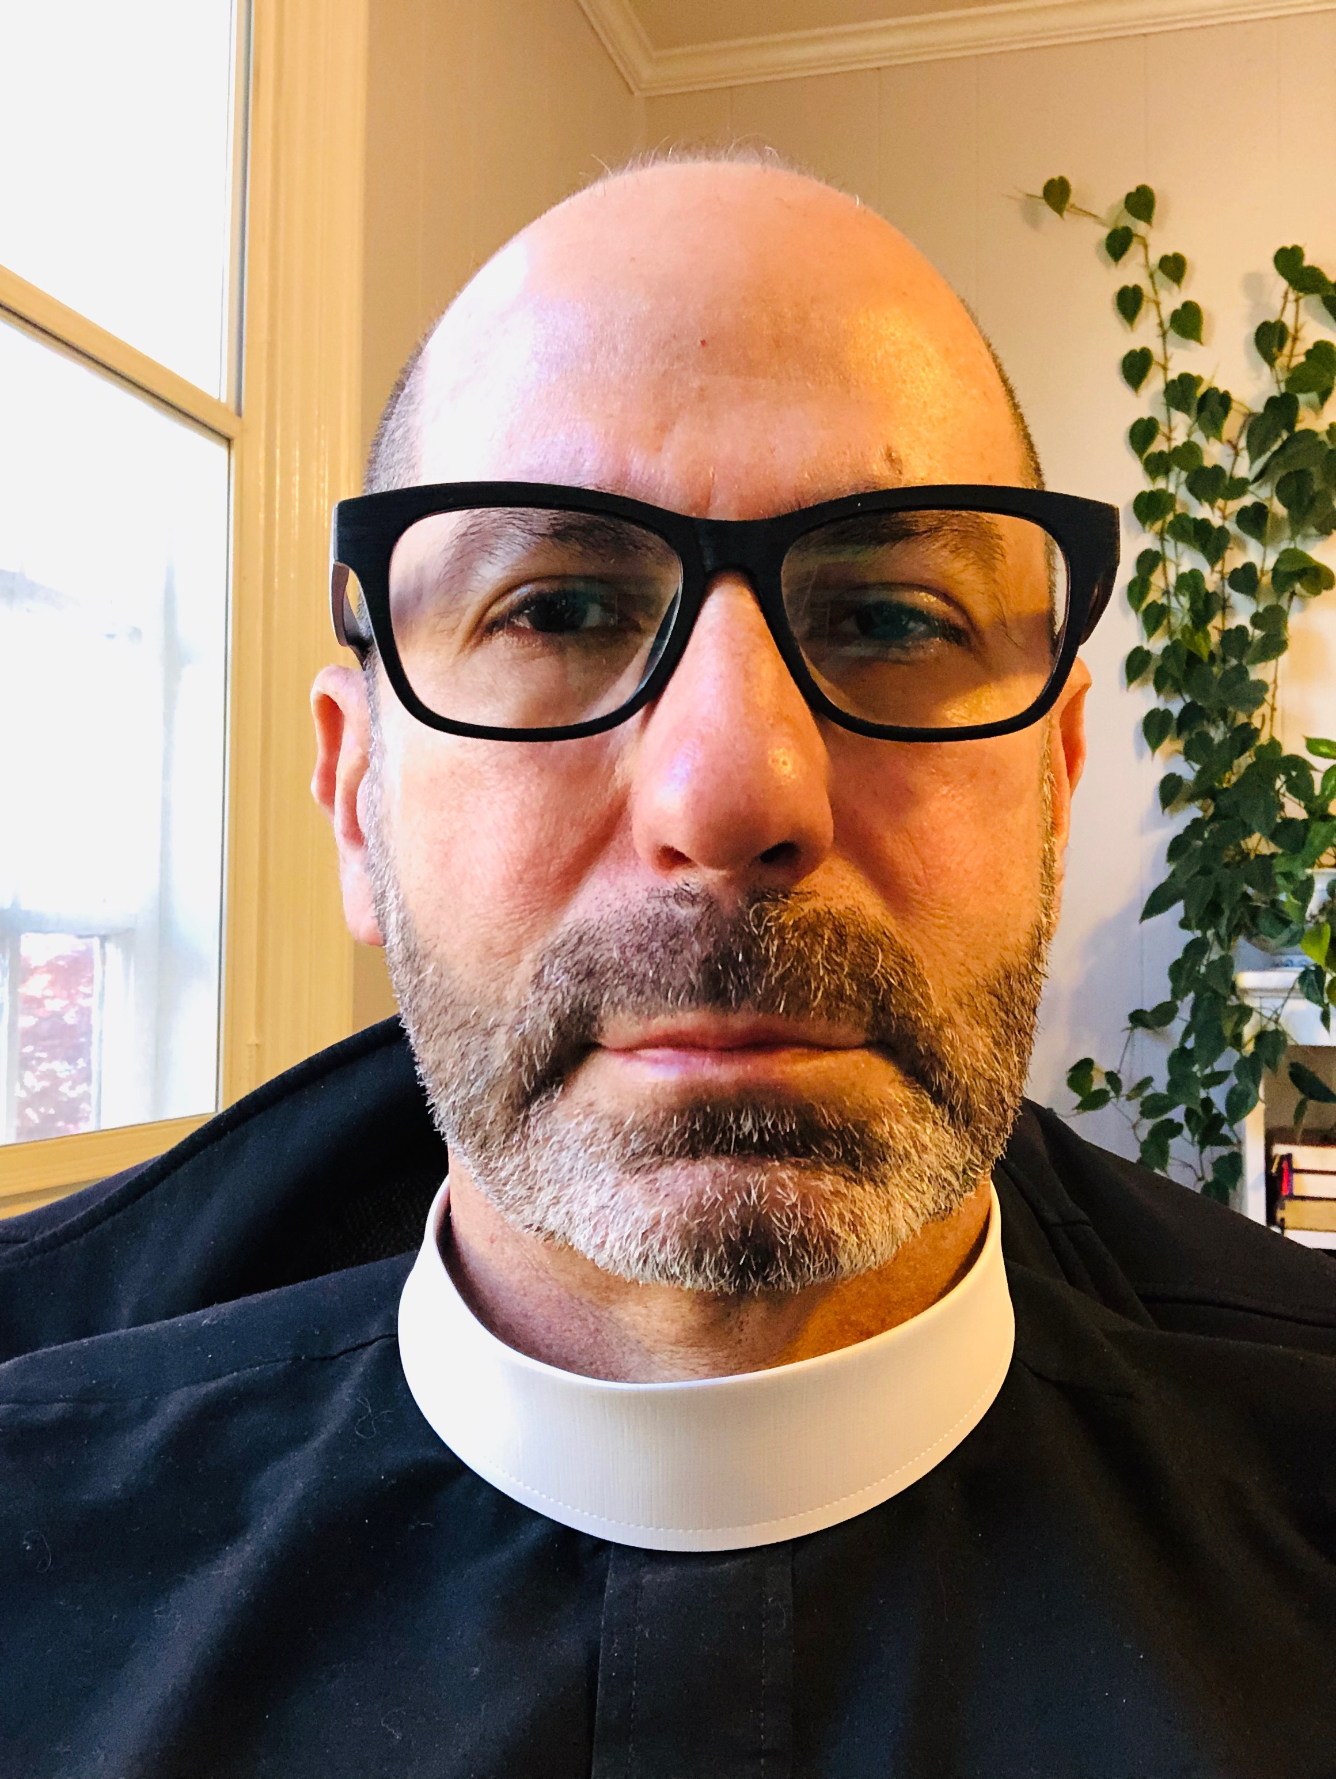**NEXT SUNDAY AUGUST 11th**

Bishop will be present at St. Peter’s during the 1pm worship service to receive

**Father Jorge Rosa**

Following worship, a reception with light refreshments will be held in Daniel Hall.

Come join this Celebration for Father Jorge Rosa.



August 14th

Recharge & Rejoice activities on Wednesday night resume!

Dinner service begins 5:30pm. Chicken Pot Pie, Fruit salad, and brownies.

EYC activities begin at 6:30pm

August 17th

Rebecca Roberts ordination; St. Catherine’s, 571 Holt Rd Marietta GA at 10am

August 18th

Backpack Blessing at the 10am worship service

Celebration of Ministries in Daniel Hall following 10 am service

Path to Shine fundraiser “Day at the Braves” details on bulletin board in Daniel Hall

August 25th

Breakfast Resumes, serving from 8:45am to 10am

Formation for Adults offered 11:20am – noon

Mission & Outreach travel to the Church of the Common Ground

August 27th

Canterbury Meetings resume, Krannert Center at Berry

September 8th

Formation for Kids and Youth, 9:15am-9:50am

Children’s Chapel is back at 10am

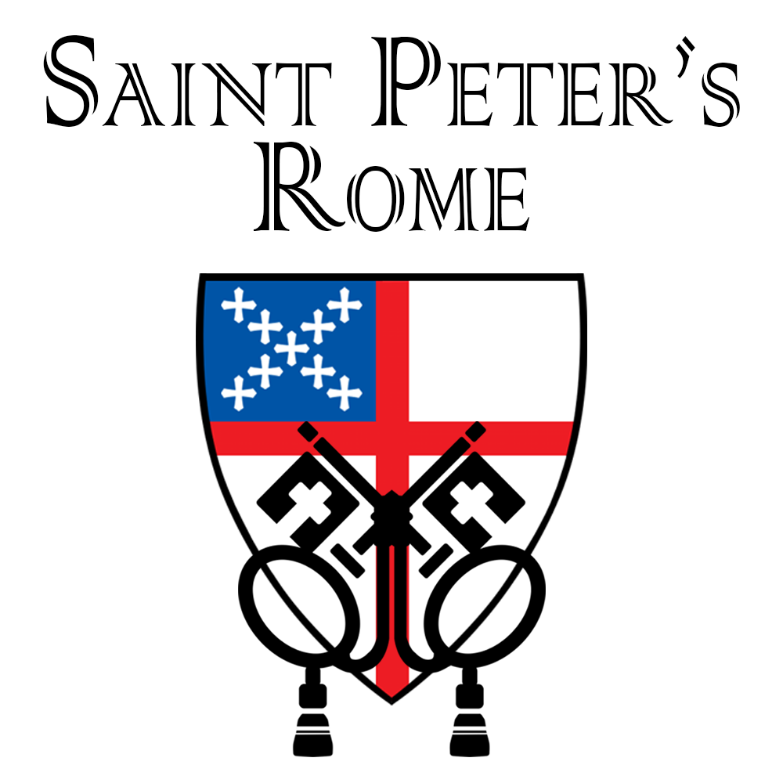



Do you receive the

Weekly Wednesday Email Blast from St. Peter’s?

If not, give the office a call or email to confirm your contact information in the church database.

**Church Office**: Phone - 706.291.9111 Fax - 706.232.5007 -

Email: [elizabeth@stpetersrome.org](mailto:elizabeth@stpetersrome.org) - [**www**.stpetersrome.org](http://www.stpetersrome.org)

**Mail Address: 101 East Fourth AVENUE, Rome GA 30161**

**Office Hours:** Monday – Thursday 8am to 4pm.

Fridays 9am -noon

**Connect on Facebook:** St Peter’s Episcopal Church, St Peter’s Sunday School, St. Peter’s Rome EYC, & St. Peter’s Junior Choir

**VESTRY OF THE MONTH for AUGUST:**

Allien McNair 706.936.0518