

**ANNOUNCEMENTS**

**August 25, 2019**

***“Enter reverently, meditate quietly, worship devoutly, leave gratefully, serve Christ faithfully.”***

**WELCOME TO ALL OUR VISITORS!**  If you are interested in knowing more about St. Peter’s, please see an usher or one of the greeters who stand with the clergy after the service.

**TODAY AT ST. PETER'S**

8:30 am Holy Eucharist Rite I

8:45 am Breakfast served until 10am

10:00 am Holy Eucharist Rite II

11:20 am Adult Formation, Daniel Hall

1:00 pm Holy Eucharist Rite II in Spanish

**Nursery available on Sundays from 9am until 12noon**

**This week…**

Monday – Thursday **8:30am Morning Prayer, Chapel**

Monday/August 26 **9:30am Women’s Bible Study**

Tuesday/August 27 **11am** **Chair Yoga**

**12:15pm Healing Service**

Wednesday/August 28 **5:30 pm Celtic Service**

Recharge & Rejoice **5:30 pm Dinner service begins**

**6:00 pm Episcopal 101**

**6:30 pm EYC Activities**

**7:00 pm Adult Choir Rehearsal**

**Intercessory Prayer List:** Mike Alexander, Jack Edgens, Kate Ammons,

Bo Warren, Ryan Stubblefield, Emily Barba, Debbie Hayes, Basilia Perez, Hayden Sizemore, Nora Barrientos, Werner Schmitz, Stephen Padgett, Roman Jones, Ivey Sirmans, Betsy Awsumb, John Flanigen, Kevin Skelly, Walter Coker, Dana Holcombe, Daniel Bump, Tony Ryder, Agnes Lee, Virglio Bentacourt, Holly Linaugh, Barbara Dixon, Suzanne Protz, Robert Hernandez, Norma Perez, Allan Brown and those who serve their needs.

*To add a name to the PRAYER LIST or MILITARY LIST, contact the church office. Once a name is added to the* ***Prayer list*** *it will remain until the end of the month, then it will be removed. If you wish it to be added for another month, please contact the church office. Names added to the* ***Military list*** *will remain until YOU notify the office to remove.*

**Lay Ministers:**

(8:30) Reader/Prayers/Chalice Bearer – Tricia Richards

(10:00) 1st Lesson-Tom Dasher; 2nd Lesson–D’Ann Downey; Prayers –Chris Edgeworth. Chalice Bearers – Sammie Edgeworth, Chris Edgeworth.

**Altar Candles:** given to the Glory of God and in Celebration and Thanksgiving for Father John and Mother Melissa.

**Flowers on the Altar:** given by Dana and Jack Edgens to the Glory of God and in loving memory of Mr. and Mrs. Edwin C. Byington and other departed family members.

**Flowers in the Chapel**: given to the Glory of God and in loving memory of Christy Jones Hernandez Nixon daughter of Sharon and Jerry Norman.

**HAPPY BIRTHDAY** to those celebrating birthdays (August 25-August 31). Janet Byington, Leigh Patterson, Victor Chin, Logan Mull, JadaJoy Holley, Patricia Harvey, Cynthia Burnes, Teague Williams, Jerry Norman, Todd Horton, Larry Osborn, Elise O’Neill, Gemma Warner, Jason Stephens.



Jr. Choir is back on Wednesdays beginning

**SEPTEMBER 4th**

Come Join Our Song at 6:15pm

3rd floor, 2nd door on the left.

**St. Peter’s Celebrates 175 Years !**

**September 15th**

11:15am Dedication of Children’s Play Area

3:00-4:00 Hymn Fest featuring choirs from St. Peter’s,

First Baptist, First Methodist & First Presbyterian Churches

4:00-4:40 Meet and talk with community leaders and friends

~ Parish Celebration ~

in Daniel Hall

4:45 – Beverages served

5:00 - Light appetizers served

5:30 – Catered, buffet-style dinner

**DINNER RESERVATIONS REQUIRED:**

**Call or email the church office by 9/4/2019 with**

**# Adults, # Children (under the age of 11) and**

**# requesting VEGETARIAN option.**

**No charge for dinner!**



**Living Compass Fall Program**

Monday, September 16 – October 14

1pm, 401 East Fourth Avenue

**Join a class offered on Celtic Christian Spirituality.**

Celtic theology uses poetry, nature, prayer and the belief in the interconnectedness of all beings.

Group led by D’Ann Downey, 706.266.3444 or ddowneywarley@comcast.net

Centering Prayer will NOT meet this week, 8/28/2019.



The Book of Acts

Thursday mornings at 10am beginning September 5th

RhodesWyatt room

YOU ARE INVITED……

* 35th Annual Meeting
* Tuesday, August 27th at 5:30pm
* Second Avenue Baptist Church
* 823 E. 2nd Avenue
* FREE event with refreshments

For more information: 706.378.0030 or habitat@habitatcoosavalley.org

**ADULT FORMATION – 11:20am Daniel Hall**

8/25 – Come spend time with Mother Melissa

9/01 – No Adult Formation

9/08 – Formation in the Nave

George Thomason takes you through the historic years of St. Peter’s Church.

Grab your coffee fix BEFORE you join.

9/15 – Dedication of New Play Area

9/22 – No Adult Formation, Trey Clegg Singers

9/29 – Fred Tarrant shares Our Musical History

Recharge & Rejoice Wednesdays

August 28th

* 5:30pm Dinner service begins
* Beef or Mushroom Stroganoff over

noodles, green beans, fruit salad,

chess cake squares.

* 6:30pm EYC activities

Call/email the church office by NOON on Tuesday with your dinner reservation, Adults $6, Students (school age children) $4, Family maximum $20

If **YOUTH** are participating in EYC activities do **NOT** include them in your family dinner reservation.



**Chefs Needed for Canterbury Club**

**Tuesday evenings at 6pm, beginning August 27**

This semester we will continue to eat vegetarian to make meal preparation less complicated. I have many EASY, AFFORDABLE recipes that I can share with you.

This weekly meal is the highlight for many of our students. Please contact me if you are able to provide this ministry. =) Rebecca Segrest, 706.331.6363



**Nursery / Toddler care is available** and located on the 2nd floor of the Education Building.

9:00 am through noon

on Sundays.

**If your younger children are staying with you in the pew during service, we are delighted to have the whole family joining us in worship.**

**Little ones are always welcome**.

**For Busy Little Hands in Church:**

We provide Activity Bags at both entrances to the church. The bags are filled with coloring sheets, crayons, pipe cleaners & finger labyrinths.

**Please RETURN the bags at the end of the service.**



**TODAY** – following 10 am worship service come to the **MAGIC SHOW**

while your parents attend Adult Forum.

Sunday School for children 3 yrs to 5th grade returns September 8th – 9:15am – 9:50am



A year of WONDER

**NEW ADULT** Sunday School class beginning **Sept. 15th**

Class will meet **9:15-9:50am**; while children & youth are in their respective Sunday School classes.

Come join Mother Melissa in Rhodes Wyatt as you begin the EARLY BIRD Class.

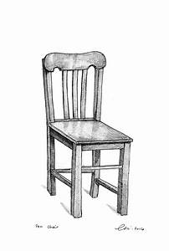

EMPTY SEAT – IS SOMEONE MISSING who sits near you in church, or in a group you attend?

Don’t let their absence go unnoticed, reach out.

If they are hospitalized or in need of prayers, clergy visit, home communion, meals or flowers, please notify the

Church Office 706.291.9111 or e[lizabeth@stpetersrome.org](mailto:lizabeth@stpetersrome.org).

Do you receive the

Weekly Wednesday Email Blast

from St. Peter’s?

If not, give the office a call or email to confirm your contact information in the church database.

**LARGE FONT SERVICE BULLETINS for the 10am worship service now available, see an usher for a copy.**



Payments made to the Restore and Renew 175th Birthday campaign should be remitted on a separate check from your regular pledge giving. THANK YOU

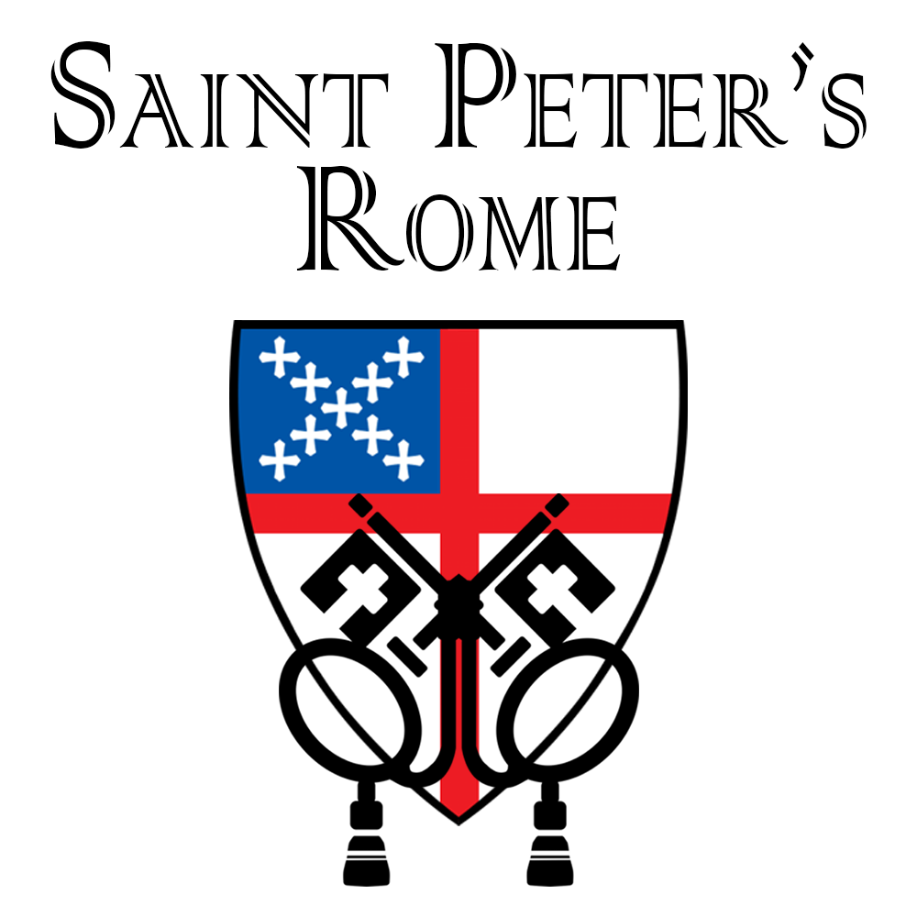

**Church Office**: Phone - 706.291.9111 Fax - 706.232.5007 -

Email: [elizabeth@stpetersrome.org](mailto:elizabeth@stpetersrome.org) - [**www**.stpetersrome.org](http://www.stpetersrome.org)

**Mail Address: 101 East Fourth AVENUE, Rome GA 30161**

**Office Hours:** Monday – Thursday 8am to 4pm.

Fridays 9am -noon

**Connect on Facebook:** St Peter’s Episcopal Church, St Peter’s Sunday School, St. Peter’s Rome EYC, & St. Peter’s Junior Choir

**VESTRY OF THE MONTH for AUGUST:**

Allien McNair 706.936.0518