

**ANNOUNCEMENTS**

**August 11, 2019**

***“Enter reverently, meditate quietly, worship devoutly, leave gratefully, serve Christ faithfully.”***

**WELCOME TO ALL OUR VISITORS!**  If you are interested in knowing more about St. Peter’s, please see an usher or one of the greeters who stand with the clergy after the service.

**TODAY AT ST. PETER'S**

8:30 am Holy Eucharist Rite I

10:00 am Holy Eucharist Rite II

1:00 pm Holy Eucharist Rite II in Spanish

2:00 pm Reception for Father Jorge Rosa

**Nursery available on Sundays from 9am until 12noon**

**This week…**

Monday/August 12 **8:30am Morning Prayer, Chapel**

**9:30am Women’s Bible Study**

Tuesday/August 13 **8:30am Morning Prayer, Chapel**

**11am** **Chair Yoga**

**12:15pm Healing Service**

Wednesday/August 14 **8:30am Morning Prayer, Chapel**

**3:30pm** **Centering Prayer**

**5:30 pm Celtic Service**

Recharge & Rejoice **5:30 pm Dinner service begins**

**6:30 pm EYC Activities**

Thursday/August 15 **8:30am Morning Prayer, Chapel**

**Intercessory Prayer List:** Mike Alexander, Jack Edgens, Kate Ammons,

Bo Warren, Ryan Stubblefield, Emily Barba, Debbie Hayes, Basilia Perez, Hayden Sizemore, Nora Barrientos, Werner Schmitz, Stephen Padgett, Roman Jones, Ivey Sirmans, Betsy Awsumb, John Flanigen, Kevin Skelly, Walter Coker, Dana Holcombe, Daniel Bump, Tony Ryder, Agnes Lee and those who serve their needs.

*To add a name to the PRAYER LIST or MILITARY LIST, contact the church office. Once a name is added to the* ***Prayer list*** *it will remain until the end of the month, then it will be removed. If you wish it to be added for another month, please contact the church office. Names added to the* ***Military list*** *will remain until YOU notify the office to remove.*

**Lay Ministers:**

(8:30) Reader/Prayers/Chalice Bearer – Mark Jester

(10:00) 1st Lesson-Rebecca Segrest; 2nd Lesson–Bob Steinbruegge;

Prayers –Andye Moss

Chalice Bearers – Andye Moss, Jennifer Sikes, Bill Byington, Tom Dasher.

**Altar Candles:** given to the Glory of God and in Celebration and Thanksgiving for Father John and Mother Melissa.

**Flowers on the Altar:** given by Bob and Anthea Evans to the Glory of God and in memory of departed loved ones.

**Flowers in the Chapel**: given to the Glory of God in memory of and in thanksgiving for the lives of Irene Matthews Hight, Alberta & Charles Hight and Arthur Booth, Jr. by Mr. & Mrs. Charles A. Hight, Jr.



EMPTY SEAT - IS SOMEONE MISSING who sits near you in church, or in a group you attend?

Don’t let their absence go unnoticed, reach out.

If they are hospitalized or in need of prayers, clergy visit, home communion, meals or flowers, please notify the

Church Office 706.291.9111 or e[lizabeth@stpetersrome.org](mailto:lizabeth@stpetersrome.org).

**HAPPY BIRTHDAY** to those celebrating birthdays (August 11-August 17). Sam Peirson, Guy Hunter, Isabella Carlton, Mike Lupo, Christopher Kerr, Jeanne Mathews, Amy Massey, Ellice Curry-Tucker, Gabriel Warner, Campbell Ledbetter, Nia Rose, Karen Hellriegel, Amanda Kinder, and Harris McElrath.

**LARGE FONT SERVICE BULLETINS for the 10am worship service now available, see an usher for a copy.**

**ADULT FORMATION – Returns August 25th 11:20am in Daniel Hall**

8/25 – Come spend time with Mother Melissa

9/01 – No Adult Formation, Labor Day Weekend

9/08 – Formation in the Nave, join George Thomason as he takes you through the

historic years of St. Peter’s Church.

Grab your coffee fix BEFORE you join the group.

9/15 – No Adult Formation, St. Peter’s 175th Birthday Celebration

9/22 – No Adult Formation, Trey Clegg Singers

9/29 – Fred Tarrant shares Our Musical History

Recharge & Rejoice Wednesdays are BACK

Beginning August 14th



* Dinner service begins 5:30pm.
* Chicken or Veggie Pot Pie,

Fruit salad, and brownies.

* EYC activities begin at 6:30pm

Call/email the church office by NOON on Tuesday with your dinner reservation, Adults $6, Students (school age children) $4, Family maximum $20

**Rebecca Roberts** Ordination August 17th

St. Catherine’s, 571 Holt Rd Marietta GA, 10am



**NEXT SUNDAY - August 18th**

Backpack Blessing at the 10am worship service.

Celebration of Ministries in Daniel Hall following the 10 am service.

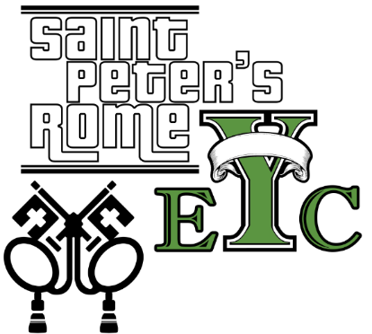

**EYC is BACK! Come join Mother Melissa as you start a new year together.**

**Wednesday, August 14th 6:30pm**

**Chefs Needed for Canterbury Club**

**Tuesday evenings at 6pm, beginning August 27**

This semester we will continue to eat vegetarian to make meal preparation less complicated. I have many EASY, AFFORDABLE recipes that I can share with you.

This weekly meal is the highlight for many of our students. Please contact me if you are able to provide this ministry. =) Rebecca Segrest, 706.331.6363

**TODAY at 1pm**

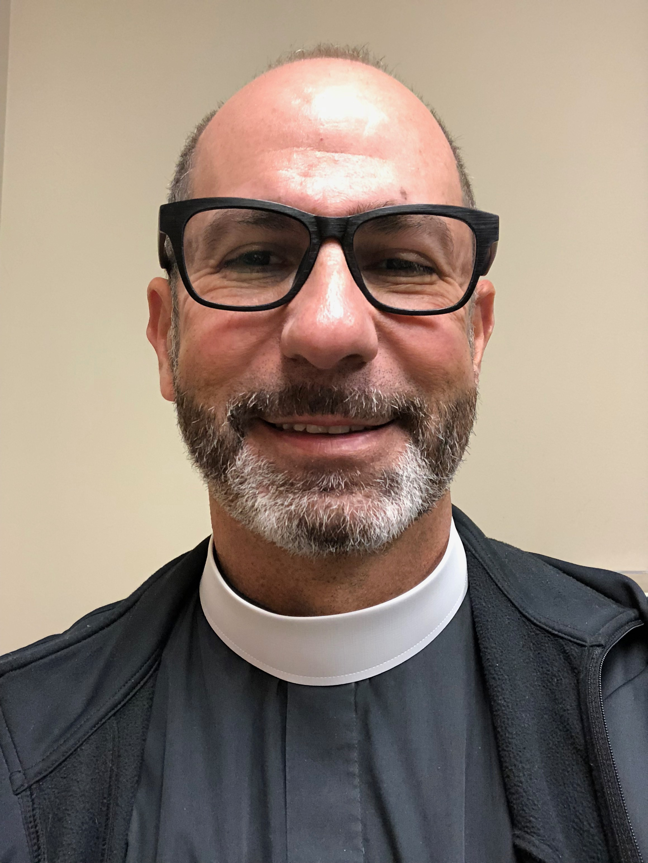Bishop Wright will be present at St. Peter’s during the 1pm worship service to receive

**Father Jorge Rosa**

Following worship, a reception with light refreshments will be held in Daniel Hall.

**Come join this Celebration for Father Jorge Rosa.**



**One Community United House Meetings:**

August 13 Lovejoy Baptist Church 6-7pm

August 22 Rome First United Methodist 6-7pm

Contact Jan Routledge with any questions, [janroutledge@yahoo.com](mailto:janroutledge@yahoo.com), 706.506.4596



Episcopal 101 Class

Wednesday Evenings at 6pm in Rhodes Wyatt Room

August 21st, 28th, September 11th, 18th, 25th,

October 9th, 16th, & 23rd

If you are considering confirmation at St. Peter’s **OR** simply want to learn more about the Episcopal tradition come, join the Episcopal 101 Class. All are Welcome!

Join Father John and explore the Episcopal tradition.

Theology on Tap

3rd Thursdays each month August – December

Sit down in a casual setting, have a drink and talk theology with

Father John & Mother Melissa.

**1st meeting NEXT WEEK - August 15th**

**6pm at Rome City Brewing**



**St. Peter’s 175th Celebration—**

**Sunday, September 15th**

Plan to celebrate St. Peter’s presence in Rome for 175 years in worship and community outreach!!!

**3pm –** St. Peter’s to HOST the Second Annual Community Hymn Fest with choirs from St. Peter’s, First Baptist & First Methodist. Regional Clergy and Chairs of Non-profit Organizations supported by St. Peter’s will receive personal invitations.

Historical commentary of church and grounds immediately after the musical celebration.

Light refreshments served following the Hymn Fest for parishioners and guests. All are encouraged to join our guests for conversation and connections to leaders in our community.

**5pm –**

Parish Celebration in Daniel Hall following the public celebration.

175th Birthday Celebrations highlighted by light appetizers, beverages, and a catered meal.



**Nursery / Toddler care is available** and located on the 2nd floor of the Education Building.

9:00 am through noon

on Sundays.

**If your younger children are staying with you in the pew during service, we are delighted to have the whole family joining us in worship.**

**Little ones are always welcome**.

**For Busy Little Hands in Church:**

We provide Activity Bags at both entrances to the church. The bags are filled with coloring sheets, crayons, pipe cleaners & finger labyrinths.

**Please RETURN the bags at the end of the service.**

Sunday School for children 3 yrs to 5th grade returns September 8th – 9:15am – 9:50am



A year of WONDER



**August 25th**

Come join us for BREAKFAST

Serving from 8:45am to 10am

Adults $3.00

Children $2.00 up to age 12

**OFFICE VOLUNTEER**

**Looking for a place at St. Peter’s**

**to volunteer your time and talent?**

The Church could use your help in the office to answer phones,

fold/stuff bulletins and be a cheery face to guest.

Please contact Elizabeth at the church office if you are available.

YOU choose your preferred day of the month and either 9-12:30 or 12:30-4 shift. THANK YOU

**The RUTH & NAOMI Shelter for**

**Women and Children is officially OPEN**

St. Peter's has selected the SECOND TUESDAY each MONTH to provide a meal for the shelter. The meal needs to serve 12 women and 12 children.  
If you are willing to team with other St. Peter’s Parishioners to provide a meal please contact Peggy Nash.

Peggy Nash [peggynash@bellsouth.net](mailto:peggynash@bellsouth.net) OR 706.766.4434

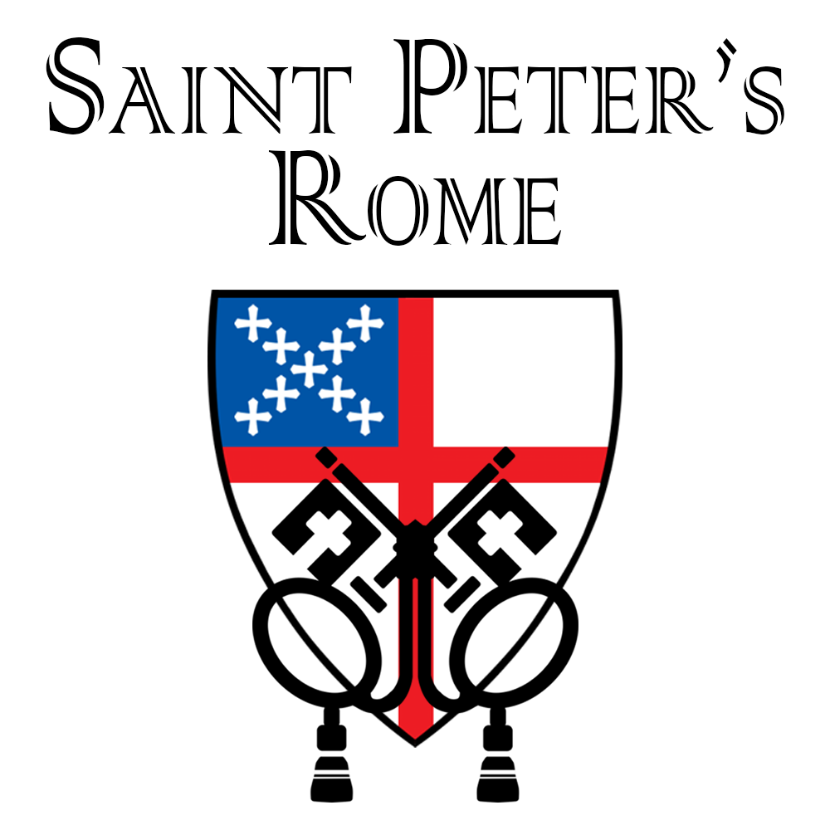

Do you receive the

Weekly Wednesday Email Blast

from St. Peter’s?

If not, give the office a call or email to confirm your contact information in the church database.

**Church Office**: Phone - 706.291.9111 Fax - 706.232.5007 -

Email: [elizabeth@stpetersrome.org](mailto:elizabeth@stpetersrome.org) - [**www**.stpetersrome.org](http://www.stpetersrome.org)

**Mail Address: 101 East Fourth AVENUE, Rome GA 30161**

**Office Hours:** Monday – Thursday 8am to 4pm.

Fridays 9am -noon

**Connect on Facebook:** St Peter’s Episcopal Church, St Peter’s Sunday School, St. Peter’s Rome EYC, & St. Peter’s Junior Choir

**VESTRY OF THE MONTH for AUGUST:**

Allien McNair 706.936.0518