

**ANNOUNCEMENTS**

**May 12, 2019**

***“Enter reverently, meditate quietly, worship devoutly, leave gratefully, serve Christ faithfully.”***

**WELCOME TO ALL OUR VISITORS!**  If you are interested in knowing more about St. Peter’s, please see an usher or one of the greeters who stand with the clergy after the service.

**TODAY AT ST. PETER'S**

8:30 am Holy Eucharist Rite I

8:45 am Breakfast served until 10am

9:15 am Sunday School for Children & Youth

10:00 am Children’s Chapel

10:00 am Holy Eucharist Rite II

11:20 am Adult Formation in Daniel Hall

1:00 pm Holy Eucharist Rite II in Spanish

**Nursery available on Sundays from 9am until 12noon**

**This week…**

Monday/May 13 **1pm Living Compass St. Francis Study**

Tuesday/May 14 **11am Chair Yoga**

**12:15pm Healing Service**

Wednesday/May 15 **5:30 pm Celtic Service**

**Recharge & Rejoice 5:30 pm Dinner**

**6:15 Jr. Choir**

**6:30 EYC**

Thursday/May 16 **10:00 am FINAL Bible Study**

**Lay Ministers:** (8:30) Reader/Prayers/Chalice Bearer –Tricia Richards

(10:00) 1st Lesson-Chris Edgeworth; 2nd Lesson–Brian Hampton;

Prayers – Beth Hughes;

Chalice Bearers –Devon Smyth, Hollye Smith, Jack Niedrach, Glenn Segrest.

**Altar Candles:** given to the glory of God and in loving memory of Jean McRae and Pistol Knight by Nancy and Jack Knight.

**Flowers on the Altar:** given to the Glory of God and in loving memory of Jack Rogers by Cissy Rogers.

**Flowers in the Chapel**: given by Andye Moss and the Drew Moss family to the Glory of God and in loving memory of their Mothers & Grandmothers.

**Intercessory Prayer List:** Mike Alexander, Jack Edgens, Bryant Steele, Kate Ammons, Mary McGuffey, Diane Cantrell, Debbie Hayes, Shana Pardue, Joe McNair, Stephen Padgett, Ryan Stubblefield, Bo Warren, Lila Everett, Pam Stewart, Nora Barrientos, Basilia Perez and those that serve their needs.

If you or someone you know is hospitalized or in need of prayers, clergy visit, home communion, meals or flowers, please notify the CHURCH OFFICE

706.291.9111 or e[lizabeth@stpetersrome.org](mailto:lizabeth@stpetersrome.org).

Remember area hospitals & care facilities do NOT notify us with their admissions.

*To add a name to the PRAYER LIST or MILITARY LIST, contact the church office. Once a name is added to the* ***Prayer list*** *it will remain until the end of the month, then it will be removed. If you wish it to be added for another month, please contact the church office. Names added to the* ***Military list*** *will remain until YOU notify the office to remove.*

**HAPPY BIRTHDAY** to those celebrating birthdays (May 12- May 18)

Elizabeth Thurmond, Sebastian White, Mary Louise Lever, Janet Flippen, Janice Holley-Houck, Jim McCallie, Christy Pruitt and Janice Wright.



**ADULT FORUM**

**Today –** *“Honor your father and your mother, that your days may be long upon the land which the Lord your God is giving you.”*  A special Tribute to all women with a lesson called “There’s something about Mary.” Men are also invited to pay tribute to the women in their lives.

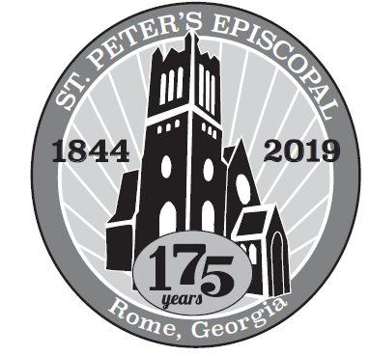

**Restore and Renew 175th Birthday**

Please remember all payments for the 175th B-day campaign should be remitted on a **separate check.** DO NOT combine them with any other remittance to the church, *Thank You.*



**Community Kitchen May 24th & 28th**

**Two shifts8:30am-10:15 OR 10:15am to 12noon.**

**Andye Moss 706.506.4695**

**OUR FINAL**

**RECHARGE & REJOICE**

**Dinner**

**WORSHIP – Celtic Service at 5:30pm**

**DINNER begins at 5:30PM**



**Back yard BBQ –**

**Grilled burgers & dogs,**

**macaroni salad, bake beans, chips, cookies**

**Grilled portobello mushrooms for our vegetarians.**

**RESERVATIONS required by noon on TUESDAY:**

**DINNER** – Adults $5, Children $3, Family max $20

Reservations are required.

For reservations contact church office: [706.291.9111/elizabeth@stpetersrome.org](mailto:706.291.9111/elizabeth@stpetersrome.org)

**Lunch & Learn Sessions**

12noon to 1pm ~ Bring your own lunch

Join with others in the community to help address the complexities of poverty and how we can reduce barriers that keep individuals in poverty.

May 16th St. Peter’s Episcopal Church

June 6th First Baptist Church

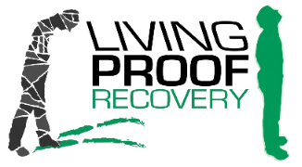**LIVING PROOF RECOVERY**

is a local non-profit organization whose mission is to provide women with long term recovery needs from substance disorders through advocates, training, peer support & spiritual guidance.

There is a critical need for ladies to answer the phones

**Monday-Friday from 5-8pm**

If you are interested, please visit [www.livingproofrecovery.org](http://www.livingproofrecovery.org)



SUMMER KICK OFF

EYC LOCK IN – FRIDAY MAY 17TH 6PM

PARENT PICK UP ON SATURDAY AT 9am



Are you ready to JOURNEY?

**Rising Kindergarten-5th grade**

**EYC join the Journey**

**as helpers!**

(potty trained preschoolers are welcome for a

Mini-Journey on Monday & Tuesday)

VBS 2019 June 17th - June 20th

9am-noon

Help bring the journey alive for our kids by donating items you have from **ITALY ~ GERMANY ~ SPAIN**

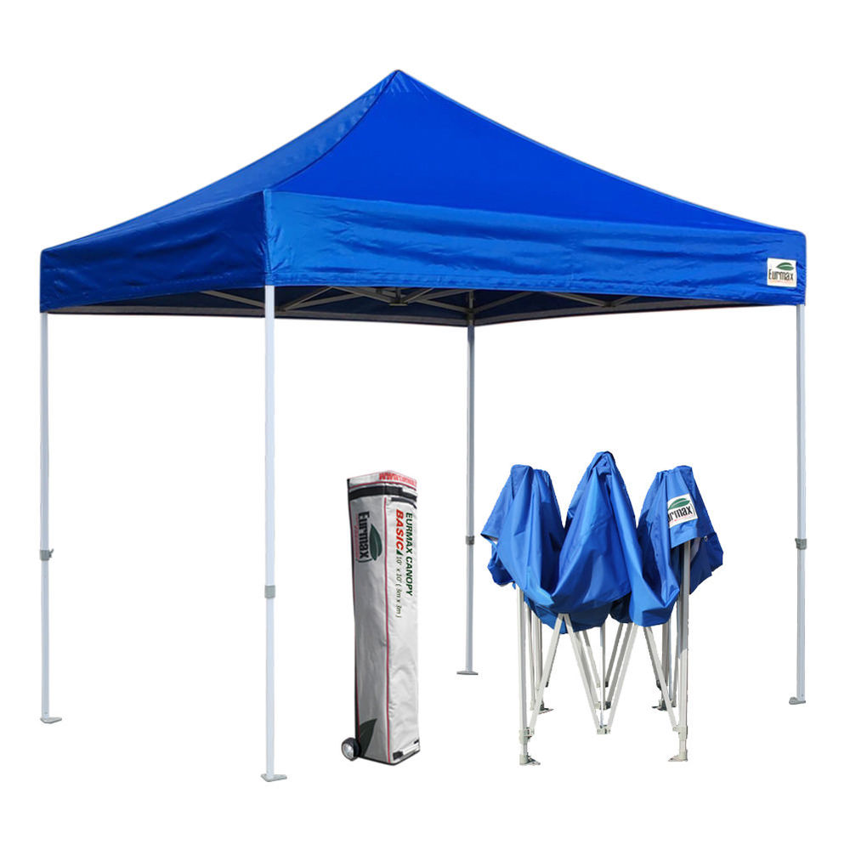Souvenirs, clothing, artifacts, anything that will help illustrate these countries, your items will be returned.

**Needed THREE 10x10 pop up canopies.**

Volunteers needed,

we have a job for everyone!



**Nursery Toddler care is available** and located on the 2nd floor

of the Education Building

beginning at 9:00 am through noon on Sundays.

**If your younger children are staying with you in the pew during service, we are delighted to have the whole family joining us in worship.**

**Little ones are always welcome**.

**For Busy Little Hands in Church:**

We provide Activity Bags at both entrances to the church. The bags are filled with coloring sheets, crayons, and

pipe cleaners.

**Please RETURN the bags at the end of the service.**

**BREAK for the SUMMER –** Programs/activities that will suspend during the summer months are listed below with dates for their **final** meeting.

May 12th Children and Youth Sunday School

May 15th Wednesday Night Meal

May 15th Wednesday EYC activities

May 15th Jr. Choir

May 12th Children’s Chapel

May 12th Adult Formation

May 16th Thursday Bible Study

June 30th Sunday Morning Breakfast

**Chair Yoga** No meeting on July 2nd

**Centering Prayer** No Meeting on May 15th, June 5th & August 28th

**SEE YOU ALL BACK IN THE FALL!**

**Most activities will resume after Labor Day**

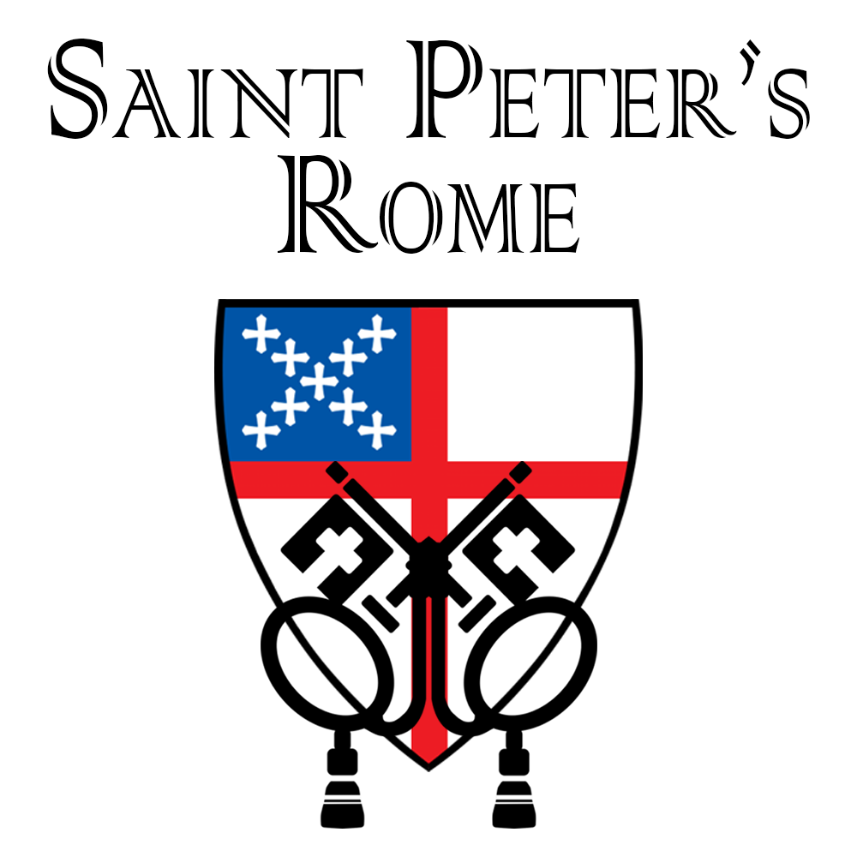

**Church Office**: Phone - 706.291.9111 Fax - 706.232.5007 -

Email: [elizabeth@stpetersrome.org](mailto:elizabeth@stpetersrome.org) - [**www**.stpetersrome.org](http://www.stpetersrome.org)

**Mail Address: 101 East Fourth AVENUE, Rome GA 30161**

**Office Hours:** Monday – Thursday 8am to 4pm. Fridays 9am -noon

**Connect on Facebook:** St Peter’s Episcopal Church, St Peter’s Sunday School, St. Peter’s Rome EYC, & St. Peter’s Junior Choir

**VESTRY OF THE MONTH for MAY:** Shane Walley 706.346.8874