

**ANNOUNCEMENTS**

**May 5, 2019**

***“Enter reverently, meditate quietly, worship devoutly, leave gratefully, serve Christ faithfully.”***

**WELCOME TO ALL OUR VISITORS!**  If you are interested in knowing more about St. Peter’s, please see an usher or one of the greeters who stand with the clergy after the service.

**TODAY AT ST. PETER'S**

8:30 am Holy Eucharist Rite I

8:45 am Breakfast served until 10am

9:15 am Sunday School for Children & Youth

10:00 am Children’s Chapel

10:00 am Holy Eucharist Rite II

11:20 am Adult Formation in Daniel Hall

1:00 pm Holy Eucharist Rite II in Spanish, Chapel

**Nursery available on Sundays from 9am until 12noon**

**This week…**

Monday/May 6 **1pm Living Compass St. Francis Study**

Tuesday/May 7 **12:15pm Healing Service**

Wednesday/May 8 **5:30 pm Celtic Service**

**Recharge & Rejoice 5:30 pm Dinner**

**6:15 Jr. Choir**

**6:30 EYC – Schroeder’s**

Thursday/May 9 **10:00 am NO Bible Study**

**Lay Ministers:** (8:30) Reader/Prayers/Chalice Bearer –Tricia Richards

(10:00) 1st Lesson-Knox Sirmans; 2nd Lesson–Isabella Warner;

Chalice Bearers –Eugenia Knauss, Matt Knauss, Simon Wilson, Josie Cole.

Prayers Gabriel Warner

Celebrant Eugenia Knauss

Crucifer Isabella Warner

Verger Amelia Herring

Torches Hank Crawford & Madeline Herring

Banner Bearer Bennett Smyth

**Altar Candles:** given to the glory of God and in loving memory of Jean McRae and Pistol Knight by Nancy and Jack Knight.

**Flowers on the Altar:** given to the Glory of God and in loving memory of departed loved ones of the Jimmy Smith Family and Kathryn Smith.

**Flowers in the Chapel**: given by John and Mary Kirkland to the Glory of God and in memory of departed loved ones.

**Intercessory Prayer List:** Mike Alexander, Jack Edgens, Bryant Steele, Kate Ammons, Mary McGuffey, Diane Cantrell, Debbie Hayes, Shana Pardue, Joe McNair, Stephen Padgett, Ryan Stubblefield and those that serve their needs.

If you or someone you know is hospitalized or in need of prayers, clergy visit, home communion, meals or flowers, please notify the CHURCH OFFICE 706.291.9111

or e[lizabeth@stpetersrome.org](mailto:lizabeth@stpetersrome.org).

Remember area hospitals & care facilities do NOT notify us with their admissions.

*To add a name to the PRAYER LIST or MILITARY LIST, contact the church office. Once a name is added to the* ***Prayer list*** *it will remain until the end of the month, then it will be removed. If you wish it to be added for another month, please contact the church office. Names added to the* ***Military list*** *will remain until YOU notify the office to remove.*

**HAPPY BIRTHDAY** to those celebrating birthdays (May 5– May 11) Lynne Moosburg, Trinity Pyle, Timmy King, Woody Ledbetter, Peyton Albertson, Bruce Hunter, Charlie Bell, Jim Keaten, and Elaine Smith.



**ADULT FORUM**

**Today –** Dr. Marshall Jenkins – Forming Authentic Witnesses: Thoughts on the Purpose and Practice of the Sermon on the Mount.

**May 12th –** *“Honor your father and your mother, that your days may be long upon the land which the Lord your God is giving you.”*  A special Tribute to all women with a lesson called “There’s something about Mary.” Men are also invited to pay tribute to the women in their lives.

**Lunch & Open House**

**TODAY after Church**

**11:30-2:30**

Food trucks from Timbo’s Smokehouse, Don Neo & Sweet Frog will provide the refreshments. Your lunch purchase will benefit Good Neighbor Ministries.

**LIVING PROOF RECOVERY**

is a local non-profit organization whose mission is to provide women with long term recovery needs from substance disorders through advocates, training, peer support & spiritual guidance.

At this time, there is a critical need for ladies to answer the phones **Monday-Friday**

**from 5-8pm.** If you are interested please attend an OPEN HOUSE on Wednesday May 1st, 6-7:30pm at 408 Shorter Ave. For more information please visit www.livingproofrecovery.org



Lili Bressette

“I will graduate from Rome High School with plans to attend Georgia Highlands in the fall to complete my core requirements then I will attend the University of Georgia to study business.”

Josie Cole

“I will be attending the University of North Georgia in Dahlonega in the fall and plan to major in civil engineering, I’ll miss participating in Rome High’s Varsity soccer, cross country, and swim team as well as volunteering for National Honors Society projects, BEAR club and Interact Club. Even more I’ll miss the love and support I’ve received from this church community. I am grateful for what I have learned that I will take with me to Dahlonega.

Eugenia Knauss

“I plan to finish my core education at Georgia Highlands and then get my bachelors in nursing, and from there become a nurse anesthetist. I am in national honors society, an honors graduate, an ap merit scholar, finished 4 dual enrollment credits, and have a 3.9. I was in the band three years and varsity soccer 3 years. “

John Knauss

“I plan to go to Jacksonville State University to pursue a degree in music. I’m a member of both the top band and chorus, an AP merit scholar, and have a 4.0.”



**Lunch & Learn Sessions**

Join with others in the community to help address the complexities of poverty and how we can reduce barriers that keep individuals in poverty.

May 16th St. Peter’s Episcopal Church

June 6th First Baptist Church

12noon to 1pm ~ Bring your own lunch

**RECHARGE & REJOICE**

**WEDNESDAYS!**

**WORSHIP – Celtic Service at 5:30pm**

**DINNER begins at 5:30PM**

 **Jr. Choir 6:15-7pm! EYC 6:30-8pm**

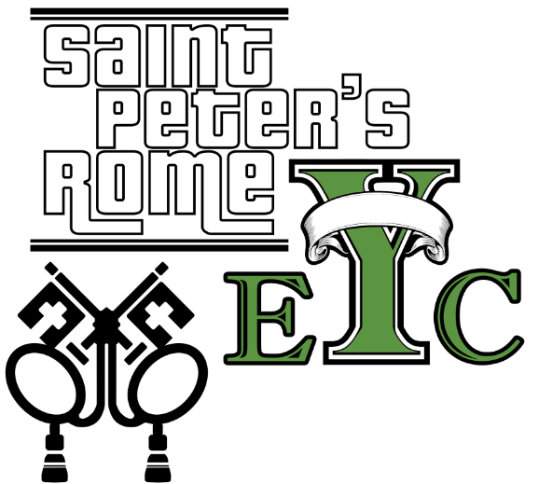

**Schroeder’s**

**Bring $5 for food**

**FINAL RECHARGE & REJOICE**

**MAY 15th don’t miss the Back-Yard BBQ.**

**RESERVATIONS required by noon on TUESDAY:**

**DINNER** – Adults $5, Children $3, Family max $20

Reservations are required.

For reservations contact church office: [706.291.9111/elizabeth@stpetersrome.org](mailto:706.291.9111/elizabeth@stpetersrome.org)

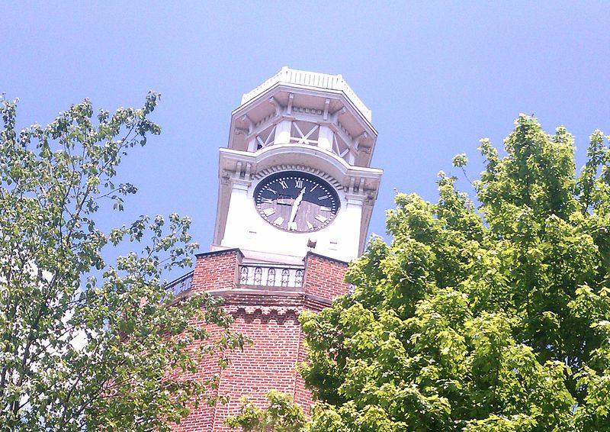

**“As Time Goes By…”**

**Garden dedicated to Anne Culpepper. Wednesday May 5th**

**11:30am at Clocktower.**

**Dedication is OPEN to the public.**



**Nursery Toddler care is available** and located on the 2nd floor of the Education Building beginning at 9:00 am through noon on Sundays.

**If your younger children are staying with you in the pew during service, we are delighted to have the whole family joining us in worship.**

**Little ones are always welcome**.

**For Busy Little Hands in Church:**

We provide Activity Bags at both entrances to the sanctuary. The bags are filled with coloring sheets, crayons, and pipe cleaners.

**Please RETURN the bags at the end of the service.**



**May 12th**

**Our final Sunday School**

**& Children’s Chapel before we break for summer!**



**Immigration Education & Dialogue**

**for Clergy and Lay Leaders**

**May 11th, 10am-2pm, Cathedral**

The session will start with an overview of the U.S. immigration system, common immigration myths and concerns, and a description of what immigration reform could look like.  Many U.S.-born Americans are not well versed on the U.S. immigration system; hence, it’s important to cover this “head” knowledge before engaging in dialogue to get into the heart of the matter.  
Next, the session will bring people together in small groups to engage in guided dialogue about immigration. The dialogue session uses a short film about immigrant journeys and challenges and will include community members who can share their immigration experience as well as their experience working with immigrant communities.  
**$10 per person includes lunch.**

A donation will also be taken to support the ministry of

El Refugio and Just Faith Ministries in their work with immigrants.

**REGISTER ON THE DIOCESE WEBSITE to attend.**

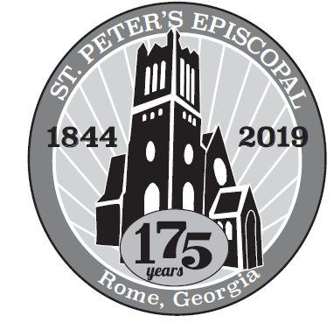**Restore and Renew 175th Birthday**

Please remember all payments for the 175th b-day campaign should be remitted on a **separate check.** DO NOT combine them with any other remittance to the church, *Thank You.*

**Church Office**: Phone - 706.291.9111 Fax - 706.232.5007 -

Email: [elizabeth@stpetersrome.org](mailto:elizabeth@stpetersrome.org) - [**www**.stpetersrome.org](http://www.stpetersrome.org)

**Mail Address: 101 East Fourth AVENUE, Rome GA 30161**

**Office Hours:** Monday – Thursday 8am to 4pm. Fridays 9am -noon

**Connect on Facebook:** St Peter’s Episcopal Church, St Peter’s Sunday School, St. Peter’s Rome EYC, & St. Peter’s Junior Choir

**VESTRY OF THE MONTH of MAY:** Shane Walley 706.346.8874

