ANNOUNCEMENTS
January 27, 2019
“Enter reverently, meditate quietly, worship devoutly, leave gratefully, serve Christ faithfully.”

WELCOME TO ALL OUR VISITORS! If you are interested in knowing more about St. Peter’s, please see an usher or one of the greeters who stand with the clergy after the service.

TODAY AT ST. PETER'S
8:30 am Holy Eucharist Rite II
8:45 am Breakfast served until 10am
9:15 am Youth & Children’s Sunday School
10:00 am Holy Eucharist Rite II
10:00 am Children’s Chapel
11:20 am Adult Formation in Daniel Hall
1:00 pm Holy Eucharist Rite II in Spanish, Chapel
Nursery available on Sundays from 9am until 12noon

This week…
Tuesday/ January 29 11:00 am Chair Yoga
12:15 pm Healing Service
Wednesday/January 30 3:30pm Centering Prayer NEW DAY & TIME
5:30 pm Celtic Service
Recharge & Rejoice 5:30 pm Dinner FUN FOR ALL AGES
6:00 pm Living Compass Rhodes Wyatt
6:30 pm EYC
Thursday/ January 31 10:00 am Bible Study – Rhodes Wyatt Acts of the Apostles

Lay Ministers: (8:30) Reader/Prayers/Chalice Bearer – Dawn Hampton
(10:00) 1st Lesson-Andye Moss; 2nd Lesson–Brian Hampton; Prayers – Randy Muller
Chalice Bearers –Sunny Knauss, Curt Yarbrough, Andye Moss, Sammy Edgeworth

Altar Candles – are given to the Glory of God and in memory of departed loved ones of Billie Abney and Sara Clark.

Altar Flowers – are given by Ann Pullen, Clay Pullen, Christopher Livesay and Mary George Pullen Livesay to the Glory of God and in loving memory of William George Pullen.

Chapel Flowers – are given to the Glory of God and in thanksgiving for their parents by Helen & Jim Keaten and Laura & Ken Davis.

Intercessory Prayer List Mike Alexander, Neil Sanders, Jack Edgens, Regan Hice, Bryant Steele, Jim Hamrick, Danny Hill, Michael Foster, Jeanne Mathews, Basilia Perez, Nora Barrientos, Brooks Arnold, Bess Creech, Walter Coker, Beth King Molly Rutledge, Bill Davis, Sr., and those that provide them care.

If you or someone you know is hospitalized or in need of prayers, clergy visit, home communion, meals or flowers, please notify the CHURCH OFFICE 706.291.9111 or elizabeth@stpetersrome.org.
Remember area hospitals & care facilities do NOT notify us with their admissions.

To add a name to the PRAYER LIST or MILITARY LIST, contact the church office. Once a name is added to the prayer list it will remain until the end of the month, then it will be removed. If you wish it to be added for another month, please contact the church office.

SYMPATHY OF THE PARISH is extended to the Lansing Family on the death of Virginia Maxfield Lansing on January 22, 2019 in Chapel Hill North Carolina. Virginia is the mother of Doug Lansing.

HAPPY BIRTHDAY to those celebrating birthdays (January 27 – February 3). Daniel Carpenter, Keith Lewallen, Diane Nance, Mary Burke Smith, Glenn Segrest, Ann Spears, Janet Morris, Beth Hughes, Toni King, Nash Cooper.
CONGRATULATIONS of the Parish extended to Mary and Stephen Patton on the birth of their grandaughter, Eleanor Reid Patton. Proud parents that welcomed her birth on Monday 1/14/2019 are Pat and Christina Patton.

GREAT KINDNESS CHALLENGE
Jr. EYC of St. Peter’s challenge YOU to join them through the end of February to participate in the Great Kindness Challenge. There is a list of suggested random acts of kindness located in the sanctuary as well as in Daniel Hall. Pick one up and try to check off as many as possible from now through the end of February or choose your own random acts. If the act can be captured in a photograph, please snap a picture and post it to social media #stpeterskindnessmaters or email the photo stpetersromefamily@gmail.com.
YOUTH Sunday & PJ’s for PJ’s – February 24th
Children are invited to participate in a PJ’s for PJ’s Event. Our mission project for February will include pajamas for kids at RESTORATON ROME. Children and Youth can skip the fancy church clothes and come to church in their PJ’s in exchange for a new set of PJ’s for Restoration Rome kids.
RECHARGE & REJOICE WEDNESDAYS!

WORSHIP – Celtic Service 5:30pm

DINNER 5:30PM Cheesy Beef n Macaroni, green beans, apple pie spice cake

FUN FOR ALL AGES – Cookie Decorating and Trivia

PIZZA & Making VALENTINES
6:30 – 8pm

RESERVATIONS required by noon on TUESDAY for:
DINNER – Adults $5, Children $3, Family max $20 Reservations are required.
For reservations contact church office: 706.291.9111/elizabeth@stpetersrome.org

Final Week to Sign UP for groups that will be gathering March through June.
Foyer Groups are monthly gathering of 6-8 people for a meal, conversation, reminiscing, and laughter. Long time members as well as newcomers make this an awesome way to get acquainted.
Contact the church office THIS WEEK if you want to be included.

NEW DAY AND TIME

CENTERING PRAYER
WEDNESDAYS at 3:30pm

Come join us
If you are available to help out on a spring clean-up day OR are willing to help as needed throughout the year please contact the church office. No special talent required.
Time to spruce up

JOY Trip Survey – Pick up & complete the brief JOY survey to assist Parish Life in planning future trips.
Surveys in Daniel Hall & in the Sanctuary.

Nursery/Toddler care is available and located on the 2nd floor of the Education Building beginning at 9:00 am through noon on Sundays.

If your younger children are staying with you in the pew during service, we are delighted to have the whole family joining us in worship.

Little ones are always welcome.

For Busy Little Hands in Church:
We provide Activity Bags at both entrances to the sanctuary. The bags are filled with coloring sheets, crayons, and pipe cleaners.
Please RETURN the bags at the end of the service.

Children’s Sunday School in February…..

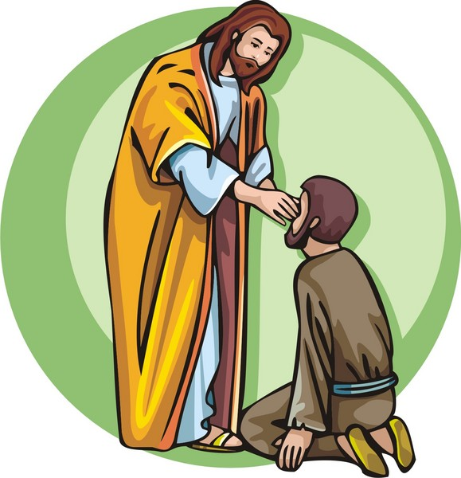
The Miracles of Jesus

Church Office: Phone - 706.291.9111 Fax - 706.232.5007 -
Email: elizabeth@stpetersrome.org
Mail Address: 101 East Fourth AVENUE, Rome GA 30161
Office Hours: Monday – Thursday 8am to 4pm. Fridays 9am -noon
Connect on Facebook: St Peter’s Episcopal Church, St Peter’s Sunday School, St. Peter’s Rome EYC, & St. Peter’s Junior Choir www.stpetersrome.org
VESTRY OF THE MONTH FOR JANUARY Erika Wilson, 334.328.8807

