ANNOUNCEMENTS
November 18, 2018
“Enter reverently, meditate quietly, worship devoutly, leave gratefully, serve Christ faithfully.”

WELCOME TO ALL OUR VISITORS! If you are interested in knowing more about St. Peter’s, please see an usher or one of the greeters who stand with the clergy after the service.

TODAY AT ST. PETER'S
8:30 am Holy Eucharist Rite II
8:45 am Breakfast served until 10am
9:15 am Youth & Children’s Sunday School
10:00 am Holy Eucharist Rite II
10:00 am Children’s Chapel
11:20 am Adult Forum in Daniel Hall
1:00 pm Holy Eucharist Rite II in Spanish, Chapel
Nursery available on Sundays from 9am until 12noon

This week…
Tuesday/ Nov 20 11:00 am Chair Yoga
12:15 pm Healing Service-Chapel
Wednesday/Nov 21 5:30pm Celtic Service
No Recharge & Rejoice Activities this week
Thursday/ Nov 22 THANKSGIVING BLESSINGS

LAY MINISTERS: (8:30) Reader/Prayers/Chalice Bearer – Mark Jester
(10:00) 1st Lesson- Dagmar Carlton; 2nd Lesson–Betsy Awsumb; Prayers – Wade Carpenter
Chalice Bearers –Curt Yarbrough, Tom Dasher, Billie Abney, Sara Clark.

CANDLES – are given by Roger and Elizabeth Ard to the Glory of God and in Thanksgiving for the life of Mary Ann Ard.

ALTAR FLOWERS are given by Mr. and Mrs. Charles Hight and family to the Glory of God and in loving memory of Mr. and Mrs. Charles Kimbrell and Mr. and Mrs. Charles Hight, Sr.

CHAPEL FLOWERS are given to the Glory of God and in loving memory of Willie Starnes by Beth Starnes and her family.

INTERCESSORY PRAYER LIST Mike Alexander, Neil Sanders, Jack Edgens, Regan Hice, Bryant Steele, Jim Hamrick, Danny Hill, Dana Edgens, Michael Foster, Sandra Robinson, Bess Creech, Walker Coker, Sammie Peirson, Marsha Welch, Bill Davis, Carolyn & Ed Grove, Basilia Perez, Nora Barrientos, Kathy Rood and those that provide them care.

If you or someone you know is hospitalized or in need of prayers, clergy visit, home communion, meals or flowers, please notify the CHURCH OFFICE 706.291.9111 or elizabeth@stpetersrome.org.
Remember area hospitals & care facilities do NOT notify us with their admissions.

To add a name to the PRAYER LIST or MILITARY LIST, contact the church office. Once a name is added to the prayer list it will remain until the end of the month, then it will be removed. If you wish it to be added for another month, please contact the church office.

Happy Birthday to those celebrating birthdays (November 18-November 24) Norma Littlejohn, D’Ann Downey, Harper Smith, George Beaucham, Susan Alred, Alicia Wright, Sam Berry, Rosalee Kelley, Steve Gunther, Christina Hubbard, Allison Hubbard and Annette Morris.

JOY November 27th
Trip to the Outlet Shoppes at Woodstock
Cost $32, lunch on your own at the location of your choice.
Monday FINAL DAY to call the office to sign up!

AN OPPORTUNITY FOR SHARING AND SUPPORT

Bryant Steele has been seriously ill and has chosen to share the physical and emotional journey he is taking. His article will be included in the December newsletter.

Understanding how different each journey is and how difficult yet cathartic sharing that journey may be, we would like to give other parishioners the opportunity to share their journey. If you yourself travel(ed) a similar journey or have been the care provider we invite you to write a brief article to be included in the December Newsletter.
You may email them to, elizabeth@stpetersrome.org or drop off at the church office.
Adult Forum

November 18th – Roger Ard, “Good God?”
November 25th – Bob Evans leads discussion on Bishop Tutu’s book “The Book of Forgiveness”

December – Terry Morris begins a 4-week series “A Historian looks at religion in America’s Past”.

2019 Calendar Collection
Bins in Daniel Hall through December 2nd

LIVING COMPASS – Upcoming ADVENT Study
Mondays – 1pm 401 East 4th Avenue - D’Ann Downey Nov. 26-Dec 17.
Wednesdays – 6pm Willingham House - Beth Novian Hughes Nov. 28 – Dec 19.

LIVING WELL THROUGH ADVENT 2018, Practicing Generosity
With All Your Heart, Soul, Strength and Mind.

You will find the Advent Booklets placed around the church. Feel free to pick up an Advent study guide for home use even if you do not plan to attend the class.
More information contact:
D’Ann Downey at ddowneywarley@comcast.net
Beth Hughes at novianhughes@gmail.com

END OF THE YEAR GIVING……

- STOCK/MONEY MARKET GIFTS TO ST. PETER’S To ensure accurate recording of your gifts please begin the process in plenty of time for the check to be received in the church office by MONDAY DECEMBER 31st. Most transactions take at least 2 weeks to complete. All gifts should be processed through the St. Peter’s account at Benjamin Edwards. Contact the church office for full details.
PAY PAL – Do you use Pay Pal to make your financial gifts to the church? At the end of the year to ensure proper recording of your gift please, COMPLETE all Pay Pal transfers by DECEMBER 25th. THANK YOU

- 2018 Pledges To ensure accurate year end giving statements please be certain that all gifts to be recorded for 2018 are in the church office by MONDAY DECEMBER 31ST.

Thank You

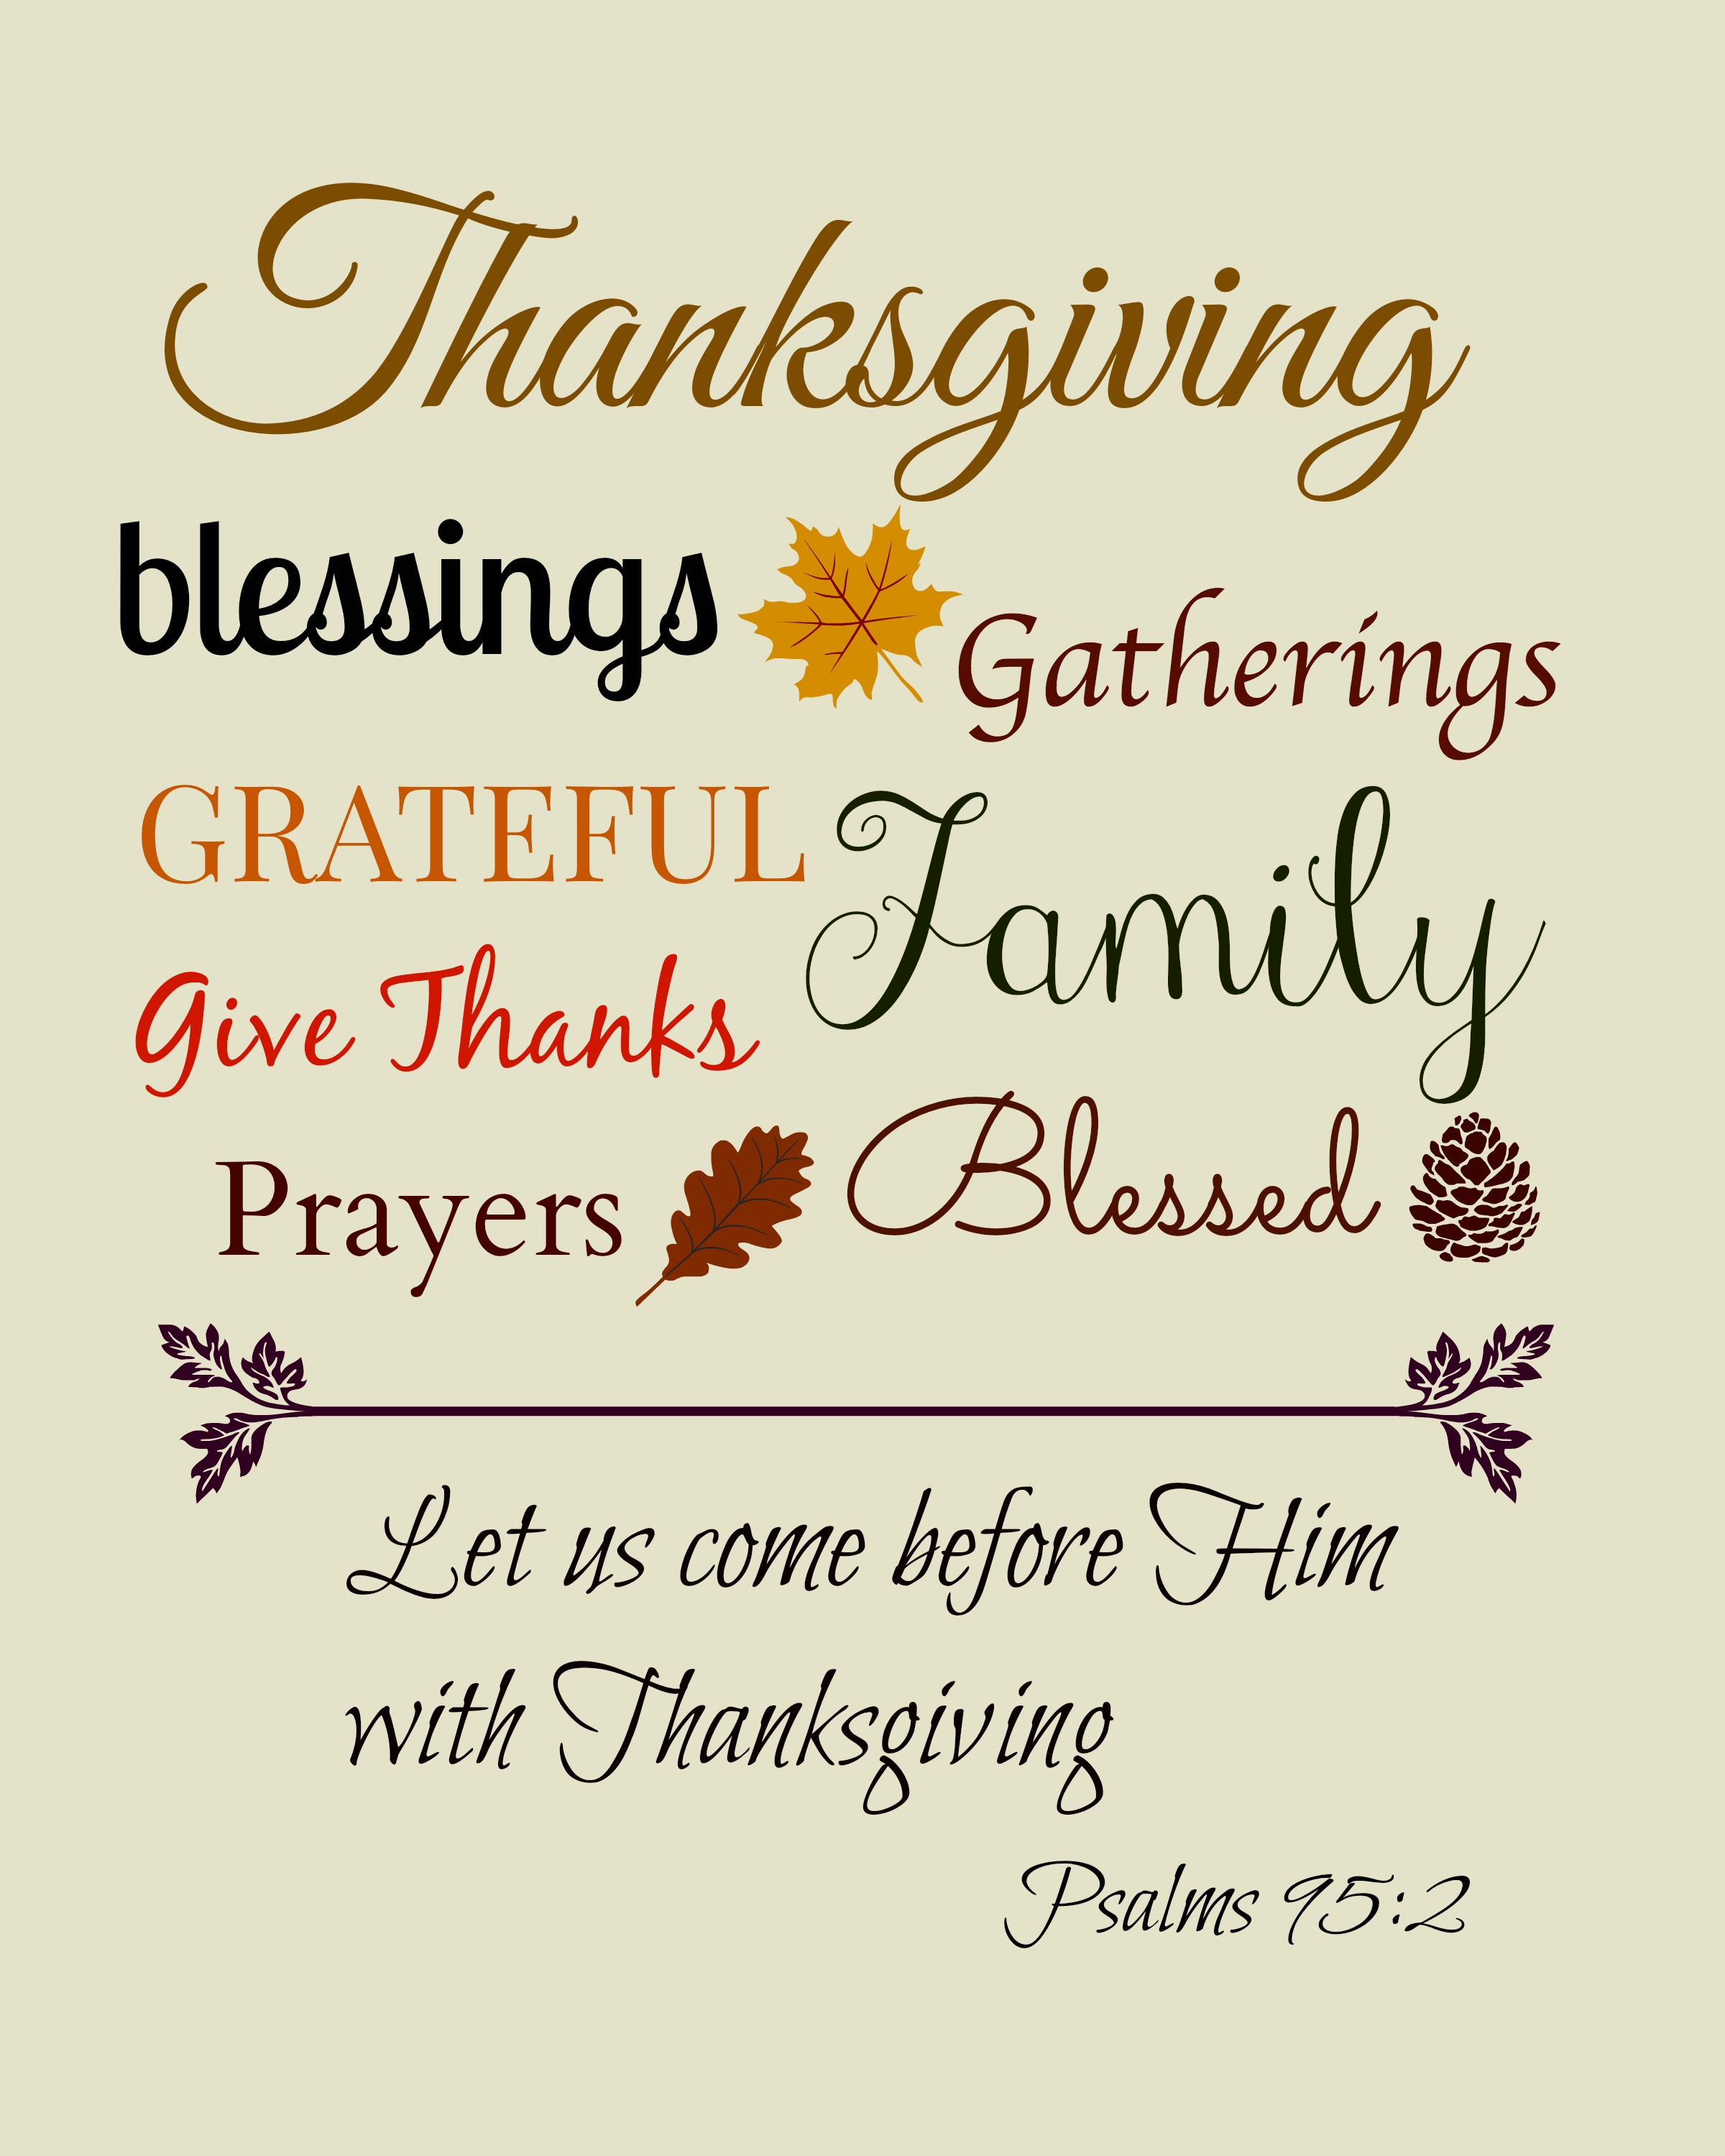
THANKSGIVING WEEK SUSPENDED ACTIVITIES:

Wednesday Recharge & Rejoice Dinner
EYC
Jr. & Youth Choirs
Thursday Centering Prayer
OFFICE CLOSED
Friday OFFICE CLOSE
Sunday Formation for Children & Youth ~ Children’s Chapel

Did you miss the ANNUAL PARISH meeting last week – Extra copies of the Parish Report are available in the church office or Daniel Hall, pick one up today.
CHILDREN’S CORNER!

Sunday School in November - Saints

Nursery/Toddler care is available and located on the 2nd floor of the Education Building beginning at 9:00 am through noon on Sundays.

If your younger children are staying with you in the pew during service, we are delighted to have the whole family joining us in worship.

Little ones are always welcome.

For Busy Little Hands in Church:
We provide Activity Bags filled with coloring sheets, crayons, and pipe cleaners.
Please RETURN the bags at the end of the service.

ADVENT ACTIVITIES FROM FAMILY MINISTIRES
4-6 pm in Daniel Hall

Advent Wreaths – Advent I (Dec. 2nd) Cost $5 per wreath

Gingerbread Houses – Advent II (Dec. 9th) Cost $5 per house

Advent III (Dec. 16)- Salt Dough ornaments & Advent Service, no charge
Light refreshments will be available all 3 dates, feel free to brown bag dinner if you like!
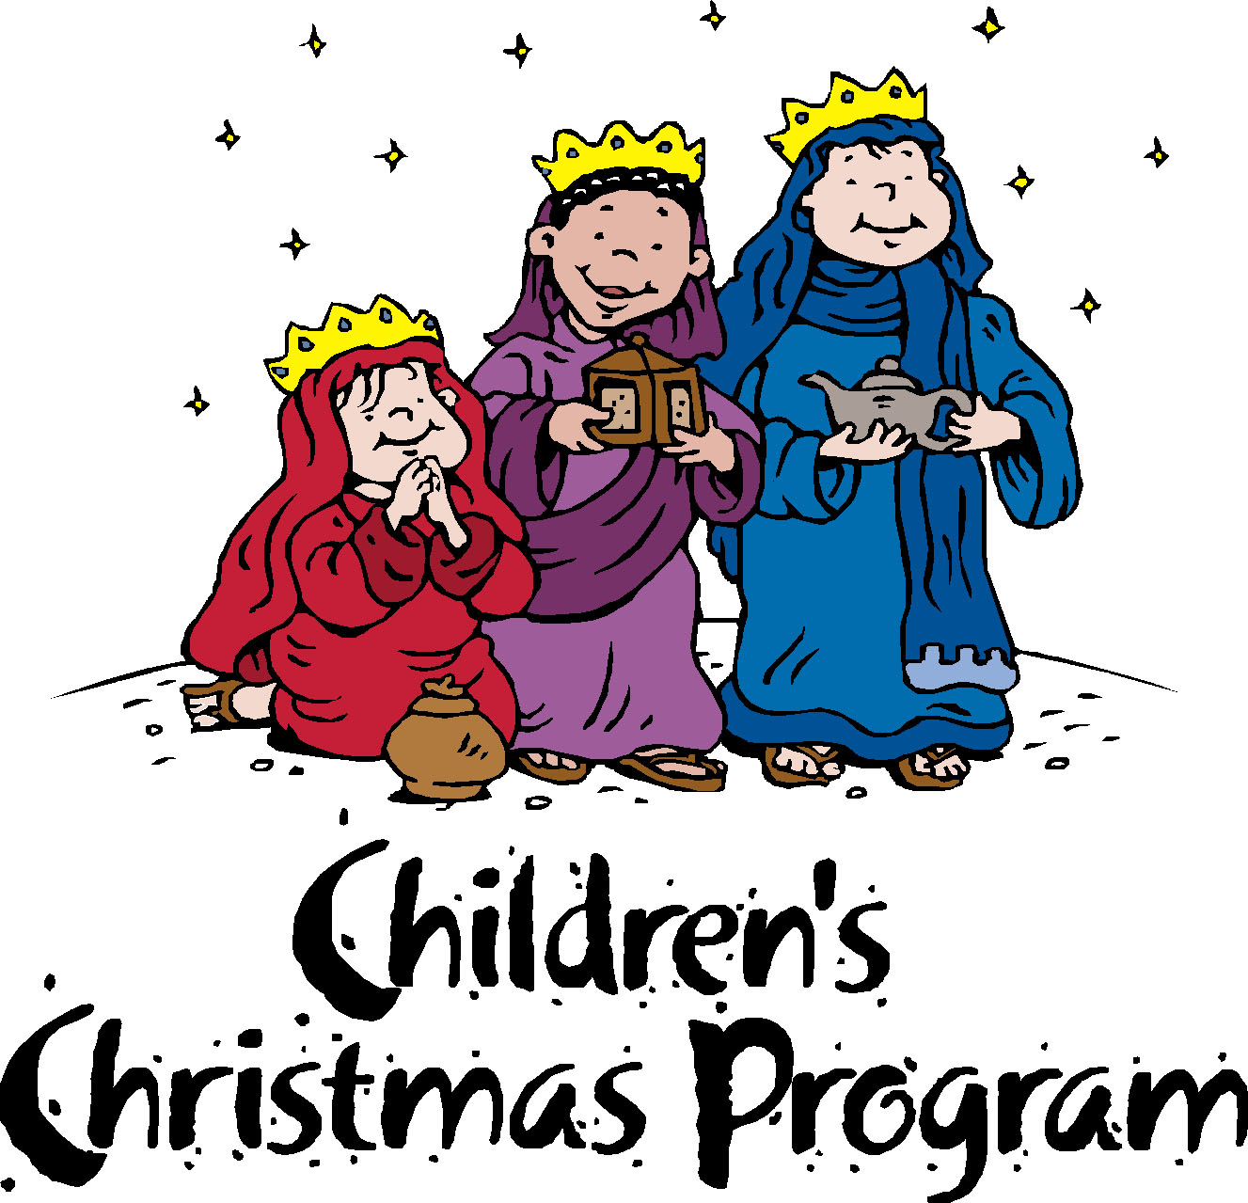
Children’s Pageant – December 19th
Dinner served at 5:30
Pageant begins 6:30 in the Sanctuary

Church Office: Phone - 706.291.9111 Fax - 706.232.5007 -
Email: elizabeth@stpetersrome.org
Mail Address: 101 East Fourth AVENUE, Rome GA 30161
Office Hours: Monday – Thursday 8am to 4pm. Fridays 9am -noon
Connect on Facebook: St Peter’s Episcopal Church, St Peter’s Sunday School, St. Peter’s Rome EYC, & St. Peter’s Junior Choir
www.stpetersrome.org
VESTRY for the MONTH of NOVEMBER– Charlie Hardaker 706.331.7454

