ANNOUNCEMENTS
October 28, 2018
“Enter reverently, meditate quietly, worship devoutly, leave gratefully, serve Christ faithfully.”

WELCOME TO ALL OUR VISITORS! If you are interested in knowing more about St. Peter’s, please see an usher or one of the greeters who stand with the clergy after the service.

TODAY AT ST. PETER'S
8:30 am Holy Eucharist Rite II
8:45 am Breakfast served until 10am
9:15 am Youth & Children’s Sunday School
10:00 am Holy Eucharist Rite II
10:00 am Children’s Chapel
11:20 am Adult Forum in Daniel Hall
12:00 pm Consecration Luncheon – Forrest Place
1:00 pm Holy Eucharist Rite II in Spanish, Chapel
Nursery available on Sundays from 9am until 12noon

This week…
Monday / Oct 29 1pm Living Compass, 401 E. 4th Avenue
Tuesday/ Oct 30 11:00 am Chair Yoga
12:15 pm Healing Service-Chapel
Wednesday/Oct 31 5:30pm Celtic Service
5:30pm Dinner ONLY
6:00 pm Living Compass Willingham House
Thursday/ Nov 1 10am Bible Study – Rhodes Wyatt Room
6:30pm Centering Prayer

LAY MINISTERS: (8:30) Reader/Prayers/Chalice Bearer – Dawn Hampton
(10:00) 1st Lesson- Rebecca Segrest; 2nd Lesson–Christopher Edgeworth; Prayers – Tom Dasher
Chalice Bearers –Jennifer Sikes, Sunny Knauss, Billie Abney, Sara Clark.

CANDLES – are given to the Glory of God and in loving memory if Bill and Janice Byars and William M. Byars Jr. by Lee and Becky Jones and Ben and Abby Stell.

ALTAR FLOWERS are given by Jack and Mary McGuffey to the Glory of God and in memory of departed loved ones of the Johnson and McGuffey families.

CHAPEL FLOWERS are given to the Glory of God and in memory of Henry (Hank) Ortman by Stefani Ortman and family.

INTERCESSORY PRAYER LIST – Mike Alexander, Neil Sanders, Jack Edgens, Regan Hice, Bryant Steele, Jim Hamrick, Kathy Rood, Danny Hill, Dana Edgens, Michael Foster, Bill Davis, Carolyn & Ed Grove, Nora Barrientos, Basilia Perez, Bess Crawford, Steve Lob, Bess Creech, Walter Coker, Sammie Peirson, Brooks Arnold, Gloria Herren, Knox Yeary and those that provide them care.

If you or someone you know is hospitalized or in need of clergy, home communion, meals or flowers, please notify the CHURCH OFFICE 706.291.9111 or elizabeth@stpetersrome.org.
Remember area hospitals & care facilities do NOT notify us with their admissions.

To add a name to the PRAYER LIST or MILITARY LIST, contact the church office. Once a name is added to the prayer list it will remain until the end of the month, then it will be removed. If you wish it to be added for another month, please contact the church office.

Happy Birthday to those celebrating birthdays (October 28 – November 3) Seth Turner, Sylvia Hine, Jack Niedrach, John Burnes, Mary Patton, Jack Albertson, and Jennifer Anderson.

Parish Dinner, October 31, 2018
Homestyle Meatloaf, Mac n Cheese, Green Beans, Tossed Salad, Peach Cobbler
Adults $5, Children under age 11 $3, Family Maximum $20

Due to Halloween we will suspend Jr. and Youth Choirs as well as EYC.
Recharge and Rejoice will return on Wednesday, November 7th.

JOY November 27th
Trip to the Outlet Shoppes at Woodstock.
Cost $32, lunch on your own at the location of your choice.
Members sign up NOW, guest may sign up beginning November 12th.
Call or email the office to sign up!

Events & Activities:
November 10th - Morning Prayer at the Marina & Sailing on Knotty Fun
November 11th - Lunch following 10am worship at St. Peter’s
2019 Calendar Collection Continues – bins located in Daniel Hall
Canterbury Club events are OPEN to everyone currently enrolled in a college program, alumni, friends and family.

NO ADULT FORMATION TODAY due to Consecration Luncheon

ANNUAL PARISH MEETING – NOVEMBER 11th

In Daniel Hall following 10 am worship service.

LIVING COMPASS
Mondays
1pm 401 East 4th Ave. led by D’Ann Downey October 22-Nov. 12
Wednesdays
6 p.m. Willingham House led by Beth Hughes Oct. 3-Nov. 7

The subject for this week’s Living Compass groups is Richard Rohr’s meditations on “Unknowing”.
You do not have to sign up for the entire series of classes if you cannot make all of them. Please bring a device to the meetings that you can receive your emails on.

END OF THE YEAR ~ Stock or Money Market Gifts to St. Peter’s ~
To ensure accurate recording of your gifts please begin the process in plenty of time for the check to be received in the church office by MONDAY DECEMBER 31st.
Most transactions take at least 2 weeks to complete.
All gifts should be processed through the St. Peter’s account at Benjamin Edwards.
Contact the church office for full details on how to make this transaction occur. Thank You

Mission & Outreach FINAL WEEK
P.A.W.S – Public Animal Welfare Services
Needed items:

Dry Dog Food
Wet Cat Food
Puppy and Kitten food wet or dry
Horse Pellet bedding
Heartworm test
Parvo test
Combo test
Medicated shampoo for cats & dogs
Flea & tick shampoo for cats & dogs
Flea & Tick treatments for all weights
Collars all sizes
Harnesses all sizes
Canned cheese for Kong’s
Dog & Cat treats

Items needed about every 4-6 months
Kuranda beds https://kuranda.com/donate/1402
Towels ~ Pee Pads ~ Stainless steel bowls 3qt & 5qt ~Kong toys ~ Cat toys (prefer NON fabric)
CHILDREN’S CORNER!

Sunday School in November - Saints

Nursery/Toddler care is available and located on the 2nd floor of the Education Building beginning at 9:00 am through noon on Sundays.

If your younger children are staying with you in the pew during service, we are delighted to have the whole family joining us in worship.

Little ones are always welcome.

For Busy Little Hands in Church:
We provide Activity Bags filled with coloring sheets, crayons, and pipe cleaners.
Please RETURN the bags at the end of the service.

ADVENT ACTIVITIES FROM FAMILY MINISTIRES

Advent Wreaths – December 2nd 4-6pm in Daniel Hall

Gingerbread Houses – December 9th 4-6pm in Daniel Hall

Special Advent Service – December 16th 4-6pm
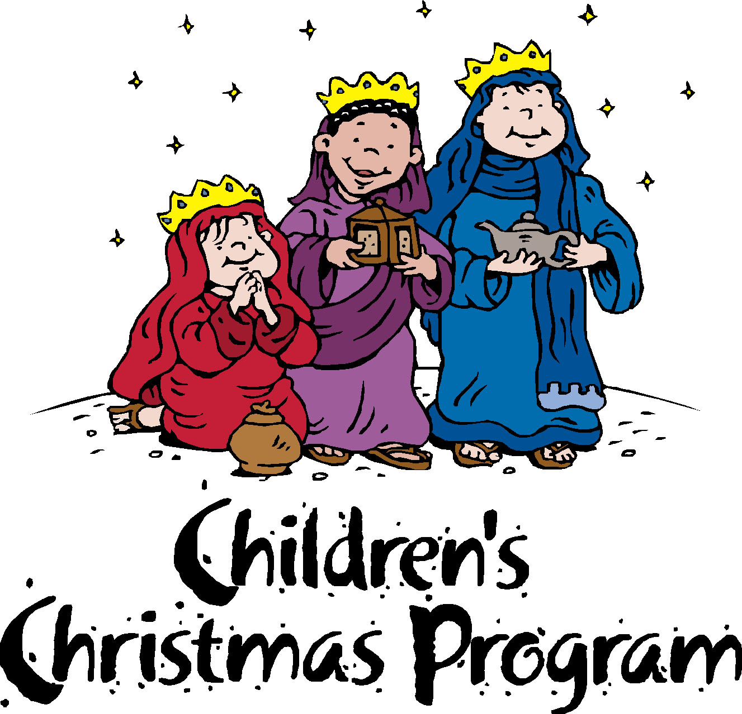

December 19th
Dinner served at 5:45, Pageant begins 6:45pm in Sanctuary

Church Office: Phone - 706.291.9111 Fax - 706.232.5007 -
Email: elizabeth@stpetersrome.org
Mail Address: 101 East Fourth AVENUE, Rome GA 30161
Office Hours: Monday – Thursday 8am to 4pm. Fridays 9am -noon
Connect on Facebook: St Peter’s Episcopal Church, St Peter’s Sunday School, St. Peter’s Rome EYC, & St. Peter’s Junior Choir
www.stpetersrome.org
VESTRY for the MONTH of NOVEMBER– Charlie Hardaker 706.331.7454

