

**ANNOUNCEMENTS**

**October 8, 2017**

***“Enter reverently, meditate quietly, worship devoutly, leave gratefully, serve Christ faithfully.”***

**WELCOME TO ALL OUR VISITORS!**  If you are interested in knowing more about St. Peter’s, please see an usher or one of the greeters who stand with the clergy after the service.

**TODAY AT ST. PETER'S**

8:30 am Holy Eucharist Rite I

9:00 am Breakfast

10:00 am Holy Eucharist Rite II (Nursery available)

Children’s Chapel

11:15 am Christian Formation- Children, Youth & Adults

5:00 pm Eucharist in Spanish in the Chapel

7:00 pm C3 – Canterbury Club – Willingham House

**LOOKING AHEAD:**

Monday/ Oct 9 **Living Compass 1pm**

Tuesday/ Oct 10 **Chair Yoga 11am**

**Healing Service 12:15pm**

**Margaret Ingram Funeral 2pm**

**Canterbury Club 6pm McAllister Hall**

Wednesday/Oct 11 **Celtic Service 5:30**

**Parish Dinner 5:45**

**Living Compass 6pm**

**EYC – Scavenger Hunt**

Thursday/Oct 12 **Centering Prayer 6:30 pm**

Friday/Oct 13 **Restoration Rome 9am**

**LAY MINISTERS:** (8:30) Reader/Prayers/Chalice Bearer – Mark Jester;

(10:00) 1st Lesson –Chris Edgeworth; 2nd Lesson – Delores Nowell; Prayers – Tm Dasher; Chalice Bearers –Beth Hughes, Sunny Knauss, Brian Hampton, Allien McNair.

**ALTAR ARRANGEMENTS** are given by Dale and Todd Carroll to the Glory of God and in memory of John D. and Julie Clothier.

**CHAPEL ARRANGEMENTS** are given to the Glory of God and in honor of M.J. Chisholm and her family on M.J.’s birthday by her friends.

**INTERCESSORY PRAYER LIST** Charlie Rutledge, Mike Alexander, Neil Sanders, Fran Bagley, Barbara Wyatt, Jack Edgens, June Dellis, Terry Morris, Troy Beacham, Randy Warley, Bryant Steele, Alicia Segars, Mildred Edgeworth, Cathy Varidel, JoAnne Massey Lyles, Larry Drapper, Enloe Willingham, Jamie Hughes, Matt Bowen, Ray Trussell, Opal Hicks, Rev. Wayne Johnston, Bill Guche and those who provide them care.

*To add a name to the PRAYER LIST or MILITARY LIST, contact the church office. The prayer list will be refreshed the 1st Sunday of every month.*

**Happy Birthday** to those celebrating birthdays (October 8 – October 14) John Thacker, Bob Steinbruegge, M.J. Chisholm, Cameron O’Riley, Mary-Jo Woolcock, Timothy Pape, Henry Brown, Russ Jennings, and Thomas Lemming.



**MISSION AND OUTREACH**

October our focus is The **PAWS** Center whose mission is to shelter lost, unwanted, and neglected animals. We will be collecting **cat toys and clumping cat litter** for our feline friends. **Dishwasher safe dog toys (such as Kong toys), leashes, and treats for our canine companions.**

**WORRIED about that HOLIDAY EATING?**

Join a LIVING COMPASS *“Mindful Eating”* group starting **October 16th**. “*Mindful Eating”* study groups will meet for 4 weeks with a culminating Pot Luck for the congregation on Wednesday November 15th.

Three Meeting Times to fit your schedule:

* Monday at 1pm at 401 E. 4th Ave
* Tuesday at 9:30am in Rhodes Wyatt
* Wednesday at 6pm in Rhodes Wyatt

Call Beth Hughes (706.506.9636) or D’Ann Downey (706.266.3444) to hold your spot!

**WEDNESDAY DINNER 10/11/2017 Beef Stroganoff, green beans, rolls, dessert. Vegetarian mushroom cream sauce over noodles also available. Reservations Required,** call or email the church office by noon on Tuesday with your reservation. Adults $5, Children $3, Maximum family expense $20



**BAPTISM – November 5, 2017,** All Saints Sunday will be the next opportunity for Baptism at St. Peter’s. Please contact one of the clergy or the church office if you or a family member are planning to be baptized. Rehearsal scheduled on Saturday November 4th.

**ADULT FORUM –** In October join adults at 11:15 as they study the lessons taught on the Andy Griffith show about life, faith, and family. Today Janet Byington leads the discussion.

**OKTOBERFEST**

****Just a few weeks away and YOU are needed as a **VOLUNTEER**:

* Decorators - Servers (no cooking)
* Help with games – Bartenders - Costume judges

Call/email the office to volunteer today! **Octoberfest scheduled for October 25th.**

**CANTERBURY CLUB CORNER**

**This week’s meeting** on 10/10 will meet at 6pm at McAllister Hall, immediately following a talk by Dr. Bill Brown on religion & evolution that begins at 5pm in McAllister Auditorium. **Talk is open to the public.**

**Calendar collection** Canterbury Club wants to put your extra 2018 calendars to good use. As part of our service to the community, we are collecting calendars for families served by DFACS. Collection boxes located in Daniel Hall & the church office through DECEMBER 11th.

**NEW CONSECRATION SUNDAY** October 29, 2017.

****Make plans now to attend morning worship & enjoy a catered luncheon following the 10 am service. Reservation forms located in your bulletin.

**JOIN our YOUTH in WORSHIP**

Next Sunday, 10/15/2017 is Youth Sunday.

Youth will lead worship during the 10am service.

**LIVING COMPASS WELLNESS SURVEY** Please place your completed survey in the basket in Daniel Hall. If you do not have a survey there are copies there for you to take home and complete. THANK YOU

**READY SET SMILE –** Your Photo Sessions begin this week for the new St. Peter’s Pictorial Directory. If you have forgotten your selected appointment date/time, please call the church office. Helpful Hints for your photo session are on the church website under PARISH NEWS as well as the October Letter to the Romans.

**RESTORATION ROME – Clothes Closet**

Volunteers are needed to help work on Friday mornings from 9-12. **Please call Jeanne Mathews at 796-676-1039** to volunteer or if you have questions. They also accept gently used children's and teen clothing, new socks and underwear, toys and shoes.

**CHILDREN’S CORNER!**

**Seventeenth Sunday after Pentecost**

**Nursery/Toddler care is available** and is located on the 2nd floor of the Education Building for the 10am service, beginning at 9:45am.

**Children’s Chapel** is available for children ages pre-k through 3rd grade during the 10am worship service on the 2nd floor of the Education Building.

**If your younger children are staying with you in the pew during service, we are delighted to have the whole family joining us in worship.**

**Little ones are always welcome**.

**For Busy Little Hands in Church:** We provide scriptural coloring sheets, crayons, and a children’s guide to the Eucharist, in the back of the church to help children in understanding our scripture readings and our corporate worship.

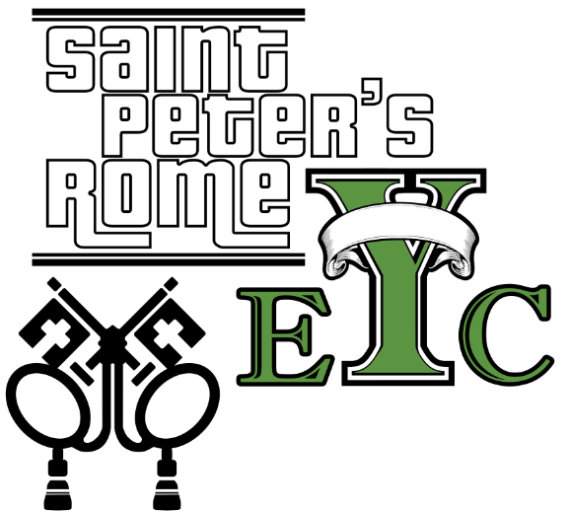Wednesday, October 11th

Scavenger Hunt & Snacks

Drop off at the church at 6:30, pick up at 8:15

**EYC is open to all students grades 6 to 12.**

**Friends are Welcome!**

October 15th – **YOUTH SUNDAY**



**GET CONNECTED!**

Want to see what our small ones and youth are up to at St. Peter’s? Check out our Facebook pages: **St. Peter’s Sunday School** &

**St. Peter’s Rome EYC.**

**Church Office**: Phone - 706.291.9111 Fax - 706.232.5007 Email: [elizabeth@stpetersrome.org](mailto:elizabeth@stpetersrome.org)

**Office Hours:** Monday – Thursday 8am to 4pm and Friday 9am to 12 noon

St Peter’s Episcopal Church/St Peter’s Sunday School/St. Peter’s Rome EYC

St. Peter’s Junior Choir

**www**.stpetersrome.org